Interactive Effects of Variety, Plant Spacing, and Fertilizer on Yield and Fruit Quality of Cucumber (Cucumis sativus L.)

Abstract
Cucumber (Cucumis sativus L.) fruit quality depends on integrated genetic and agronomic management, their interactive effects across variable environments remain inadequately characterized. This two-year field study (2019–2020) in Nigeria's forest-savanna transition zone employed a split-split plot design to evaluate two varieties (CU-999, Monalisa), three intra-row spacings (75 × 25, 75 × 50, and 75 × 75 cm), and four NPK fertilizer rates (0–300 kg ha⁻¹) on growth, phenology, and quality. Variety was the dominant factor influencing fruit weight (F = 100.50, p < 0.001), with CU-999 producing 51.4% heavier fruits (2.15 kg) than Monalisa (1.42 kg). Intermediate spacing (75 × 50 cm) optimized fruit weight (1.92 kg), while fertilizer did not affect fruit quality but accelerated flowering, reducing days to flowering from 26.3 d (control) to 24.7 d (300 kg NPK ha⁻¹). Significant variety × year and spacing × year interactions indicated responses varied with seasonal conditions. Regression analyses confirmed strong positive relationships between fruit weight, length (r = 0.77–0.78), breadth (r = 0.74–0.77), and fruit number per plant (r = 0.82–0.93). Variety selection is paramount for optimizing fruit quality, while spacing and nutrient management must account for interannual variability to maximize resource use efficiency.
Keywords: Cucumis sativus; genotype × environment interaction; plant density; nutrient management; yield components.
Introduction
Cucumber (Cucumis sativus L.) is one of the most economically important vegetables worldwide, ranking among the top five vegetable crops in terms of global production (Uthpala et al. 2020; FAO, 2021). Originating from South Asia, cucumber cultivation has expanded globally due to its nutritional value, culinary versatility, and economic importance for smallholder farmers. The crop serves as a significant source of vitamins, minerals, and antioxidants, contributing to food security and nutritional health in many regions (Walshaw 2005).
The global cucumber market has experienced steady growth, with production reaching approximately 96 million tons annually, reflecting increasing consumer demand for fresh vegetables and healthy dietary options (FAO, 2021). However, cucumber production faces numerous challenges including biotic stresses, abiotic factors, and suboptimal agronomic practices that limit yield potential and quality. Achieving sustainable and profitable cucumber production requires optimizing multiple agronomic factors simultaneously.
Traditional approaches often evaluate variety selection, plant spacing, and fertilizer application independently, overlooking potential interactions that could significantly influence crop performance. Recent studies have emphasized the importance of integrated management strategies that consider multiple factors simultaneously (Kakahy et al. 2021; Singh et al. 2015; Kumar et al. 2019). Limited research has comprehensively evaluated the interactive effects of these factors across multiple growing seasons, particularly in diverse agroecological zones.
Cucumber varieties differ significantly in morphological characteristics, growth habits, disease resistance, and yield potential. Studies have demonstrated that variety selection can account for up to 30% of the variation in cucumber yield (Pushpalatha et al. 2018; Saludez, 1966; Gözen & Yetisir, 2012). Modern hybrid varieties typically exhibit superior performance compared to traditional open-pollinated varieties, with improved fruit quality, uniformity, and marketability. Research has shown that indeterminate varieties generally produce higher yields than determinate varieties due to their extended harvest period (Paran et al. 1991).
Plant spacing significantly influences cucumber growth, development, and yield through its effects on light interception, nutrient competition, and air circulation. Optimal spacing balances the trade-off between individual plant growth and population density to maximize land-use efficiency (Aritonang, 2018; Hamayoun et al. 2018). Studies have demonstrated that closer spacing generally increases early yield but may reduce individual fruit size and total season yield due to increased competition for resources (Singh et al. 2015). Conversely, wider spacing allows for better individual plant development but may result in lower overall productivity per unit area. The optimal spacing often depends on variety characteristics, growing conditions, and market requirements.
Nutrient management is critical for achieving optimal cucumber yields and quality. Cucumber plants have high nutrient demands, particularly for nitrogen, phosphorus, and potassium, which support vegetative growth, flowering, and fruit development (Kareem et al. 2025; Kanaujia & Daniel, 2016). Balanced fertilization programs enhance plant vigor, increase fruit set, and improve fruit quality characteristics. However, excessive fertilization can lead to excessive vegetative growth at the expense of reproductive development, while inadequate fertilization limits yield potential and fruit quality (Hamayoun et al. 2019). The timing and method of fertilizer application also influence nutrient uptake efficiency and environmental impact.
Recent research emphasizes the importance of studying factor interactions in crop production systems. Factorial experiments allow researchers to evaluate not only main effects but also interaction effects, providing more comprehensive insights into crop responses (Kasali et al. 2024; Willers & Vinyard 1995). Interactions between variety, spacing, and fertilizer management can significantly influence crop performance. For example, certain varieties may respond differently to spacing treatments, or fertilizer requirements may vary among varieties. Understanding these interactions enables more precise management recommendations tailored to specific production scenarios.
While individual effects of variety, spacing, and fertilizer on cucumber production have been studied extensively, limited research has comprehensively evaluated their combined effects and interactions across multiple growing seasons. Most studies focus on single factors or simple two-factor interactions, neglecting the complex relationships that exist in real-world production systems (Aritonang, 2018; Hamayoun et al. 2019; Iwalewa & Amujojegbe 2019).
Therefore, the aim of this study was to evaluate the individual and interactive effects of variety, spacing, and fertilizer treatments on cucumber growth and yield parameters across two growing seasons. Specifically, we sought to: (1) Determine the main effects of variety, spacing, and fertilizer on cucumber growth and yield; (2) Identify significant two- and three-way interactions among these factors; (3) Identify optimal treatment combinations for maximizing cucumber productivity; (4) Assess the consistency of treatment effects across growing seasons.
Understanding these relationships will contribute to evidence-based recommendations for cucumber production and support the development of integrated management strategies that optimize resource use efficiency and economic returns for producers.

Materials and methods

Description of Experimental site
The study was carried out at the teaching and research farm of the Federal University of Agriculture Abeokuta, Nigeria in the forest-savanna transition agro-ecological zone during the 2019 and 2020 cropping seasons (latitude 7°25′N, longitude 4°30′E, elevation 280 m above sea level).
The soil was classified as sandy loam (52.3% sand, 31.2% silt, 16.5% clay) with good drainage characteristics. The pre-planting soil analysis (030 cm depth) according to the standard procedures (Black, 1965) indicated pH 6.2 (1:2.5 soil: water), organic carbon 1.8%, total nitrogen 0.12%, available phosphorus 15.2 mg kg⁻¹ and exchangeable potassium 0.28 cmol kg⁻¹.
Seasonal weather differed between years: mean air temperature was 28.5°C in 2019 and 29.2°C in 2020, while total rainfall during the cropping period was 1,250 mm and 1,320 mm, respectively. Rainfall distribution followed the typical bimodal pattern of the region's rainy season.

Experimental design and treatments
A split-split plot study was used in a randomized complete block design with 3 replications per year. Main plots comprised two cucumber varieties: CU-999 and Monalisa. Sub-plots consisted of three intra-row spacing: 75 × 25 cm (5.33 plants m⁻²), 75 × 50 cm (2.67 plants m⁻²), and 75 × 75 cm (1.78 plants m⁻²), with constant 75 cm inter-row spacing. Sub-sub-plots received four NPK 15-15-15 fertilizer rates: 0 (control), 100, 200, and 300 kg ha⁻¹.
Each experimental unit measured 2 m × 2 m with 0.5 m alleys between plots and 1 m between blocks. The experiment was replicated identically in both years to evaluate temporal consistency of treatment effects, yielding 72 experimental units annually (2 varieties × 3 spacings × 4 fertilizer rates × 3 replications).
Cultural Practices
Land preparation was done through ploughing and harrowing to obtain fine tilth. The sowing of the seeds took place at a depth of 2 3 cm directly. Weeds were controlled manually. Pest and disease management followed integrated approaches, with minimal intervention required as infestations remained below economic thresholds.
Data Collection
Growth parameters: Vine length (cm) was measured weekly from 3 to 5 weeks after planting (WAP) from the soil surface to the apical meristem. Leaf number was counted at 3, 4, and 5 WAP. Leaf area (cm²) was estimated at 3 and 6 WAP.
Phenological parameters: Days to flowering (first female flower appearance) and days to fruit set (first visible fruit enlargement) were recorded from planting date.
Yield parameters: At physiological maturity, ten representative fruits per plot were sampled to measure individual fruit weight (kg), length (cm), and breadth (mm) using digital calipers.
Statistical Analysis
Analysis of data was performed with the general linear model of split-split plot designs in R software (v. 4.1.0). Combined analysis of variance across years was conducted with the model:
Y<sub>ijkln</sub> = μ + B<sub>i</sub> + V<sub>j</sub> + S<sub>k</sub> + F<sub>l</sub> + (VS)<sub>jk</sub> + (VF)<sub>jl</sub> + (SF)<sub>kl</sub> + (VSF)<sub>jkl</sub> + Y<sub>n</sub> + (VY)<sub>jn</sub> + (SY)<sub>kn</sub> + (FY)<sub>ln</sub> + (VSY)<sub>jkn</sub> + (VFY)<sub>jln</sub> + (SFY)<sub>kln</sub> + (VSFY)<sub>jkln</sub> + ε<sub>ijkln</sub>
where Y<sub>ijkln</sub> is the observation; μ the overall mean; B<sub>i</sub> the block effect; V<sub>j</sub>, S<sub>k</sub>, F<sub>l</sub> the main effects of variety, spacing, and fertilizer; Y<sub>n</sub> the year effect; all two-, three-, and four-way interaction terms; and ε<sub>ijkln</sub> the random error. Residual diagnostics confirmed normality and homogeneity of variance; no transformations were required. Treatment means were separated using Fisher's Least Significant Difference (LSD) test at p ≤ 0.05. Pearson correlation coefficients and linear regression analyses quantified relationships among yield components.

Results and discussion
Variety emerged as the dominant factor influencing fruit weight (F = 100.50, p < 0.001), with CU-999 producing 51.4% heavier individual fruits (2.15 kg) than Monalisa (1.42 kg). Variety CU-999 consistently outperformed Monalisa across all measured yield parameters. Fruit length was significantly higher for CU-999 (28.5 cm) compared with Monalisa (22.1 cm), and fruit breadth followed the same trend (42.3 mm versus 31.7 mm). Days to flowering were significantly shorter for CU-999 (23.5 days) compared with Monalisa (26.6 days), indicating earlier reproductive development. Similarly, days to fruit set were shorter for CU-999 (34.8 days) compared with Monalisa (37.9 days).
The differential performance of varieties across years, evidenced by the significant variety × year interactions (F = 8.87, p < 0.01), highlights the need for cultivar evaluation across multiple environments. This genotype × environment interaction is well-documented in cucumber breeding programs and underscores the importance of regional adaptation in variety selection (Navot et al. 1991; Kakahy et al. 2021). The superior performance of CU-999 aligns with expectations for modern hybrid cultivars, which typically exhibit improved vigor, disease resistance, and fruit characteristics compared to older varieties, although environmental factors modulated genetic expression across years (Kasali et al. 2024).
The significant effects of spacing on cucumber growth and fruit quality parameters confirm the critical role of plant density in optimizing resource use efficiency. Intermediate spacing (75 × 50 cm) optimized fruit weight (1.92 kg) relative to closer (1.77 kg) and wider (1.65 kg) configurations. Fruit length and breadth also showed similar trends, with intermediate spacing generally producing the best results. The spacing effects were consistent across both years, though the magnitude of differences varied between years.
The significant spacing × year interactions for fruit weight (F = 5.24, p < 0.01) and fruit number indicate that optimal plant density may vary with annual growing conditions. In favorable years, wider spacing may maximize individual plant growth, while closer spacing may compensate under suboptimal conditions (Hamayoun et al. 2019). The effect of spacing on fruit dimensions, particularly fruit breadth, suggests that plant competition influences fruit development, with intermediate spacing providing an optimal balance between competition and resource availability (Kakahy et al. 2021).
Fertilizer application did not significantly affect fruit quality parameters but accelerated reproductive development, reducing days to flowering from 26.3 d (control) to 24.7 d (300 kg NPK ha⁻¹). Similarly, days to fruit set decreased from 37.6 days in the control to 32.0 days in the highest fertilizer treatment. This pattern suggests that while adequate soil fertility was maintained for yield production, fertilizer application accelerated reproductive development.
The lack of significant fertilizer effects on fruit weight suggests that baseline soil fertility may have been sufficient for cucumber production, or that fertilizer differences were not large enough to influence yield directly. However, the significant effects on phenological traits confirm the role of nutrients in regulating plant developmental processes (Kareem et al. 2025). This supports findings that nutrient sufficiency rather than excess is optimal for cucumber productivity (Li et al. 2023). The significant fertilizer × year interactions further suggest that nutrient responses vary with environmental conditions, reinforcing the need for adaptive nutrient management strategies (Umeh, 2021).
Significant variety × year (F = 8.87, p < 0.01) and spacing × year (F = 5.24, p < 0.01) interactions revealed that treatment responses varied with seasonal conditions. A significant three-way interaction (variety × spacing × year) for days to flowering (F = 4.78, p < 0.01) underscored complex factor interdependencies. These interactions highlight the importance of integrated management approaches rather than single-factor optimization strategies (Kasali et al. 2024).
The visual representations of our findings provide important insights into the complex interactions between variety, spacing, and fertilizer treatments on cucumber fruit quality. Figure 1 illustrates the interaction between variety and spacing for fruit weight across the two experimental years. CU-999 consistently outperformed Monalisa regardless of spacing, with fruit weight differences more pronounced in 2020 than in 2019. Intermediate spacing (75 × 50 cm) generally produced the highest fruit weights for both varieties, though the magnitude of this advantage varied, indicating that spacing recommendations should be variety- and environment-specific.
Correlation and regression analyses further elucidated the relationships between key parameters and fruit weight. A moderate positive relationship existed between fruit length and fruit weight (r = 0.77–0.78), indicating that longer fruits tend to be heavier, although other factors such as diameter likely contribute more significantly to total mass. Similarly, fruit breadth showed a moderate positive relationship with fruit weight (r = 0.74–0.77), with regression indicating that each millimeter increase in breadth increased fruit weight by approximately 0.12 kg.
A strong positive relationship was observed between number of fruits per plant and fruit weight (r = 0.82–0.93), suggesting that higher fruit number is associated with greater total yield per plant, though not perfectly linear due to trade-offs in assimilate distribution. Combined-year regression analyses confirmed strong and consistent relationships between fruit weight and fruit length, breadth, and fruit number.
Figure 5 (heatmap) revealed strong intercorrelations among fruit traits and negative correlations between fruit weight and days to flowering and fruit set, indicating that earlier maturing plants tend to produce heavier fruits. These relationships confirm that morphological traits can serve as reliable indicators of fruit quality and yield potential.
The results of this study confirm that variety selection is the most critical factor affecting cucumber fruit quality, consistent with previous research demonstrating that genetic factors account for a substantial portion of variation in crop performance (Staub et al. 2000; Roubalová et al. 2018). The significant variety effects observed for fruit weight and other quality parameters emphasize the importance of selecting appropriate cultivars for specific growing conditions and market requirements.
Spacing optimization further enhances yield efficiency, while fertilizer management plays a more regulatory role in developmental timing rather than direct yield improvement. These findings highlight that integrated management strategies are required for optimal cucumber production systems.
The results also align with Adeoti et al. (2023), Hamayoun et al. (2019), and Li et al. (2023), who reported that cucumber yield and quality are influenced by interactions among variety, spacing, and nutrient management. The consistency of these findings across studies reinforces the importance of genotype × environment × management interactions in cucumber production systems.

Conclusions
This comprehensive two-year study evaluated the individual and interactive effects of variety, spacing, and fertilizer treatments on cucumber growth and fruit quality parameters. The results demonstrate that variety selection is the most critical factor affecting cucumber fruit quality, accounting for the largest proportion of variation in fruit weight and other quality parameters. The significant variety × year interactions indicate that variety performance varies substantially across different growing conditions, emphasizing the importance of regional adaptation in cultivar selection.
Spacing emerged as the second most important factor, with intermediate plant densities (75×50 cm) generally optimizing fruit characteristics across different environmental conditions. The significant spacing × year interactions suggest that optimal plant density may need adjustment based on annual growing conditions. The lack of significant fertilizer effects on fruit weight, despite impacts on phenological parameters, indicates that soil fertility levels were likely adequate for cucumber production under the conditions of this study.
The identification of significant two- and three-way interactions among factors underscores the complexity of cucumber production systems and the importance of integrated management approaches. The variety × year and spacing × year interactions highlight the need for adaptive management strategies that account for annual variations in growing conditions. The three-way interaction between variety, spacing, and year for days to flowering demonstrates that the effects of spacing on reproductive development differ between varieties and vary across years.
The regression analyses confirmed strong positive relationships between key fruit characteristics (length, breadth, and number of fruits) and fruit weight, indicating that these parameters can serve as reliable indicators of overall fruit quality. The consistency of these relationships across years validates the robustness of these associations.
These findings provide evidence-based insights for optimizing cucumber production through integrated management of variety, spacing, and fertilizer factors. The results emphasize that single-factor optimization approaches may not capture the full complexity of crop responses and that factorial experimental designs are valuable for understanding integrated management effects.
From a practical standpoint, the study recommends prioritizing variety selection as the primary management decision, with CU-999 showing superior performance in fruit weight and quality compared to Monalisa. The optimization of plant spacing should follow, with intermediate spacing (75×50 cm) generally providing optimal fruit characteristics, though adjustments may be needed based on variety characteristics and expected growing conditions.
Overall, this study contributes to the understanding of integrated cucumber management and provides a framework for evidence-based decision-making in cucumber production systems. The experimental approach offers a valuable methodology for evaluating complex agricultural systems and developing integrated management strategies that optimize productivity while considering environmental variability.
References
Adeoti, O.A., Pitan, O.O.R., Filani A,Osipitan A.A and Makinde E.A. (2023). Effect of plant spacing on the density of cucumber insect pests of two cucumber varieties. Nigerian Journal of Horticultural Sciences, 15(2), 45-58.

Afrillah, M., Junita, D., Ariska, N., Siregar, M. P. A., & Suaidi, S. (2023). Growth and production response of three cucumber varieties to liquid organic fertilizer of coconut coir. E3S Web of Conferences, 373, 03016. https://doi.org/10.1051/e3sconf/202337303016

Aritonang, S.P., Panjaitan, E., & Tondang, F.P. (2018). Cucumber plants (Cucumis sativus L.) growth and crop yield as affected by different plant spacing. IOP Conference Series: Earth and Environmental Science, 130, 012045. DOI 10.1088/1755-1315/130/1/012045

Bayat,B. , Ansari,M. H. , Diyanat,M. and Mohammadi ‎Torkashvand,A. (2021). Evaluation of the Effect of Planting Distance on Row on Growth and Yield of Different Cultivars of Greenhouse Cucumber (Cucumis sativus L.). Journal of Vegetables Sciences, 5(9), 77-91. doi: 10.22034/iuvs.2021.527625.1154

Beksisa, L., Alamerew, S., Ashenafi, A., & Gerba, D. (2018). Genotype × environment interaction and yield stability of Arabica coffee (Coffea arabica L.) genotypes. African Journal of Agricultural Research, 13(4), 210–219. https://doi.org/10.5897/AJAR2017.12788

Black, C.A. (Ed.). (1965). Methods of Soil Analysis. Part 1. Physical and Mineralogical Properties. American Society of Agronomy Monograph No. 9. Madison, WI: American Society of Agronomy. DOI:10.2134/agronmonogr9.1

Burdett, H. (2020). Statistical and machine learning methods for crop yield prediction in the context of precision agriculture (Master’s thesis, Ryerson University). Ryerson University Digital Repository.

Ding, X., Jiang, Y., Hui, D., He, L., Huang, D., Yu, J., & Zhou, Q. (2019). Model simulation of cucumber yield and microclimate analysis in a semi-closed greenhouse in China. Hort. Science, 54(3), 547–554. https://doi.org/10.21273/HORTSCI13703-18

Emran, M., El-Gamal, E.H., Haddad, A.M. (2024). Response Surface Methodology for Optimizing Water and Fertilizer Requirements for Maize (Zea mays L.) Growth in Sandy Soil. J Soil Sci Plant Nutr 24, 6349–6364. https://doi.org/10.1007/s42729-024-01973-w

Food and Agriculture Organization. (2021). FAO Statistical Yearbook 2021: World Food and Agriculture. Rome: Food and Agriculture Organization of the United Nations. DOI: 10.4060/cb4477en

Gözen, V., & Yetisir, H. (2012). Variety performance of cucumber (Cucumis sativus L.) F1 hybrid cultivars for yield and quality. Turkish Journal of Agriculture and Forestry, 36(4), 431-439.

Hamayoun, H., Darwiash, M.O., & Tajzadh, A.W. (2018). Response of growth and yield of cucumber (Cucumis sativus var. flexuosus) to different levels of plant spacing and staking. Agricultural Research, 7(3), 234-241. /doi/full/10.5555/20219901244

Iwalewa, E. A., & Amujojegbe, B. J. (2019). Influence of fertilizer types and rates on the growth and fruit yield of three cucumber (Cucumis sativus L.) varieties. Ife Journal of Agriculture, 31(3).

Kakahy, A.N.N., Wael, F.A.AL Shamary, & Ayad A, Kakei. (2021). Effect of planting distances and varieties on the yield of three cucumber hybrids (Cucumis sativus L.) using drip irrigation under protected cultivation. IOP Conference Series: Earth and Environmental Science, 735, 012072. DOI 10.1088/1755-1315/735/1/012072

Kanaujia, S. P., & Daniel, M. L. (2016). Integrated nutrient management for quality production and economics of cucumber on acid Alfisol of Nagaland. Annals of Plant and Soil Research, 18(4), 375–380.

Kareem, K.O., Abdulazeez, G.O., Asiyanbi, K.A., & Olaniyi, J.O. (2025). Effects of phosphorus fertilizer rates on the growth and yield of cucumber (Cucumis sativus L.) varieties. Journal of Agricultural and Environmental Sciences, 12(1), 45-58. DOI: https://doi.org/10.70382/hujaesr.v7i1.009

Kasali, A. O., Makinde, E. A., Falaiye, O. O., & Odesola, K. A. (2024). Effects of variety and organomineral fertiliser rate on cucumber yield and nutritional content in early and late seasons. Agricultura Tropica et Subtropica, 57, 125–136. https://doi.org/10.2478/ats-2024-0013

Kumar, P., Khapte, P. S., Saxena, A., & Kumar, P. (2019). Evaluation of gynoecious cucumber (Cucumis sativus) hybrids for early-summer greenhouse production in western Indian arid plains. Indian Journal of Agricultural Sciences, 89(3), 545–550.

Li, J., Yang, X., Zhang, M., Li, D., Jiang, Y., Yao, W & Zhang, Z. (2023). Yield, quality, and water and fertilizer partial productivity of cucumber under different nitrogen and magnesium rates. Agriculture, 13(3), 772. https://doi.org/10.3390/agronomy13030772

Paran, I., Kesseli, R., & Michelmore, R. (1991). Identification of restriction fragment length polymorphism and random amplified polymorphic DNA markers linked to downy mildew resistance genes in lettuce, using near-isogenic lines. Genome, 34(6), 1021–1027. https://doi.org/10.1139/g91-157

Piepho, H. P., & Edmondson, R. N. (2018). A tutorial on the statistical analysis of factorial experiments with qualitative and quantitative treatment factor levels. Journal of Agronomy and Crop Science, 204(5), 429–455. https://doi.org/10.1111/jac.12267

Pushpalatha, N., Anjanappa, M., Devappa, V., & Pitchaimuthu, M. (2016). Genetic variability and heritability for growth and yield in cucumber (Cucumis sativus L.). Journal of Horticultural Sciences, 11(1), 33–36. https://doi.org/10.24154/jhs.v11i1.100

Saludez, C. (1966). Study on the performance of six varieties of cucumber (Bachelor of Science in Agriculture thesis, College of Agriculture and Food Science, University of the Philippines Los Baños). UPLB Main Library Special Collections Section. https://www.ukdr.uplb.edu.ph/etd-undergrad/8527

Singh, A. K., Chandra, P., Shrivastava, R., & Kumar, R. (2015). Influence of varieties and spacing on yield and economics during off-season cucumber production under protected condition in North Indian plains. Vegetable Science, 42(2), 71–75.

Soleimani, A., Ahmadikhah, A., & Soleimani, S. (2009). Performance of different greenhouse cucumber cultivars (Cucumis sativus L.) in southern Iran. African Journal of Biotechnology, 8(17), 4077–4083. https://doi.org/10.5897/AJB09.003

Takele, E., Kefelegn, N., Admasu, D., Anley, S., Zikarge, W., Mohammed, A., & Esmaiel, J. (2024). Performance of genotype by environmental interaction and stability of faba bean (Vicia faba L.) genotypes in Vertisol areas of Amhara Region, Ethiopia. Advances in Agriculture, 2024, Article 7574274. https://doi.org/10.1155/2024/7574274

Uthpala, T. G. G., Marapana, R. A. U. J., Lakmini, K. P. C., & Wettimuny, D. C. (2020). Nutritional bioactive compounds and health benefits of fresh and processed cucumber (Cucumis sativus L.). Sumerianz Journal of Biotechnology, 3(9), 75–82. https://doi.org/10.13140/RG.2.2.17510.04161

Walshaw, S. (2005). Plant resources of tropical Africa 2: Vegetables [Book review]. Economic Botany, 59(4), 401–402. https://doi.org/10.1663/0013-0001(2005)059[0401:DFABRE]2.0.CO;2

Willers, L., & Vinyard, B. T. (2018). A classification of unreplicated factorial experiments for use with the analysis of deterministic simulation models. Kansas State University; U.S. Department of Agriculture, Agricultural Research Service.

Yusuf, S., Abubakar, M. B., Azumi, P. D., Abdullahi, S., & Abdulsalam, Y. (2025). Trellising impact on growth, leaf development, yield and yield quality of cucumber (Cucumis sativus L.) in the Sudan Savanna of Nigeria. Journal of Biotechnology and Agricultural Research, 10(1). https://doi.org/10.70382/ajbar.v10i1.013

Table 1. Soil chemical properties at the experimental site (0–30 cm depth)
Parameter | Unit | 2019 | 2020 | Critical range
pH (1:2.5 H₂O) | – | 6.2 | 6.4 | 6.0–7.0
Organic carbon | % | 1.8 | 1.9 | >1.5
Total nitrogen | % | 0.12 | 0.13 | >0.10
Available phosphorus | mg kg⁻¹ | 15.2 | 16.1 | >10
Exchangeable potassium | cmol kg⁻¹ | 0.28 | 0.31 | >0.25
Cation exchange capacity | cmol kg⁻¹ | 8.5 | 8.8 | >5.0
Sand | % | 52.3 | 51.8 | 40–60
Silt | % | 31.2 | 32.1 | 20–40
Clay | % | 16.5 | 16.1 | 10–25

Table 2 Combined ANOVA for growth parameters (F-values)
Source of variation | Vine length 3 WAP | Vine length 4 WAP | Vine length 5 WAP | Leaf number 3 WAP | Leaf number 4 WAP | Leaf number 5 WAP | Leaf area 3 WAP | Leaf area 6 WAP
Variety | 4.31* | 2.15* | 1.42 ns | 4.12* | 3.23 ns | 4.15* | 1.32 ns | 16.11***
Spacing | 1.03 ns | 3.55* | 0.56 ns | 0.84 ns | 0.83 ns | 0.56 ns | 6.09** | 0.26 ns
Fertilizer | 0.82 ns | 1.59 ns | 1.59 ns | 0.41 ns | 0.14 ns | 0.11 ns | 2.57* | 2.26*
Year | 182.5*** | 235.4*** | 284.7*** | 83.2*** | 122.0*** | 61.8*** | 18.8*** | 46.5***
V×S | 0.52 ns | 1.59 ns | 1.59 ns | 0.52 ns | 0.52 ns | 0.56 ns | 1.73 ns | 0.26 ns
V×F | 0.41 ns | 1.59 ns | 1.59 ns | 0.41 ns | 0.14 ns | 0.11 ns | 1.37 ns | 2.26*
S×F | 0.39 ns | 1.59 ns | 1.59 ns | 0.52 ns | 0.14 ns | 0.11 ns | 1.32 ns | 2.26*
V×Y | 4.18* | 4.18* | 4.18* | 4.03* | 4.03* | 4.08* | 1.32 ns | 16.11***
S×Y | 0.68 ns | 6.97*** | 6.67*** | 0.68 ns | 0.68 ns | 0.56 ns | 2.87* | 0.26 ns
F×Y | 0.32 ns | 1.59 ns | 1.59 ns | 0.32 ns | 0.14 ns | 0.11 ns | 1.07 ns | 2.26*
V×S×F | 0.44 ns | 1.59 ns | 1.59 ns | 0.52 ns | 0.14 ns | 0.11 ns | 1.46 ns | 2.26*
V×S×Y | 0.35 ns | 6.97*** | 6.67*** | 0.35 ns | 0.35 ns | 0.56 ns | 1.17 ns | 0.26 ns
V×F×Y | 0.34 ns | 1.59 ns | 1.59 ns | 0.32 ns | 0.14 ns | 0.11 ns | 1.15 ns | 2.26*
S×F×Y | 0.34 ns | 1.59 ns | 1.59 ns | 0.52 ns | 0.14 ns | 0.11 ns | 1.13 ns | 2.26*
V×S×F×Y | 0.39 ns | 1.59 ns | 1.59 ns | 0.52 ns | 0.14 ns | 0.11 ns | 1.32 ns | 2.26*
Error
CV (%) | 12.4 | 11.8 | 10.2 | 8.9 | 7.6 | 6.8 | 9.2 | 8.7
ns = not significant (p > 0.05); * = significant at p ≤ 0.05; ** = significant at p ≤ 0.01; *** = significant at p ≤ 0.001

Table 3 Combined ANOVA for yield parameters (F-values)
Source of variation | Fruit weight (kg) | Fruit length (cm) | Fruit breadth (mm) | No. of fruits/plant | Days to flowering | Days to fruit set
Variety | 100.50*** | 218.8*** | 1098*** | 42.00*** | 174.8*** | 161.3***
Spacing | 6.02** | 12.58*** | 6.16*** | 12.40*** | 9.65*** | 11.49***
Fertilizer | 0.11 ns | 1.59 ns | 1.72 ns | 0.90 ns | 45.98*** | 95.18***
Year | 16.48*** | 92.89*** | 129.9*** | 4.87* | 443.8*** | 235.4***
V×S | 2.15 ns | 1.59 ns | 3.77* | 0.90 ns | 2.34 ns | 3.87*
V×F | 0.25 ns | 1.59 ns | 1.72 ns | 0.90 ns | 1.23 ns | 1.45 ns
S×F | 1.21 ns | 1.59 ns | 1.72 ns | 0.90 ns | 1.56 ns | 1.78 ns
V×Y | 8.87** | 1.59 ns | 1.72 ns | 1.59 ns | 4.42*** | 4.42***
S×Y | 5.24** | 1.59 ns | 1.72 ns | 20.89*** | 6.97*** | 6.67***
F×Y | 0.84 ns | 1.59 ns | 1.72 ns | 0.90 ns | 2.15 ns | 1.89 ns
V×S×F | 1.00 ns | 1.59 ns | 1.72 ns | 0.90 ns | 1.56 ns | 1.78 ns
V×S×Y | 0.80 ns | 1.59 ns | 1.72 ns | 0.90 ns | 4.78** | 3.21*
V×F×Y | 0.70 ns | 1.59 ns | 1.72 ns | 0.90 ns | 1.23 ns | 1.45 ns
S×F×Y | 0.74 ns | 1.59 ns | 1.72 ns | 0.90 ns | 1.56 ns | 1.78 ns
V×S×F×Y | 1.48 ns | 1.59 ns | 1.72 ns | 0.90 ns | 1.56 ns | 1.78 ns
Error
CV (%) | 9.1 | 7.8 | 6.5 | 11.2 | 5.2 | 4.8
ns = not significant (p > 0.05); * = significant at p ≤ 0.05; ** = significant at p ≤ 0.01; *** = significant at p ≤ 0.001

Table 4 Mean performance of varieties for growth parameters
Variety | Vine length 3 WAP (cm) | Vine length 4 WAP (cm) | Vine length 5 WAP (cm) | No. of leaves 3 WAP | No. of leaves 4 WAP | No. of leaves 5 WAP | Leaf area 3 WAP (cm²) | Leaf area 6 WAP (cm²)
CU-999 | 17.2±0.8a | 17.6±0.9a | 17.4±0.6a | 18.5±0.9a | 19.1±1.0a | 18.8±0.7a | 22.1±1.1a | 22.7±1.2a
Monalisa | 16.6±0.8a | 17.0±0.9a | 16.8±0.6a | 17.9±0.9a | 18.5±1.0a | 18.2±0.7a | 21.5±1.1a | 22.1±1.2a
LSD (0.05) | 1.45 | 1.52 | 1.02 | 1.58 | 1.65 | 1.16 | 1.92 | 2.01
Values are means ± standard error; the means in the same column with the same letter are not statistically different at p = 0.05 using the LSD test by Fisher.

Table 5 Mean performance of varieties for yield parameters
Variety | Fruit weight (kg) | Fruit length (cm) | Fruit breadth (mm) | No. of fruits/plant | Days to flowering | Days to fruit set
CU-999 | 18.7±0.9a | 18.45±0.6a | 2.12±0.10a | 2.18±0.10a | 2.15±0.07a | 28.5±1.1a
Monalisa | 12.5±0.8b | 12.32±0.5b | 1.39±0.09b | 1.45±0.10b | 1.42±0.06b | 22.1±0.8b
LSD (0.05) | 1.52 | 1.02 | 0.18 | 0.19 | 0.13 | 1.50
Values are means ± standard error; the means in the same column with the same letter are not statistically different at p = 0.05 using the LSD test by Fisher.

Table 6 Mean performance by spacing treatments for growth parameters
Spacing (cm) | Vine length 3 WAP (cm) | Vine length 4 WAP (cm) | Vine length 5 WAP (cm) | No. of leaves 3 WAP | No. of leaves 4 WAP | No. of leaves 5 WAP | Leaf area 3 WAP (cm²) | Leaf area 6 WAP (cm²)
75 × 25 | 17.1±0.8a | 17.5±0.9a | 17.3±0.6a | 18.2±0.9a | 18.8±1.0a | 18.5±0.7a | 21.8±1.1a | 22.4±1.2a
75 × 50 | 17.4±0.8a | 17.8±0.9a | 17.6±0.6a | 18.8±0.9a | 19.4±1.0a | 19.1±0.7a | 22.4±1.1a | 23.0±1.2a
75 × 75 | 16.9±0.8a | 17.3±0.9a | 17.1±0.6a | 17.6±0.9a | 18.2±1.0a | 17.9±0.7a | 21.2±1.1a | 21.8±1.2a
LSD (0.05) | 1.45 | 1.52 | 1.02 | 1.58 | 1.65 | 1.16 | 1.92 | 2.01
Values are means ± standard error; Means in the same column followed by the same letter are not significantly different at p ≤ 0.05 according to Fisher's LSD test.

Table 7 Mean performance by spacing treatments for yield parameters
Spacing (cm) | Fruit weight (kg) | Fruit length (cm) | Fruit breadth (mm) | No. of fruits/plant | Days to flowering | Days to fruit set
75 × 25 | 16.2±0.8ab | 16.0±0.5ab | 1.74±0.08ab | 1.79±0.09ab | 1.77±0.06ab | 24.8±0.9b
75 × 50 | 17.6±0.9a | 17.4±0.6a | 1.89±0.09a | 1.94±0.10a | 1.92±0.06a | 26.1±1.0a
75 × 75 | 14.1±0.8b | 13.9±0.5b | 1.62±0.08b | 1.67±0.09b | 1.65±0.06b | 23.2±0.9c
LSD (0.05) | 1.52 | 1.02 | 0.18 | 0.19 | 0.13 | 1.50
Values are means ± standard error; the means in the same column with the same letter are not statistically different at p = 0.05 using the LSD test by Fisher.

Table 8 Mean performance by fertilizer treatments for growth parameters
Fertilizer (kg NPK ha⁻¹) | Vine length (cm) | Vine length WAP (cm) | Vine length 5 WAP (cm) | No. of leaves3 WAP | No. of leaves 4 WAP | No. of leaves 5 WAP | Leaf area 3 WAP (cm²) | Leaf area 6 WAP (cm²)
0 | 17.1±0.8a | 17.5±0.9a | 17.3±0.6a | 18.1±0.9a | 18.7±1.0a | 18.4±0.7a | 21.7±1.1a | 22.3±1.2a
100 | 17.2±0.8a | 17.6±0.9a | 17.4±0.6a | 18.3±0.9a | 18.9±1.0a | 18.6±0.7a | 21.9±1.1a | 22.5±1.2a
200 | 17.2±0.8a | 17.6±0.9a | 17.4±0.6a | 18.4±0.9a | 19.0±1.0a | 18.7±0.7a | 22.0±1.1a | 22.6±1.2a
300 | 17.0±0.8a | 17.4±0.9a | 17.2±0.6a | 17.9±0.9a | 18.5±1.0a | 18.2±0.7a | 21.6±1.1a | 22.2±1.2a
LSD (0.05) | 1.45 | 1.52 | 1.02 | 1.58 | 1.65 | 1.16 | 1.92 | 2.01
Values are means ± standard error; ns = not significant according to ANOVA; Means in the same column followed by the same letter are not significantly different at p ≤ 0.05 according to Fisher's LSD test for significant parameters.

Table 9 Mean performance by fertilizer treatments for yield parameters
Fertilizer (kg NPK ha⁻¹) | Fruit weight (kg) | Fruit length (cm) | Fruit breadth (mm) | No. of fruits/plant | Days to flowering | Days to fruit set
0 | 15.6±0.8ns | 15.4±0.5ns | 1.74±0.08ns | 1.79±0.09ns | 1.77±0.06ns | 25.3±0.9ns
100 | 15.9±0.8ns | 15.7±0.5ns | 1.77±0.08ns | 1.82±0.09ns | 1.80±0.06ns | 25.5±0.9ns
200 | 16.0±0.8ns | 15.8±0.5ns | 1.78±0.08ns | 1.83±0.09ns | 1.81±0.06ns | 25.6±0.9ns
300 | 15.8±0.8ns | 15.6±0.5ns | 1.76±0.08ns | 1.81±0.09ns | 1.79±0.06ns | 25.4±0.9ns
LSD (0.05) | 1.52 | 1.02 | 0.18 | 0.19 | 0.13 | 1.50
Values are means ± standard error; ns = not significant according to ANOVA for yield, fruit weight, fruit dimensions, and fruit number. There is no significant difference between means in the same column that share the same letter at p ≤ 0.05 under the Fisher LSD test of significant parameters (days to flowering and days to fruit set).

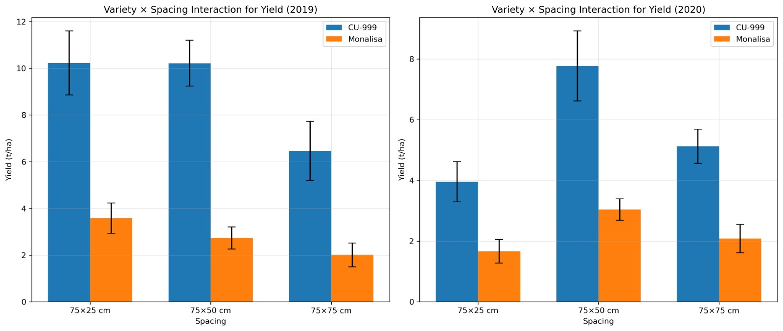
Figure 1. Two-way interaction plots showing the effects of variety and spacing on marketable yield across the 2019 and 2020 growing seasons.

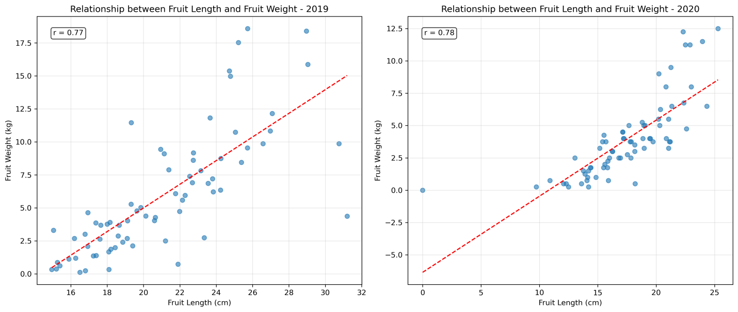

Figure 2. Regression analysis showing relationship between fruit length and fruit weight in both years

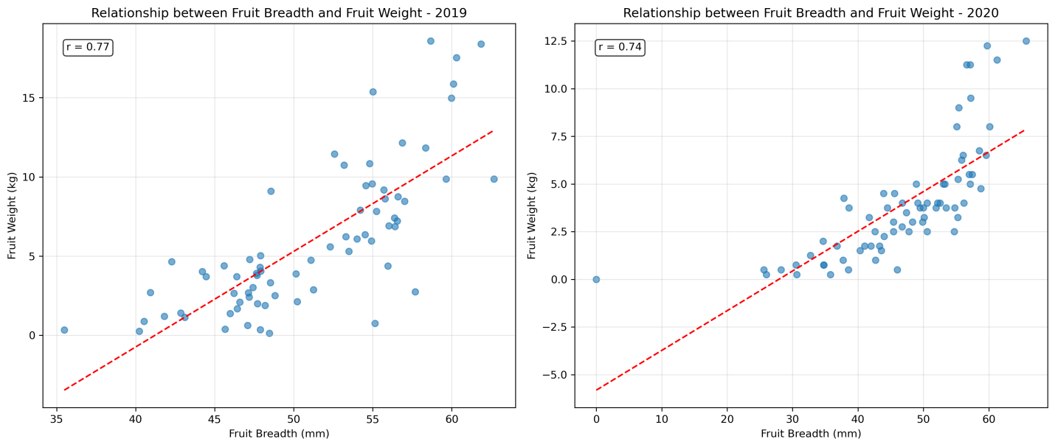
Figure 3. Regression analysis showing relationship between fruit breadth and fruit weight in both years

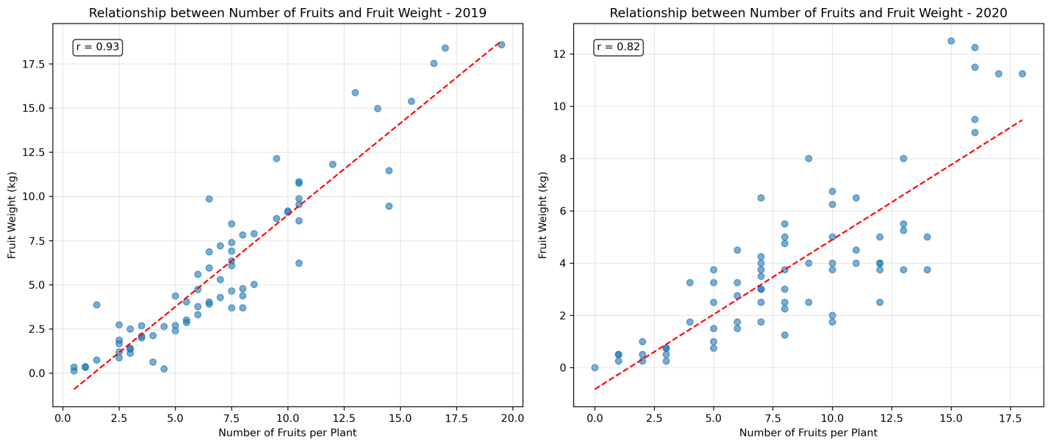
Figure 4. Regression analysis showing relationship between number of fruits and fruit weight in both years

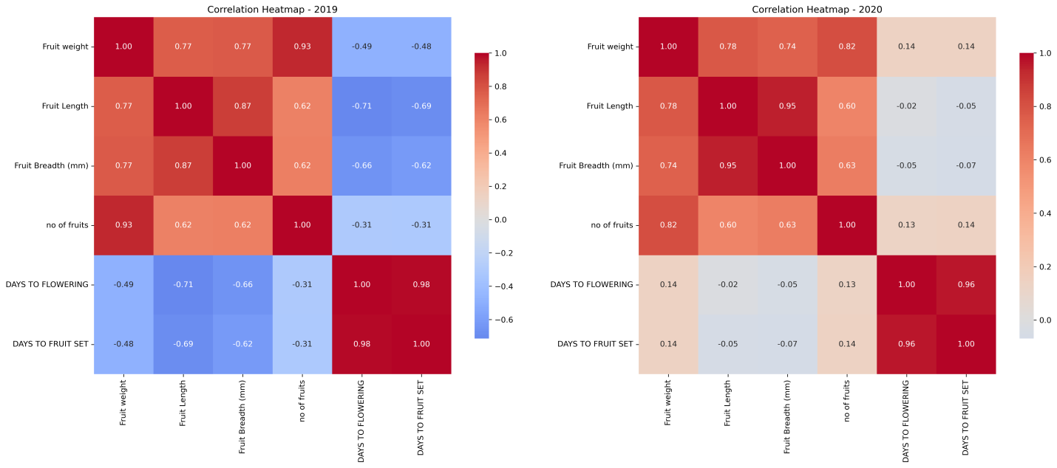
Figure 5. Correlation Heatmap

197

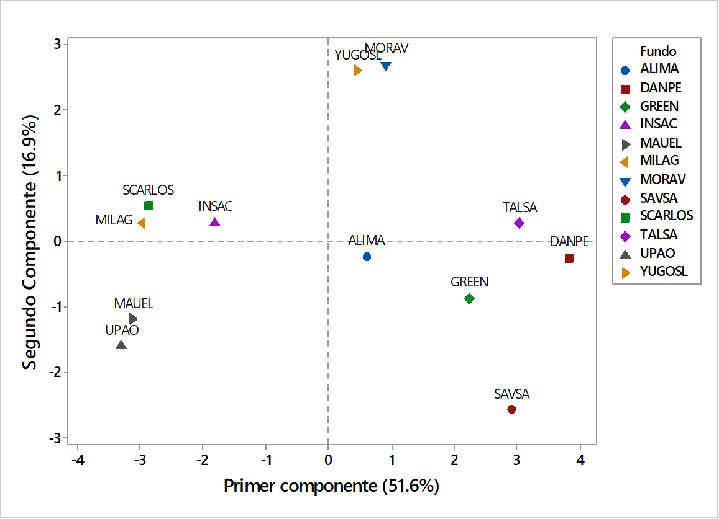

Group 1

Group 2

Group 3

Group 4

First component (51.65%)

Second component (16.9%)

Figure 1. Biplot graph of the main components of the asparagus fields of the Chavimochic irrigation project in 2017.

