**Nephroprotective and antioxidant effects of aqueous extract of *Amblygonocarpus andongensis* (Fabaceae) stem bark on acute kidney injury induced by unilateral ureteral obstruction in Wistar rats**

Odile Baponwa1*, Perfusion A. Amang2, Christophe Mezui3,4, Benoît B. Koubala5, Gaël T. Siwe6, ArnaudW. Biandebe2, Luc V. Vandi2, Finsia Egre2, Francis Takvou2, DalbaïHawa’ou6, Moussa Adamou2 and Paul V. Tan6

**Affiliations of authors:**

1 Department of Biological Sciences of Living Organisms, Faculty of Science, University of Garoua, P.O. Box 346, Garoua, Cameroon

2Department of Biological Sciences, Faculty of Science, University of Maroua, P.O. Box 814, Maroua, Cameroon

3Department of Biological Sciences, Higher Teachers’ Training College, University of Yaoundé I, P.O. Box 047, Yaoundé, Cameroon

4Department of Biotechnology and pharmacognosy, Faculty of Science, University of Ebolowa, P.O. Box 118, Ebolowa, Cameroon

5Department of Chemistry, Faculty of Science, University of Maroua, P.O. Box 814, Maroua, Cameroon

6Department of Animal Biology and Physiology, Faculty of Science, University of Yaoundé I, P.O. Box 812,Yaoundé, Cameroon

**Running title: Nephroprotective and antioxidant properties of *Amblygonocarpus andongensis* on acute kidney injury induced by unilateral ureteral obstruction**

**\* Corresponding author:** [baponwaodile@gmail.com](mailto:baponwaodile@gmail.com), P.O. Box 346, Garoua, Cameroon, (+237) 677919873

**Abstract**

The aim of this study was to evaluate the mechanism of action of the aqueous extract of *A. andongensis* stem bark (AEAASB) on acute kidney injury (AKI) induced by unilateral ureteral obstruction (UUO). 36 rats were divided into six groups of six animals each. AKI was induced by UUO on all animals except normal and sham control groups. The animals were treated with distilled water (control groups) and AEAASB (test groups), daily for 3 days. Some parameters were evaluated. AEAASB caused a significant decrease in the obstructed kidney weight, leucocyte counts, urinary protein and serum creatinine levels and consequently increase urinary creatinine level and the value of renal creatinine clearance compared to the negative control. This extract significantly reduced malondialdehyde levels and increased levels of superoxide dismutase, catalase, reduced glutathione and nitric oxide. Microphotographs confirm that AEAASB prevented renal tissue damage due to OUU. Principal component analysis and agglomerative hierarchical clustering showed that AEAASB has therapeutic effects on AKI associated with OUU and that the 500 mg/kg dose was the most effective. The nephroprotective effects of AEAASB are thought to result from its antioxidant, vasodilatory and inhibitory action on the renin-angiotensin-aldosterone system, *via* an increase in nitric oxide production.

**Keywords** Aqueous extract of *A. andongensis* stem bark, Unilateral ureteral obstruction, Nephroprotection, Antioxidant, Vasodilation.

**INTRODUCTION**

Obstructive nephropathy is a renal disorder due to a bilateral excretory tract obstruction or a unilateral single kidney obstruction (Martínez-Klimova et al. 2019). It can lead to acute kidney injury (AKI) or chronic renal failure when the obstruction is not removed early (Yaxley & Yaxley, 2023)**.** Obstructive nephropathy accounts for approximately 10 % of all cases of both acute and chronic kidney failure (Mourmouris et al. 2014). Worldwide, AKI is a major cause of mortality and morbidity (Ronco et al. 2019). It is estimated that there are more than 13 million cases each year, 11 million of which occur in poor or low-income countries Lewington et al. 2013; Rondeau, 2020). The condition is responsible for nearly 1.7 million deaths per year worldwide, with 1.4 million in low- and middle-income countries (Rondeau, 2020).

AKI secondary to obstructive nephropathy is a frequent clinical situation. It accounts for 5 to 10 % of all AKI cases (Chávez-Iñiguez et al. 2020). In institutions with limited technical resources, particularly in developing countries, AKI linked to obstruction poses serious health problems involving the vital prognosis of those affected (Tondi et al. 2015). The most common causes of obstructive nephropathy are pelvic cancers (bladder, prostate hyperplasia and prostate cancer), urinary lithiasis, ureteral obstruction due to schistosomiasis and congenital malformations (Halle et al. 2016; Lanzy et al. 2021).

Renal dysfunction due to acute kidney injury is always preceded by mainly hemodynamic and inflammatory renal insults (Ichai et al. 2016). At the onset of obstruction, intra-tubular pressure increases due to urine retention. When this pressure is sufficiently high, it opposes that of glomerular filtration and leads to a decrease in glomerular filtration rate (Ucero et al. 2014; Yaxley and Yaxley, 2023). Depending on the severity of the blockage, renal failure can rapidly become life-threatening. Early removal of the obstruction therefore conditions the reversibility of the pathology (Guerrot and Tamion, 2013). If the obstruction continues for several days, AKI develops into tubulointerstitial fibrosis (Ucero et al. 2014). Beyond 3 weeks of total obstruction, the potential for renal parenchymal recovery is very low (Hammer and McPhee, 2019).

Symptoms commonly observed in acute kidney injury secondary to obstructive nephropathy include asthenia, anorexia, vomiting, oedema, nephrotic colic, dysuria, anuria and haematuria (Halle et al. 2016; Lanzy et al. 2021). In the case of acute complete obstruction, nephrotic or ureteral colic is frequently present due to distension of the bladder, collecting system or renal capsule. The obstruction could be incomplete, and is therefore not always associated with anuria (Calop et al. 2008). Whatever the cause, the diagnostic and therapeutic management of AKI linked to obstruction is similar and consists of emergency drainage of the urinary tract, correction of metabolic disorders and clinical and biological monitoring (Nedjim et al. 2020). To complete the renal recovery process, removal of the obstruction requires emergency surgical management (Lanzy et al. 2021).

Unilateral ureteral obstruction (UUO) is a widely used model to study obstructive nephropathy in order to prevent or restore renal function (Ucero et al. 2014; Bao et al. 2018). Nowadays, several studies have shown the efficacy of medicinal plant extracts in the treatment of various diseases. *Amblygonocarpus andongensis* (Fabaceae) is a vascular plant from tropical regions of Africa, widely used for its therapeutic properties (Arbonnier, 2000). This plant has been classified as having powerful antioxidant activity (Atawodi et al. 2015). The bark of this plant is said to have anti-inflammatory, anti-ulcer, healing and cardiovascular disease properties (Oluranti et al. 2012; Odukoya et al. 2022). Previous studies have demonstrated its antioxidant activity against paracetamol-induced liver and kidney failure in rats (Baponwa et al. 2022). As renal failure is a multi-factorial disease, the aim of this study was to elucidate the nephroprotective mechanism of the aqueous extract of *A. andongensis* stem bark on another model of acute kidney injury, namely unilateral ureteral obstruction.

**MATERIALS AND METHODS**

**Animal material**

Adult healthy Wistar male rats strain aged 12 weeks and weighing between 180 and 220 g were used for this experiment. These animals were bred at the animal house of the Biological Sciences Laboratory of the University of Maroua, Cameroon. They were housed in wire mesh cages maintained at room temperature with a natural light/dark cycle. All the animals received a standard diet and unlimited tap water daily. Experimentation was carried out in accordance with the European Convention for the Protection of Vertebrate Animals used for Experimental and other Purposes (Anderson, 2004).

**Plant material**

The fresh stem barks of *A. andongensis* were collected in the locality of Gouna (08°31'02.6''N and 013°33'44.3''E) located in Lagdo sub-Division, Benoue Division, North region, Cameroon. The bark collected was weighed, thoroughly washed and dried at room temperature in the laboratory. The dry bark were ground and reduced to a fine powder. Identification and authentication of the collected plant were done by Dr. DAMOLAI GOUNKAGOU Botanist at the Department of Life and Earth Sciences of the Higher Teachers’ Training College of the University of Yaoundé I and by Mrs. NGWA ADELINE NEH of the Herbarium of Garoua Wildlife School by comparison with specimens No HEFG/1736.

**Preparation of aqueous extract of *A. andongensis* stem bark**

A mass of 500 g of dry powder of *A. andongensis* stem bark was prepared by decoction in 3.5 L of distilled water for 15 minutes. This decoction was cooled at room temperature for 45 minutes and then filtered using Whatman No. 3 paper. The filtrate obtained was evaporated in an oven at 50 °C for 24 hours. The dry extract obtained was 65.47 g, giving a yield of 13.09 % (Baponwa et al. 2020).

**Experimental design**

Thirty-six rats were divided into 6 groups of 6 animals each, including three control groups (normal, operation-Sham and negative) and three test groups (AEAASB 125, 250 and 500 mg/kg). Under ketamine (2.5 mg/kg, i.p)/diazepam (5 mg/kg, i.p) anaesthesia, a left flank laparotomy was performed on all animals except the normal control group. The left ureter (negative control and test groups) was ligated with 5-0 silk suture (0.1 mm suture diameter) (Agary Pharmaceutical Ltd) using two suture knots at two locations (approximately 0.5 cm apart), one proximal near the kidney and the other distal. A section was made between the knots and then the abdomen was closed by suture (Ucero et al. 2014; Kaeidi et al. 2020). The surgery-Sham control underwent laparotomy following the same procedure but the double ligation and section of the ureter were not performed. Table 1 shows the distribution and treatment of the animals in the different groups.

Groups of animals were treated with the different solutions 30 min after surgery, once a day for three days. On the 3rd day after the different treatments, the animals were fasted and urine was collected from each animal for 24 h using individual metabolic cages. After 24 h fasting, all animals were sacrificed under ketamine (2.5 mg/kg, i.p)/diazepam (5 mg/kg, i.p) anaesthesia.

**Collection of blood and organ samples**

The blood of each animal was collected after rupture of the jugular vein in EDTA (Ethylene Diamine Tetra-acetic acid) tubes and dried respectively for the analysis of hematological and biochemical parameters. Kidney, liver, heart, spleen, lung, stomach and testes from each animal were removed and weighed to determine their relative mass (Govindappa et al. 2019). One kidney from each animal was used to prepare the homogenates. The second kidney was rinsed in physiological saline (0.9 %) and then preserved in 10 % formaldehyde for histological sections (Suzuki et al. 2012).

**Determination of relative organ weight**

The relative weights of the sampled organs were obtained using the formula (Govindappa et al. 2019):

$$Relative organ weight (\%g/g)=\frac{Absolute weight of the organ \left(g\right)}{Body weight of the animal on the day of sacrifice (g)}100$$

**Evaluation of urinary parameters**

The pH, osmolarity and protein levels were measured using urine strips (Urinalysis 11A Reagent Strips, Mission brand manufactured by ACON Laboratories, Inc). Creatininuria was assessed by the Jaffé colorimetric method cited by (Delanghe and Speeckaert, 2011) using the kit manufactured by SGMitalia S.r.L. Urine output (ml/min) after 24 h was calculated according to the formula (Bazzano et al. 2015):

$$Urine flow rate (mL/min) =\frac{24 h urine volume (mL)}{1440 min}$$

Serum creatinine was assessed by the same method as creatinineuria. Serum urea was measured by the UV kinetics method, Urease-GLDH (Glutamate dehydrogenase) using the kit manufactured by SGMitalia S.r.L.

**Estimation of renal clearance**

Glomerular filtration was assessed by creatinine clearance (Clcr) following the formula (Bazzano et al. 2015):

$$Clcr (mL/min) =\frac{Urine creatinine (mg/dL) x Urine output (mL/min)}{Serum creatinine (mg/dL)}$$

**Analysis of hematological parameters**

The levels of total white blood cells, granulocytes, monocytes, lymphocytes, red blood cells and haemoglobin of the animals were determined by blood count, using the Mindray BC-2800 haematology auto-analyser.

**Determination of some parameters of oxidative stress and nitric oxide**

To prepare the homogenates, 2.8 mL of phosphate buffer solution (0.2 M, pH 7.4, pKa 7.2) was added to the crushed 0.5 g of kidney in ice-cold conditions. The mixtures were homogenized and then centrifuged at 3,000 rpm for 15 minutes at 4°C. The supernatants were recovered for assays of total protein using the method of Biuret (Henry et al. 1974), malondialdehyde (MDA)(Wilbur et al. 1949), superoxide dismutase (SOD)(Misra and Fridovich, 1972), catalase (CAT)(Sinha, 1972), reduced glutathione (GSH)(Ellman, 1959) and nitric oxide (NO) (Montgomery and Dymock, 1961).

**Histopathological examination**

Histological analysis of kidney was carried out in the Animal Physiology Laboratory of the University of Yaoundé I using the haematoxylin-eosin staining protocol described by Eroschenko (2017).

**Data analysis**

The data were analysed by the ANOVA test followed by Tukey's post-test using Graph Pad Prism software version 8.0.1. Results were expressed as mean ± standard error of the mean and differences between groups were considered significant at the 5 % level. Principal component analysis (PCA) and agglomerative hierarchical clustering (AHC) were realized with XLSTAT 2021.2.2.

**RESULTS**

**Effects of aqueous extract of *A. andongensis* stem bark on changes in rat body weight**

Fig 1 shows the changes in body weight of the animals over the course of the experiment. In the normal control group, an increase in body weight as a function of time was noted, followed by a decrease on day 4 after fasting. However, a decrease in body weight as a function of time was noted in all the other groups except the Sham control, in which an increase was observed on day 3. However, there were no significant differences in mean body weight between the groups.

**Effects of aqueous extract of *A. andongensis* stem bark on food and water intake in rats**

Figs 2 and 3 show, respectively, the curves representing the food and water intakes by the different groups of animals during the experiment. From day 1 to day 3, the amounts of food and water consumed by the negative control group remained low compared with the normal and sham control groups. In the groups receiving AEAASB at the different doses, food intake did not vary significantly. However, water intake increased from day 2 to day 3, particularly with the 500 mg/kg extract dose compared with the negative control.

**Effect of aqueous extract of *A. andongensis* stem bark on morphological aspects of the kidneys of rats subjected to OUU**

Observation of the macroscopic appearance of the animals’ kidneys revealed that in the Sham control group (photo B) the morphology was similar to that of the kidneys in the normal control group (photo A) (Fig 4). In all the other groups, the left kidney that had undergone OUU was larger than the right kidney (photos C, D, E, F).

**Effects of aqueous extract of *A. andongensis* stem bark on the relative weight of some rat organs**

In the negative control group, a significant increase in the relative weight of the obstructed kidney (p < 0.001) compared with the Sham control was noted (Table 2). However, treatment with AEAASB resulted in a significant decrease in the relative weight of the obstructed kidney, particularly at doses of 250 (p < 0.05) and 500 mg/kg (p < 0.001) compared with the negative control. There were no significant differences in the relative masses of unobstructed kidneys between the groups of animals.

A significant increase in the relative weight of the liver and a significant decrease in that of the stomach were noted in the Sham control compared with the normal control (Table 2). A significant increase in relative liver weight was also observed in the negative control compared with the Sham control. However, a significant decrease in relative liver weight accompanied by an increase in stomach weight was observed in the AEAASB 500 mg/kg group (p < 0.001) compared to the negative control.

**Effects of aqueous extract of *A. andongensis* stem bark on some urinary parameters in rats**

Table 3 shows the results of the effects of AEAASB on some of the animals' urinary parameters. In the negative control group, there was a significant decrease in urine flow rate (p < 0.01) and a significant increase in urine protein levels (p < 0.001) compared with the Sham control group. However, treatment with AEAASB, particularly at doses of 250 and 500 mg/kg, resulted in a significant increase in urine output (p < 0.01) and a significant decrease in urine protein levels (p < 0.001) compared with the negative control group. OUU and treatment with AEAASB did not result in significant changes in pH and osmolarity.

**Effects of aqueous extract of *A. andongensis* stem bark on some hematological parameters in rats**

A significant increase in the total white blood cell count (p < 0.001) in the Sham control group compared with the normal control group was noted (Table 4). In the negative control group, there was a significant increase in the total white blood cell count (p < 0.001), particularly granulocytes (p < 0.001), monocytes (p < 0.001) and lymphocytes (p < 0.05) compared with the Sham control group. However, a significant decrease in total white blood cell count (p < 0.001), granulocytes (p < 0.001), monocytes and lymphocytes (p < 0.01) was observed in animals treated with AEAASB at the dose of 500 mg/kg compared to the negative control group.

**Effects of aqueous extract of *A. andongensis* stem bark on some serum parameters and renal creatinine clearance**

A significant increase in creatinine levels and a consequent significant decrease in renal creatinine clearance were observed in the negative control group (p < 0.001) compared with the Sham control (Table 5). In the groups treated with AEAASB at the doses of 250 and 500 mg/kg, creatinine levels were significantly decreased and renal creatinine clearance was significantly increased (p < 0.001) compared to the negative control.

**Effects of aqueous extract of *A. andongensis* stem bark on levels of total protein, nitric oxide and some oxidative stress parameters in rat kidney tissue**

In the negative control group, there was a significant increase in MDA levels (p < 0.001) in renal tissues accompanied by a significant decrease in NO and GSH levels (p < 0.001) compared to the Sham control (Table 6). However, administration of AEAASB, in particular at the dose of 500 mg/kg, resulted in a significant decrease in MDA levels (p < 0.05) associated with an increase in NO, catalase and GSH levels (p < 0.001) compared with the negative control. There were no significant differences in total protein levels between groups of animals.

**Effects of aqueous extract of *A. andongensis* stem bark on histopathological changes in kidney tissue of rats subjected to OUU**

Microphotographs of the kidneys of animals in the normal and Sham control groups showed an architecture consisting of glomeruli, the urinary space, and proximal and distal convoluted tubules of normal appearance (Fig 5). In the negative control group, dilatation associated with thinning of the tubule wall and a decrease in glomerular cell density were noted. In the 125 and 250 mg/kg AEAASB dose groups, persistent tubular dilatation was noted, whereas in animals treated at the dose of 500 mg/kg AEAASB, the renal microstructure was similar to that of the normal and Sham controls.

**Principal component analysis**

The biplot of score and loading represents the dispersion of the six groups and the variables studied around two principal components F1 and F2 (Fig 6). Histological parameters (presence or absence of tubular dilatation and thinning of the tubule wall) were considered in this analysis as supplementary variables. The biographical graph (scores and load diagrams) resulting from the principal component analysis (PCA) illustrate the relationship between the parameters measured (urinary, hematological, serum, oxidative stress with level of NO) and represents the separation of the different groups among the first two principal components, F1 and F2. Of all the principal components, F1 and F2 accounted for 95.49 % of the total variance in the data set. F1 contributed 82.15 %, while F2 contributed 13.33 % of the total variance. The groups were successfully distinguished from each other by the principal components.

Treatments of rats subjected to OUU with AEAASB at different doses (125, 250 and 500 mg/kg) were pooled and distanced from the negative control. This may indicate that EAETAA has significant therapeutic effects against OUU in rats. Measured variables such as urinary protein levels, serum creatinine, total leukocytes, granulocytes, monocytes, lymphocytes, MDA and obstructed kidney weight) were classified into component F1 which showed an inverse correlation with component F2 variables, (urine output, urinary creatinine, SOD, GSH, NO, renal creatinine clearance). The presence of tubular dilatation and thinning of the tubular wall explained the F1 component, whereas their absence was closer to the F2 component.

**Agglomerative hierarchical clustering**

Fig 7 shows the dendrogram presenting the similarity and distance between the different groups of rats according to the agglomerative hierarchical clustering (AHC). The lowest truncation distinguishes 3 clusters: C1 (normal control, Sham control and the group given 500 mg/kg AEAASB), C2 (negative control and the group given 125 mg/kg AEAASB) and C3 (the group given 250 mg/kg AEAASB).

**DISCUSSION**

UUO is a widely used experimental model to study obstructive renal failure resulting from a physical blockage of the urinary flow. To facilitate the surgical procedure, male animals are preferred because of the ease with which the ureter can be identified. The kidney that has undergone UUO is characterized by tubular dilatation, interstitial expansion, proximal tubular mass loss, hypertrophy, hydronephrosis, leukocyte infiltration, tubular epithelial cell death and fibroblast formation (Ucero et al. 2014). These alterations are the result of several molecular processes that lead to progressive tubulointerstitial fibrosis (Ucero et al. 2014; Chaabane et al. 2013).

It all starts with the stationary flow of urine due to the UUO, which leads to hydronephrosis by increasing hydrostatic pressure, dilating first the collecting ducts and then the distal and proximal tubules (Martínez-Klimova et al. 2019). Thus, the obstructed kidney will increase in volume and therefore in weight during the acute phase. In the present study, the increase in kidney weight following UUO was observed in the negative control after three days. These results are in agreement with Nilsson et al. (2017) who had shown that UUO for three days resulted in hydronephrosis characterised by a significant increase in the weight of the affected kidney. In this work, treatment with aqueous extract of *A. andongensis* at doses of 250 mg/kg and 500 mg/kg significantly decreased the weight of the obstructed kidney compared with that of the negative control, suggesting that AEAASB has hydronephrosis-limiting effects.

In the process of hydronephrosis, the increase in pressure in the proximal tubules has two effects: a decrease in glomerular filtration rate (GFR) and damage caused by mechanical stretching of the tubular epithelial cells. The decrease in GFR is related to obstruction, which leads to a progressive decrease in renal blood flow and an increase in renal vasoconstriction, which can lead to inadequate blood supply and ischaemia (Martínez-Klimova et al. 2019). Indeed, estimating GFR by measuring renal creatinine clearance is a commonly used method (Gowda et al. 2010). Creatinine is a breakdown product of creatine present in the muscles, most of which is excreted in the urine. When renal function is compromised, serum creatinine levels increase (Zuo et al. 2008). Renal creatinine clearance represents the volume of blood plasma cleared of creatinine per unit time. An increase in serum creatinine and a sudden fall in GFR are signs that indicate AKI (Shabaz and Gupta, 2024). In this study, a significant increase in serum creatinine associated with a significant decrease in renal creatinine clearance was noted in the negative control group compared with the Sham control. Treatment with AEAASB, particularly at doses of 250 and 500 mg/kg, resulted in a significant fall in serum creatinine levels and a significant increase in renal creatinine clearance compared with the negative control group. Mohammadi-Sichani et al. (2022) have shown that an increase in GFR is associated with a decrease in the severity of hydronephrosis, which would favour functional recovery of the kidney.

During tubular dilatation due to UUO, increased renal vasoconstriction and hydrosodic overload are mediated by tubulo-glomerular feedback and stimulation of the renin-angiotensin-aldosterone system (RAAS). The reduction in renal blood flow caused by obstruction results in tubulo-glomerular feedback, the aim of which is to regulate blood flow. Due to the volume overload of the kidney, this results in an increase in NaCl supply to the cells of the *macula densa*, which leads to its increased uptake in the loop of Henle (Chalisey and Karim, 2012). This uptake leads to the release of adenosine, which acts on A1 receptors in extraglomerular mesangial cells and triggers an increase in cytosolic calcium. This signal reaches the smooth muscle cells of the afferent arteriole which leads to vasoconstriction and a reduction in GFR (Johns and  Ahmeda, 2014; Chávez-Iñiguez et al. 2020). The reactivity of the tubulo-glomerular feedback is determined by the action of angiotensin II (stimulation of the RAAS). Angiotensin II binds directly to its receptors on the smooth muscle cells of renal arterioles and stimulates contraction of these muscles (Gao et al. 2014). It also stimulates the sympathetic nerve to promote vascular smooth muscle resistance in the kidney (Pojoga et al. 2015). Angiotensin II also stimulates aldosterone secretion, which leads to Na+ reabsorption in the distal tubule (Shier et al. 2016). It is important to note that in a hydronephrotic state, the increased activity of tubuloglomerular feedback is linked to reduce NO availability (Chalisey and Karim, 2012). In this study, a significant decrease in NO levels was observed in the negative control group compared with the sham control. In animals treated with AEAASB, particularly at 500 mg/kg, there was a significant increase in NO levels in renal tissues compared with the negative control. According to Patzak et al. (2001), the renal vasoconstrictor effect is inhibited by locally produced NO. Furthermore, an increase in NO concentration leads to an increase in sodium and water excretion, whereas a NO deficit leads to sodium retention (Carlström et al. 2008; Hegarty et al. 2002). In the kidney, NO plays a role in regulating renal hemodynamics, maintaining medullary perfusion, mediating natriuresis, attenuating tubuloglomerular feedback, inhibiting tubular sodium reabsorption and modulating renal sympathetic neuronal activity. The net effect of NO in the kidney is to promote natriuresis and diuresis (Chalisey and Karim, 2012).

As for injury, nephron destruction during OUU is initiated by increased intratubular hydrostatic pressure causing mechanical stretching of tubular epithelial cells and secondary ischaemia (Ucero et al. 2014). Following injury, mediators (exosomes, chemokines and cytokines) are secreted by parenchymal, endothelial and tubular epithelial cells from day one and lasts throughout the OUU (Du and Zhu, 2014). In response to the local expression of these mediators, leukocytes more mainly macrophages, T lymphocytes and neutrophils are recruited to the peritubular interstitium of the kidney. The leukocytes in turn amplify the inflammation, which causes further damage to other tubular cells (Ucero et al. 2014). Hence the high levels of leukocytes and in particular granulocytes, monocytes and lymphocytes observed after three days of OUU in the group of untreated animals (negative control). In animals treated with AEAASB at a dose of 500 mg/kg, leukocyte cell populations decreased significantly in number. These results are in line with those of previous studies showing that this extract attenuated the inflammation associated with paracetamol-induced nephrotoxicity in rats (Baponwa et al. 2020).

In the course of obstructive nephropathy, the mechanisms that induce oxidative stress are not fully understood, but oxidative stress is an important contributor to the pathogenesis of UUO (Kinter et al. 1999). During damage caused by mechanical stretching of the cells, the release of reactive oxygen species (ROS) increases in the obstructed kidney. Angiotensin II, produced as a result of continuous activation of the RAAS, contributes significantly to the release of large quantities of ROS by also activating nicotinamide adenine dinucleotide phosphate (NADPH) oxidases (NOX) (Aranda-Rivera et al. 2021). ROS cause oxidative cell damage by reacting with various structural components of cells, resulting in lipid peroxidation. MDA is one of the major products of lipid peroxidation, as shown by Manucha et al. (2005) who found high levels of MDA following OUU. In addition, Sugiyama et al. (2005) reported a decrease in the activity of the antioxidant enzymes SOD, catalase and glutathione peroxidase in cases of hydronephrosis. In this study, a significant increase in MDA levels associated with a significant decrease in SOD and GSH levels was observed in untreated animals that had undergone OUU, whereas in animals treated with 500 mg/kg AEAASB, a significant decrease in MDA levels associated with a significant increase in SOD, catalase and GSH levels was noted. According to Martinez-Klimova et al. (2019), antioxidant treatments could have positive effects by blocking the RAAS.

Observations of microphotographs of kidney sections from the animals involved in the present study revealed normal renal architecture in the sham group, while the negative control group showed tubular dilatation associated with thinning of the tubular wall and a reduction in glomerular cell density. Proteinuria was also noted in the latter group. Proteinuria is an indicator of glomerular damage (Makris and Spanou, 2016). Jin et al. (2017) showed macro and micromorphological alterations accompanied by significant renal dysfunction in the hours or days following OUU, compared with the Sham group indicates that obstructive AKI was successfully induced. In the 125 and 250 mg/kg AEAASB groups, persistence of tubular dilatation was noted, whereas in animals treated with 500 mg/kg AEAASB, renal microstructure was similar to that of normal and Sham controls. Sinha et al. (2012) showed that the removal of obstruction in the AKI phase alone does not lead to resolution of this damage but that early or late addition of a RAAS blocker would prevent or allow better renal recovery.

**CONCLUSION**

AEAASB has nephroprotective effects which are thought to result, on the one hand, from its vasodilatory properties and, on the other, from its inhibition of the renin-angiotensin-aldosterone system, *via* an increase in NO production. PCA and AHC have shown that *A. andongensis* has therapeutic effects against AKI associated with OUU. The 500 mg/kg dose was the most effective, as the values of the parameters measured were very similar to those of the normal and Sham control groups.

**References**

Anderson D. Revision of Council of Europe Convention ETS 123 Guidelines for the Accommodation and Care of Animals Used for Experimental and Other Scientific Purposes. Altern Lab Anim. 2004; 32(1):183-185. <https://Doi.org/10.1177/026119290403201s30>

Aranda-Rivera AK, Cruz-Gregorio A, Aparicio-Trejo OE, Ortega-Lozano AJ, Pedraza-Chaverri J. Redox signaling pathways in unilateral ureteral obstruction (UUO)-induced renal fibrosis. Free radic boil med. 2021:17265-17281. <https://Doi.org/10.1016/j.freeradbiomed.2021.05.034>

Arbonnier M. Arbres, arbustes et lianes des zones sèches d'Afrique de l'Ouest. CIRAD-MNHN. Monpellier, France; 2000.

Atawodi SE, Olowoniyi OD, Adejo GO and Liman ML. Review of the antioxidant potential of African medicinal and food plants. In: Dubey NK. Plants as a source of natural antioxidants, CAB International. Boston USA; 2015: 1-14.

Bao YW, Yuan Y, Chen JH, Lin WQ. Kidney disease models: tools to identify mechanisms and potential therapeutic targets. Zool Res. 2018; 39(2):72-86. <https://Doi.org/10.24272/j.issn.2095-8137.2017.055>

Baponwa O, Amang AP, Mezui C, Koubala BB, Siwe GT, Vandi VL, et al. Antioxidant mechanism of renal and hepatic failure prevention related to paracetamol overdose by the aqueous extract of *Amblygonocarpus andongensis* stem bark. BioMed Res Int. 2022:1-16. <https://Doi.org/10.1155/2022/1846558>

Bazzano T, Restel TI, Porfrio LC, Schiaveto A, Souza AS, Silva IS. Renal biomarkers of male and female Wistar rats (Rattus norvegicus) undergoing renal ischemia and reperfusion. Acta Cir Bras. 2015; 30(4):277-288. <https://Doi.org/10.1590/S0102-865020150040000007>

Calop J, Limat S, Fernandez C. Pharmacie clinique et thérapeutique. 3ème édition. Elsevier Masson : Paris France; 2008. <https://Doi.org/10.1016/j.phhp.2008.12.009>

Carlström M, Brown RD, Edlund J, Sällström J, Larsson E, Teerlink T, et al. Role of nitric oxide deficiency in the development of hypertension in hydronephrotic animals. Am J Physiol Renal Physiol. 2008; 294(2):F362-370. <https://Doi.org/10.1152/ajprenal.00410.2007>

Chaabane W, Praddaude F, Buleon M, Jaafar A, Vallet M, Rischmann P, et al. Renal functional decline and glomerulotubular injury are arrested but not restored by release of unilateral ureteral obstruction (UUO). Am J Physiol Renal Physiol. 2013; 304(4):F432-439. <https://Doi.org/10.1152/ajprenal.00425.2012>

Chalisey A, Karim M. Hypertension and Hydronephrosis: Rapid Resolution of High Blood Pressure Following Relief of Bilateral Ureteric Obstruction. J Gen Intern Med. 2012; 28(3):478-481. <https://Doi.org/10.1007/s11606-012-2183-5>

Chávez-Iñiguez JS, Navarro-Gallardo GJ, Medina-González R, Alcantar-Vallin L, García-García G. Acute Kidney Injury Caused by Obstructive Nephropathy. Int J Nephrol. 2020:1-10. <https://Doi.org/10.1155/2020/8846622>

Delanghe JR, Speeckaert MM. Creatinine determination according to Jaffe-what does it stand for? NDT Plus. 2011; 4(2):83-86. <https://Doi.org/10.1093/ndtplus/sfq211>

Du T, Zhu YJ. The regulation of inflammatory mediators in acute kidney injury via exogenous mesenchymal stem cells. Mediators Inflamm. 2014:1-10. <https://Doi.org/10.1155/2014/261697>

Ellman GL. Tissue sulfhydryl group. ArchBiochemBiophys. 1959; 82(1):70-77. <https://Doi.org/10.1016/0003-9861(59)90090-6>

Eroschenko VP. Atlas of histology with functional correlations, 13th edition Wolters kluwer; Philadelphia, United States; 2017.

Gao P, Xu TT, Lu J, Li L, Xu J, Hao DL, et al. Overexpression of SIRT1 in vascular smooth muscle cells attenuates angiotensin II-induced vascular remodeling and hypertension in mice. J Mol Med. 2014; 92(4):347-357. <https://Doi.org/10.1007/s00109-013-1111-4>

Govindappa PK, Gautam V, Tripathi SM, Sahni YP, Raghavendra HLS. Effect of Withania somnifera on gentamicin induced renal lesions in rats. Braz J Pharmacogn. 2019; 29(2):234-240. <https://Doi.org/10.1016/j.bjp.2018.12.005>

Gowda S, Desai PB, Kulkarni SS, Hull VV, Math AA, Vernekar SN. Markers of renal function tests. N Am J Med Sci. 2010; 2(4):170-173. <https://www.ncbi.nlm.nih.gov/pmc/articles/PMC3354405/>

Guerrot D, Tamion F. Insuffisance rénale aiguë obstructive : le point de vue du réanimateur. Prog Urol- FMC. 2013; 23(1):19-22. <https://Doi.org/10.1016/j.fpurol.2012.10.001>

Halle MP, Toukep LN, Nzuobontane SE, Ebana HF, Ekane GH, Priso EB. The profile of patients with obstructive uropathy in Cameroon: case of the Douala General Hospital. Pan Afr Med J. 2016; 23(67):1-6. <https://Doi.org/10.11604/pamj.2016.23.67.8170>

Hammer GD, McPhee SJ. Pathophysiology of disease: an introduction to clinical medicine, Eighth edition, McGraw-Hill Education: New York, USA; 2019.

Hegarty NJ, Watson RWG, Young LS, O’neill AJ, Brady HR, Fitzpatrick JM. Cytoprotective effects of nitrates in a cellular model of hydronephrosis. Kidney Int. 2002; 62(1):70-77. <https://Doi.org/10.1046/j.1523-1755.2002.00404.x>

Henry RJ, Canon DC, Winkelman JW. Clinical chemistry, principles and techniques. Harper and Row, Hagerstown, New York; 1974.

Ichai C, Vinsonneau C, Souweine B, Armando F, Canet E, Clec'h C, et al. Insuffisance rénale aiguë en périopératoire et en réanimation (à l’exclusion des techniques d’épuration extrarénale). Anesth Reanim. 2016; 2(3):184-205. <https://Doi.org/10.1016/j.anrea.2016.04.001>

Jin Y, Shao X, Sun B, Miao C, Li Z, Shi Y. Urinary kidney injury molecule-1 as an early diagnostic biomarker of obstructive acute kidney injury and development of a rapid detection method. Mol Med Rep. 2017; 15(3):1229-1235. <https://Doi.org/10.3892/mmr.2017.6103>

Johns EJ,  Ahmeda AF. Renal Circulation, Reference Module in Biomedical Sciences. Elsevier. 2014. <https://Doi.org/10.1016/B978-0-12-801238-3.00200-2>

Kaeidi A, Taghipour Z, Allahtavakoli M, Fatemi I, Hakimizadeh E, Hassanshahi J. Ameliorating effect of troxerutin in unilateral ureteral obstruction induced renal oxidative stress, inflammation, and apoptosis in male rats. Naunyn Schmiedebergs Arch Pharmacol. 2020; 393(5):879-888. <https://Doi.org/10.1007/s00210-019-01801-4>

Kinter M, Wolstenholme JT, Thornhill BA, Newton EA, McCormick ML, Chevalier RL, Unilateral ureteral obstruction impairs renal antioxidant enzyme activation during sodium depletion. Kidney Int. 1999; 55(4):1327-1334. <https://Doi.org/10.1046/j.1523-1755.1999.00358.x>

Lanzy A, Voumbo MYVY, Ondziel OAS, Niama AC, Mouss RBB, Atipo AMO, et al. Épidémiologie et étiologies de l’insuffisance rénale aigue obstructive au centre hospitalier universitaire de Brazzaville. Health Sci Dis. 2021; 22(11):98-102. <https://Doi.org/10.5281/hsd.v22i11.3081>

Lewington AJ, Cerda J, Mehta RL. Raising awareness of acute kidney injury: a global perspective of a silent killer. Kidney Int. 2013; 84:457-467. <https://Doi.org/10.1038/ki.2013.153>

Makris K, Spanou L. Acute kidney injury: definition, pathophysiology and clinical phenotypes. Clin Biochem Rev. 2016; 37(2):85-98. <https://www.ncbi.nlm.nih.gov/pmc/articles/PMC5198510/>

Manucha W, Carrizo L, Ruete C, Molina H, Valle’s P. Angiotensin II type I antagonist on oxidative stress and heat shock protein 70 (HSP 70) expression in obstructive nephropathy. Cell mol biol (Noisy-le-grand). 2005; 51(6):547-555. <https://ncbi.nlm.nih.gov/16309579/>

Martínez-Klimova E, Aparicio-Trejo OE, Tapia E, Pedraza-Chaverri J. Unilateral ureteral obstruction as a model to investigate fibrosis-attenuating treatments. Biomol. 2019; 9(141):1-28. <https://Doi.org/10.3390/biom9040141>

Misra HP, Fridovich I. The role of superoxide anion in the auto oxidation of epinerine to adrenochrome and a simple assay for superoxide dismutase. J Biol Chem. 1972; 247(10):3170-3175. <https://Doi.org/10.1016/S0021-9258(19)45228-9>

Mohammadi-Sichani M, Radmanesh F, Taheri S, Ghadimi K, Khodadadi S, Salehi H, et al. Evaluation of glomerular filtration rate decline in patients with renal colic. Am J of Clin Exp Urol. 2022; 10(1):31-36. <https://www.ncbi.nlm.nih.gov/pmc/articles/PMC8918396/>

Montgomery HAC, Dymock J. The determination of nitrite in water. Analyst. 1961; 86:414-416.

Mourmouris P, Chiras T, Papatsoris A. Obstructive uropathy: from etiopathology to therapy. World J Nephrol. 2014; 3(1):1-6. <https://Doi.org/10.14740/wjnu154w>

Nedjim AS, Abdie EM, Larrache Y, Mahanna AITH, Nachid A, Moatz A, et al. Les insuffisances rénales obstructives : une analyse portant sur 59 cas. Rev Afr Urol Androl. 2020; 2(3):95-98. <https://revue-uroandro.org/index.php/uro-andro/article/download/427/148>

Nilsson L, Palm F, Nørregaard R. 15-Deoxy-Δ12,14 -prostaglandin J2 Exerts Antioxidant Effects While Exacerbating Inflammation in Mice Subjected to Ureteral Obstruction. Mediators Inﬂamm. 2017:1-10. <https://Doi.org/10.1155/2017/3924912>

Odukoya JO, Odukoya JO, Mmutlane EM, Ndinteh DT. Ethnopharmacological study of medicinal plants used for the treatment of cardiovascular diseases and their associated risk factors in sub-Saharan Africa. Plants. 2022; 11(10):1387. <https://Doi.org/10.3390/plants11101387>

Oluranti AC, Michael UO, Jane UOC, Ayembe NA. Ethnobotanical studies of medicinal plants used in the management of Peptic ulcer disease in Sokoto State, North Western Nigeria. Int Res J Pharm. 2012; 2(9):225-230. <https://www.researchgate.net/publication/375547286>

Patzak A, Mrowka R, Storch E, Hocher B, Persson PB. Interaction of angiotensin II and nitric oxide in isolated perfused afferent arterioles of mice. J Am Soc Nephrol. 2001; 12(6):1122-1127. <https://Doi.org/10.1681/ASN.V1261122>

Pojoga LH, Yao TM, Opsasnick LA, Siddqui WT, Reslan OM, Adler GK, et al. Cooperative Role of Mineralocorticoid Receptor and Caveolin-1 in Regulating the Vascular Response to Low Nitric Oxide-High Angiotensin II-Induced Cardiovascular Injury. J of Pharmacol Exp Ther. 2015; 355(1):32-47. <https://Doi.org/10.1124/jpet.115.226043>

Ronco C, Bellomo R, Kellum JA. Acute kidney injury. Lancet. 2019; 394(10212):1949-1964. <https://Doi.org/10.1016/S0140-6736(19)32563-2>

Rondeau E. L’insuffisance rénale aiguë : enjeux actuels et défis futurs? RMGF. 2020; 13:32-36. <https://becomeditions.com/pdfs/rmgf/PDF-RMGF-13/Itineraire2.pdf>

Shabaz H, Gupta M. Creatinine clearance. StatPearls [Internet]. Treasure Island, Publishing; 2024. <https://www.ncbi.nlm.nih.gov/books/NBK544228/>

Shier D, Butler J, Lewis R. Hole’s human anatomy & physiology, 14th edition. Graw-Hill Education; New York USA; 2016.

Sinha A, Bajpai M, Shashank P, Ranjan S, Sharma MC. Unilateral ureteric obstruction: Role of renin angiotensin system blockade on renal recovery: an experimental study. J Indian Assoc Pediatr Surg. 2012; 7(2):49-53. <https://Doi.org/10.4103/0971-9261.93960>

Sinha AK. Colorimetric assay of catalase. Anal Biochem. 1972; 47(2):389-394. <https://Doi.org/10.1016/0003-2697(72)90132-7>

Sugiyama H, Kobayashi M, Wang DH, Sunami R, Maeshima Y, Yamasaki Y, et al. Telmisartan inhibits both oxidative stress and renal ﬁbrosis after unilateral ureteral obstruction in acatalasemic mice. Nephrol Dial Transplant. 2005; 20(12):2670-2680. <https://Doi.org/10.1093/ndt/gfi045>

Suzuki Y, Imada T, Yamaguchi I, Yoshitake H, Sanada H, Kashiwagi T, Takaba K. Effects of prolonged water washing of tissue samples fixed in formalin on histological staining. Biotech Histochem. 2012; 87(4):241-248. <https://Doi.org/10.3109/10520295.2011.613410>

Tondi ZMM, Diongole HM, Abdou I, El MT, Aboubacar I. Profil épidémiologique, clinique et thérapeutique de l’insuffisance rénale aiguë obstructive au Niger. Nephrol Ther. 2015; 11(5):351. <https://Doi.org/10.1016/j.nephro.2015.07.281>

Ucero AC, Benito-Martin A, Izquierdo MC, Sanchez-Niño MD, Sanz AB, Ramos AM et al. Unilateral ureteral obstruction: beyond obstruction. Int Urol Nephrol. 2014; 46:765-776. <https://Doi.org/10.1007/s11255-013-0520-1>

Wilbur KM, Bernheim F, Shapiro OW. Determination of lipid peroxidation. Arch BiochemBiophys. 1949; 24:305-310.

Yaxley J, Yaxley W. Obstructive uropathy-acute and chronic medical management. World J Nephrol. 2023; 12(1):1-9. <https://Doi.org/10.5527/wjn.v12.i1.1>

Zuo Y, Wang C, Zhou J, Sachdeva A, Ruelos VC. Simultaneous Determination of Creatinine and Uric Acid in Human Urine by High-Performance Liquid Chromatography. Anal Sci. 2008; 24:1589-1592. <https://Doi.org/10.2116/analsci.24.1589>

**Table 1** Distribution and treatment of the different groups of animals subjected to the OUU

|  |  |  |
| --- | --- | --- |
| **Groups** | **Induction of AKI** | **Solutions administered (orally)** |
| Normal control | No UUO | Distilled water (5 ml/kg) |
| Sham control | Surgery without UUO | Distilled water (5 ml/kg) |
| Negative control | UUO | Distilled water (5 ml/kg) |
| AEAASB 125 | UUO | AEAASB 125 mg/kg |
| AEAASB 250 | UUO | AEAASB 250 mg/kg |
| AEAASB 500 | UUO | AEAASB 500 mg/kg |

**Table 2. Effects of AEAASB on the relative weight of some organs.**

|  |  |  |  |  |  |  |  |  |
| --- | --- | --- | --- | --- | --- | --- | --- | --- |
| **Groupes** | **Kidneys (%g/g)** | | **Heart (%g/g)** | **Liver (%g/g)** | **Lungs (%g/g)** | **Rate (%g/g)** | **Stomach (%g/g)** | **Testes (%g/g)** |
| **Left** | **Right** |
| Normal control | 0.31 ± 0.01 | 0.31 ± 0.01 | 0.33 ± 0.00 | 2.61 ± 0.04 | 0.78 ± 0.04 | 0.18 ± 0.01 | 1.93 ± 0.06 | 1.16 ± 0.07 |
| Sham control | 0.32 ± 0.01 | 0.34 ± 0.01 | 0.30 ± 0.00 | 2.88 ± 0.04♦♦♦ | 0.84 ± 0.04 | 0.27 ± 0.02 | 1.52 ± 0.06 | 1.32 ± 0.06♦♦♦ |
| Negative control | 0.73 ± 0.04■■■ | 0.36 ± 0.01 | 0.32 ± 0.00 | 3.08 ± 0.02■■ | 0.82 ± 0.05 | 0.29 ± 0.01 | 1.49 ± 0.02 | 1.29 ± 0.05 |
| AEAASB 125 | 0.64 ± 0.02 | 0.36 ± 0.00 | 0.31 ± 0.01 | 2.30 ± 0.05 | 0.76 ± 0.06 | 0.29 ± 0.02 | 1.53 ± 0.05 | 1.29 ± 0.08 |
| AEAASB 250 | 0.61 ± 0.02* | 0.36 ± 0.00 | 0.33 ± 0.01 | 2.30 ± 0.04 | 0.85 ± 0.02 | 0.26 ± 0.01 | 1.69 ± 0.02* | 1.35 ± 0.05 |
| AEAASB 500 | 0.56 ± 0.01*** | 0.35 ± 0.00 | 0.30 ± 0.01 | 2.78 ± 0.05*** | 0.77 ± 0.02 | 0.21 ± 0.01 | 1.96 ± 0.02*** | 1.27 ± 0.07 |

Values were expressed as Mean ± MSE.

AEAASB 125, AEAASB 250 and AEAASB 500: groups treated with aqueous extract of *A. andongensis* stem bark at doses of 125, 250 and 500 mg/kg, respectively.

♦♦♦ p < 0.001 significant difference compared to the Normal control

■■p < 0.01, ■■■p < 0.001 significant difference compared to the Sham control

*p < 0.05, ***p < 0.001 significant difference compared to the negative control.

**Table 3. Effects of AEAASB on some urinary parameters of rats.**

|  |  |  |  |  |  |
| --- | --- | --- | --- | --- | --- |
| **Groups** | **Urine output (ml/min x10-2)** | **Urinary creatinine (mg/dl)** | **Urinary pH** | **Urinary osmolarity** | **Urinary protein (mg/dl)** |
| Normal control | 0.72 ± 0.00 | 27.5 ± 0.33 | 7.00 ± 0.27 | 1.02 ± 0.00 | 100.00 ± 0.00 |
| Sham control | 0.72 ± 0.00 | 26.25 ± 0.08 | 7.20 ± 0.25 | 1.01 ± 0.00 | 100.00 ± 0.00 |
| Negative control | 0.69 ± 0.00■■ | 09.79 ± 0.18■■■ | 7.25 ± 0.28 | 1.02 ± 0.00 | 300.00 ± 0.00■■■ |
| AEAASB 125 | 0.72 ± 0.00** | 23.25 ± 0.01*** | 7.42 ± 0.33 | 1.02 ± 0.00 | 233.30 ± 42.16 |
| AEAASB 250 | 0.72 ± 0.00** | 26.04 ± 0.02*** | 7.40 ± 0.29 | 1.01 ± 0.01 | 140.00 ± 40.00** |
| AEAASB 500 | 0.72 ± 0.00** | 27.90 ± 0.02*** | 7.80 ± 0.25 | 1.01 ± 0.00 | 100.00 ± 0.00*** |

Values were expressed as Mean ± MSE.

AEAASB 125, AEAASB 250, AEAASB 500: groups treated with aqueous extract of *A. andongensis* stem bark at doses of 125, 250 and 500 mg/kg, respectively.

■■p < 0.01, ■■■p < 0.001 significant difference compared to the Sham control

**p < 0.01, ***p < 0.001 significant difference compared to the negative control.

**Table 4. Effects of AEAASB on some hematological parameters of rats.**

|  |  |  |  |  |  |  |
| --- | --- | --- | --- | --- | --- | --- |
| **Groups** | **Total white blood cell count (x109/l)** | **Granulocytes (%)** | **Monocytes (%)** | **Lymphocytes (%)** | **Red blood cell count (x1012/l)** | **Hemoglobin (g/dl)** |
| Normal control | 1.08 **±** 0.09 | 4.57 **±** 0.34 | 3.38 ± 0.29 | 91.23 ± 1.24 | 6.65 **±** 0.16 | 13.92 **±** 1.03 |
| Sham control | 1.83 **±** 0.14**♦♦♦** | 4.28 **±** 0.56 | 3.36 ± 0.36♦♦♦ | 92.13 ± 2.30 | 5.86 **±** 0.17 | 12.17 **±** 1.05 |
| Negative control | 2.78 **±** 0.09■■■ | 7.02 **±** 0.22■■■ | 5.95 ± 0.16■■■ | 98.53 ± 0.60■ | 5.88 **±** 0.17 | 12.13 **±** 1.33 |
| AEAASB 125 | 2.53 **±** 0.13 | 3.82 **±** 0.24*** | 4.90 ± 0.20* | 93.92 ± 0.47 | 6.52 **±** 0.15 | 13.65 **±** 0.32 |
| AEAASB 250 | 2.50 **±** 0.06 | 4.46 **±** 0.25*** | 4.74 ± 0.08** | 91.66 ± 0.83** | 6.72 **±** 0.08 | 13.88 **±** 0.21 |
| AEAASB 500 | 2.00 **±** 0.04*** | 4.44 **±** 0.40*** | 3.94 ± 0.14*** | 91.58 ± 1.05** | 6.82 **±** 0.11 | 14.18 **±** 0.27 |

Values were expressed as Mean ± MSE.

AEAASB 125, AEAASB 250, AEAASB 500: groups treated with aqueous extract of *A. andongensis* stem bark at 125, 250 and 500 mg/kg, respectively.

♦♦♦p < 0.001, significant difference compared to the normal control

■■■p < 0.001 significant difference compared to the Sham control

*p < 0.05, ***p < 0.001 significant difference compared to the negative control.

**Table 5. Effects of AEAASB on some markers of renal function.**

|  |  |  |  |
| --- | --- | --- | --- |
| **Groups** | **Serum creatinine (mg/dl)** | **Serum Urea (mg/dl)** | **Renal creatinine Clearance (ml/min)** |
| Normal control | 0.30 ± 0.01 | 59.63 ± 7.92 | 0.66 ± 0.02 |
| Sham control | 0.30 ± 0.02 | 58.50 ± 7.21 | 0.63 ± 0.02 |
| Negative control | 1.69 ± 0.09■■■ | 61.62 ± 10.01 | 0.04 ± 0.01■■■ |
| AEAASB 125 | 0.93 ± 0.05** | 60.85 ± 3.68 | 0.18 ± 0.01* |
| AEAASB 250 | 0.75 ± 0.05*** | 59.57 ± 6.21 | 0.25 ± 0.02*** |
| AEAASB 500 | 0.49 ± 0.04*** | 59.20 ± 10.00 | 0.41 ± 0.01*** |

Values were expressed as Mean ± MSE.

AEAASB 125, AEAASB 250, AEAASB 500: groups treated with aqueous extract of *A. andongensis* stem bark at doses of 125, 250 and 500 mg/kg, respectively.

■■p < 0.01, ■■■p < 0.001 significant difference compared to the Sham control

*p < 0.05, **p < 0.01, ***p < 0.001 significant difference compared to the negative control.

**Table 6. Effects of AEAASB on total protein, nitric oxide levels and some oxidative stress parameters in rats.**

|  |  |  |  |  |  |  |
| --- | --- | --- | --- | --- | --- | --- |
| **Groups** | **Total Protein (mg/ml)** | **NO (mmol/mg of protein)** | **MDA (mmol/mg of protein)** | **SOD (U/mg of protein)** | **CAT (µmol/min/mg of protein)** | **GSH (mmol/mg of protein)** |
| Normal control | 24.96 **±** 1.12 | 1.23 ± 0.03 | 0.02 **±** 0.00 | 16.68 **±** 0.32 | 88.42 **±** 3.83 | 1.34 **±** 0.10 |
| Sham control | 25.04 **±** 0.72 | 1.23 ± 0.03 | 0.02 **±** 0.00 | 16.43 **±** 0.57 | 85.55 **±** 2.47 | 1.27 **±** 0.12 |
| Negative control | 24.25 **±** 1.14 | 0.93 ± 0.04■■■ | 0.03 **±** 0.00■■■ | 13.41 **±** 0.31■ | 70.55 **±** 4.00 | 0.70 **±** 0.09■■■ |
| AEAASB 125 | 23.83 **±** 1.09 | 1.06 ± 0.02**\*** | 0.02 **±** 0.00 | 17.38 **±** 0.93**\*\*** | 80.73 **±** 6.08 | 1.07 **±** 0.05**\*** |
| AEAASB 250 | 23.83 **±** 1.56 | 1.10 ± 0.02**\*\*** | 0.02 **±** 0.00**\*** | 17.35 **±** 0.81**\*\*** | 92.24 **±** 2.56**\*** | 1.20 **±** 0.05**\*\*** |
| AEAASB 500 | 25.95 **±** 1.15 | 1.31 ± 0.02**\*\*\*** | 0.02 **±** 0.00**\*** | 18.31 **±** 0.92**\*\*\*** | 104.90 **±** 4.60**\*\*\*** | 1.37 **±** 0.05**\*\*\*** |

Values were expressed as Mean ± MSE.

AEAASB 125, AEAASB 250 and AEAASB 500: groups treated with aqueous extract of *A. andongensis* stem bark at the doses of 125, 250 and 500 mg/kg, respectively.

■■■p < 0.001 significant difference compared to the Sham control

*p < 0.05, **p < 0.01, ***p < 0.001 significant difference compared to the negative control.

**Fig. 1. Effects of AEAASB on body weight changes in rats.** Values were expressed as Mean ± MSE, AEAASB 125, AEAASB 250 and AEAASB 500: groups treated with aqueous extract of *A. andongensis* stem bark at doses of 125, 250 and 500 mg/kg respectively.

**Fig. 2. Effects of AEAASB on food intake.** AEAASB 125, AEAASB 250 and AEAASB 500: groups treated with aqueous extract of *A. andongensis* stem bark at doses of 125, 250 and 500 mg/kg respectively.

**Fig. 3. Effects of AEAASB on water intake**. AEAASB 125, AEAASB 250 and AEAASB 500: groups treated with aqueous extract of *A. andongensis* stem bark at doses of 125, 250 and 500 mg/kg respectively.

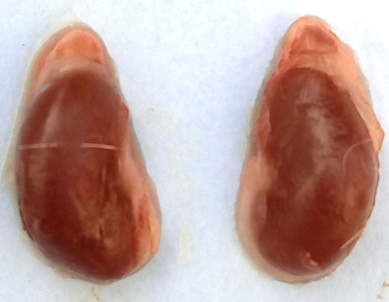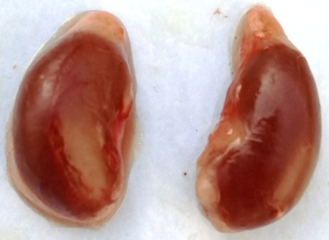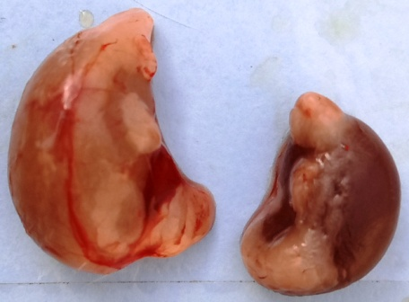

2

2

1

1

2

1

B

C

A

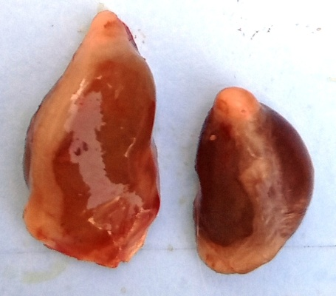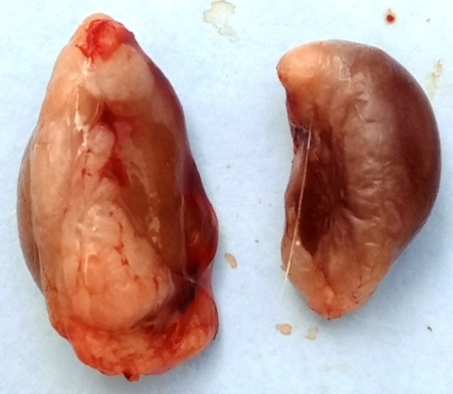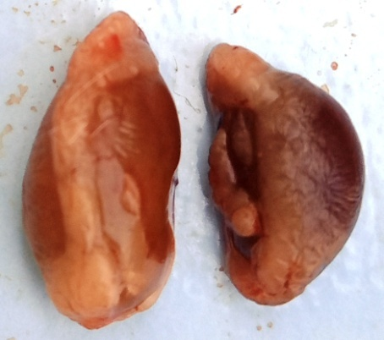

2

2

2

1

1

1

F

D

E

**Fig. 4. Photographs of the kidneys of rats subjected to OUU.** A: Normal control, B: Sham control, C: Negative control, D, E, F: groups treated with aqueous extract of *A. andongensis* stem bark at doses of 125, 250 and 500 mg/kg respectively. 1: left kidney, 2: right kidney.

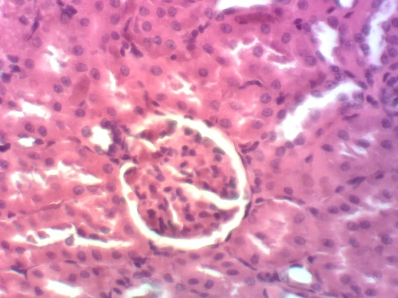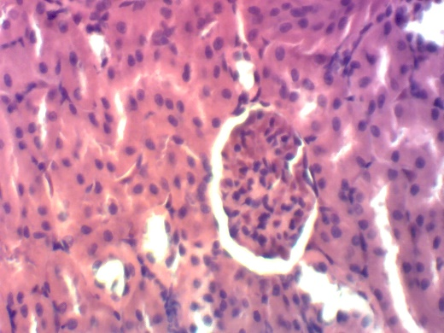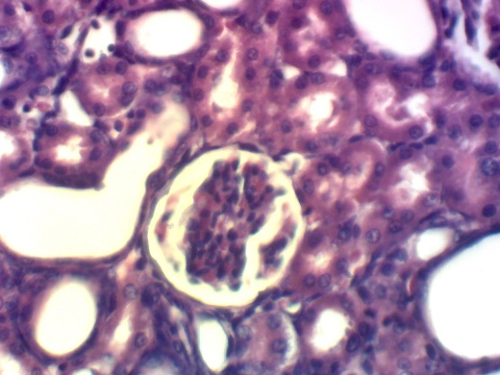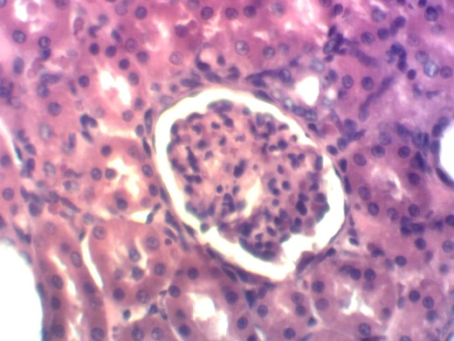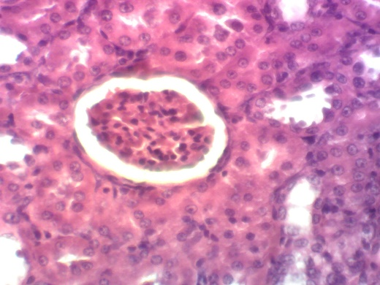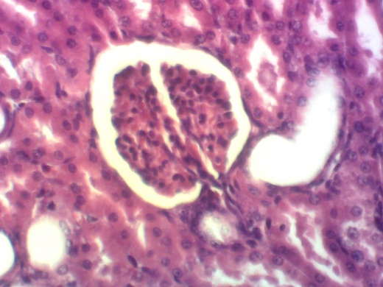

**Dct**

**Pct**

**Gl**

**Us**

**Gl**

**Gl**

**Dt**

**Dt**

**Dt**

**Dt**

**Dt**

**Gl**

**Gl**

**Gl**

**A**

**B**

**C**

**D**

**F**

**E**

**Tt**

**Tt**

**Tt**

**Fig. 5.** **Microphotographs of rat kidneys (x 200, Haematoxylin-eosin)**. A: Normal control, B: Sham control, C: Negative control, D, E, F: groups treated with aqueous extract of *A. andongensis* stem bark at doses of 125, 250 and 500 mg/kg, respectively, Gl: Glomerulus, Us: Urinary space, Dct: Distal convoluted tubule, Pct: Proximal convoluted tubule; Dt : Dilation of the tubules; Tt: Thinning of the tubular wall.

**Fig. 6. Biplot showing the principal component analysis (PCA) score and the loadings of the different variables studied in the different groups of rats.** AEAASB 125, AEAASB 250 and AEAASB 500: groups treated with aqueous extract of *A. andongensis* stem bark at the doses of 125, 250 and 500 mg/kg, respectively.

**Fig. 7. Dendrogram obtained by agglomerative hierarchical clustering (AHC) of the different groups of rats (determined by the different parameters measured)**. AEAASB 125, AEAASB 250 and AEAASB 500: groups treated with aqueous extract of *A. andongensis* stem bark at the doses of 125, 250 and 500 mg/kg, respectively.

**List of Reviewers**

Pr OKOKON E. Jude

Department of Pharmacology and Toxicology, Faculty of Pharmacy, University of Uyo, Uyo, Nigeria.

E-mail: [judeefiom@yahoo.com](mailto:judeefiom@yahoo.com)

Pr Thamer ALJUTAILY

Department of Food Science and Human Nutrition, College of Agriculture and Veterinary Medicine, Qassim University, Buraydah 51452, Saudi Arabia

E-mail: [thamer.aljutaily@qu.edu.sa](mailto:thamer.aljutaily@qu.edu.sa)

Pr USUNOMENA USUNOBUN

Edo State University Uzairue, Department of Biochemistry, Iyamho, Edo State, Nigeria.

E-mail: [usunobun.usunomena@edouniversity.edu.ng](mailto:usunobun.usunomena@edouniversity.edu.ng)

Pr OGBONNAYA MBA

Department of Pharmacology and Toxicology, Faculty of Pharmaceutical Science, Nnamdi Azikiwe University, Awka, Nigeria.

E-mail: [mbabte@yahoo.com](mailto:mbabte@yahoo.com)