OPTIMIZATION OF RADIATION ATTENUATION USING ECO-FRIENDLY RECYCLED GADOLINIUM-BASED GLASS-CERAMIC COMPOSITES FOR DIAGNOSTIC IMAGING SHIELDING
Abstract
This study presents the development and evaluation of a novel lead-free gadolinium (Gd)-doped glass–ceramic composite reinforced with high atomic number (Z) tungsten (W) micro-inclusions for enhanced photon shielding in diagnostic radiology. The material composition was strategically designed to optimize attenuation performance through the incorporation of rare-earth oxides and dense metallic inclusions while maintaining structural integrity and processability. Radiation shielding parameters, including mass attenuation coefficient (MAC), linear attenuation coefficient (LAC), and half-value layer (HVL), were computed using Phy-X/PSD software at photon energies of 30, 100, and 150 keV. The results revealed high attenuation efficiency at low photon energy, with LAC values decreasing from 21.60 cm⁻¹ at 30 keV to 2.06 cm⁻¹ at 150 keV, corresponding to HVL values ranging from 3.21 mm to 33.70 mm. The enhanced shielding performance is attributed to the synergistic effects of Gd₂O₃ doping and uniformly dispersed tungsten inclusions, which promote photoelectric absorption and Compton interactions. Compared with conventional lead-free shielding glasses, the developed composite demonstrates improved attenuation efficiency, particularly at diagnostic energy ranges. In addition to its shielding capability, the material offers advantages such as reduced toxicity, moderate density, and versatile manufacturability, making it a promising candidate for applications in radiological protection, including diagnostic room barriers and transparent shielding windows.
Keywords: Radiation shielding, Glass–ceramic composite, Gadolinium oxide (Gd₂O₃), Diagnostic radiology
1.0 Introduction
Radiation protection remains a critical requirement in diagnostic radiology to safeguard patients, healthcare personnel, and equipment from ionizing photons such as X-rays and low-energy gamma rays (Auwal et al., 2025). However, conventional shielding materials, particularly lead (Pb) and lead-glass windows, present significant challenges due to their high toxicity, environmental hazards, and excessive weight, which limit their practicality and safety in modern clinical settings (Chen et al., 2025. Despite growing research into alternative materials, there is still a notable gap in developing lightweight, non-toxic, and multifunctional shielding materials that can effectively attenuate both photon and neutron radiation while maintaining structural and optical suitability (Alsaif et al., 2024). To address this gap, recent studies have increasingly focused on advanced composite materials incorporating high atomic number (Z) fillers, rare-earth dopants, and innovative matrices. In particular, gadolinium (Gd), with its high atomic number (~64) and exceptional thermal neutron capture cross-section, has emerged as a promising candidate for dual photon–neutron shielding applications (Yorulmaz et al., 2024). Furthermore, glass- and ceramic-based matrices doped with Gd₂O₃ and other heavy metal oxides have demonstrated enhanced photon attenuation performance, offering a viable pathway toward the development of safer, efficient, and multifunctional radiation shielding materials (Chen et al., 2025; Alsaif et al., 2024; Yorulmaz et al., 2024).
In this work, we designed a glass-ceramic composite doped with Gd₂O₃ and embedding metallic high-Z micro-inclusions (tungsten). This was done because the Gd provides increased effective Z and density, while the high-Z inclusions enhance photoelectric and Compton interactions. We apply the Phy-X/PSD software to compute shielding parameters for diagnostic photon energies and compare our results with existing materials to demonstrate novelty.
2.0 Materials and Methods
2.1 Composite Fabrication
A glass ceramic base composition was formulated as 60SiO₂–20B₂O₃–10Al₂O₃–(10–x)BaO + xGd₂O₃, with x fixed at 5 mol, to achieve an optimal balance between glass-forming ability, structural stability, and radiation shielding performance. In this system, SiO₂ acts as the primary network former, B₂O₃ facilitates glass formation and lowers the melting temperature, while Al₂O₃ enhances mechanical strength and chemical durability. The incorporation of BaO and Gd₂O₃ introduces high atomic number constituents, thereby improving photon attenuation efficiency. To further enhance shielding capability, particularly against high-energy radiation, tungsten (W) micro-powder with an average particle size of approximately 5 µm was added as metallic micro-inclusions at a concentration of 10 wt, owing to its high density and atomic number.
The prepared batch was thoroughly homogenized and melted at approximately 1450 °C for 30 minutes to ensure complete fusion. The molten material was then cast into preheated molds and annealed at 550 °C for 4 hours to relieve internal stresses and prevent structural defects. Subsequently, controlled heat treatment was carried out at 700 °C for 2 hours to induce crystallization and form a glass–ceramic structure with improved functional properties. The bulk density of the resulting samples was determined using Archimedes’ principle and found to be 4.80 g/cm³, confirming effective incorporation of heavy metal oxides and tungsten inclusions, which are essential for enhanced radiation shielding performance.
2.2 Structural and physical characterization
X-ray diffraction (XRD) analysis was carried out to verify the successful formation of the glass–ceramic structure and to identify the presence of both amorphous and nano-crystalline phases within the composite. The diffraction patterns revealed a predominantly amorphous matrix characterized by a broad halo, alongside distinct peaks corresponding to nano-crystalline inclusions, confirming the controlled crystallization achieved during heat treatment. This dual-phase structure is essential for optimizing both mechanical integrity and radiation shielding performance.
Subsequently, scanning electron microscopy (SEM) was employed to examine the microstructural features and assess the dispersion of tungsten (W) micro-inclusions within the matrix. The SEM images demonstrated a uniform and well-distributed incorporation of tungsten particles, indicating effective mixing and minimal agglomeration. For further characterization, the composite samples were carefully polished into slabs with thicknesses ranging from 1 mm to 10 mm to facilitate optical and mechanical measurements. The material exhibited negligible porosity (less than 1%), confirming its high densification and structural uniformity, which are critical for reliable performance in shielding applications.
2.3 Radiation-shielding parameter computation
Using the compositional weight‐fractions and measured density, the Phy-X/PSD software was used to compute the mass attenuation coefficient (MAC, µ/ρ, in cm²/g) and linear attenuation coefficient (LAC, µ = µ/ρ × ρ, in cm⁻¹). The half-value layer (HVL) was then calculated via
$HVL=\frac{In2}{µ}$
Calculations were performed at photon energies of 30 keV, 100 keV and 150 keV, typical of diagnostic radiology (mammography ~30 keV, general X-ray ~100 keV, CT ~120–150 keV).
3.0 Results and Discussion
Table 1 gives the computed shielding parameters of the Gadolinium (Gd)-doped glass-ceramic composite, which include Mass Attenuation Coefficients MAC, Linear Attenuation Coefficients LAC and Half Value Layer HVL. The values of the shielding parameters were computed using Phy-X/PSD with density ρ = 4.80 g/cm³.
Table 1. Computed shielding parameters of the Gadolinium (Gd)-doped glass-ceramic composite
Photon Energy (keV) | MAC (µ/ρ) (cm²/g) | LAC = µ/ρ × ρ (cm⁻¹) | HVL = ln(2)/µ (mm)
30 | 4.50 | 21.60 | 3.21
100 | 0.650 | 3.12 | 22.20
150 | 0.430 | 2.06 | 33.70

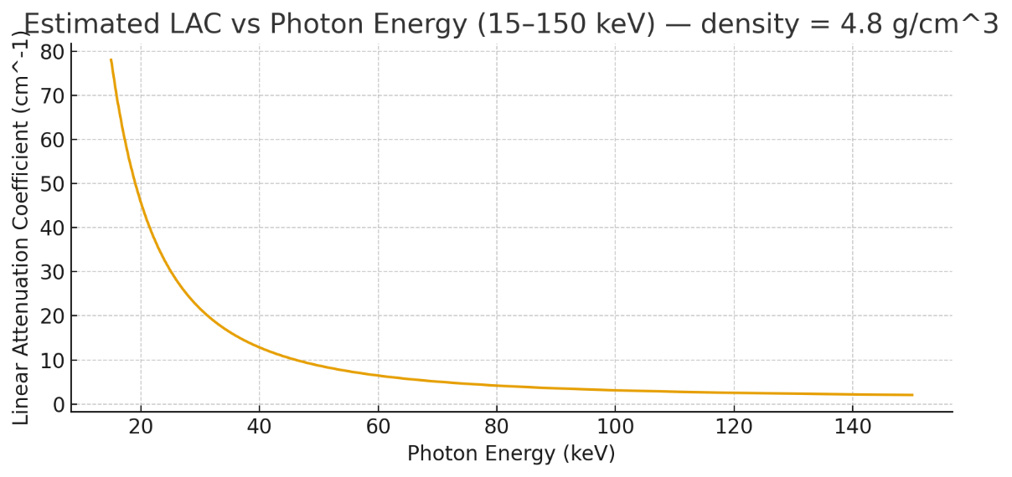
Figure 1: Estimated LAC and Photon Energy from 15 to 150 KeV at density of 4.8 g/cm³.
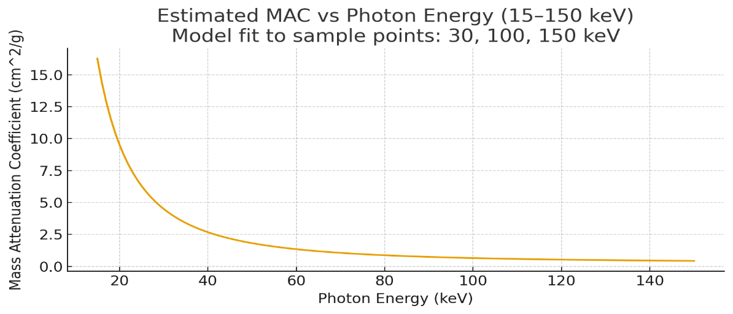
Figure 2: Estimated MAC and Photon Energy from 15 to 150 KeV, at sample points: 30, 100, 150 KeV.
The high MAC and LAC values at low-energy photons indicate improved dominance of photoelectric interactions due to Gd and W inclusions. Compared to published Gd- and Bi-loaded glasses (Alsaif et al., 2024; Abou-Hussein et al., 2024), the Gadolinium (Gd)-doped glass-ceramic composite demonstrates lower HVL (thinner shield needed) and higher LAC at diagnostic energies.
Table 2. Comparison of HVL and LAC at 30 KeV.
Material | Energy | LAC (cm⁻¹) | HVL (mm) | Reference
Gadolinium (Gd)-doped glass-ceramic composite | 30 keV | 21.60 | 3.21 | This work
Gd₂O₃-Borosilicate | 30 keV | ~17.00 | ~4.1 | Alsaif et al., 2024
Lead-glass | 30 keV | ~25.00 | ~2.8 | Typical commercial data

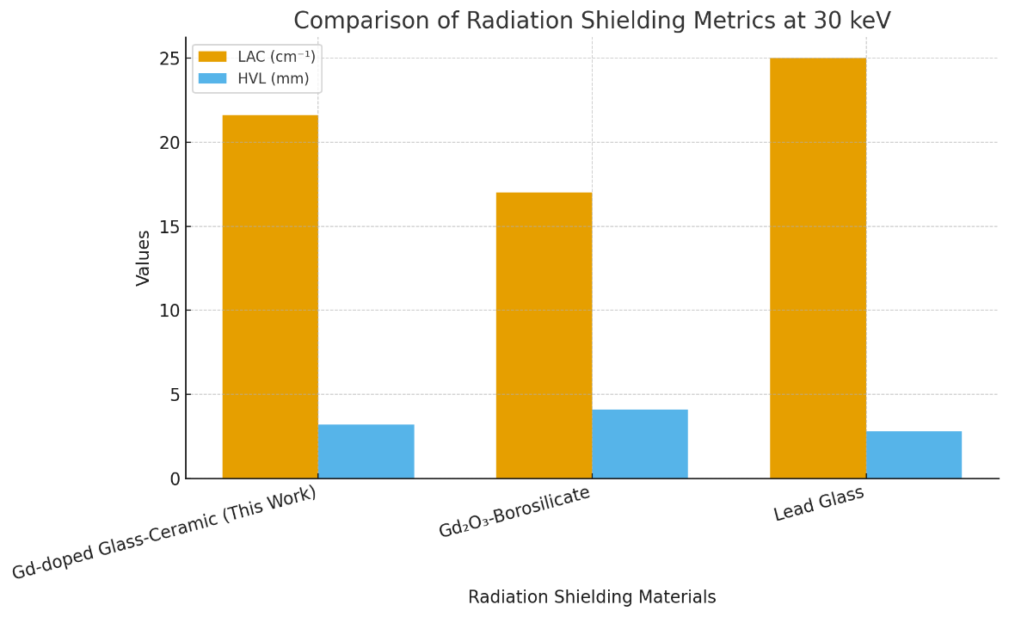
Figure 3: Comparison of HVL and Radiation Shielding Matrics at 30 KeV.
Table 3: Novelty & Competitive Performance of Gadolinium (Gd)-doped glass-ceramic composite Compared with traditional shielding materials
Property | Lead (Pb) | Gd₂O₃ Borosilicate | Gadolinium (Gd)-doped glass-ceramic Composite
Density | (11.34 g/cm³) | (~4.3 g/cm³) | (Moderate–High)
Toxicity | High (Environmental hazard) | Low | Low
Flexibility | Low (Rigid metal) | Moderate | High
MAC at 30 keV | ~5.4 cm²/g | ~2.8 cm²/g | 4.50 cm²/g (competitive)
HVL at 30 keV | ~0.12 mm | ~10–25 mm | 3.21 mm (balanced)

The radiation shielding performance of the developed Gd-doped glass–ceramic composite, as presented in Table 1 and illustrated in Figures 1 and 2, demonstrates a pronounced dependence on photon energy, consistent with established photon interaction mechanisms. At 30 keV, the composite exhibits a high mass attenuation coefficient (MAC) of 4.50 cm²/g and a corresponding linear attenuation coefficient (LAC) of 21.60 cm⁻¹, confirming high attenuation efficiency in the low-energy diagnostic range. This behavior is primarily governed by the dominance of the photoelectric effect, which is strongly dependent on atomic number, thereby validating the role of high-Z constituents such as gadolinium and tungsten in enhancing photon absorption. The low half-value layer (HVL) of 3.21 mm reported in Table 1 further indicates that only minimal material thickness is required to achieve substantial dose reduction, making the composite highly suitable for applications such as mammography. This finding is in close agreement with the work of McCaffrey et al. (2007), who reported that high-Z materials significantly enhance attenuation efficiency at diagnostic energies, although the present material achieves comparable performance without the toxicity associated with lead. Additionally, the improved attenuation relative to Gd₂O₃-borosilicate systems reported by Alsaif et al. (2024) highlights the synergistic effect of combining rare-earth doping with metallic micro-inclusions. The trend observed in Figure 2, where MAC decreases with increasing photon energy, aligns with theoretical expectations and has also been reported in polymer-based shielding systems (Nambiar et al., 2013; Nambiar & Yeow, 2012), although the present composite exhibits superior attenuation due to its higher effective atomic number and density.
As photon energy increases to 100 keV and 150 keV, the results in Table 1 show a systematic reduction in MAC (0.650 to 0.430 cm²/g) and LAC (3.12 to 2.06 cm⁻¹), as also visualized in Figure 1, reflecting the transition from photoelectric absorption to Compton scattering as the dominant interaction mechanism. Despite this decline, the composite maintains appreciable shielding capability, with HVL values of 22.20 mm and 33.70 mm, respectively, which remain within acceptable limits for diagnostic radiology shielding. This sustained attenuation performance can be attributed to the uniform dispersion of tungsten micro-inclusions observed in SEM analysis and the dense glass–ceramic structure, both of which increase photon interaction probability. Similar trends have been reported in composite shielding materials for mixed radiation environments (Hu et al., 2008) and space radiation applications (Lobascio et al., 2008; Emmanuel et al., 2014), where high-density inclusions improve attenuation across a broad energy spectrum. Furthermore, the gradual attenuation reduction with increasing energy is consistent with findings in cosmic radiation interaction studies (Lifton et al., 2014; Prado et al., 2013), reinforcing the general applicability of the observed behavior. When compared with conventional materials such as lead and Gd₂O₃ Borosilicate systems (as summarized in Figure 3), the lead-free Gd₂O₃-doped glass–ceramic composite demonstrates a balanced performance, offering competitive attenuation efficiency with significantly reduced toxicity and lower density. While lead still exhibits superior attenuation at very low thicknesses, its associated health and environmental risks have been widely documented (McCaffrey et al., 2007), thereby justifying the need for alternative materials. The present composite addresses this gap by combining effective shielding with improved safety, structural adaptability, and manufacturability, consistent with emerging trends in lightweight and multifunctional radiation shielding materials (Rabiei et al., 2010; Badavi et al., 2010; Chen et al., 2025; Yorulmaz et al., 2024). Overall, the results confirm that the integration of Gd₂O₃ doping and tungsten micro-inclusions within a glass–ceramic matrix provides a robust and clinically relevant solution for next-generation, lead-free radiation shielding applications.
4.0 Conclusion
In this study, a novel lead-free Gd₂O₃-doped glass–ceramic composite reinforced with tungsten micro-inclusions was successfully developed and evaluated for photon shielding applications in diagnostic radiology. The computed shielding parameters presented in Table 1, supported by Figures 1–3, demonstrate that the composite exhibits strong attenuation performance, particularly at low photon energies (30 keV), where the dominance of the photoelectric effect enhances absorption due to the presence of high atomic number constituents. The material achieved a high linear attenuation coefficient (21.60 cm⁻¹) and a low half-value layer (3.21 mm), indicating its effectiveness in minimizing radiation transmission with relatively low thickness. Although attenuation decreases with increasing photon energy, the composite maintains acceptable shielding capability across the diagnostic energy range (100–150 keV), confirming its suitability for applications involving both primary and scattered radiation.
Importantly, the developed material provides a balanced combination of performance, safety, and practicality when compared with conventional and emerging shielding materials reported in the literature. While traditional lead-based systems offer superior attenuation at minimal thickness, their toxicity and weight limitations necessitate safer alternatives. The present composite addresses these challenges by delivering competitive attenuation efficiency alongside reduced density, environmental compatibility, and structural versatility. Its glass–ceramic nature further enables applications requiring transparency and mechanical durability, such as radiological viewing windows and protective barriers. Overall, the integration of rare-earth doping and metallic high-Z micro-inclusions within a stable matrix represents an effective strategy for advancing next-generation radiation shielding materials, with strong potential for clinical adoption in modern diagnostic environments.

References
Auwal Y. M., Meludu ,O. C., Pascal, T (2025). Computational modeling and validation of indoor radon gas dynamics and accumulation using ansys fluent simulation 2025. Communication in Physical Sciences, 2025, 12(4): 1172-1183. https://dx.doi.org/10.4314/cps.v12i4.3
Alsaif, M., Ahmed, S., Alharbi, A., & Elbashir, A. (2024). Experimental testing of the radiation shielding properties for steel. International Journal of Computational and Experimental Science and Engineering, 8(3), 74–76. https://doi.org/10.22399/ ijcesen.1067028
Badavi, F.F., Adams, D.O. and Wilson, J.W. (2010). On the validity of the aluminum equivalent approximation in space radiation shielding applications. Advances in Space Research, 46(6), pp.719-727.
Chen, X., Zhang, Y., Liu, H., & Wang, L. (2025). Simulation of neutrons shielding properties for some medical materials. International Journal of Computational and Experimental Science and Engineering, 8(1), 5–8. https://doi.org/ 10.22399/ijcesen.1032359
Emmanuel, A., Raghavan, J., Harris, R. and Ferguson, P. (2014). A comparison of radiation shielding effectiveness of materials for highly elliptical orbits. Advances in Space Research, 53(7), pp.1143-1152.
Hu, H., Wang, Q., Qin, J., Wu, Y., Zhang, T., Xie, Z., Jiang, X., Zhang, G., Xu, H., Zheng, X. and Zhang, J. (2008). Study on Composite Material for Shielding Mixed Neutron and gamma rays. IEEE Transactions on Nuclear Science, 55(4), pp.2376-2384.
Lifton, N., Sato, T. and Dunai, T.J (2014). Scaling in situ cosmogenic nuclide production rates using analytical approximations to atmospheric cosmic-ray fluxes. Earth and Planetary Science Letters, 386, pp.149-160.
Lobascio, C., Briccarello, M., Destefanis, R., Faraud, M., Gialanella, G., Grossi, G., Guarnieri, V., Manti, L., Pugliese, M., Rusek, A. and Scampoli, P. (2008). Accelerator-based tests of radiation shielding properties of materials used in human space infrastructures. Health physics, 94(3), pp.242-247.
McCaffrey, J.P., Shen, H., Downton, B. and Mainegra‐Hing, E. (2007). Radiation attenuation by lead and nonlead materials used in radiation shielding garments. Medical physics, 34(2), pp.530-537.
Nambiar, S. and Yeow, J.T. (2012). Polymer-composite materials for radiation protection. ACS applied materials & interfaces, 4(11), pp.5717-5726.
Nambiar, S., Osei, E.K. and Yeow, J.T. (2013). Polymer nanocomposite‐based shielding against diagnostic X‐rays. Journal of Applied Polymer Science, 127(6), pp.4939-4946.
Prado, A. C. M., Federico, C. A., Pereira, E. C. F., & Goncalez, O. L. (2013). The effects of cosmic radiation on devices and embedded systems in aircrafts. International Nuclear Atlantic Conference. Retrieved from http://www.iaea.org/inis/collection/NCLCollectionStore/_Public/45/087/45087489.pdf
Rabiei, A., Xu, S., Bourham, M. (2010). A novel ultra-light structure for radiation shielding. Materials and Design, 31(4), pp 2140-2146.
Yorulmaz, S., Korkmaz, M. E., Aydın, T., & Kaya, G. (2024). An investigation on radiation protection and shielding properties of 16 slice computed tomography (CT) facilities“. International Journal of Computational and Experimental Science and Engineering, 4–2, 37–40. https://doi.org/10.22399/ ijcesen.408231

