OPTIMIZATION OF DRYING PROCESS PARAMETERS OF CASSAVA CHIPS IN ROTARY DRYER
Onyeagba Obinna B.¹ and Eje Brendan E. ²
Machine Building Department,
Scientific Equipment Development Institute, Enugu (A unit of NASENI) Nigeria¹
Department of Agricultural and Bioresource Engineering,
Enugu State University of Science and Technology Enugu State, Nigeria²
Email: obinnaonyeagba@yahoo.com¹ brendaneje@yahoo.com²
ABSTRACT
Cassava chips were dried inside a rotary dryer with the aim of optimizing its drying process parameters using response surface methodology. drying temperature, cassava chip size, drum speed and load quantity were considered as the independent variables while the moisture content, swelling index and thermal degradation of cassava chips were used as the dependent valuables. The higher and lower factor values of the four independent valuables were obtained using Minitab 17. An experimental plan was developed from the statistical tool employed which designed the experiment into 30runs. At optimal value conditions of 216⁰C drying temperature, 2.5mm cassava chips size, 8.4rpm drum speed and load quantity of 6tons, the experimental results yielded 9.34% moisture content, 1.69 swelling index and 1.01% thermal degradation. The model obtained from the response surface curves were used to develop a selection chart which will be useful to control time, quality and cost of drying in Nigerian agro storage industries.
Keywords: optimization, drying, cassava chips, parameters, rotary dryer, process
- INTRODUCTION
Preservation is one of the many steps that comes under post-harvesting of agricultural products which reduce post-harvest losses and increases food availability from existing production (Gamble, 2015). In developing nations like Nigeria and other countries in Asia, Africa, and South America, 40% of total agricultural products get spoilt due to lack of proper post-harvest management method [Postharvest Management, 2006, Nachiketh et al, 2016]. Drying is an energy intensive process that results in the removal of moisture from a body by evaporation. It is also a mass transfer process consisting of the removal of water or another solvent by evaporation from solid, semi-solid or liquid [Onweude et al, 2016]. This process is often used as a final production step before selling or packaging products. According to Thesaurus and Encyclopedia, (2011), every agricultural product is said to be dried only

When its final agricultural product is solid in the form of continuous sheet, long pieces, particles or powder. Examples are paper, wood, corn flakes, sand etc. Agricultural materials especially starchy foods such as cassava meals are hygroscopic so they can lose or absorb moisture depending on the ambient air condition [Serpil and Servet 2006]. Cassava has been established to be an important food crop in the tropics and a major source of carbohydrate with 88% of it been produced and consumed in Africa by human beings [Taiwo 2006] and statistics has shown that Nigeria is currently the largest producer of cassava in the world [FAO. 2004, 2006]. Besides serving as the primary staple food for millions of people, it can be converted into dried stable products such as chips and pellets which are useful as basic raw material in animal feed formulations, ethanol production and cassava beer [Ashaye, et al 2005]. Processing the tubers into chips reduces the moisture content to a very low level and reduces post-harvest losses. According to Kuye et al (2004), these cassava chips are marketed locally in all the southern states in Nigeria to a tune of 1500tons per day. [Rasaq, 2019a] it was reported that 10 - 40% of yam lost to post-harvest are due to lack of appropriate storage facilities. Ademiluyi (2016) developed software for design and construction of rotary dryer for drying ground cassava. Its drying stage determines the quality of the dried chips produced bearing in mind that undesirable biochemical changes, subsequent contamination and spoilage of the chips can only be prevented if the drying process is fast enough and the final product is dry enough [Maskan 2000]. Cassava has high moisture content which if not removed within 72 – 92hours will cause the growth of microorganism in the cassava which eventually will spoil the cassava. Cutting these cassava roots into chips are the most common form in which dried cassava root are marketed and still retain its rich nutrients. Rasaq (2019c) did an analysis on a biogas driven combined cooling, heating and power generation system that harmonizes power generation with food drying and cold storage to solve the problem of heavy post-harvest loss in the sub-Saharan African region because they lack clean energy. They proposed a system that is able to dry 816.73 T of cassava tubers, 267.33 T of maize and cold-store 3.365 T of tomato every year. Rasaq (2019b) did a review on the contributions of combined power and drying, application of phase change materials and hybrid drying systems with regard to agricultural products. They indicated that deployment of biomass powered combined heat and power systems might be a good solution to post-harvest wastes since both electricity and heat for drying of agricultural products can be simultaneously obtained. However, as these challenges have established that drying will help save post-harvest lost, the aim of study is to optimize the drying process parameter of cassava chips in rotary dryer since no work has been done on the process parameter with the specific objectives of developing a mathematical model for the process, developing a selection chart for cassava chips drying process parameter using a rotary dryer for industrial use and optimizing the drying temperature, cassava chip size, drum speed and load quantity using response surface method approach. This process parameter will help speed up the drying time, quality and reduce the cost of drying.
2. MATERIALS AND METHOD
The cassava used for this work was sourced from Nweke J. C. farm in Nenwe, Aninri L.G.A., Enugu state. The back was peeled with a knife and cut into chips of various dimensions using cassava chipping machine and weighted.
Moisture Content was calculated using equation 1(Lazzari, 1994)
$Mc \left(\%\right)=\frac{Wi-Wf}{Wi} ×100$ (1)
Where W_{i =} initial weight of cassava chips and W_{f} = final weight of cassava chips

The Swelling Index: After drying the cassava chips, it was introduced into a 1000ml measuring cylinder, the initial volume ($V_{i}$) was recorded and water was added to fill the cylinder to the brim, the set up was allowed to settle for 20minutes then the final volume ($V_{f}$) was taken to calculate the swelling index, using equation 2.(lateef et al,2015) $Si= \frac{V_{f}}{V_{i}}$ (2)
Thermal Degradation: The dried cassava chips were weighed; the burnt cassava chips were selected and also weighed. The thermal degradation was calculated using equation 3.
$Td (\%)= \frac{ W_{b}}{W_{tot}}$ $×100$ (3)
Where $W_{b}$ = weight of burnt cassava chips and $W_{tot}$ = total weight of dried cassava chips
Drying Efficiency: the drying efficiency was calculated using equation 4 according to Matuam et al (2015) $η= \frac{m_{c}* L_{c}}{A_{c}* C_{c}* ∆T}$ (4)
Where $m_{c}$ is mass of water evaporated from the cassava chips(kg), $L_{c}$ is latent heat of vaporization (kj/kg), $A_{c}$ is mass of air (kg), $C_{c}$ = specific heat of air (kj/kg⁰C), $∆T$ = temperature difference (⁰C)
Equilibrium Moisture Content: the equilibrium moisture content of cassava chips were calculated using equation 5 according to Mitchell (2018).
$E_{mc}= \frac{1800}{V} \left[\frac{(kN_{C}}{1-kN_{C}}+ \left(\frac{K_{C1 }KN_{C }+2K_{C1}K_{C2}K^{2}N_{C}^{2}}{1+ K_{C1}KN_{C}+ K_{C1}K_{C2}K^{2}N_{C}^{2}}\right)\right]$ (5)
Where $E_{mc }$the equilibrium moisture is content, $N_{C}$ is relative humidity and V, K, $K_{C1},K_{c2}$ are coefficients which were calculated using equations 6 -9.
V = 330 + 0.452T + 0.00415T² (6)
K = 0.791 + 0.000463T – 0.000000844T² (7)
K_{C1} = 6.34 + 0.000775T – 0.0000935T² (8)
K_{C2} = 1.09 + 0.0284T – 0.0000904T² (9)
Where T is the dry bulb temperature.
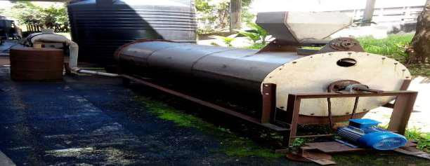
Figure 1: Rotary Dryer
The rotary dryer is made of stainless steel with a capacity of 9.3 tonnes per hour and dimensions of 880mm diameter, 1770mm height and 3660mm length. It has a heat source, an electric motor, air blower and the drying chamber. The optimization of the settings and the empirical relationships between the drying process parameters (factors) and responses in rotary drying of cassava chips were analyzed by response surface method approach. This involves Response Surface Method (RSM) experimental design, evaluation and modeling such as model fitting, selection and development of established optimal parameter table for cassava chips drying.
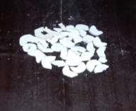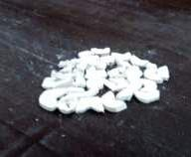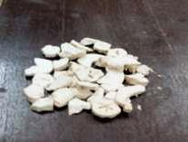
3mm thickness 4mm thickness 5mm thickness
Figure 2. Cassava Chips granulometric classification pictures
2.1: Procedures for optimization of cassava chips drying process.
Evaluation, modeling and optimization of cassava chips drying process involves:
- Development of appropriate RSM experimental plan.
- Selection of a response surface model.
- Optimization of the selected models.
- Verification/confirmation of the modeling and optimization results.
Design of experiment choice was based on variables number, objective of study, resource availability and source of data collection. Cassava drying in rotary dryer process parameters – drying temperature , cassava chips size, Drum speed, Load quantity on moisture content, swelling index and thermal degradation were studied. [Minitab software, Version 17. 2006] was used to generate 30 experimental runs to study variable number (K = 4) for independent variables including drying temperature$(D_{t})$, cassava chips size$(C_{S})$, Drum speed$(D_{s})$, Load quantity$(L_{q})$, were used for the design. These independent variables constitute the factors and were coded as $x_{1}, x_{2, } x_{3} and x_{4}$respectively. The responses of Moisture content$(M_{c})$, swelling index$(S_{i})$ and thermal degradation $(T_{d})$ were calculated using the results of the experimental runs. The search for models that will describe the responses adequately started with fitting of linear function due to desire to quantify the parameters with simplest possible functions. The limits for cassava chips drying process parameters experimental plan study are depicted in tables 1, with the values of -1 and +1 for the four parameters. The axial point value was augmented to ±2.336 since the typical α of (+2,-2) could not give significant models. The 0 level, –2.336 and +2.336 were calculated by interval addition in Minitab, and a design matrix was obtained.
Table 1: Limits of cassava chips drying process Parameters
S/N | Factor Description | Factor Symbols |  | Factor Values
 |  | Coded | Actual | High (+1) | Low (-1)
1 | Drying temperature (⁰C) | $$x_{1}$$ | $$D_{t}$$ | 200 | 160
2 | Cassava Chips Size (mm) | $$x_{2}$$ | $$C_{s}$$ | 5 | 3
3 | Drum Speed(rpm) | $$x_{3}$$ | $$D_{s}$$ | 14 | 10
4 | Load quantity (tons) | $$x_{4}$$ | $$L_{q}$$ | 9 | 6
The choice of centre points offers a logical balance among the strength, durability and economic considerations associated with the objective of this study. The Moisture content$(M_{c})$, swelling index$(S_{i})$ and thermal degradation $\left(T_{d}\right)$ are the actual values of cassava chips drying process responses in their original/ natural units. Thereafter, the natural values of these responses were determined using the transformation equations 1 which relate the coded and actual values of the factors [Agunwamba 2007] X = $\frac{x-\left(\frac{x_{max}+ x_{min}}{2}\right)}{\left(\frac{x_{max}- x_{min}}{2}\right)}$ (10)
Coded variable is denoted as X and natural units of independent variable is x, then maximum and minimum independent factors respectively are x_{max} and x_{min}.
Table 2: RSM design table for cassava chips drying process parameters
Experimental Runs |  | Coded Values |  |  |  | Actual Values
Std Order | Run Order | X1 | X2 | X3 | X4 | Drying Temperature (⁰C) | Cassava Chip Size (mm) | Drum Speed (rpm) | Load Quantity (tons)
1 | 1 | -1 | -1 | -1 | -1 | 160 | 3 | 10 | 6
2 | 2 | 1 | -1 | -1 | -1 | 200 | 3 | 10 | 6
3 | 3 | -1 | 1 | -1 | -1 | 160 | 5 | 10 | 6
4 | 4 | 1 | 1 | -1 | -1 | 200 | 5 | 10 | 6
5 | 5 | -1 | -1 | 1 | -1 | 160 | 3 | 14 | 6
6 | 6 | 1 | -1 | 1 | -1 | 200 | 3 | 14 | 6
7 | 7 | -1 | 1 | 1 | -1 | 160 | 5 | 14 | 6
8 | 8 | 1 | 1 | 1 | -1 | 200 | 5 | 14 | 6
9 | 9 | -1 | -1 | -1 | 1 | 160 | 3 | 10 | 9
10 | 10 | 1 | -1 | -1 | 1 | 200 | 3 | 10 | 9
11 | 11 | -1 | 1 | -1 | 1 | 160 | 5 | 10 | 9
12 | 12 | 1 | 1 | -1 | 1 | 200 | 5 | 10 | 9
13 | 13 | -1 | -1 | 1 | 1 | 160 | 3 | 14 | 9
14 | 14 | 1 | -1 | 1 | 1 | 200 | 3 | 14 | 9
15 | 15 | -1 | 1 | 1 | 1 | 160 | 5 | 14 | 9
16 | 16 | 1 | 1 | 1 | 1 | 200 | 5 | 14 | 9
17 | 17 | 0 | 0 | 0 | 0 | 180 | 4 | 12 | 7.5
18 | 18 | 0 | 0 | 0 | 0 | 180 | 4 | 12 | 7.5
19 | 19 | 0 | 0 | 0 | 0 | 180 | 4 | 12 | 7.5
20 | 20 | 0 | 0 | 0 | 0 | 180 | 4 | 12 | 7.5
21 | 21 | -2.336 | 0 | 0 | 0 | 132.68 | 4 | 12 | 7.5
22 | 22 | 2.336 | 0 | 0 | 0 | 227.32 | 4 | 12 | 7.5
23 | 23 | 0 | -2.336 | 0 | 0 | 180 | 1.634 | 12 | 7.5
24 | 24 | 0 | 2.336 | 0 | 0 | 180 | 6.366 | 12 | 7.5
25 | 25 | 0 | 0 | -2.336 | 0 | 180 | 4 | 7.268 | 7.5
26 | 26 | 0 | 0 | 2.336 | 0 | 180 | 4 | 16.732 | 7.5
27 | 27 | 0 | 0 | 0 | -2.336 | 180 | 4 | 12 | 3.951
28 | 28 | 0 | 0 | 0 | 2.336 | 180 | 4 | 12 | 11.049
29 | 29 | 0 | 0 | 0 | 0 | 180 | 4 | 12 | 7.5
30 | 30 | 0 | 0 | 0 | 0 | 180 | 4 | 12 | 7.5

The search for models that will describe the responses adequately started with fitting of linear function because of the desire to quantify the parameters with simplest possible functions. However, failure of the test for adequacy requires the ascension to the next order level until a satisfactory and adequate model is developed. The 0 Level i.e control value for all the variables (cassava chips drying process parameters) that will be used for the experiment are determined from the machine operation specifications. The limits of cassava chips drying process parameters are shown in table 1. In each of the tests for the determination of the actual levels for any of the factors, the other three factors were kept constant at their design values. According to Eze et al (2017), Thermal degradation which is characterized by darkening colour change was also used for determining the high level operational parameter limit for drying temperature. In line with Murray and Lary (2008) study the cassava chips rotary dryer process parameter design generated was subsequently approximated with a regression equation and used to develop models for predicted response, Y i.e. Moisture content$(M_{c})$, swelling index$(S_{i})$ and thermal degradation $(T_{d})$of constant (intercept), β₀ with linear coefficient, β_{i}, and cross product coefficient. x_{i} and x_{j} are the coded independent variables, β_{ij}, in the form
$Y=β_{0}+\sum_{j-1}^{k}{β_{j}}x_{j}+\sum_{j<}{\sum_{j-2}^{k}{β_{ij}x_{i}x_{j}}}$ (11)
Equation 11 is used to predict response surface models with quadratic effects and two factor interaction for Moisture content, swelling index and thermal degradation as affected by the cassava chips rotary dryer process parameters namely Drying Temperature, cassava chip size, Drum speed and Load quantity [Nicolai et al 2004]. The response design comprises of two level factorial points (-1, 1), center points (0) and axial points (α = ± 2.336) for each independent variable to estimate the second order polynomial while the best overall design occurs at $∝=\sqrt[4]{nf}$ and $n=30$ for a blocked design [Murray and Lary 2008]. .
$Y=β_{0}+\sum_{j-1}^{k}{β_{j}x_{j}}+\sum{β_{jj}x_{j}^{2}}+\sum_{j<}{\sum_{j-2}^{k}{β_{y}x_{i}x_{j}}}$ (12) Considering a need to quantify the parameters with simplest possible functions, the search for models that will describe the responses adequately started with fitting of linear function. The optimized responses and factors were subjected to desirability function analysis to get the actual desired responses as influenced by the cassava chips rotary drying process parameters. The values obtained from the desired responses were used for development of selection chart that will serve as a guide for cassava chips drying in rotary dryer.
3. RESULT AND DISCUSSIONS
Figures 3 depicts the 3D response surface curve for cassava chip moisture content the desirable factor of 5% and 10% on the contour plot is the one that minimizes the cassava chip moisture content (MC) for x3 x4, x4x2 etc these optimum response was attained at center point in the surface plot as you can see the deep green colours are very small in the surface plots for moisture content showing reduction in the moisture content
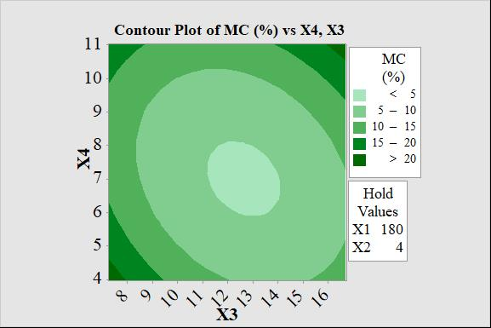
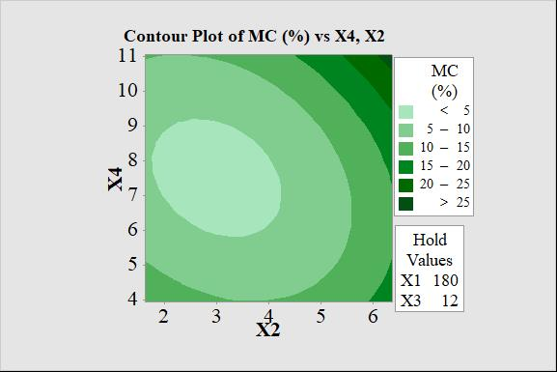
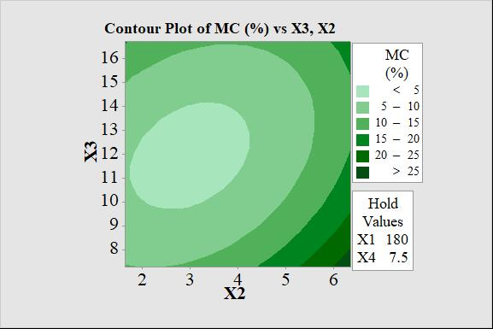
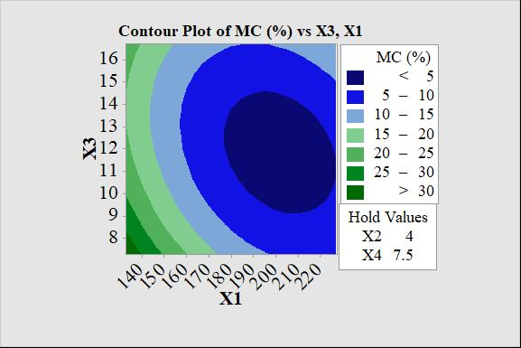
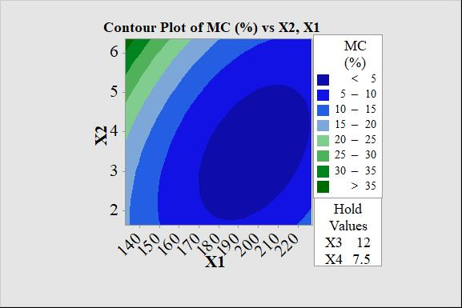
Figure 3: $RSM Plot$ of Cassava chip $MC (\%)$ against drying process Parameters.
In Figure 4, the optimization goal here is to maximize swelling index of cassava chips, As depicted in the 3D curves, a stationary response surface ridge pattern and the desirable response was optimum at maximum values of 2.9 which is deep green colour and 3.3 for x1 and x4 and minimum values of 2.1 and 2.0 for x2 and x3. The lighter shades indict the optimum points from the contour plots. They all have different hold values for x2 x1, x4x3 etc
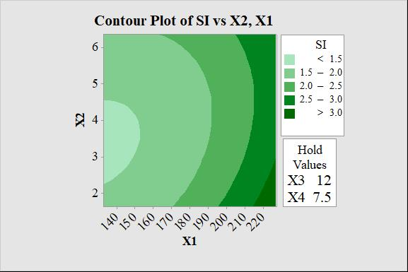
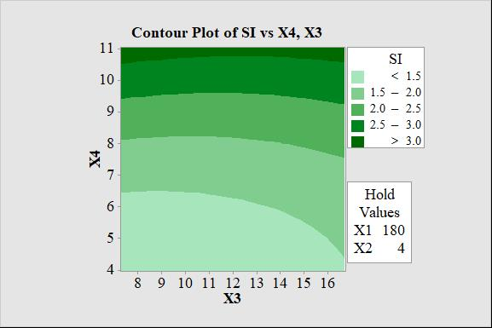
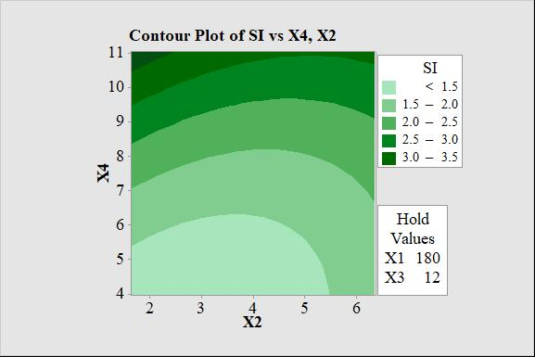
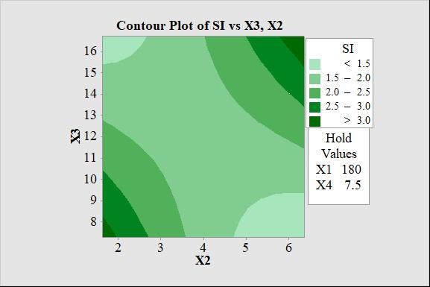
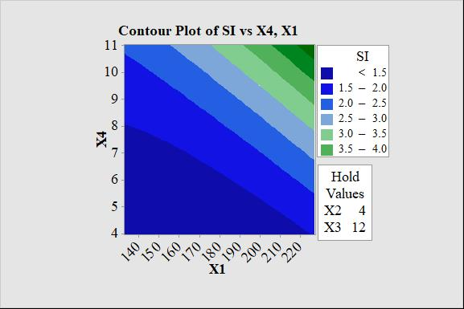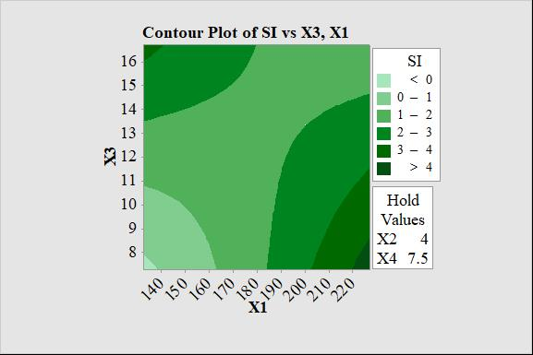

Figure 4: Contour/surface $Plot$ of cassava chips SI against drying process Parameters.
Response surface plots of thermal degradation of cassava chips are shown in Figure 5, all the response surface plots exhibited a minimal ridge response surface pattern. The desirable response of 1.2%, 2.3%, 1.8% and 1.5% were attained at drying temperature (x1), cassava chips (x2), drum speed(x3) and load quantity(x4) respectively which minimizes thermal degradation for x1, x2, x3 and x4 at a minimal point values. Going through the surface plot it has all the same colour indicting little or no lose and the contour plots from the TD key of 1 and 2 colours has the smallest values
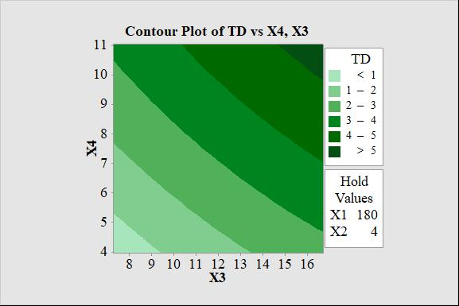
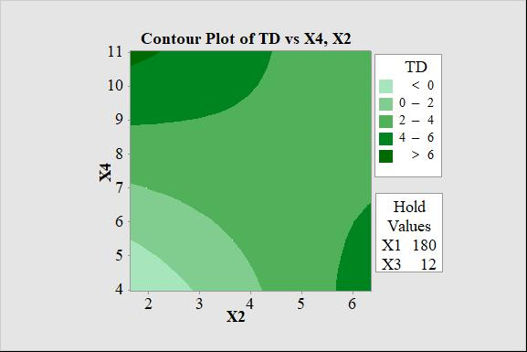
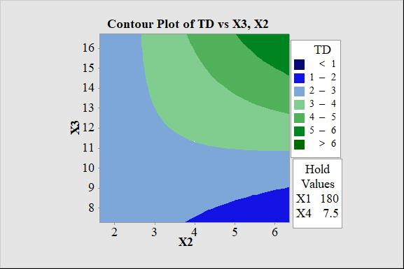
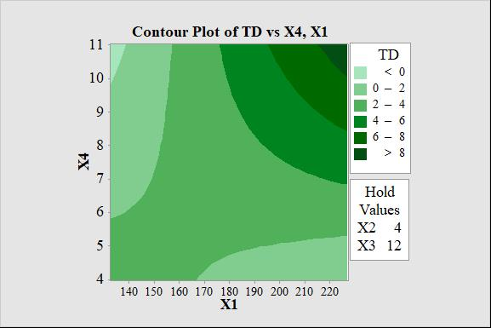
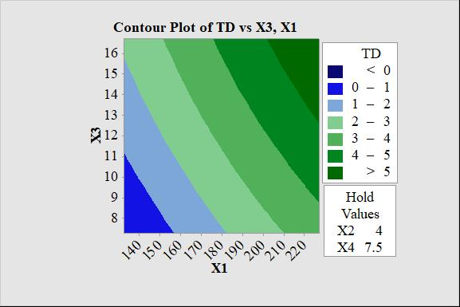
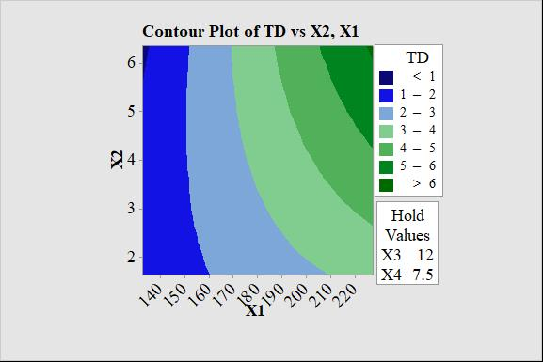
Figure 5: $RSM Plot$ of cassava chip$TD$ against drying process Parameters.
Kathleen et al (2004) observed that optimization using the response surface – contour and surface plots – is technically unreliable when there are more than one response and multiple predictors. Thus it can lead to multiplicity of optimal settings established for one response. Inspection of the contour and surface graphs revealed that for a particular response, some factor pairs are in the maximum region while others indicate minimum optimal region. The indeterminate tendency of this approach gave rise to the need to adopt a more suitable optimization approach which can define the optimal settings of the cassava chips drying process parameters for all the responses.
The desirability function optimization plots are shown in Figures 6 as obtained by the application response optimizer capability of Minitab software, Version 17. 2006.
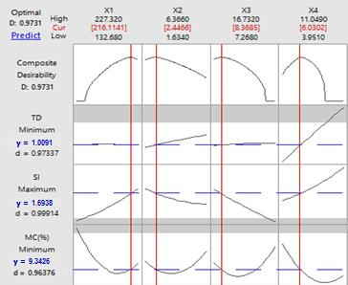
Figure 6: Improved cassava chips drying Process Optimization Plot.
An optimal value of 9.34% moisture content, 1.69 Swelling Index and 1.01% thermal degradation were gotten for cassava chip drying process using rotary dryer and 216^{O}C, 2.5mm, 8.4rpm and 6.0tons for values of drying temperature, cassava chip size, drum speed and load quantity respectively
Table 3: Comparison of my cassava chips study with other works
Parameters | SON standard 2004 | Stephensule et al 2017 | Lateef et al 2015 | My work
Moisture content (%) | 13% maximum | 11.85 | 8.78 | 9.34
Swelling index | - | - | 1.72 | 1.69
Thermal degradation (%) | - | - | - | 1.01
Equations (13) to (15) are the models for calculating the cassava chips quality as influenced by the drying process parameters. These empirical relationships were obtained from the response surface plots of cassava chips quality against drying process parameters. The drying efficiency before optimization was 17.6% whereas drying efficiency after optimization was 20.3% producing a drying efficiency difference of 2.7%. The equilibrium moisture content was calculated as 12.8%
$M_{C}\left(\%\right)=245.2-1.457D_{T}+4.71C_{S}-11.80D_{S}-9.82L_{Q}+0.003855D_{T}D_{T}+1.042C_{S}C_{S}+0.3274D_{S}D_{S}+0.561L_{Q}L_{Q}-0.0546D_{T}C_{S}+0.01881D_{T}D_{S}-0.0142D_{T}L_{Q}-0.359C_{S}D_{S}+0.421C_{S}L_{Q}+0.223D_{S}L_{Q}$ (13)
$S_{I}= -3.68+0.0232D_{T}-1.065C_{S}+0.903D_{S}-0.638L_{Q}+0.000155D_{T}D_{T}+0.0630C_{S}C_{S}+0.00439D_{S}D_{S}+0.02796L_{Q}L_{Q }-0.00175D_{T}C_{S}-0.007342D_{T}D_{S}+0.00412D_{T}L_{Q}+0.0972C_{S}D_{S}-0.0395C_{S}L_{Q}-0.0073D_{S}L_{Q}$ (14)
$T_{D}\left(\%\right)=12.01-0.1094D_{T}+0.158C_{S}-0.146D_{S}-1.414L_{Q}-0.000061D_{T}D_{T}-0.0243C_{S}C_{S}-0.00546D_{S}D_{S}-0.0108L_{Q}L_{Q}+0.00737D_{T}C_{S}+0.00013D_{T}D_{S}+0.01850D_{T}L_{Q}+0.1248C_{S}D_{S}-0.3383C_{S}L_{Q}-0.0010D_{S}L_{Q}$ (15)
where:
M_{C} = Moisture Content D_{S} = Drum Speed C_{S} = cassava chip size
S_{I} = Swelling Index D_{T} = Drying Temperature L_{Q} = Load Quantity
T_{D} = Thermal Degradation 1
These equations 13, 14 and 15 should be used in simulation of the expected responses- moisture content, swelling index and thermal degradation during the drying process of cassava chips using rotary dryer with respect to the parameters; drying temperature, cassava chip size, drum speed and load quantity.
Table 4: Cassava Chips Drying Parameters Selection Charts
Cassava drying quality | Drying temperature(^{O}C) | Cassava chip size(mm) | Drum speed(rpm) | Load quantity(tons)
Moisture
Content (%)
2.5 | 227.0 | 1.0 | 13 | 1.00
5.0 | 204.5 | 1.8 | 12 | 1.50
7.5 | 182.0 | 3.0 | 12 | 2.50
10.0 | 159.0 | 5.0 | 12 | 3.75
12.5 | 150.0 | 5.8 | 8 | 7.50
15.0 | 141.0 | 6.0 | 5 | 11.5
17.5 | 132.0 | 7.0 | 3 | 15.25
20.0 | 125.0 | 7.5 | 3 | 19.50
22.5 | 118.0 | 8.0 | 3 | 23.00
25.0 | 111.0 | 8.2 | 1 | 27.50
Swelling
Index
1.00 | 228 | 19 | 25 | 12
1.25 | 222 | 16 | 23 | 11
1.50 | 216 | 13 | 21 | 10
1.75 | 210 | 10 | 19 | 9.5
2.00 | 204 | 7 | 17 | 8.5
2.25 | 197 | 3.8 | 15 | 7.5
2.50 | 168 | 4.0 | 9 | 7.0
2.75 | 140 | 4.2 | 3 | 6.5
3.00 | 112 | 4.6 | 3 | 4.5
3.25 | 84 | 4.6 | 3 | 2.5
Thermal
Degradation (%)
0.5 | 236 | 8.0 | 17 | 13.4
1.0 | 225 | 7.0 | 16 | 11.6
1.5 | 210 | 5.6 | 15 | 9.8
2.0 | 195 | 4.2 | 14 | 8.5
2.5 | 180 | 2.8 | 11 | 6.7
3.0 | 165 | 1.8 | 10 | 5.8
3.5 | 150 | 0.8 | 7 | 4.5
4.0 | 135 | 0.7 | 4 | 3.2
4.5 | 120 | 0.3 | 3 | 1.9
5.0 | 105 | 0.2 | 2 | 0.6
This selection chart on table 4 should be used for optimization of cassava chips drying process with respect to time, quality and cost as the need be.
4. CONCLUSION
The outcome of this study shows subsided moisture content with enhanced swelling index and infinitesimal thermal degradation there by maintaining the original properties of the cassava. A selection chart was developed in table 4 to help for mass production of the cassava chip for the food industry by increasing cassava chip production with cut down on waste through low cost and quality drying process method which will be very useful to Nigerian and African agro processing and storage industries.
ACKNOWLEDGEMENT
The authors would like to thank the management and staff of scientific equipment development institute Enugu (a unit of NASENI) and department of agricultural & bioresource Engineering, Enugu state university of science and technology Enugu, Nigeria for their support in this research.
REFERENCE
- Ademiluyi FT. (2016). Development of Software for Design and Construction of Rotary Dryer for Drying Ground Cassava. International Journal of Engineering and Technology. 6 (8): 260-270.
- Agunwamba, JC. (2007). Engineering Mathematical Analysis. De-Adroit Innovation, Enugu. 503-507.
- Ashaye OA, Adegbulugbe TA, Dawodu OJ. (2005). Evaluation of the processing technologies of cassava chips and flour in Oyo and Ogun States of Nigeria. World journal of agricultural sciences. 1 (1): 56 – 58.
- Eze, S., T. Onah and A. Odukwe. (2017). Effect of Production Parameters on Flexural strength of Injection Moulded PVC. International Journal of Scientific and Technology Research; 6 (7): 362 – 367.
- FAO (2004). A cassava industrial revolution in Nigeria: The potential for a new industrial crop. Food and agriculture organization of the united nations, Rome. (2): 154 – 165.
- FAO (2006). Bankable investment project profile cassava production, processing and marketing project. Food and agriculture organization of the united nations, Rome. (4): 251 -262.
- Gamble HR (2015). Trends in food production practices relative to foodborne parasites. woodhead publishing series in food science, technology and nutrition. 11 - 22
- Kathleen MC, Natalia YK, Kamnwa JR. (2004). Response Surface Methodology. CASOS Technical Report; 22-24.
- Kuye OO, Adinya IB, Inyang NN. (2004). the role of extension in agricultural and rural development. Journal of agro- business and rural development. 4 (4): 60 – 65.
- Lateef AS, Eniyome S.U, micheal OF. (2015). Effect of dryer parameters on the drying characteristics and quality of cassava flour. African Journal of Food Science and Technology. 6 (7): 185-193.
- Lazzari FA. (1994). Comparison of methods for moisture content determination on soya beans in: proceedings of the 6th international working conference on stored- product protection. National convention centre CAB international Washington Oxford. Vol 2: 701- 703.
- Maskan M. (2000). Microwave /air and microwave finish drying of banana. Journal of food Engineering. 44: 71- 78.
- Matuam B, Edoun M, Kuitche A, Zeghmati B. (2015). Experimental Evaluation of the Thermal Performance of Dryer Airflow Configuration. International Journal of Energy Engineering. 5 (4): 80-86.
- Minitab software, Version 17. (2006). User‘s Guide Technical Manual. Minitab Inc.
- Mitchell PH. (2018). Calculating the Equilibrium Moisture Content for Wood Based on Humidity Measurements. Bioresources. 13: 171–175.
- Murray RS, Lary JS. (2008). Theory of Problems of Statistics. 4th edition. New York: McGraw Hill, USA. 316 – 420
- Nachiketh R, Paschapure M, Nippanikar N, Karigoudar S, Nataraj JR, Badarinarayana K. (2016). Performance Studies of Sustainable Solar Dryer for Drying Agricultural Products. Indian Journal of Science and Technology. 9 (45): 45-56.
- Nicolai RP, Dekke R, Piersma N,Van GJ. (2004). Automated Response Surface Methodology for Stochastic Optimization Models with Unknown Variance. Simulation Conference. 1: 499.
- Onweude DI, Hashim NJ, Rimfiel B, Nawi NM, Abdan K. (2016) modeling the thin layer drying of fruits and vegetables: A review. Comprehensive reviews in food science and food safety 15(3): 599 – 618.
- Postharvest Management of Fruit and Vegetables in the Asia-Pacific Region. (2006). Tokyo, Japan: Asian Productivity Organization.1:1- 312.
- Rasaq OL,Jiang L, Pathare PB, Wang YD, A.P, Roskilly AP. (2019a). Recent advances in sustainable drying of agricultural produce: A review. Applied Energy. 233–234.
- Rasaq OL, Jiang L,Wang Y, Pathare PB, Aguilar MC, Wang R, Eshoul NM, Roskilly AP.(2019b).Techno-Economic Analysis of a Cogeneration System for Post-Harvest Loss Reduction: A Case Study in Sub-Saharan Rural Community. Energies.12 (872): 1 – 19
- Rasaq OL, Jianga L, Wanga YD, Pathareb PB, Roskillya AP. (2019c). Techno-economic analysis of a biogas driven poly-generation system for postharvest loss reduction in a Sub-Saharan African rural community. Energy conversion and management. 196: 591–604.
- Serpil S, Servet GS. (2006). Physical properties of foods. Springer science and business media, LLC, New York.
- Standard Organization of Nigeria. (2004). Standard for Edible Cassava Flour. Nigerian Industrial Standards Lagos, Nigeria. 344.
- StephenSule, Offiah VO, Orjime KS. (2017). Chemical Composition of Chips from Selected Cassava Varieties in Makurdi, Benue State. Research Journal of Food and Nutrition. 1 (1): 29-33.
- Taiwo KA. (2006). Utilization potentials of cassava in Nigeria:the domestic and industrial products. Food reviews international. 22: 29 – 42.
- Thesaurus and Encyclopedia (2011). definition of drying. Free online dictionary Farlex; Retrieved 23 April

