Development Of Regression Models To Measure Energy And Inflation Time Of A Novel Fabricated Tyre Pressure Control Unit

Amosun ST.*¹, Samuel OD.², Bolaji BO.³, Ismaila SO.⁴, Anisiji EO.¹

ABSTRACT

Regulating tyre pressure constantly while in operation is very critical to its operation and performance. This work presents regression models to measure energy and inflation time of a developed automatic tyre pressure control unit. A novel automatic tyre pressure control unit was fabricated using mechatronic engineering approach of system integration. The control unit is designed to comprise air compressor, microcontroller, pressure sensor and rotary valves. The paper also proposes an ordinary (non survival) linear regression models to predict the variations in energy and inflation time with inflation pressure. The developed statistical models help to predict required energy and inflation time at different inflation pressures.

Keywords: Control, Regression model, Inflation Pressure, Tyre, Mechatronic.

INTRODUCTION

Previous researches have shown that over and under inflation of tyres either increase the wear rate of the centre of the tyre, causes the tyre to lose traction, reduce tyre footprint, affect braking and vehicle performance and increase fuel consumption (Kubba and Jiang, 2011). Generally, adjusting the accurate tyre pressure is essential for good handling, traction, and durability (Gillepsie, 1992; Mushiri et al, 2016). As expected, accurate tyre inflation pressure enables drivers to achieve comfort during driving coupled with the durability of the tyre . In spite of the numerous benefits afore-mentioned, there is a need to establish a mean of sustaining tyre inflation pressure. Recently, research studies show that a simple inflation system that is easy and inexpensive to produce would bring huge savings in fuel, pollution, and human lives when implemented on a large scale (Matusko et al, 2008). Simango et al (2017) reported that most road accidents attributed to tyre failure were due to insufficient air pressure in the tyres. The need to monitor the pressure in these tyres is paramount since they are the linkage between the vehicle and the ground and also facilitate the vehicle movement. In a passenger car tyre; the recommended inflation pressure lies within 2.4-3.5bar pressure range. Barber et al (2004) also revealed that a decrease of 0.5bar in the recommended tyre pressure may increase the tyre rolling resistance by 10%, leading to the increase in fuel consumption by 2.5%. A car that has tyres that are 20% underinflated has an increased rolling resistance of 20%; reducing tyre lifetime by up to 50% and leading to increased fuel consumption by 6%. Even then, many vehicles with under inflated tyres are observed to be on the road due to the unawareness of the fact that correct tyre inflation, within the design limits of loads and speed, can safe tyre life up to 20% which is nine months of its life span. It can also safe fuel from 4% to 10%, increase braking efficiency up to 20%, lightens steering system and ease self-steer. The reported impacts of tyre under inflation include approximately 5-12% degradation in tyre wear for an individual tyre which is 0.75bar underinflated, and 0.5-1.0% increase in fuel consumption (degradation in fuel economy) for a vehicle running with all tyres underinflated by 0.75bar (Yang et al, 2014; Ivanov et al, 2010b, Gosh, 2007). Greater fleet productivity and protection of fleet assets can be obtained through effective tyre pressure management system. As at now, tyres are not manufactured in Nigeria. Most of the tyres used in the country are used tyres with few new ones. According to Kayisoglu et al (2014), the standard thickness of the used tyre threads will be reduced so with continual use and un-monitored pressure, this tyre easily burst thereby posing serious threat to human life. However, majority of tyre of various specifications exist in Nigeria. Table 1 summarizes the varieties of tyres commonly available in Nigeria. As observed, various sizes of different tyres can be procured by the customers.

Table 1: Types of tyre available in Nigeria
Tyre Parameter | Dunlop Champiro Spirit | General Mitchelin
Rim diameter code | R13 R14 R15 | R16 R17
Section width (mm)  Maximum load (kg) | 155 195 195  437 710 615 | 215 245  775 925
Diameter (mm)  Maximum pressure (bar) | 578 629 635  3.03 2.90 3.52 | 707 750  3.03 3.79
Source: Amosun, 2016
Not quite long, Krivtsov et al (2002) developed an empirical tool for tyre failure. The model was reported to assist in identifying the source of failure. Schjønning et al (2008) also modeled the influence of tyre inflation pressure on the stress distribution interface. To the best authors’ knowledge, the report on the effect of inflation tyre pressure on the energy and inflation time and its regression models is absent in literature. Pelc (2007) has indicated that such models are relevant for adequate diagnosing tools to prevent untimely wear of tyre and futuristic planning. In spite of wide exploration of design and modeling of tyres , few reported exist on models to measure energy and inflation time of tyre pressure control system. From the foregoing literature cited, there are almost no detailed reports on development of models for tyre pressure control systems. Therefore, in order to eliminate the lapses in knowledge of such reports in the literature, regression models to measure energy and inflation time was developed.

2. MATERIALS AND METHOD
Various components are required for the fabrication and assembly of a tyre pressure control unit. It consists of air compressor, actuator, microcontroller, pressure sensors, indicator, display unit and relay. The control loop was divided into three parts; measurement by a sensor connected to the tyre, decision in a controller element, action through an output device (actuator).The monitoring system is an automated system which regulates and maintains the air pressure in the tyre at a preset pressure level. Figures (1) presents the schematic of the tyre pressure control.

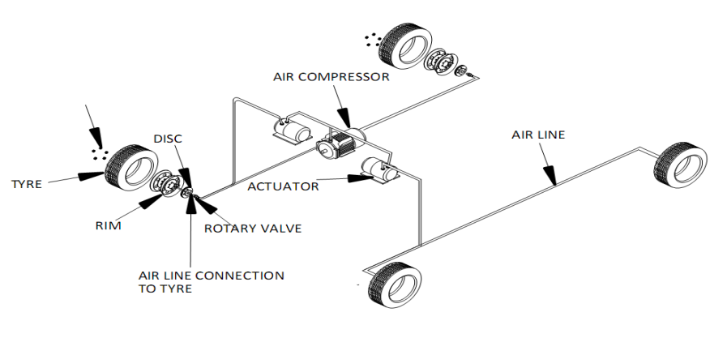
Figure 1: Schematic diagram of the tyre pressure control unit.

2. Design for the major components of the unit
2.1 Design of diaphragm tyre pressure sensor
The sensor was designed and calibrated for 0 to 4.50 bar static pressure variations. The output voltage per volt of excitation for the sensor (B₀) was designed with the aid of equation (1) and the detail discussed elsewhere (Mohapatra, 2011).

$B_{0}=\frac{\left(0.82\right)PR_{d}^{2}(1-V^{2})}{Et_{d}^{2}}$ (1)
where P, $R_{d}$, V, E and $t_{d}$ are the maximum pressure (bar), radius of diaphragm (m), Poisson’s ratio, Young modulus (N/m) and diaphragm thickness (m), respectively.
2.2. Diaphragm deflection

Sensor output is determined from the center deflection ${(D}_{c})$of the diaphragm as expressed by equation (2) and reported by Mohapatra (2011). For perfect linearity condition the deflection $D_{c}<\frac{t_{d}}{4}$ at maximum pressure where $D_{c}≤t_{d}$.
$D_{c}=\frac{3PR_{d}^{4}(1-V^{2})}{16Et_{d}^{3}}$ (2)

2.3 Air compressor

The air compressor which is always on a standby mode is triggered to inflate the tyre by the microcontroller. The volume of pressurized air supplied by the compressor to inflate the tyres is calculated using equation (3) in line with the method used by Rashidi et al (2013).When the maximum air pressure is attained as sensed by the pressure sensor the air supply from the compressor is stopped.

$V_{pa}=V_{ta}*\frac{{Max}_{ap}-{Min}_{ap}}{A_{p}}$ (3)

where${ Max}_{ap}$, ${Max}_{ap}$, $A_{p}$ are the maximum air pressure of the tyres (bar), minimum air pressure of the tyre (bar) and atmosphere pressure (bar) while $V_{pa}$ and $V_{ta}$ are the required pressurized air volume to inflating all the tyres (m³) and total air volume in the tyre (m³), respectively.

2.4 Rotary valves

The rotary valves inflate the tyres with the help of the solenoid valves attached to it. The valves which are connected to the centre of the external rim of the tyres move independently of the tyres.

2.5 Design of microcontroller
This design employed programmable intelligence computer, PIC16f876a, which serves as the brain of the unit. It is an intelligent system that is capable of monitoring an event and taking a decision based on the data gathered. It monitors four pressure sensors attached to the micro inputs. The pressure sensor was made of spongy foam doped with resistor properties. When the sensor is depressed the resistance of the probe decreases. A software program was written and embedded in the microcontroller which counts the number of pulses in the pressure sensor. The 4mhz crystals provides the operating speed for the microcontroller.

2.6 Actuator
The unit consists of four relays, the front left, front right, rear left and rear right. When the pressure sensors are not pressed the reading on LCD displays is minimal. As the air supplied to the tyre begins to saturate, the return pressure begins to act on the sensors. This pressure on the sensors causes the resistance of the input to the microcontroller to alter in accordance with the level of pressure experienced by the sensors. All sides of the input to the microcontroller have equal priority that provided operating speed to the microcontroller. The side that experiences the level of pressure that was calibrated to be the ideal pressure for the tyre stops the air pumped into the tyre. On the other hand, any tyre that experiences reduction in the air that is in it short of the programmable ideal level gets pumped till the ideal pressure level is attained. The opening and closing of the actuator are done by the opening and closing of the relay attached to both sides of the tyre.

2.7 Development of the models for energy and inflation time

The energy (W) and inflation time ($t_{s}$) vs. inflation pressure$(d_{ps}$) required to inflate R16 tyre size at zero nominal pressure were expressed by equations (4) and (5), respectively.

$W=-β_{1 }{d_{ps}}^{2}+β_{2}d_{ps}-β_{3 }$ (4)

$t_{s}={-β}_{4 }{d_{ps}}^{3}+β_{5 }{d_{ps}}^{2}+β_{6}d_{ps}+β_{7}$ (5)

The W and${ t}_{s}$ vs. $d_{ps}$ required to inflate R15 tyre size at zero nominal pressure were correlated with the equations (6) and (7), respectively.

$$W= β_{8}d_{ps}-β_{9} (6)$$

$$t_{s}=β_{10}d_{ps}-β_{11} (7)$$

The W and$t_{s}$ as a $d_{ps}$ required to inflate R15 tyre size at zero nominal pressure were correlated with the equations (8) and (9), respectively.

$$W=-β_{12 }{d_{ps}}^{2}+β_{13}d_{ps}{+β}_{14} (8)$$
$t_{s}= β_{15 }{d_{ps}}^{2}+β_{16}d_{ps}+β_{17}$ (9)

3. RESULTS AND DISCUSSION
3.1 Principal units of tyre pressure control unit
The tyre pressure control unit developed is done with the designed parameters highlighted in Table 1. Components were assembled according to functions.
Table 1. Design of principal unit of trye pressure
Key units of tyre control unit | Value
Output voltage${ B}_{0}$ | 2m V/V
Diaphragm deflection$D_{c}$  Required pressurized air volume to inflate all the tyres$V_{pa}$ | 0.31346cm  180m³
Power required  Diameter of hose (mm)  Compressor capacity | 115.31W  1.27cm  20.7bar

3.2 Correlation developed for Energy and inflation time of tyre control unit
Correlations developed for energy ($W_{s }$) and inflation time ($t_{s }$) (See Figures 2 to 4) presented in Table 2. As noticed in the curves, varying ranges of inflation pressure (dp_{s}) has slight impact on the $W_{s }$ and $t_{s }$ of the fabricated tyre control unit

Table 2: Correlation between energy and inflation time vs. inflation pressure
Relations | Model equations | Tyre types | R²
Energy-inflation pressure | $$W_{S}=-4.3599{d_{ps}}^{2}+50.448d_{ps}-10.35$$ | R16 | 0.9954
Inflation time-inflation pressure | $t_{S}=-5.7539{d_{ps}}^{3}$ +28.59${d_{ps}}^{2}$ +31.313$d_{ps}$ +20.6 | R16 | 0.9908
Energy-inflation pressure | $$W_{S}=40.156d_{ps}-0.2$$ | R15 | 1
Inflation time-inflation pressure | $$t_{S}=120.35d_{ps}-0.266$$ | R15 | 1
Energy-inflation pressure | $$W_{S}=0.2783{d_{ps}}^{2}+27.708d_{ps}+0.95$$ | R13 | 0.9996
Inflation time-inflation pressure | $$t_{S}=0.525{d_{ps}}^{2}+84.002d_{ps}+2.6167$$ | R13 | 0.9998

Variations in the $W_{s }$and $t_{s }$ vs. dp_{s} for the control unit of R16 tyre are depicted in Fig. 2. As observed, the $W_{s }$ and $t_{s }$ values of the unit increased and varied between 10 and 111 J and 30 and 233 s as the dp_{s} increased from 0.35 to 3.5 bar, respectively. The quadratic equation such as ($-4.3599{d_{ps}}^{2}+50.448d_{ps}-10.35$) and polynomial equation ($-5.7539{d_{ps}}^{3}$ +28.59${d_{ps}}^{2}$ +31.313$d_{ps}$ +20.6) are detected suitable for the changes of $W_{s }$ and $t_{s }$ vs. dp_{s} because of high regression coefficient (R²) of 0.9954 and 0.9908, respectively.
In a similar research work on tyre, Rashidi et al. [19] established a regression coefficient of 0.986 for three-model linear regression in their studies of prediction of bias-ply tyre deflection based on contact area index, inflation pressure and vertical load.

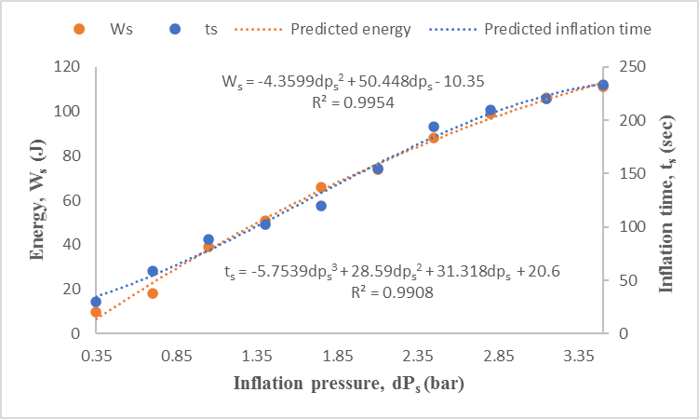
Figure 2: Predicted inflation time and energy vs. Inflation pressure for R13 tyre
Changes in the $W_{s }$ and $t_{s }$ vs. dp_{s} for the control unit of R15 tyre are portrayed in Figure 3. As detected, the $W_{s }$ and $t_{s }$ values of the unit increased and varied between 14 and 141 J and 42 and 423 s as the dp_{s} increased from 0.35 to 3.5 bar, respectively. The linear equations such as ($120.35d_{ps}-0.2667$) and (40.156$d_{ps}$-0.2) are detected suitable for the changes of $W_{s }$ and $t_{s }$ vs. dp_{s} because of R² of 1.0 for the model.
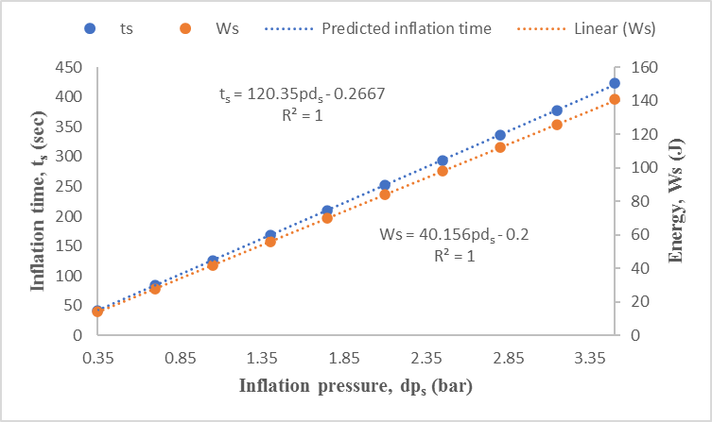
Figure 3: Predicted inflation time and energy vs. Inflation pressure for R15 tyre

Variation in the $W_{s }$ and $t_{s }$ vs. dp_{s} for the control unit of R13 tyre are shown in Fig. 4. As shown, $W_{s }$ and $t_{s }$ values of the unit increased and varied between 11 and 101 J and 33 and 302s as the dp_{s} increased from 0.35 to 3.5 bar, respectively. The quadratic equations such as ($0.2783{d_{ps}}^{2}+27.708d_{ps}+0.95$) and (0.5257${d_{ps}}^{2}$ +84.02$d_{ps}$ +2.6167) are confirmed adequate for the changes of $W_{s }$ and $t_{s }$ vs. dp_{s} because of high R² of 0.996 and 0.9998, respectively.
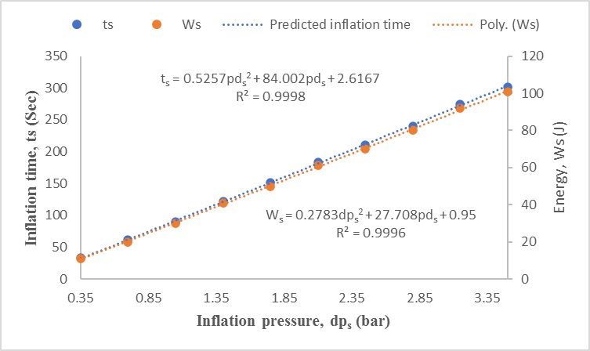
Figure 4: Predicted inflation time and energy vs. Inflation pressure for R13 tyre

CONCLUSION

The regression models developed can be used to predict the inflation time and energy requirement thus the behaviour of automatic tyre pressure control unit. This can be very useful to the researchers and designers in the field of tyre pressure control systems. However, it is recommended that more work should be done on tyre pressure control system technology using other modeling methods such as computer simulations and predictions.

REFERENCE
Kubba AE, Jiang KA. (2011) Comprehensive Study on Technologies of Tyre Monitoring System and Possible Energy Solutions. United States of America Open Access Sensors Journal, pp.12-19.
Gillespie TD. (1992). Fundamental of vehicle dynamics. Penysylvannia, PA, USA International Journal of Society of Automative engineers, 2(2): 137-139
Mushiri T, Allan T, Mbohwa C. (2016) Design of an automatic tyre pressure inflation system for small vehicles. Proceedings of the 2016 International Conference on Industrial Engineering and Operation Management, Detroit, Michigan, USA, September 23-25, 2016.
Matusko J, Petrovic I, Pevic N. (2008) Neural Network Based Tyre/Road. Friction Force Estimation. Journal of Engineering Applications of Artificial intelligence, 3(21): 442-456.
Simango D, Musaidzi H, Rangi BP, Mlambo P, Muvunzi R.(2017). Design of a real time tyre pressure monitoring system. 11th Zimbabwe International Research Symposium, Harare.
Barber TE, Remer SY, Sandlass GS, Maki A. (2004) Predicting Tyre Handling Performance Using Neural Network models. SAE Technical Paper: 01-1574.
Yang X, Behrooz M, Olatunbosun OA. (2014). A neutral network approach to predicting car tyre micro-scale and macro-scale behavior. Journal of intelligent learning system and applications, 6:11-20.
Ivanov V, Shyrokau B, Augsburg K, Gramstat S. (2010b). Advancement of vehicle dynamics control with monitoring the tyre rolling environment.SAE International Journal of Passenger Cars-Mechanical System, 3(1):198-216.
Gosh P. (2007). Optimization of tyre design parameters through finite element analysis and correlation with performance. SAE Technical Paper, 26043.
Kayisoglu B, Engin Y, Dalmis IS, Akdemir B, Bayhan Y, Kullukcu A. (2014) Developing an Automatic Tyre Pressure Control System To Improve the Tractive Efficiency of Tractors. Journal of Agricultural Machinery Science, 10 (3): 253-259.
Amosun ST. (2016) Development of a tyre pressure contol unit. Unpublished Ph.D thesis, Abeokuta, Nigeria.
Krivtsov VV. Tananko DE, Davis TP. (2002). Regression approach to tire reliability analysis. Journal of Reliability Engineering and System Safety,78 (3): 267-273.
Schjønning P, Lamandé M, Tøgersen FA, Arvidsson J, Keller T. (2008). Modelling effects of tyre inflation pressure on the stress distribution near the soil–tyre interface. Journal of Biosystems Engineering, 99 (1):119-133.
Pelc J. (2007). Towards realistic simulation of deformation and stresses in pneumatic tyres. Journal of Applied Mathematical Modeling 2007; 31: 530-540.
Mohapatra AG. (2011). Design and implementation of diaphragm tyre pressure sensor in a direct tyre pressure monitoring system for automotive safety application International Journal of Engineering Science and Technology 2011; 8(3): 6514-6524.
Rashidi M, Azadeh S, Fatehirad P, Emadi SM, Lofti-Aski A. (2013). Prediction of bias-ply tyre deflection based on contact area index, inflation pressure and vertical load using linear regression model. Journal of World Applied Science, 911-918.

