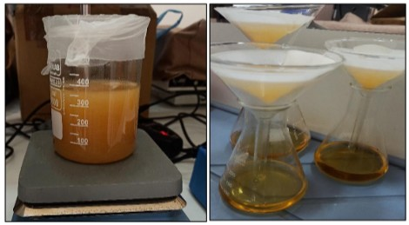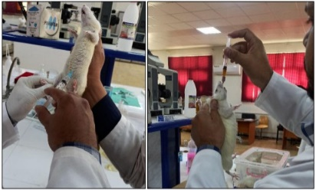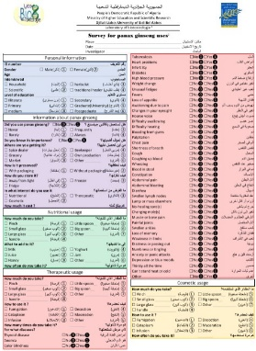
Ethnobotanical survey
Antioxidant activity
in vitro
Analgesic activity
in vivo
Study design
Nutritionnel usage
Cosmeceutical usage
Therapeutic usage
Information about panax ginseng
Panax ginseng collection and Extract preparation
in vitro
Personal information
Figure 1: Study design
Figure 2. abdominal constriction induced by injection of 0.6% acetic acid
Figure 3. Repartition of interrogated people according to their knowledge of the panax ginseng importance.

Figure 4. Repartition of interrogated people according to their panax ginseng usage

Yes: panax ginseng is used for the treatment, No: panax ginseng is not used for the treatment

Figure 5. Therapeutic usage of panax ginseng

Bars with different letters are significantly different (p<0.05).
Figure 6. Analgesic effect of panax ginseng extracts by injection of acetic acid.

