Edge detection of lithological structures Using Analytical Signal Technique on gravity data; A case of Gombe arm of Benue Trough
ABSTRACT
The boundaries between the different litho-structures in the Gombe arm of Benue trough were delineated by interpreting gravity data of the study area using the Analytical signal method. This helped to reveal the potentials in the area. The bouguer and analytical signal maps of the area were produced to show the distribution of the anomalies in the study area. The method displays the gravity anomalies of an area through the amplitudes of the directional analytic signals. The study area showed high anomalies in the northeastern part and southern part of the study area i.e. Dukku and Akko, which was attributed to the presence of metamorphic rocks which caused positive anomalies and sedimentary rocks in the areas which caused the negative anomalies.
Key words: Edge detection, Lithological structure, gravity data, Analytical signal.
INTRODUCTION
The Gombe arm of Gongola Basin (Benue trough) is located between Chad basin (Sedimentary) and Benue trough (Basement complex). It is rich in so many geological structures. Edges or boundaries between structures that have different lithological structure is a place where scientific research has revealed that it has the potential to contain most of the mineralized deposits. This makes edge detection very significant around such places.
Gravity surveying is a potential field method because it uses a natural source. No external agent or energy source is required in conducting the measurement (Bello and Kaila, 2020). Gravity method of geophysical prospecting is one of the most effective non-destructive and non-invasive techniques of mapping the properties of the earth subsurface for diverse economic and environmental applications (Alhassan et al., 2021). Gravity method takes into consideration the correlation between the discrepancies in the local acceleration due to gravity with the density of the materials located at the earth subsurface. It is used widely for large-scale crustal studies such as mapping variations in subsurface rocks densities (Sultan, 2009); (El-Bohoty, 2012); (Mandal, 2013); (Biswas A, 2014). It is also used for mapping basement topography and study of the structure and mapping of the sedimentary basin (Okpoli and Akingboye, 2019), investigation of regional groundwater in crystalline rock. Other applications include environmental and engineering investigations, among others, Gravity inter- pretations are aimed at delineating the subsurface litho-structures and other features such as amplitude, shape, frequency and closure of the gravity anomalies from bouguer anomaly, residual and regional maps/proﬁles and numerous enhancement maps (Okpoli and Akingboye, 2019).
Satellite gravity data are found useful and helpful. Data acquisition is easier compared to land gravity survey and it takes small time to map a large area of land. Satellite gravity data made is available for researches and surveys by important bodies such as NASA and Bureau Gravimetric International (BGI). Many researches that require the use of gravity data now employs satellite gravity data (Bello and Kaila, 2020); (Alhassan et al, 2021). Analytical signal Method was used on Gravity data by many scholars like Bello and Kaila ( 2020) that applied AS on satellite gravity data of Dutse. Okpoli and Akingboye (2019) studied litho-structure and depth around Igabi area, Northwestern Nigeria using high-resolution gravity data. Musa (Musa, 2021) applied Analytic Signal Depth on High Resolution Aeromagnetic Data over the Gongola Basin Upper Benue Trough Northeastern Nigeria.
This work is aimed at interpreting gravity data Using Analytical Signal technique to delineate subsurface lithological structures and Detect edges of gravity sources based on density contrasts of subsurface rocks in the study area. Analytic signal method was used on satellite gravity data obtained from National Aeronautics and Space Administration (NASA). The work only revealed the gravity/density contrast and edges of anomaly sources. It is so special as it is the first time satellite gravity data of Gombe was used using AS method for edge detection and yet gave a fruitful result. The edge location will serve as a hint to other surveyors that are interested in locating portions that have economic values within the study area.
The study area
The study covers Gombe town and its surroundings which lie between the latitudes 9º 30΄ and 12⁰ 30΄N and longitudes 8º 45΄and 11º 45΄E on the sub –Sudan savanna region of the country at the north east of river Benue and east of Yankari Game Reserve (Ikusemoran Mayomi, Didams Gideon and Michael Abashiya, 2018). It covers area of 20,265 km². Gombe is situated on the eastern border of Bauchi, northwestern border of Adamawa state, northwestern border of Taraba state, West of Borno state and southwest of Yobe state. Gombe has an approximate altitude between 400m to 500m above mean sea level. The topography consists of mountains and undulating hills (southern and central parts) and open plains (northern part of the state) (Ikusemoran et al., 2018). Figure 1 shows the towns across the state obtained from google.

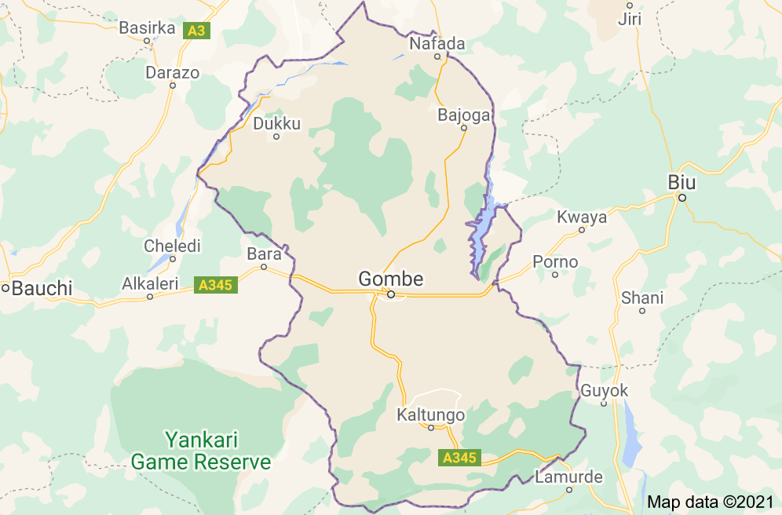
Fig 1. Map of the study area (Google maps).
Analytical Signal (AS) Method
The magnitude of the analytic signals (AS) of potential field data in the x, y, and z directions is defined by equation (1) (Iduma, 2018)
│AS│ =$\sqrt{{\left(\frac{∂g}{∂x}\right)}^{2}+{\left(\frac{∂g}{∂y}\right)}^{2}{+\left(\frac{∂g}{∂z}\right)}^{2}}$ (1)
𝜕g⁄𝜕𝑧 is the vertical gradient of the gravity values. The vertical gradient is the ratio of the difference of the values of the recorded gravity vector at a point on two different vertical positions to the spatial separation between the two points.
gravitational potential 𝑈 is related to acceleration due to gravity g by expression in equation (2)
𝑔 = −∇𝑈 (2)
which obeys Laplace equation. Laplace equation is given in equation (3)
∇² U = ∇. ∇U = -$(\frac{∂g}{∂x}+ \frac{∂g}{∂y}+ \frac{∂g}{∂z}$) = 0 (3)
which will help in getting the vertical gradient expressed in equation (4)
$\frac{∂g }{∂z}= -\left(\frac{∂g}{∂x}+ \frac{∂g}{∂y}\right)$ (4)
(Iduma, 2018)
Thus the amplitude of the AS was computed based on the combination of the three orthogonal gradients of the gravity values. The plot of the amplitude of AS over a geologic contact is a Gaussian-shaped symmetric function with maximum occurring directly over the top of the contact and width directly related to the depth of the contact (Bello and Kaila, 2020). The amplitude of the analytic signal is expressed by the vector addition of the vertical and horizontal components of the derivative of the gravity values.
The magnitude of AS is utilized for estimation of shape and horizontal depth of the anomaly. The amplitude of AS is maximum over the source of anomaly which makes it easy to detect near-vertical subsurface contacts or faults with significant density contrast by mapping the maxima which are located directly over the boundaries of the contact.
MATERIALS AND METHOD
The materials used include Microsoft excel software, Surfer software, Satellite Gravity data and Google map.
The airborne gravity dataset of the study area was acquired from the National Aeronautics and Space Administration (NASA)’s Gravity Recovery and Climate Experiment (GRACE) website and processed using the analytic signal (AS) for edge detection and resolution of physical features of the subsurface topography. The data was collected from NASA in their TOPEX website. It was downloaded as PDF file and then converted to excel file. It appears in three columns as x, y and z representing longitude, latitude and bouguer data respectively.
The derivatives dg/dx, dg/dy where calculated in excel software where x is longitude, y is latitude and g is bouguer data. The vertical component dg/dz was then obtained using the relation in equation. These values were used to calculate the analytical signal values using the relation in equation (1). The values of bouguer anomaly were used to obtain the bouguer grid and subsequently the bouguer contour map in surfer software. Likewise, the analytical signal values were gridded then the AS map was plotted in the surfer software.
RESULTS AND DISCUSSION:
After the data acquisition, analytic signal (AS) was then applied on the data for characterization of physical features of the subsurface topography. All those actions were carried out on Surfer and Excel softwares.
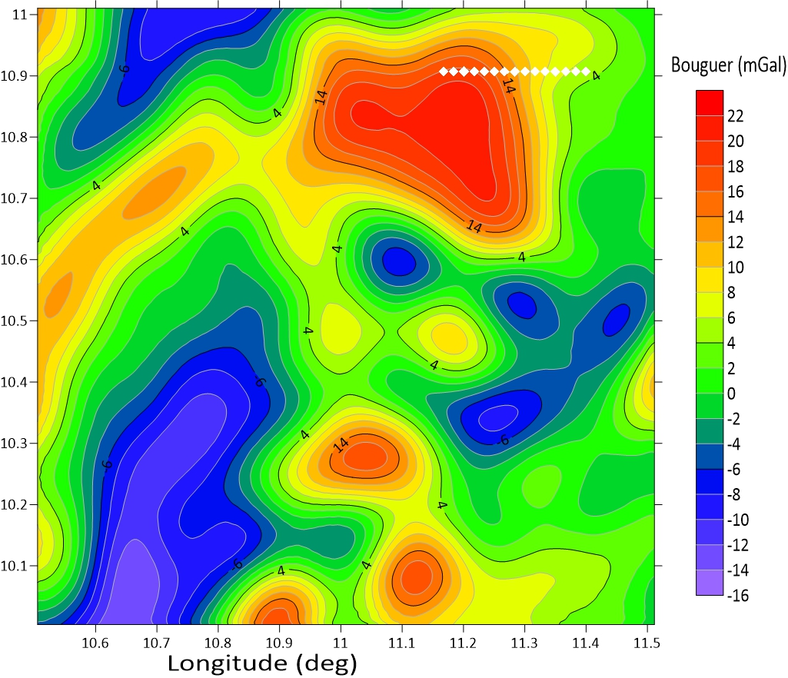
Latitude (deg)
Figure 2: Bouguer map of the study area.

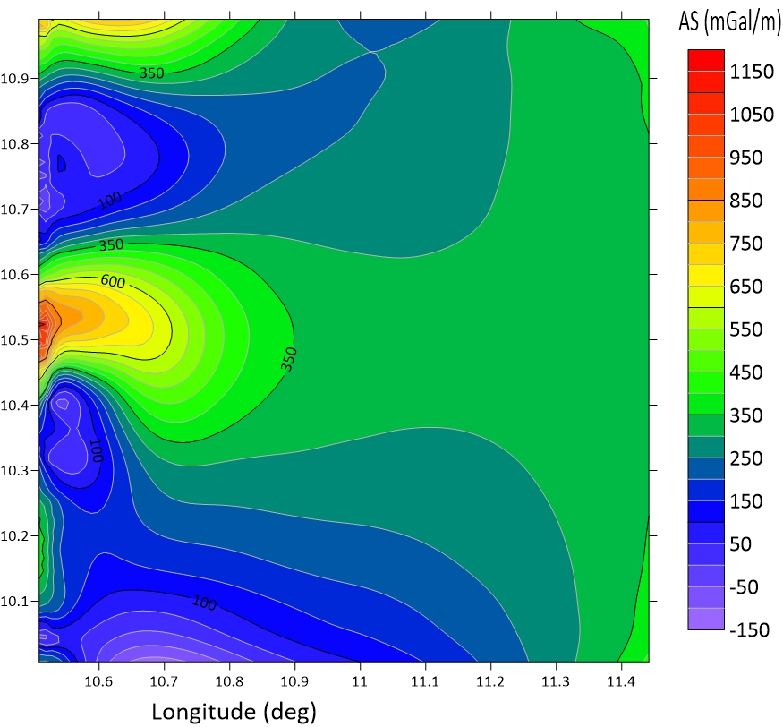
Figure 3: Analytical signal map of the area
Figure 2 shows the distribution of gravity anomalies. It shows the areas of low anomaly and high anomaly. The highest anomalous positions can be observed in the north eastern part of the map and some southern part of the map that have red colors. Most of the high readings were observed in the southern parts of Nafada Local government area with the reading ranging from 14-22mGal, which could be attributed to intrusion of dense metamorphic rocks.
The Low gravity anomalies are observed in the north-west with its minimum value appearing in the south-west which covered the southern part of Dukku LGA and Akko LGA. This suggests the existence of sedimentary rocks which are low in density, since sedimentary rocks are characterized by low density values. Negative bouguer anomaly amplitude result is owed to the mountainous regions, where the survey was carried out; thereby reducing out the attraction of the mountainous mass.
Maximum AS occurs directly over the top of the contact. The northwest region of Dukku LGA displays higher analytic signal amplitude (1150mGal/m) than the sources at mid-western part of the analytical signal map in Figure 3. High amplitude regions are likely occupied by denser biotite granitic and gneissic rocks. The lowest amplitude can be observed at south-western part of the map which covers Akko area and some parts of Dukku LGA. Low amplitude regions are probably dominated by migmatites, schistose, less dense felsic rocks (por- phyritic granites) and fractures.
The analytic signal filter has been used for edge detection of gravity bodies and to generate a maximum value directly over the causative body. The edge is where we have zero values of Analytical signal which can be observed around latitude 10.6 and longitude 10.8 that is located at the north western part of the map in figure 3.

CONCLUSION
Analytical signal method was used to enhance weaker local anomalies, defining the edges of geologically anomalous density distributions and to identify geologic units. The anomalies observed in the study area reveal the presence of mineralized zones, sub-surface rocks, mountainous rocks which were evenly distributed in the study area.
The generated maps can serve as spotlight for further exploration of mineralized zones in the study area which could be substantiated by core drilling. Aero radiometric survey, ground follow-up and geo- chemical surveys should be carried out in the study area to quantify the extent of other mineralization and viable economic minerals hosted in the delineated mineralized zones.
COMPETING INTERESTS
The authors declare that there is no competing interest.
ACKNOWLEDGEMENTS
We acknowledge the effort of NASA for making the data used available.

REFERENCES
Ahmad Alhassan, Bello Yusuf Idi, M Maharaz Nasir, Nuraddeen Usman, Abdullahi Hussaini, Nasiru Bala, Auwal Ibrahim, Nasiru Yakubu, Ibrahim Ayuba. (2021). Detection of lithological boundaries using second order vertical derivatives of aerogravity data; a case of Hadejia segment of the Chad basin, Jigawa state Nigeria. Bima Journal of Science and Technology, 5(2).
Ahmad Alhassan, Bello Yusuf Idi, Maharaz M Nasir, Auwal Aliyu, Yusuf Abdulhameed, Nasiru Bala, Abdullahi Hussaini. (2021). Interpretation of Gravity Data of Hadejia and Its Environs Using Tilt Angle Derivative Method. Dutse Journal of Pure and Applied Sciences (DUJOPAS), 7(4b), 48-56.
Bello Yusuf Idi and Kaila Yusuf Baban. (2020). Application of Aero Gravimetry for Litho Structural and Depth Characterization of Greater Dutse, Jigawa State, Nigeria. Dutse Journal of Pure and Applied Sciences (DUJOPAS), Vol. 6 No. 3.
Biswas A, M. A. (2014). Delineation of subsurface structure using self-potential, gravity and resistivity surveys from South Purulia Shear Zone, India. Implication to Uranium Mineralization Interpretation. . Int J Geo, 2(2):103.
El-Bohoty M, B. L. (2012). Comparative study between the structural and tectonic situation of southern Sinai, and red sea, Egypt, as deduced from magnetic, gravity, and seismic data. . National Res Inst Astron Geophys. 42(2): , 357–388.
Iduma, I. S. (2018). Structural Interpretation of Northern Sokoto Basin, Using Airborne Magnetic Data. International Journal of Innovative Research in Science, Engineering and Technology, 2347-6710.
Ikusemoran Mayomi, Didams Gideon and Michael Abashiya. (2018). Analysis of the Spatial Distribution of Geology and Pedologic Formations in Gombe State, North Eastern Nigeria. Journal of Geography and Geology, 10(1).
Mandal, A. B. (2013). Geophysical anomalies associated with uranium mineralization from Beldih mine, South Purulia Shear Zone, India. J Geol Soc India. 82(6), 601–606.
Musa H., B. N. (2021). Analytic Signal Depth from High Resolution Aeromagnetic Data over the Gongola Basin Upper Benue Trough Northeastern Nigeria.
Okpoli C. C. and Akingboye A. (2019). Application of high-resolution gravity data for litho-structural and depth characterization around Igabi area, Northwestern Nigeria. NRIAG Journal of Astronomy and Geophysics, 8(1), 231-241. doi:DOI:10.1080/20909977.2019.1
Sultan, S. A. (2009). Geophysical measurements for subsurface mapping and groundwater exploration at the central part of the Sinai Peninsula, Egypt. . The Arabian J Sci Eng. 34(1A):17.

