EVALUATION OF DECOMPOSITION RATES AND PATTERNS BETWEEN HOUSED AND OPEN EARTH SURFACE OF PORCINE CARRIONS IN A TROPICAL CLIMATE OF NORTHERN CROSS RIVER STATE, NIGERIA.
Michael E. Nandi* Eric M. Mobu
Department of Anatomy and Forensic Anthropology, Faculty of Basic Medical Sciences, Cross River University of Technology, Okuku Campus, Nigeria.
enandi15@gmail.com, mobueric@gmail.com

ABSTRACT

The assessment of the rate and pattern of decomposition is a basic tool in the investigation of crimes involving death and in forensic practice around the globe. This study is aimed at assessing the pattern of decomposition of porcine carrions in housed and open earth surface environments. This study involved two pigs (sus scrofa domestica) weighing 18kg and 19kg respectively. Both pigs were sacrificed by strangulation, one kept in open earth surface and the second kept in a cemented, roofed and highly ventilated room. This research lasted for a period of thirty (30) days. Rectal temperatures were taken on both carrions before and after death to determine algor mortis. Subsequently, the rectal and ambient temperature checks were done periodically at ten (10) minutes interval for the first 2hrs, followed by thirty (30) minutes duration for another 6hours of the observational period designed for the first day of sacrifice. From day 2 to day 14, the research site was visited three times daily and from day 15 to day 30, the visits reduced to twice daily for evaluation of total body score, retrieval of insects’ present and recording of the ambient temperature for both carrions. The carrions were secured from scavengers using wire mesh cages. This results showed that early postmortem changes were observed at different intervals with different temperatures recorded for both carrions. According to the results of the total body score (TBS), the housed carrion decomposed 3 times faster than that earth surface carrion even though both carrions were exposed to similar insects colonies at different stages of decomposition. Therefore, investigations of clandestine modes of death to predict postmortem interval and the quantification of the rate of decay can be accurately handled once the depositional environment of the carcass is considered.

KEY WORDS: Housed, Decomposition timeline, Open Earth Surface carrion, Strangled carrion, Total Body Score (TBS) and Accumulated Degree Days (ADD).

INTRODUCTION
Determination of post-mortem interval (PMI) of remains is a necessary part in death investigations (Campobasso et al., 2001; Mann et al., 1990). Effective estimation of post-mortem interval requires knowledge of the local factors that influences decomposition, these factors includes temperature, humidity, wind movement or velocity etc. processes (Mann et al., 1990). Many researches have utilized test subjects ranging from pigs, dogs Reed (1958), toads Cornaby, (1974) and in ideal situations, humans (Rodriguez and Bass 1985). The results from these investigations have indicated that micro-level studies, specific location and depositional environments studies are necessary to accurately assess post-mortem interval.
Decomposition process begins immediately following death when there is loss of innervations, respiration and circulation, but the rate at which these processes occurs and the stages that it involves vary due to numerous intrinsic and extrinsic factors (Maris-werner et al., 2018). Local investigations into the rate of decomposition thus provide an important component to forensic investigations relying on accurate PMI estimates, (Shean et al., 1993). Building upon previous research, this study will examine decomposition pattern of shaded and exposed (sunlight) porcine carrion. Decomposition rates can vary drastically between two locations (or microenvironments) because the climatological factors that influence the rates are environment-specific Shean et al., (1993). Many researchers have conducted decomposition studies in several geographic regions across the globe, yet taphonomic and entomological information derived from these studies is not applicable to all locations, nor have the data identified universally constants for determining the post-mortem interval/ decomposition pattern in any given situation. (Galloway 1997; Manhein 1997; Mann et al., 1990). In response, localized data on Decomposition rates have been studied to provide a better understanding of the decomposition processes.
In addition to insects’ visitation, several events, both macroscopic and microscopic, that take place immediately following the death of an individual can be used for PMI assessment. The macro level includes the processes of the four physical signs seen after death, which are headlined as autolytic processes. Autolysis and putrefaction. Autolysis simply refers to the breakdown of cells by the enzymes within them (Dix and Graham 2000). No bacteria are involved in autolysis. This autolytic stages includes; Pallor, Algor, Livor, and rigor mortis.
Algor mortis is the cooling of the body after death the rate of which (approximately 1.5 degrees F per hour) can be used as an indication of PMI (Dix and Graham, 2000). Algor mortis however, is only reliable up to 24 hours after death. Another process occurs after the heart has stopped pumping blood throughout the body, gravity causes the blood to pool or settle into the lowest parts of the body. This process and subsequent purple discoloration are known as Livor mortis or lividity. Lividity becomes fixed at approximately eight to ten hours after death, and thus can be used as a tool in estimating the post-mortem interval of the remains, but only up to the time it becomes fixed (Merkeley 1957; Dix and Graham 2000).
Rigor mortis, rigidity or contraction of muscles, from the smaller muscles to bigger ones also begins within hours after death. This rigidity results from an abundance of lactic acid resulting from the chemical breakdown of adenosine triphosphate (ATP) in the muscles. This post-mortem change can also be used to determine PMI as it occurs and dissipates at a known interval: begins one to three hours after death and dispels 24 to 36 hours after death. It is not known to be a useful indicator of time since death after 36 hours (Merkeley 1957; Dix and Graham 2000).
Putrefaction also begins immediately after death and is caused by the activity of both enzymes and anaerobic bacteria in the gut (Dix and Graham 2000). After death, aerobic microorganisms consume the available oxygen left in the intestines, which makes the conditions more favourable for anaerobic species of bacteria to proliferate and digest tissues (Merkeley 1975; Dix and Graham 2000). Bacteria similarly play an important role in the late stage of decomposition changes. Bacteria create gases (predominantly methane) that produce the bloating and swelling associated with early decomposition. Marbling of the skin also occurs when degenerated blood reacts with the hydrogen sulphide produced by the proliferating bacteria. Blood within vessels near the skin’s surface become stained black and give the skin a marbled appearance and leathery limb (Dix and Graham 2000).
The process of decomposition is continual and progressive and cannot be easily broken up into discrete and separate stages. At the same time, researchers continue to discuss decomposition in terms of such stages because they act as a set of standard criteria that facilitate comparison between studies and cases. Researchers have formulated their own series of decomposition stages based on categories that most accurately reflect the sequence of tissue destruction that result from the unique environment in their study area (Galloway et al. 1989; Goff 2000; Reed 1958).
This study promises to observe the decomposition timeline of two domestic pigs (Sus scrofa) in different depositional environments. One carrion will be deposited in a room environment with shade, while the other will be placed in open earth surfaces.

MATERIALS AND METHODS
The study was conducted in University of Cross River State (UNICROSS), Department of Anatomy and Forensic Anthropology Research Facility (DAFARF) in Okuku. In this study, the taphonomy processes of decomposition pattern and the succession of necrophagous insects were observed in domestic Pig (Sus scrofa).
MATERIALS INCLUDE:
- Two domestic Pig (Susscrofa) served as the experimental specimen.
- Metal wire mesh
- Digital camera (HP Photo Smart C935)
- Stethoscope
- Forceps
- Ethanol (70 percent)
- Sample tubes
- Hand gloves
- Nose mask
- Glass rod mercury thermometer
- Sweeping net
- Weighing balance
- Measuring tape
- Stop watch
METHODS
The pig that was used were for this experiment was of sizes of about sixteen weeks old, and their weights was about 18 and 19Kg respectively. The pigs were purchased from a piggery at Okuku market, Yala, Cross River State, Nigeria.
Core/body temperature (rectal temp.), length, and girth measurement around its chest and waist were all recorded using a digital body thermometer and tape respectively. After which the pig was euthanized by strangulation around 11:02AM (Shaded carrion) and (Sunlight carrion) at 12:10pm local time. Death was confirmed by the use of a stethoscope. Immediately after, the animal was baled and taken to the study site. Core body temperature (rectal temp.) again will be taken to calculate accurately Algor mortis (post-mortem decrease in body temperature). These processes of recording Algor mortis were checked routinely in a continuous interval using core and ambient temperatures which was done ten (10) minutes interval for the first two hours of PMI, after which it was followed by thirty (30) minutes of interval for the remaining six (6) hours of interval. The two carrion were deposited on the ground surface (directly under sunlight) and the other shaded area. Both carrions were also protected from vertebrate scavengers with metal wire mesh buried deep inside the earth and the other, in a housed and shade-like environment.
Insects associated with the decomposing pig carrions was collected with blunt forceps or fine arts brush and sweep net for trapping flies. Samples of the insect and their larvae was also collected as well and preserved with 70% buffer solution concentration using the sample tubes, for identification and calculating the time taken for each species of insects that were distinctively unique on each decomposition stage, for the purpose of estimating minimum post-mortem interval (mPMI) of corpse in the region, when such services is legally required. All necrophagous flies, beetles and their larvae were sent to the Department of Zoology, for further analysis. All recordings of this research were kept in the research log book for documentation and retrieval purposes. The experimental study was carried out for a period of thirty (30) days, from March 28 to April 26, 2020. Throughout the experiments the carrion was examined for visible post mortem changes, decomposition rates, following the already established pattern of decomposition, the impact of temperature, temperature were collected at different time, 6:30am, 12:30pm and 6:30ampm on daily basis. Insect succession pattern and its activities were also recorded. The observation of visible post mortem changes was recorded for three regions: head and neck, trunk, and limbs. This however includes observable changes in colour, size, presence of maggots, flies, and other insects, decomposition fluids, changes in skin, and visibility of bone (skelontization).
Method of animal handling and sacrifice
The pigs (sus scrofa domestica) used for the experiment were purchased from a piggery market in Okuku-Yala Local Government Area and were carefully handled by medium of transportation down to the research site in a motorcycle. Both pigs were sacrificed by strangulation and left on two varying depositional environments to decompose for a period thirty (30) days interval.
Method of measuring temperature
Temperatures readings for both core and ambient were taken using a digital thermometer for the first day, which was done by first, taking temperatures of both carrion before death (ante-mortem) which was 39.7ºc and 41.0ºc respectively, followed by an interval of ten (10) minutes for the first two hours after death and then increased to thirty (30) minutes for the next six (6) hours after death. By day, the core temperature of the carrions were no longer reading as the remains temperature had conformed to the atmospheric temperature. The ambient temperature checks were continuously done for the remaining days of this studies, from day 2-14, ambient temperatures were taken three times daily, to get the daily average temperature for both carrions and day 15-30 temperature check was done twice a day to examine the minimum and maximum temperatures for each day.

Method of Insects Collection
Throughout the study duration insects associated with the decomposing pig carrions were collected with blunt forceps or fine arts brush and sweep net for trapping flies. Samples of the insect and their larvae was also collected as well and preserved with 70% buffer solution concentration using the sample tubes, for identification and calculating the time taken for each species of insects that were distinctively unique on each decomposition stage, for the purpose of estimating minimum post-mortem interval (mPMI).
Method of body scoring
Both carrion used in this research were score with a scale of TBS, which was regionally done from Head and Neck, Trunk, and Limbs, to know the stages of decomposition of each carrion, and what is the decomposition rate between the two carrion. This was done thrice daily for the duration of thirty (30) days and were calculated to know the Total Body Score for each carrion and its rate and pattern of decomposition.
Method of Soil sample collection
Soil samples of pre and post were collected for the open earth carrion, to be analysed later to know the effect of the soil on the carrion and the effect of the carrion decomposition island on the soil, as regarding soil pH and minerals.
RESULTS
This research work is a stretch work that lasted for a period of 30 days and close observations to ensure accurate results and less of errors. This research shows the assessment of decomposition pattern between bodies left on open earth and in shaded environment and how factors like temperature, altitude, humidity and insect activities affects the rate of decomposition of this bodies at different environment, climate and temperature condition using TBS scale and ADD as factor in measuring the post mortem interval.
In this study it shows clearly the difference in environment and climate factor as a key determinant for the assessment of decomposition timeline of open earth and shaded environment, also use as forensic marker to show the decomposition rates of bodies left in different crime scene.
Observable changes were seen from this studies between the housed and open earth porcine carrion in comparison between the carrion during the 30 days interval.
Stages of decomposition:
B
A
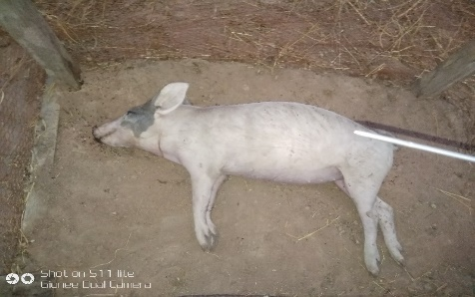
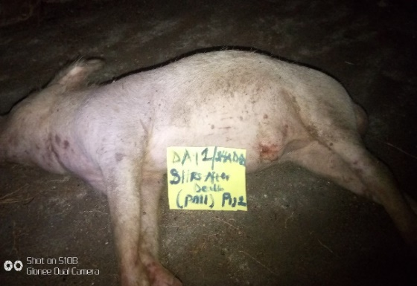
Figure 1A and B: showing the image of housed and open earth surface carrions respectively at day one. Both carrions at fresh stage of decay.
During the first eight (8) hours of PMI, the following observable changes were seen for the housed carrion, onset of pallor mortis at thirty (30) minutes after death, rigor mortis at the limb and trunk, discharge of semen from the carrion, onset of Livor mortis ( purple discoloration of skin) at one hour fifty minutes after death, distension of the scrotal sac, first arrival of blow flies, at the first five hours after death, there was oozing of fluid from the nasal and anal cavities, due to the accumulation of gases and enlargement of the penial region and full rigor mortis was achieve at eight (8) hours of PMI.
The open earth remain was observe with a visible fresh stage of decomposition on Day 1; there was an early onset of rigor in the upper and lower limbs as well as stiffness of the neck and abdominal cavity characterized by enlargement and bloating of those regions. Insect arrival began by 3:10 pm and continued to persist later on to invade the orifices (Ear, nose and rectum where fluid is found) an hour later.

B
A
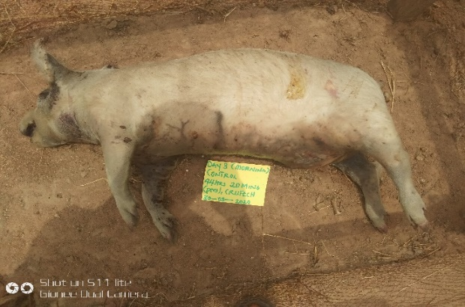
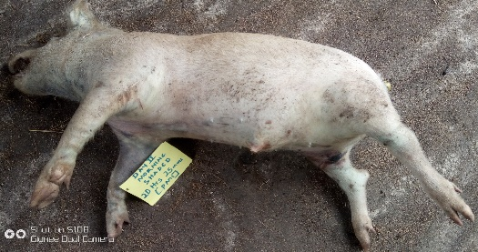
Figure 2A and B Showing carrion at day 2 (bloat stage) of decomposition 20 hours 25 minutes of PMI
At 20 hours of PMI, both carrion shows tremendous changes which include: Increase in total body mass, bloating of the body, characterized by blisters and greenish discoloration of the neck, limbs and abdominal region. Outstretch of limbs, protrusion of the scrotal sac and total lividity (Livor mortis), there was also drastic change in the colour of the tongue, from red to black, marbling of skin, protrusion of the rectum that appears leather-like, increase in flies and insects activities, caving in of the eyes
Open earth remain show increase in insect colonies, warning out of rigor replace by the onset of bloating, discharge of fluid from the eyes, mouth and anal orifices, with greenish discoloration of the inguinal region.
3. active decay stage:
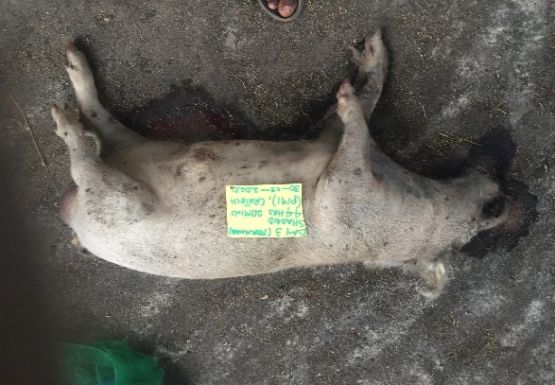
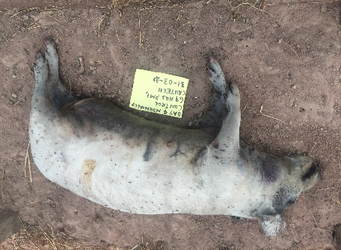

A
B
Figure 3, day 3, A and B Showing carrion at active stage of decomposition for A and B at bloat stage
Day three shows a tremendous change in the housed carrion ranging from bursting out of abdominal content, total collapse of the limb, outburst of carrion leading to purging out of fluid (onset of fresh decay) characterized by massive activity of pupae maggot, increased emergence of CDI carrion decomposition island which causes increased in putrid smell (putrescence and cadaverin) and total slippage of skin and loss of hair, caving in of eyes and neck region, total decomposition of tongue and widening of the mouth.
Open earth carrion there was further distension of abdominal content and inguinal region, carrion turning dark-brown to black, mainly in the head, neck and abdominal region. Protrusion of sag-like appearance, warning of bloating, replace by early onset of fresh decay, characterized by sagging of flesh, desiccation of the anal region, blistering around head and neck region.
B
A
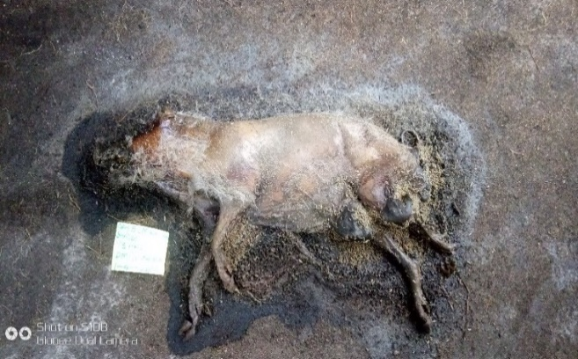
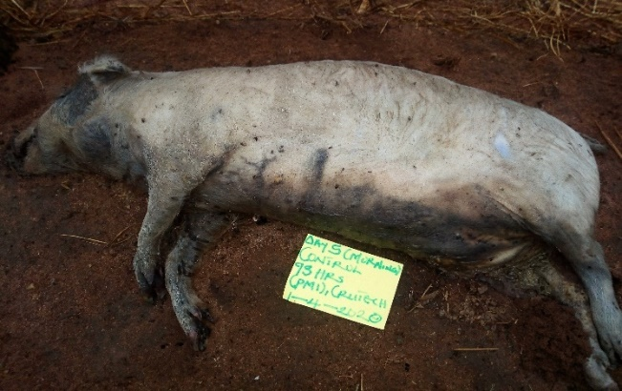
A
B
Figure 4A&B: Showing at advanced decay stage for A and active decay stage for B at day 5 respectively.
Advanced regional decomposition of the forelimb & hind limb characterized by continuous slippage of the hubs from the forelimb, advanced hair loss in the total carrion, increase in bone exposure in the hind limb, and increase in adult maggot activity, complete decay of the tongue, however, they were onset of the formation of adiopocere in the lateral half of the carrion expose to air, increased in carrion decomposition island (CDI), which also was fixed.
Presence of mild putrid smell, further and increase distension of the inguinal region, trunk with total reduction of the carrion in size, slow paste of active decay, skin texture appears leather-like, with gradual onset of adiopocere, sagging of flesh and purging of fluid, with further progress in furtive maggot activity.
5. skeletal stage:
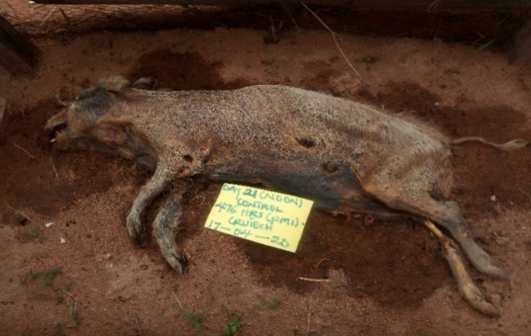
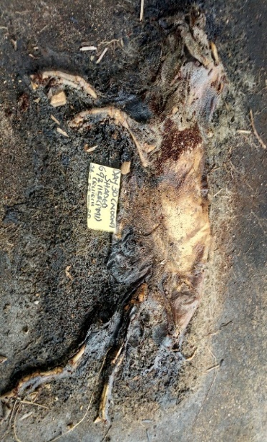
A
B
Figure 5 A&B, Showing skeletonization for carrion A and mummification at advanced decay for carrion B.
Total regional skeletonization of the head, and limbs, progress and breakage of mummified skin, presence of strong putrid smell, and moulds on carrion depict by rainfall, maggot activity, increase in insect activity, skeletonized bones still aligned/ articulated.
Further exfoliation of bones, carrion still retaining some grease, end of advanced decomposition and progress in skeletonization, black discoloration of the abdominal wall, with mild putrid smell.

Table 7: Showing ambient temperature from day 1 to day 30 of shaded carrion
Days | Average temperature | Accumulated Degree Days | Body score | Total body score
1 | 32.9 | 32.9 | H=1,T=1,L=1 | 3
2 | 31.0 | 63.9 | H=7,T=6,L=5 | 18
3 | 33.2 | 97.1 | H=7,T=7,L=6 | 20
4 | 31.8 | 128.9 | H=8,T=7,L=6 | 21
5 | 25.9 | 154.8 | H=8,T=7,L=6 | 21
6 | 28.4 | 183.2 | H=8,T=7,L=7 | 22
7 | 29.5 | 212.7 | H=9,T=8,L=7 | 24
8 | 31 | 243.7 | H=9,T=9,L=7 | 25
9 | 32.3 | 276 | H=9,T=9,L=7 | 25
10 | 30.4 | 306.4 | H=9,T=9,L=7 | 25
11 | 31.5 | 337.9 | H=9,T=9,L=7 | 25
12 | 30.2 | 368.1 | H=9,T=9,L=8 | 26
13 | 35.5 | 403.6 | H=9,T=9,L=8 | 26
14 | 32.5 | 436.1 | H=9,T=9,L=8 | 26
15 | 32.2 | 468.3 | H=9,T=9,L=8 | 26
16 | 30.8 | 499.1 | H=9,T=9,L=8 | 26
17 | 32.5 | 531.6 | H=9,T=9,L=8 | 26
18 | 31.6 | 563.2 | H=11,T=9,L=8 | 28
19 | 32.8 | 596 | H=11,T=10,L=9 | 30
20 | 30.5 | 626.5 | H=11,T=10,L=9 | 30
21 | 30.7 | 657.2 | H=11,T=10,L=9 | 30
22 | 32.7 | 689.9 | H=11,T=10,L=9 | 30
23 | 31.1 | 721 | H=11,T=10,L=9 | 30
24 | 31.1 | 752.1 | H=11,T=10,L=9 | 30
25 | 32.1 | 784.2 | H=11,T=10,L=9 | 30
26 | 32.3 | 816.5 | H=11,T=10,L=9 | 30
27 | 31.6 | 848.1 | H=11,T=10,L=9 | 30
28 | 32.3 | 880.4 | H=12,T=10,L=9 | 31
29 | 30.6 | 911 | H=13,T=11,L=9 | 33
30 | 27.7 | 938.7 | H=13,T==12,L=10 | 35
Table 8: showing the result of ambient temperature from day 1 to day 30 of open earth carrion
Days | Average temperature | ADD | Body score | Total body score
1 | 36.1ºc | 36.1 | H=1,T=1,L=1 | 3
2 | 32.3 ºc | 68.4 | H=6,T=5,L=5 | 16
3 | 31.3 ºc | 99.7 | H=6,T=6,L=5 | 17
4 | 32.1 ºc | 131.8 | H=7,T=6,L=5 | 18
5 | 26.8 ºc | 158.6 | H=7,T=6,L=6 | 19
6 | 27.2 ºc | 185.8 | H=7,T=6,L=6 | 19
7 | 28.8 ºc | 214.6 | H=8,T=6,L=6 | 20
8 | 27.8 ºc | 242.4 | H=8,T=6,L=6 | 20
9 | 31.7 ºc | 274.1 | H=8,T=6,L=6 | 20
10 | 28.8 ºc | 302.9 | H=8,T=6,L=6 | 20
11 | 32.0 ºc | 334.9 | H=8,T=6,L=6 | 20
12 | 25.7 ºc | 360.6 | H=8,T=6,L=6 | 20
13 | 27.2 ºc | 387.8 | H=8,T=6,L=6 | 20
14 | 30.7 ºc | 418.5 | H=8,T=6,L=6 | 20
15 | 28.2 ºc | 446.7 | H=9,T=6,L=7 | 22
16 | 30.8 ºc | 477.5 | H=9,T=6,L=7 | 22
17 | 31.5 ºc | 509.0 | H=9,T=6,L=7 | 22
18 | 30.6 ºc | 539.6 | H=9,T=6,L=7 | 22
19 | 32.0 ºc | 571.6 | H=9,T=6,L=7 | 22
20 | 29.8 ºc | 601.4 | H=9,T=6,L=7 | 22
21 | 30.4 ºc | 631.8 | H=9,T=6,L=7 | 22
22 | 31.3 ºc | 662.9 | H=9,T=6,L=7 | 22
23 | 30.8 ºc | 693.7 | H=9,T=8,L=7 | 24
24 | 31.2 ºc | 724.9 | H=9,T=8,L=7 | 24
25 | 32.2 ºc | 757.1 | H=9,T=8,L=7 | 24
26 | 31.0 ºc | 788.1 | H=9,T=8,L=7 | 24
27 | 31.8 ºc | 819.9 | H=9,T=8,L=7 | 24
28 | 30.8 ºc | 850.7 | H=9,T=8,L=7 | 24
29 | 31.3 ºc | 882 | H=9,T=8,L=7 | 24
30 | 28.3 ºc | 910.3 | H=9,T=8,L=7 | 24

Charts Presentations on Accumulated Degree Days in Correlations to Total Body Score

Graph 1. Showing Accumulated Degree Days vs Total Body Score for Housed carrion

Graph 2. Showing Accumulated Degree Days vs Total Body Score for open earth surface carrion
Charts 11 and 12 show the recordings for ADD and TBS at interval of 30 days. The result above shows a slight difference in accumulated degree days between housed and open earth carrion and a major difference in TBS for housed and open earth carrion respectively.

DISCUSION
The need for the assessment of decomposition pattern is very crucial when it deals with clandestine deaths, and other crime related scenario and temperature, and other factors of decomposition, like humidity, environments, manner of death, and insects play quite a significant role is this assessment. This present study was conducted to show the assessment pattern of decomposition of two domestic pigs (Sus Scrofa) that was kept on shaded and open earth surface and exposed to varying degrees of environmental factors.
The estimation of the post-mortem interval has been a huge boost to law enforcement agents and agency in the speedy resolution of crimes and gives closure to the families of those who have lost loved ones in cases of mass disasters through the identification of comingled albeit unrecognizable bodies. However, little has been done when it comes to the assessment pattern of decomposition which is a more detailed and close observation study and research.
This research work furthermore, will proceed to discuss how to assess the decomposition pattern and post-mortem interval of shaded and open earth carrion and documentations of insect succession patterns as used in this study.
After death and confirmation of the body and placement of the specimen in our anthropology facility, the primary post-mortem changes were immediately observed in patterns. The noticeable changes include; absent of pupillary reflex, rigor of muscle tissues, body temperature began to drop. Lividity was clearly seen to be formed following the pooling of blood in the capillary bed to the more dependent side on which the animal lied. Few hours later, rigor mortis started developing around smaller muscles of the limbs and jaw. From this observation and close study to the pattern of decomposition, the study found out that the use of the Glaister equation in calculating the rate at which the body cools after death was reliable in predicting the PMI. Algor mortis can therefore be used in our environment to estimate PMI. There is a however, a slight limitation to this as the use of Algor mortis as it is only limited to the first 12 hours after death, and a lot of other premortem and peri-mortem factors like ambient temperature, chemicals and diseases as major contributors to the decomposition rate of this porcine carrion, of which both carrions used in this study, were not victims of such, both carrion used were healthy and fit for the experiment. Decomposition patterns are well-studied procedure that occurs for every organism that has died. After death, organisms typically decompose in a particular predictable fashion, though subject to a number of variables which are temperature, humidity, wind, rainfall, regions, etc. This research observed that after the completion of the 30 days study period, the carrion decomposition Although these changes were different in both carrions, the one strangulated and left on open earth surface, decomposed slower, than the one strangulated and placed in a shaded environment. The decomposition stage usually follows in four stages which are fresh, bloat, active decay and dry/skeletal. But during this research it was observed that a later stage surfaced; advanced decay and mummification/skeletal stage. This stage occurred during the transition from the active decay stage to dry/skeletal stage. Therefore, it was observed that, the following stages: Fresh, Bloat, Active Decay, Advanced decay, Mummification/Skeletal and Dry/skeletal, this comparison can be seen from the results above figure 8-24 and table 5-6 and table 7-8 However, this stage discrepancy could be due to factors like increase in temperature which got as high as 40ºC for the housed environment and 35⁰C for open earth carrion during the period of this study as compared to other studies done in different geographical region by (Shattuck, 2009, Sharanowski et al., 2008), Similar to those that have been reported by other authors followed the already established patterns for open earth surface carrion as laid down by several authors (Teo, et al., 2014, Parmod, 2012).
Although little studies have been done on environments and its effects on decomposition. This studies is further explain on the effect of environment and location on decomposing bodies, in this case, the effect of shaded environment and open earth surface as it determine the stages of decomposition and each carrion was affect by environment even though there had same mode and manner of death, the environment in which the body was laid played a key role on its decomposing pattern and assessment of post-mortem interval and how humidity, heat, and temperature acted on both carrion differently in the same geographical region.
However, temperature is not left out, as the key and important aspect/factor in forensic science and also when assessing or estimating the interval of bodies and overall aspect of decomposition.
In this study, it was also observed that, rectal temperature of both carrion, this temperature also known as body temperature or core temperature, and this temperature was observed on shaded and open earth carrion which had a temperature of about 39.7⁰C while alive and 19kg as body weight size, immediately, 10 minutes after death was confirmed with a stethoscope the rectal temperature of the shaded carrion became at about 39.4⁰C, this temperature kept decreasing and slightly increased as time passes by to about 38.5⁰C at 2 hours 30 minutes interval after death and 39.2⁰C at 3 hours 30 minutes interval after death. This however, caused the rapid decomposition of the shaded body as the temperature progressively became almost the same with that of the ambient temperature at 8 hours of PMI to that of the open earth surface carrion that was having a rectal temperature of 41.0⁰C during life and 18kg and an increase of 41.5⁰C 10 minutes after death was confirmed to a degree temperature of 48.2⁰C at 6 hours 30 minutes of interval as the rectal temperature slowly matches that of the ambient temperature.
Furthermore, this parameters mentioned, played a key role to why the two bodies decomposed at a different rate and pace to each other, the shaded environment was seen as a medium to conduct more heat, as the observation of 30 days was carried out with temperature variations, humidity; the amount of water in air and the presence of insects around the carrion and the environment at different stages of decomposition compare to that of the open earth surface carrion.

CONCLUSION
In conclusion, this study is important to forensic anthropologists, entomologists and forensic experts across the world for effective determination and assessment of PMI and bring justice to the legal system. As seen in this research, the effect of depositional environment, location and environment factor like temperature play a vital role in the decomposition rate and pattern in different varying geographical location around the world. Therefore, investigations of clandestine modes of death to predict post-mortem interval and the quantification of the rate of decay can be accurately handled once the depositional environment of the carcass is considered. This study represents a baseline for comparison with future studies. This forensic snapshot serves as only one step in a sequence that can be followed by further and future research. . According to the results of this study present that, the total body score (TBS) scale, the shaded carrion under house-like environment decomposed 3 times faster than that earth surface carrion even though both carrions were exposed to similar insects colonies at different stages of decomposition.

REFERENCES
Campobasso, C. P., Di Vella G., and Introna F. (2001). Factors Affecting Decomposition and Diptera Colonization. Forensic Science International, 120(1-2): 18-27.
Cornaby, B. W. (1974). Carrion Reduction by Animals in Contrasting Tropical Habitats. Biotropica, 6:51-63.
Galloway, A., Birkby, W. H., Jones, A. M., Henry, T.E., and Parks B. O. (1989). Decay Rates of Human Remains in an Aarid Environment. Journal of Forensic Science, 34(3)607-616.

Mann, R. W., Bass, W. M., and Meadows, L. (1990). Time since Death and Decomposition of the Human Body: Variables and Observations in Case and Experimental Field Studies. Journal of Forensic Sciences, 35(1):103-111.

Parmod, K. G. (2012). An Entomological Study to Determine the Time since Death in Cases of Decomposed Bodies. Indian Academic of Forensic Medicine, 34(1)10-12.

Reed Jr., H. B. (1958). A Study of Dog Carcass Communities in Tennessee, with Special Reference to the Insects. American Midland Nation, 59:213-245.

Rodriguez, W. C., and Bass, W.M. (1983). Insect Activity and its Relationship to Decay Rates of Human Cadavers in East Tennessee. Journal Forensic Science, 28:423-432.

Sharanowski, B. J., Walker, E. G., and Anderson, G. S. (2008). Insect Succession and Decomposition Patterns on Shaded and Sunlit Carrion in Saskatchewan in three different Seasons. Forensic Science International, 179(2-3): 219-240.

Shattuck, C. M. (2009). An Analysis of Decomposition Rates on Outdoor Surface Variations in Central Texas. Thesis and Dissertions-Anthropology, Texas State University (unpublished).

Teo, C. H., Hamzah, S. P. A., Khairul, O., Atiah, A. A. G., and Hamzah, N. H., (2013). Postmortem Changes in Relation to Different types of Clothing. Malaysian Journal of Pathology, 35(1): 77-85.

