**TYPE OF ARTICLE:** Original paper on Experimental Research

**TITLE:** The Morphological Pattern of Lip Print in Relation to Nasal Index among Adults of Egba Ethnic Group in Abeokuta, Ogun State, Nigeria.

1Ade .S. Alabi*, 2Oluwatosin .E. Omoge, 3 Suwebat .B. Kareem, 4 Aminant .O. Imamfulani

1Senior Lecturer, Department of Anatomy, Faculty of Basic Medical Sciences, College of Health Sciences, University of Ilorin, Ilorin, Nigeria.

2Graduate of Department of Anatomy, Faculty of Basic Medical Sciences, College of Health Sciences, University of Ilorin, Ilorin, Nigeria.

3Lecturer 1, Department of Anatomy, Faculty of Basic Medical Sciences, College of Health Sciences, University of Ilorin, Ilorin, Nigeria.

4 Lecturer 2, Department of Physiology, Faculty of Basic Medical Sciences, College of Health Sciences, University of Ilorin, Ilorin, Nigeria.

**Author for Correspondence**: **E-mail**: [alabi.as@unilorin.edu.ng](mailto:alabi.as@unilorin.edu.ng)

**Phone No**: +234 803 057 5490

**Postal Address**: Department of Anatomy, University of Ilorin, PMB 1515

**ABSTRACT**

Anthropometry is the measurement of the human body parts and is used in anthropology for classifying people into various races and ethnicity. Cheiloscop**y** is the study of the characteristic patterns of depression and elevations seen on the oral mucosa anatomically. Nasal index serves as an important and useful anthropometric tool used in reconstructive surgeries of nose along with nasal height and breadth. The study was conducted in Abeokuta, Ogun State, Nigeria, among 410 Egba ethnic volunteers (205 males and 205 females) within the age range of 16 – 65 years. Nasal height and width were measured using Digital Sliding Vernier Caliper. The lip print of the subject were collected by gently placing a microscopic glass slide on the lip after a little application of lip gloss, then a carbon black powder was slightly blown on the microscopic glass to make the print visible. The data obtained were analyzed using SPSS version 20.0 software and the statistical significance was put into consideration using one-way Analysis of Variance (ANOVA) when (P ≤ 0.05). The result showed that the predominant lip print pattern of both sexes was Type V which is significantly sexually dimorphic in all quadrants except in the Lower Right Quadrant. The predominant Nasal Index among both sexes was 60.0 which showed predominant nasal morphology to be Leptorrhine. The study revealed no significant variation among the lip print patterns of all types of nasal morphology. This is important in identification of persons in medico-legal cases.

**Keywords**: Cheiloscopy, Nasal Index, Egba, Medico-legal.

**INTRODUCTION**

Every person has certain features that make them radically distinct from others. One such feature is **Lip prints**. Lip prints remain the same throughout life and are uninfluenced by injuries, diseases, or environmental changes (Bushra and Devanand, 2014). A significant human identification area is **Cheiloscopy,** which is referred to the study, recording and classification of the external lining of the lips and the impressions they leave (Caputo et al. 2018).Efforts has been made to help the researchers by reviewing in detail the various methods of classifying and analyzing the lip prints (Prabhu et al. 2012). The lip prints being uniform throughout the life and characteristics of person can be used to verify the presence or absence of a person from the crime, provided there has been consumption of beverages, drinks, usage of cloth, tissues or napkin etc., at the crime scene (Coward, 2007). Nasal index is measured as the ratio of maximum breadth of nose with the maximum length of nose multiplied by 100, which helps characterize nasal morphology into five types (Hyperleptorrhine, Leptorrhine, Mesorrhine, Platyrrhine, Hyperplatyrrhine) (Rohith et al. 2020). The nasal dimensions and index are important cephalometric parameters used in physical anthropometry to distinguish different human populations and to categorize the human nasal morphology (Omotoso et al. 2019).

**MATERIALS AND METHODS**

**Sampling Technique**

These subjects were randomly selected through simple random sampling method from Egbas in Abeokuta, Ogun State, Nigeria.

**Ethical Approval**

The Ethical Approval of this study was gotten from the Department of Anatomy, University of Ilorin, Ilorin, Nigeria. The subjects’ consent whose age range is within 18 – 65 years was gotten before commencing data collection. The study was carried out among the Egba individuals in Abeokuta, Ogun state in 2019.

**Sampling Size Determination**

To calculate the optimal sample size, Fischer’s formula for large population or infinite population was used and it states thus:

Z2 X PX Q

D2

POPULATION AND SAMPLE SIZE

ABEOKUTA NORTH = 198,793

ABEOKUTA SOUTH = 250,295

TOTAL ABEOKUTA POPULATION = 449,088

Age group percentage (18 – 65) = 58.70

To calculate the Sample Size, using FISHER’S FORMULA

Z2 X PX Q

D2

**Z=1.96, D=0.05, Q= 1 – P**

P = AGE GROUP X CONSIDERED POPULATION = 58.70 X 449,088

100 100

= 263614.656

P = 263614.656 = 263614.656 = 0.587

CONSIDERED POPULATION 449,088

Therefore, Q = 1 – P = 1 – 0.587

= 0.413.

Substituting values into the fisher’s formula.

Sample Size = (1.96)2 X 0.587 X 0.413

(0.05)2

= 3.8416 X 0.242431

0.0025

= 0.9313229296 = 372.52917184

0.0025

Attrition Rate = 372.52917184 + 10% of 372.52917

= 373 + 10% 0f 373 = 373 + 37.3

= 410.3 ≈ **410.**

**Lip Print Collection and Analysis**

The Subject was asked to clean his or her lip with a dry cloth and stand in a relaxed position. The lip gloss was applied on both the lower and upper lip in very minute quantity in a single motion. Then a new clear microscopic glass slide was placed on both lips in a single motion. After the slide was removed from the surface of the lip, a carbon black powder was slightly blown on the surface of the slide with the print. Then the slide was placed on the questionnaire sheet of the willing individual with the surface of the print facing upward. Thereafter, the slide was held firm to the questionnaire sheet using a cellophane tape. Thereafter, the subject’s lip was wiped off using a dry cloth.

The classification of Lip print that was adopted in this study was the **Suzuki and Tsuchihashi Classification (1970)**

* 1. Type I: Clear-cut grooves running vertically across the lip
  2. Type I: Straight grooves which disappear halfway instead of covering the entire breadth of the lip.
  3. Type II: Fork grooves in their course
  4. Type III: Intersecting grooves
  5. Type IV: Reticulate grooves
  6. Type V: The groove does not fall in any of the types I-IV and cannot be differentiated morphologically (Dongarwar et al.2013).



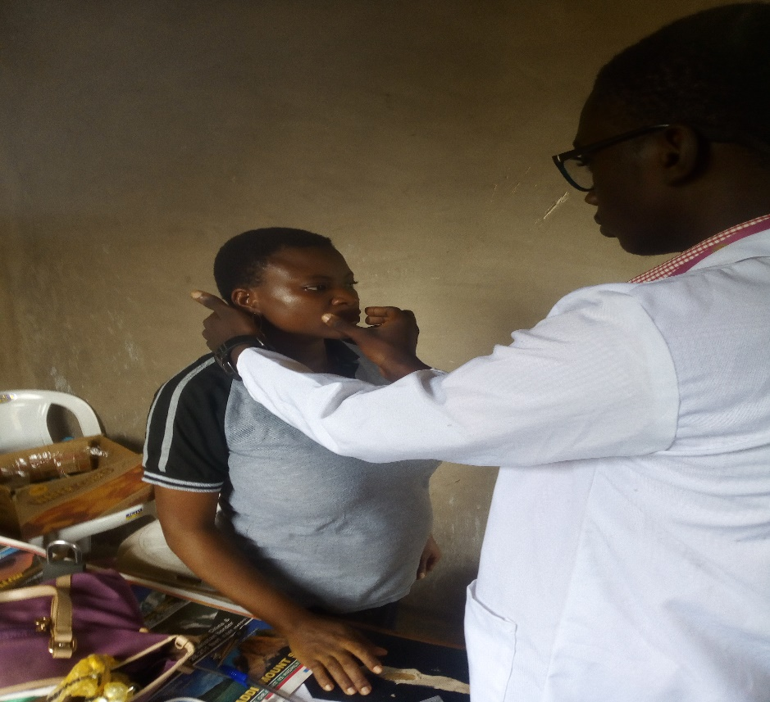**Fig.1. Diagrammatic Representation of Suzuki and Tsuchihashi classification** (Gardezi et al. 2017).

**Fig.2. Collection of Lip Print using a microscopic glass slide**

**Nasal Index Collection and Analysis**

The nasal height and width of the subject was measured respectively using a sliding digital Vernier caliper. The nasal height of the subject was measured from the bregma down to the projected region of the naris while the nasal width of the subject was measured from the left to the right ala (wing) of the nose and was recorded in the questionnaire sheet of the individual.

**Nasal index** = Width of nose (cm) X 100

Length of nose (cm)

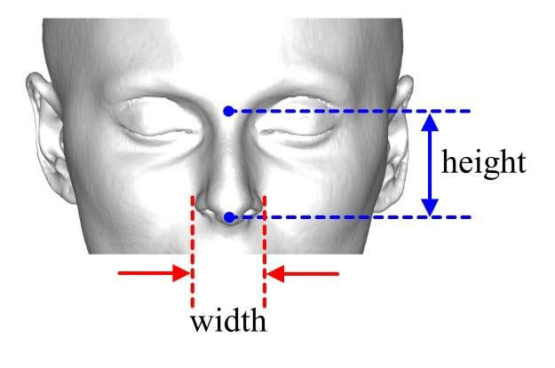

**Fig.3. Diagram showing the nasal landmarks to be considered in Nasal index measurement** (Chengyu et al.2018).

**Statistical Analysis**

Descriptive statistics for variables were used with tables. The percentage (%) distribution of lip prints pattern for the following parameters (Sex and Nasal Index) was calculated using SPSS (Statistical package for the social science, version 20.0) software. Statistical significance was put into consideration using one-way Analysis of Variance (ANOVA) when (P ≥ 0.05 or P < 0.05)

**RESULTS**

The data in this study were analyzed and the results presented in tables and graphs. The categorical variables were described as frequency (percentages). The study was from a single ethnic group; thus, only stratified based on only sex.

The distribution of the lip print types of males and females and the Chi-square test of sex associated difference in lip print pattern distribution were presented in Tables 1.1a to 1.1d.

Table 1.2 represents the distribution of the nasal morphology for the studied population and test of sex-associated difference.

Tables 1.3a to 1.3d represent the test of association between lip print types and nasal morphology; with further clarification using CHAID decision tree, which was presented in Figure 4.

**Table 1. DISTRIBUTION OF LIP PATTERNS**

**Table 1.1a:** Distribution of lip print types at upper right quadrant (URQ) and test of sex-associated difference

|  |  |  |  |  |  |  |  |  |  |
| --- | --- | --- | --- | --- | --- | --- | --- | --- | --- |
|  | **URQ** | | | | | | **Chi-Square Tests** | | |
| **Type I** | **Type I'** | **Type II** | **Type III** | **Type IV** | **Type V** | **Df** | ***X*2** | **P-value** |
| **Male** | 13 | 13 | 63 | 78 | 16 | 22 | 5 | 23.453 | **<0.001** |
| 6.3% | 6.3% | 30.7% | 38.0% | 7.8% | 10.7% |
| **Female** | 9 | 19 | 32 | 85 | 41 | 19 |
| 4.4% | 9.3% | 15.6% | 41.5% | 20.0% | 9.3% |
| **Total** | **22** | **32** | **95** | **163** | **57** | **41** |  |  |  |
| **5.4%** | **7.8%** | **23.2%** | **39.8%** | **13.9%** | **10.0%** |  |  |  |

The pre-dominant lip pattern in Male was Type III (38.0%), followed by Type II (30.7%), Type V (10.7%), Type IV (7.8%) and the least was Type I and Type I’ (6.3%). For Females, the most frequent lip pattern was Type III (41.5%), followed by Type IV (20.0%), Type II (15.6%), Type V and Type I’ (9.3%) and the least was Type I (4.4%).

The table explained that there is significant variation (P ≤ 0.05) among the lip print pattern of both sexes which states that sexual dimorphism occurs in the upper left quadrant.

**Table 1.1b:** Distribution of lip print types at upper left quadrant (ULQ) and test of sex-associated difference

|  |  |  |  |  |  |  |  |  |  |
| --- | --- | --- | --- | --- | --- | --- | --- | --- | --- |
|  | **ULQ** | | | | | | **Chi-Square Tests** | | |
| **Type I** | **Type I'** | **Type II** | **Type III** | **Type IV** | **Type V** | **Df** | ***X*2** | **P-value** |
| **Male** | 35 | 15 | 65 | 57 | 21 | 12 | 5 | 11.645 | **0.040** |
| 17.1% | 7.3% | 31.7% | 27.8% | 10.2% | 5.9% |
| **Female** | 27 | 17 | 42 | 67 | 29 | 23 |
| 13.2% | 8.3% | 20.5% | 32.7% | 14.1% | 11.2% |
| **Total** | **62** | **32** | **107** | **124** | **50** | **35** |  |  |  |
| **15.1%** | **7.8%** | **26.1%** | **30.2%** | **12.2%** | **8.5%** |  |  |  |

The pre-dominant lip pattern in Male was Type II (31.7%), followed by Type III (27.8%), Type I (17.1%), Type IV (10.2%), Type I’ (7.3%) and the least was Type V (5.9%). For Females, the most frequent lip pattern was Type III (32.7%), followed by Type II (20.5%), Type IV (14.1%), Type I (13.2%), Type V (11.2%) and the least was Type I’ (8.3%).The Study shows that Type III was the most predominant in both male and female at the Upper Right Quadrant (URL) and that Type II was predominant in males and Type III was predominant in females at the Lower Left Quadrant. The table explained that there is significant variation (P < 0.05) among the lip print pattern of both sexes which states that sexual dimorphism occurs in the upper left quadrant.

**Table 1.1c:** Distribution of lip print types at lower right quadrant (LRQ) and test of sex-associated difference

|  |  |  |  |  |  |  |  |  |  |
| --- | --- | --- | --- | --- | --- | --- | --- | --- | --- |
|  | **LRQ** | | | | | | **Chi-Square Tests** | | |
| **Type I** | **Type I'** | **Type II** | **Type III** | **Type IV** | **Type V** | **Df** | ***X*2** | **P-value** |
| **Male** | 12 | 6 | 25 | 24 | 10 | 128 | 5 | 9.721 | 0.084 |
| 5.9% | 2.9% | 12.2% | 11.7% | 4.9% | 62.4% |
| **Female** | 8 | 3 | 11 | 21 | 9 | 153 |
| 3.9% | 1.5% | 5.4% | 10.2% | 4.4% | 74.6% |
| **Total** | **20** | **9** | **36** | **45** | **19** | **281** |  |  |  |
| **4.9%** | **2.2%** | **8.8%** | **11.0%** | **4.6%** | **68.5%** |  |  |  |

The pre-dominant lip pattern in Male was Type V (62.4%),followed by Type II (12.2%), Type III (11.7%), Type I (5.9%), Type IV (4.9%) and the least was Type I’ (2.9%). For Females, the most frequent lip pattern was Type V (68.5%), followed by Type III (11.0%), Type II (8.8%), Type I (4.9%), Type IV (4.6%) and the least was Type I’ (2.2%).

The table explained that there is no significant variation (P ≥ 0.05) among the lip print pattern of both sexes which states that sexual dimorphism does not occur in the lower right quadrant.

**Table 1.1d:** Distribution of lip print types at lower left quadrant (LLQ) and test of sex-associated difference

|  |  |  |  |  |  |  |  |  |  |
| --- | --- | --- | --- | --- | --- | --- | --- | --- | --- |
|  | **LLQ** | | | | | | **Chi-Square Tests** | | |
| **Type I** | **Type I'** | **Type II** | **Type III** | **Type IV** | **Type V** | **Df** | ***X*2** | **P-value** |
| **Male** | 11 | 14 | 31 | 26 | 4 | 119 | 5 | 23.165 | **<0.001** |
| 5.4% | 6.8% | 15.1% | 12.7% | 2.0% | 58.0% |
| **Female** | 3 | 4 | 13 | 23 | 4 | 158 |
| 1.5% | 2.0% | 6.3% | 11.2% | 2.0% | 77.1% |
| **Total** | **14** | **18** | **44** | **49** | **8** | **277** |  |  |  |
| **3.4%** | **4.4%** | **10.7%** | **12.0%** | **2.0%** | **67.6%** |  |  |  |

The pre-dominant lip pattern in Male was Type V (58.0%), followed by Type II (15.1%), Type III (12.7%), Type I’ (6.8%), Type I(5.4%) and the least was Type IV (2.0%). For Females, the most frequent lip pattern was Type V (77.1%), followed by Type III (11.2%), Type II (6.3%), Type I’ and Type IV (2.0%) and the least was Type I (1.5%).The Study shows that Type V was the most predominant in both male and female at the Lower Left Quadrant (LLQ) and that Type V was predominant in males and Type III was predominant in females at the Lower Left Quadrant. The table explained that there is significant variation (P < 0.05) among the lip print pattern of both sexes which states that sexual dimorphism occurs in the lower left quadrant.

**Table 1.2:** Distribution of nasal morphology and test of sex-associated difference

|  |  |  |  |  |  |  |  |
| --- | --- | --- | --- | --- | --- | --- | --- |
|  | **Nasal Morphology** | | | | **Chi-Square Tests** | | |
| **Hyperleptorrhine** | **Leptorrhine** | **Mesorrhine** | **Platyrrhine** | **Df** | ***X*2** | **P-value** |
| **Male** | 19 | 89 | 84 | 13 | 3 | 0.891 | 0.828 |
| 9.3% | 43.4% | 41.0% | 6.3% |
| **Female** | 19 | 97 | 75 | 14 |
| 9.3% | 47.3% | 36.6% | 6.8% |
| **Total** | **38** | **186** | **159** | **27** |  |  |  |
| **9.3%** | **45.4%** | **38.8%** | **6.6%** |  |  |  |

The pre-dominant type of nasal morphology in male was Leptorrhine (43.4%) followed by Messorhine (41.0%), Hyperleptorrhine (9.3%) and the least was Platyrrhine (6.3%).

The table explained that there is no significant variation (P ≥ 0.05) among the nasal morphology of both sexes which states that sexual dimorphism does not occur in the lower right quadrant.

**Table 1.3a:** Test of association between lip print types at upper right quadrant (URQ) and the nasal morphology.

|  |  |  |  |  |  |  |  |  |  |
| --- | --- | --- | --- | --- | --- | --- | --- | --- | --- |
| **Nasal morphology** | **URQ** | | | | | | **Chi-Square Tests** | | |
| **Type I** | **Type I'** | **Type II** | **Type III** | **Type IV** | **Type V** | **df** | ***X*2** | **P-value** |
| **Hyperleptorrhine** | 0 | 3 | 7 | 19 | 4 | 5 | 15 | 20.497 | 0.154 |
| 0.0% | 7.9% | 18.4% | 50.0% | 10.5% | 13.2% |
| **Leptorrhine** | 9 | 8 | 46 | 81 | 23 | 19 |
| 4.8% | 4.3% | 24.7% | 43.5% | 12.4% | 10.2% |
| **Mesorrhine** | 11 | 21 | 35 | 52 | 25 | 15 |
| 6.9% | 13.2% | 22.0% | 32.7% | 15.7% | 9.4% |
| **Platyrrhine** | 2 | 0 | 7 | 11 | 5 | 2 |
| 7.4% | 0.0% | 25.9% | 40.7% | 18.5% | 7.4% |
| **Total** | **22** | **32** | **95** | **163** | **57** | **41** |  |  |  |
| **5.4%** | **7.8%** | **23.2%** | **39.8%** | **13.9%** | **10.0%** |  |  |  |

The pre-dominant pattern who possess the Hyperleptorrhine nasal morphology was Type III (50.0%), followed by Type II (18.4%), Type V (13.2%), Type IV (10.5), Type 1’ (7.9) and the least was Type I (0.0%). The most frequent pattern who possess the Leptorrhine nasal morphology was Type III (43.5%), followed by Type II (24.7%), Type IV (12.4%), Type V (10.2%), Type I’ (4.8%) and the least was Type I (4.3%). The most frequent pattern who possess the Mesorrhine nasal morphology was Type III (32.7%), followed by Type II (22.0%), Type IV (15.7%), Type I’ (13.2%), Type V (9.4%) and the least was Type I (6.9%).The most frequent pattern who possess the Platyrrhine nasal morphology was Type III (40.7%), followed by Type II (25.9%), Type IV (18.5%), Type I and Type V (7.4%) and the least was Type I’ (0.0%).

The table explained that there is no significant variation (P ≥ 0.05) among the lip print pattern and nasal morphology.

**Table 1.3b:** Test of association between lip print types at upper left quadrant (ULQ) and the nasal morphology.

|  |  |  |  |  |  |  |  |  |  |
| --- | --- | --- | --- | --- | --- | --- | --- | --- | --- |
| **Nasal morphology** | **ULQ** | | | | | | **Chi-Square Tests** | | |
| **Type I** | **Type I'** | **Type II** | **Type III** | **Type IV** | **Type V** | **df** | ***X*2** | **P-value** |
| **Hyperleptorrhine** | 6 | 1 | 11 | 10 | 8 | 2 | 15 | 12.685 | 0.627 |
| 15.8% | 2.6% | 28.9% | 26.3% | 21.1% | 5.3% |
| **Leptorrhine** | 26 | 14 | 46 | 61 | 23 | 16 |
| 14.0% | 7.5% | 24.7% | 32.8% | 12.4% | 8.6% |
| **Mesorrhine** | 24 | 15 | 40 | 50 | 15 | 15 |
| 15.1% | 9.4% | 25.2% | 31.4% | 9.4% | 9.4% |
| **Platyrrhine** | 6 | 2 | 10 | 3 | 4 | 2 |
| 22.2% | 7.4% | 37.0% | 11.1% | 14.8% | 7.4% |
| **Total** | **62** | **32** | **107** | **124** | **50** | **35** |  |  |  |
| **15.1%** | **7.8%** | **26.1%** | **30.2%** | **12.2%** | **8.5%** |  |  |  |

The pre-dominant pattern who possess the Hyperleptorrhine nasal morphology was Type II (28.9%), followed by Type III (26.3%), Type IV (21.1%), Type I (15.8%), Type V (5.3%) and the least was Type I’ (2.6%). The most frequent pattern who possess the Leptorrhine nasal morphology was Type III (32.8%), followed by Type II (24.7%), Type I (14.0%), Type IV (12.4%), Type V (8.6%) and the least was Type I’ (7.5%). The most frequent pattern who possess the Mesorrhine nasal morphology was Type III (31.4%), followed by Type II (25.2%), Type I (15.1%) and the least was Type I’, Type IV and Type V (9.4%).The most frequent pattern who possess the Platyrrhine nasal morphology was Type II (37.0%), followed by Type I (22.2%), Type IV (14.8%), Type III(11.1%), and the least was Type I’ and Type V (7.4%).

The table explained that there is no significant variation (P ≥ 0.05) among the lip print pattern and nasal morphology.

**Table 1.3c:** Test of association between lip print types at lower right quadrant (LRQ) and the nasal morphology.

|  |  |  |  |  |  |  |  |  |  |
| --- | --- | --- | --- | --- | --- | --- | --- | --- | --- |
| **Nasal morphology** | **LRQ** | | | | | | **Chi-Square Tests** | | |
| **Type I** | **Type I'** | **Type II** | **Type III** | **Type IV** | **Type V** | **df** | ***X*2** | **P-value** |
| **Hyperleptorrhine** | 4 | 0 | 5 | 1 | 1 | 27 | 15 | 20.550 | 0.152 |
| 10.5% | 0.0% | 13.2% | 2.6% | 2.6% | 71.1% |
| **Leptorrhine** | 8 | 4 | 15 | 29 | 9 | 121 |
| 4.3% | 2.2% | 8.1% | 15.6% | 4.8% | 65.1% |
| **Mesorrhine** | 6 | 5 | 11 | 12 | 9 | 116 |
| 3.8% | 3.1% | 6.9% | 7.5% | 5.7% | 73.0% |
| **Platyrrhine** | 2 | 0 | 5 | 3 | 0 | 17 |
| 7.4% | 0.0% | 18.5% | 11.1% | 0.0% | 63.0% |
| **Total** | **20** | **9** | **36** | **45** | **19** | **281** |  |  |  |
| **4.9%** | **2.2%** | **8.8%** | **11.0%** | **4.6%** | **68.5%** |  |  |  |

The pre-dominant pattern who possess the Hyperleptorrhine nasal morphology was Type V (71.1%), followed by Type II (13.2%), Type I (10.5%), Type III and Type IV (2.6%), and the least was Type I’ (0.0%). The most frequent pattern who possess the Leptorrhine nasal morphology was Type V (65.1%), followed by Type III (15.6%), Type II (8.1%), Type IV (4.8%), Type I (4.3%) and the least was Type I’ (2.2%). The most frequent pattern who possess the Mesorrhine nasal morphology was Type V (73.0%), followed by Type III (7.5%), Type II (6.9%), Type IV (5.7%), Type I (3.8)% and the least was Type I’ (3.1%). The most frequent pattern who possess the Platyrrhine nasal morphology was Type V (63.0%), followed by Type II (18.5%), Type III (11.1%), Type I (7.4%), and the least was Type I’ and Type IV (0.0%).

The table explained that there is no significant variation (P ≥ 0.05) among the lip print pattern and nasal morphology.

**Table 1.3d:** Test of association between lip print types at lower left quadrant (LLQ) and the nasal morphology.

|  |  |  |  |  |  |  |  |  |  |
| --- | --- | --- | --- | --- | --- | --- | --- | --- | --- |
| **Nasal morphology** | **LLQ** | | | | | | **Chi-Square Tests** | | |
| **Type I** | **Type I'** | **Type II** | **Type III** | **Type IV** | **Type V** | **df** | ***X*2** | **P-value** |
| **Hyperleptorrhine** | 3 | 1 | 2 | 3 | 0 | 29 | 15 | 20.682 | 0.147 |
| 7.9% | 2.6% | 5.3% | 7.9% | 0.0% | 76.3% |
| **Leptorrhine** | 2 | 11 | 20 | 24 | 2 | 127 |
| 1.1% | 5.9% | 10.8% | 12.9% | 1.1% | 68.3% |
| **Mesorrhine** | 9 | 6 | 19 | 17 | 4 | 104 |
| 5.7% | 3.8% | 11.9% | 10.7% | 2.5% | 65.4% |
| **Platyrrhine** | 0 | 0 | 3 | 5 | 2 | 17 |
| 0.0% | 0.0% | 11.1% | 18.5% | 7.4% | 63.0% |
| **Total** | **14** | **18** | **44** | **49** | **8** | **277** |  |  |  |
| **3.4%** | **4.4%** | **10.7%** | **12.0%** | **2.0%** | **67.6%** |  |  |  |

The pre-dominant pattern who possess the Hyperleptorrhine nasal morphology was Type V (76.3%), followed by Type I and Type III (7.9%), Type II (5.3%) and the least was Type IV (0.0%). The most frequent pattern who possess the Leptorrhine nasal morphology was Type V (68.3%), followed by Type III (12.9%), Type II (10.8%), Type I’ (5.9%) and the least was Type I and IV (1.1%). The most frequent pattern who possesses the Mesorrhine nasal morphology was Type V (65.4%), followed by Type II (11.9%), Type III (10.7%), Type I (5.7%), Type I’ (3.8%) and the least was Type IV (2.5%). The most frequent pattern who possess the Platyrrhine nasal morphology was Type V (63.0%), followed by Type III (18.5%), Type II (11.1%), Type IV (7.4%), and the least was Type I and Type I’ (0.0%).

The table explained that there is no significant variation (P ≥ 0.05) among the lip print pattern and nasal morphology which states that sexual dimorphism does not occur in the lower left quadrant.

In evaluating the possibility of a relationship between lip print pattern and nasal morphology; with sex as influence variable, Chi-square Automatic Interaction Detector (CHAID) was used to build a predictive classification tree model. The nasal morphology was response variable, while the URQ, ULQ, LRQ and LLQ were the predictor variables, which were entered into the model. Traditionally CHAID splits the lip prints into categories (nodes) with approximately equal number of observations, creating all possible cross-tabulations for each category. This process is repeated until the best outcomes are achieved.

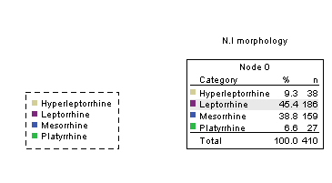

**Fig.4.** Decision tree for explaining the relationship lip print and nasal index -*clearly no pattern detected*.

**DISCUSSION**

Variations in the form of nose is said to be the greatest variation in cranium and it is greater than the body variation. Also, the various shapes of the human nose and the patterns of the lip prints have been proved to be influenced by gender or ethnicity (Radha and Srinivasan, 2019).

In this present study, the predominant lip print pattern for both the upper and lower quadrant of both sexes was Type V and the study also revealed sexual dimorphism among the lip print pattern in all quadrants except the lower right quadrant. The predominant nasal index in this study was 60.0 which is a leptorrhine (55.00 – 69.90) class of nasal morphology. In this study, there was no sexual dimorphism among the nasal index of both sexes.

**Lip Print and Sex**

A study carried out among Igbo students in Madonna university within Elele campus shows Type I to be the prevalent lip print pattern in both males and females. The study reveals no case of sexual dimorphism. (Oladipo et al. 2018).

It was also reported in Adamu et al. (2013) that Type I was predominant in females in the lower lips and that males tend to have different patterns in all quadrants. This study also showed no case of sexual dimorphism.

A study carried out among Karachi (Pakistan) population showed that the prevalent lip print pattern of both sexes was Type III which showed significant gender dimorphism (Sara et al. 2017).

In a study carried out among students of Subharati Dental College, it was established that the prevalent lip print pattern among females was Type I and Type I’ while the prevalent lip print pattern among the males was Type IV. There was no record of sexual dimorphism in the study (Sharma et al. 2009).

**Nasal Index and Sex**

Tahmasebi et al. (2015) revealed that the predominant nasal index among the males and females of Iranian population is 65.46 which is a leptorrhine class of nasal morphology. However, there was no case of sexual dimorphism.

A study carried out among the North and Southern Indians revealed 75.00 (mesorrhine) as the predominant nasal index with no case of sexual dimorphism (Ashrani et al. 2015).

A study also carried out by Radha and Srinivasan, (2019) reported that the predominant nasal index among the male and female population of the south Indian was 60.00 (leptorrhine) (Radha and Srinivasan, 2019).

**Lip Print in Egba Ethnic Group in Relation to Other Ethnic Groups**

A study of lip print conducted among the Urhobo tribe in Delta state shows Type II to be the Predominant lip print pattern in both males and females (Eboh and Nwajei, 2012).

It was established in Oladipo et al. (2018) that the cheiloscopic pattern for the Igbo ethnic group in Nigeria is Type I while the least was Type I’.

**Nasal Index in Egba Ethnic Group in Relation to Other Ethnic Groups**

Early study on the anthropometric study of the nasal index and sex among the Bekwarra ethnic group shows 85.00 to be the predominant nasal index which is the typical African nose type (platyrrhine) (Esomonu et al. 2013).

Oladipo et al. (2007) confirmed among the major ethnic groups in southern Nigeria (Ijaws, Igbos and Yorubas) that males had a higher nasal index (> 85.0, platyrrhine) than the females. This study revealed presence of sexual dimorphism.

**Relationship between lip print and Nasal index**

In this study there was no significant association between nasal index and lip print. However, there is paucity of literature with respect to this comparison.

**ACKNOWLEDGMENTS**

Authors wish to appreciate the pain staking efforts of the study subjects who sacrificed their time during the data collection exercise.

**REFERENCES**

Adamu LH, Taura MG, Hamman WO, Ojo SA, Dairu AU, Sadeeq AA, Umar KB. (2013). Relationship of thumb prints and lip prints among nigerians. Journal of dental and medical sciences. 9(2): 12 – 17.

Ashrani SK, Lokanathan TH, Rajendra R, Surendra M. (2015). Study of nasal index among student of tertiary medical care institute of southern india. International journal of anatomy research.3(4): 1675 – 1679.

Bushra K, Devvanand G. (2014). Cheiloscopy and blood groups: aids in forensic identification. The Saudi Dental Journal. 26(4): 176 – 180.

Caputo IGC, Antonio LU, Andre APR, Castro MG, Pinto LB, Cunha RD, Carvalho MSO. (2018). Cheiloscopy in the human identification. International journal of Forensic criminology, 6(6): 371 – 374.

Coward RC. (2007). The stability of lip print characteristics over time. Journal of forensic odontostomatology. 25(2): 40 – 56.

Eboh D, Nwajei MO. (2012). Cheiloscopy in relation to ethnicity, gender and monozygotic twins in south-southern Nigeria. Journal of experimental and clinical anatomy. 11(2): 1 – 7.

Esomonu UG, Ude RA, Lukpata PU, Nandi ME. (2013). Anthropometric study of the nasal index of bekwara ethnic group of cross river state, Nigeria. International journal of basic and applied sciences.5(10): 1262 – 1265.

Oladipo GS, Alabi AS, Paul CW, Amadi PN, Paul JN, Robert FO, Amasiatu VC. Gospel S. (2018). Cheiloscopy among the igbo students in Madonna university elele, rivers state, Nigeria. Saudi journal of biomedical research (SJBR).3(3): 129 – 135.

Prabhu RV, Dinkar AD, Prabhu VD, Rao PK. (2012). Cheiloscopy. Journal of forensic dental sciences. 4(1): 47 – 52.

Radha K, Srinivasan KR. (2019). Nasal index: A cross sectional study among South Indian population. Indian Journal of Clinical Anatomy and Physiology.6(2): 201 - 204.

Sara G, Nuzhat H, Sarwat, Memon. (2017). Analysis of lip print for gender identification in karachi (Pakistan) population. Journal of advances in medicine and medical research. 24(11): 1 – 6.

Sharma P, Saxena S, Rathod V. (2009). Cheiloscopy: the study of lip print in sex identification. journal of forensic dental science. 1(1): 24 – 27.

Tahmasebi F,Khanehzad M, Madadi S, Hassanzadeh G. (2015). Anthropometric studies of nasal parameters in iranian university students. Research papers.12(4): 167 – 170.