Type of article: Original Article
Contribution of G.I.S and remote sensing for the risk mapping of soil water erosion at Saida province (Western of Algeria).

Aouadj S.A^{1*}, Degdag H², Nasrallah Y³, Hasnaoui O¹, Zouidi M⁴, Allam A⁵, Nouar B¹, Khatir H⁶
¹ Laboratory of Ecology and Management of Natural Ecosystems, Abou Bakr Belkaid University, Tlemcen-Algeria.
² Laboratory for the Eco-Development of Spaces, Djillali Liabes University of Sidi Bel Abbes-Algeria.
³ Laboratory of Biotoxicology, Pharmacognosia and Biological Valuation of Plants, University of Saida-Dr Moulay Tahar-Algeria.
⁴ Centre de Recherche en Aménagement du Territoire (CRAT), Campus Zouaghi Slimane, Route de Ain el Bey, 25000 Constantine- Algeria;
⁵ Centre de Recherche en Technologie des Industries Agroalimentaires (CRTAA), Compus universitaire Targua Ouzemour, Bejaia- Algeria.
⁶ Private scientific consultant and a head of Reprodbiotech and stem cells. Montréal, Qc, Canada.

*Author for Correspondence: sidahmed.aouadj@univ-tlemcen.dz

ABSTRACT

Soil water erosion is a major aspect of landscape degradation in sub-wet to semi-arid Mediterranean environments. This problem has not been dealt with in detail in Algeria although it affects large areas. The objective of this study is to develop a methodology using remote sensing, the digital field model (DTM) and geographic information systems (GIS) to map areas with a risk of water erosion within the territory of Saida province and to produce a risk map that can be used as a reference document by the local authority. The presented methodology consists to incorporate three factors controlling the erosion: slope, material friability and land use. The resulting erosion risk map shows five areas of vulnerability to water erosion: very low, low, moderate, high and very high. Areas with high and very high risk of erosion cover more than 20% of the mountainous area and are consistent with our field observations. The methodology presented in this study can be generalized to all areas of the foothills of the Tellian Atlas, where erosion risks pose a threat to urban areas. This model is a tool to help implement a soil conservation plan in order to organise the measures to be applied and ensure sustainable soil management.

Key-words: Water erosion; remote sensing; geographic information system (GIS); Saida; sustainable soil management.

INTRODUCTION
One of the first phases of a country's development has always been the establishment of an ecosystem management strategy and vegetation mapping, an enhancement of the potential of a region, a rational management of physical and human resources. In other words, the management of natural resources.
These lands have so far remained virtually poorly exploited and their production capacity has become alarming in recent years. This is due to a climate marked by its aggressiveness, rugged terrain and inadequate and inefficient use of natural resources. This situation mainly causes a deterioration of the environment. This is particularly serious in our study area (semi-arid bioclimatic stage) where water is the main limiting factor for vegetation.
The different modes of human intervention on the natural environment gradually cause an irreversible degradation of these resources: soil resources, water, landscapes. The different types of soils are more or less sensitive to degradation factors: imbalances linked to certain crops, pollution, erosion and high human frequentation (Nasrallah et Kefifa, 2011 ; Aouadj et al., 2020a-j ; Nasrallah et al., 2021).
The main risks of physical degradation are represented: 1- by runoff and water erosion, due to the closure of the soil surface by threshing, the concentration of runoff causing significant land losses and large and devastating landings; and 2- on the other hand by compaction due to intensive mechanization (Aouadj et al., 2020b).
The soil erosion is a common phenomenon affecting most of the globe countries. In Turkey, the rate of erosion is estimated to be between 500 and 600 million t/y (Celik et al., 1996). While in Morocco (Boussema, 1996) and Tunisia (Chevalier et al., 1995) about 40%, 45% of the land is threatened by water erosion respectively. In Germany even if the forests are not really at risk to soil erosion. Nevertheless, the systems paved or gravelled forest roads used to transport of wood out of the forest represent a potential factor of soil erosion (Haas et al., 2020). Erosion represents a serious environmental, economical, agricultural and social issue. The aggravation of this phenomenon is mostly due to the degradation of the natural vegetation covers by the repeated summer fires, slope terrain, intensive raining during winter season and the unresponsible occupation of the soil by the human being. In Algeria, about 50 million hectares are vulnerable to desertification and water erosion, including 14 million hectares in mountain areas (Mostephaoui et al., 2013).
In the north and northwest of Algeria the ravishing erosion has displaced between 150 and 270 t/ha/year of land. In fact, 56.58% (Atika-Nehaï et al., 2020) to more than 68% (Meghraoui et al., 20147) of the studied areas are affected by erosion problem. Furthermore, the rate of alteration of the slopes is in the range of 8 to 17 mm/year (Rerboudj, 2015). In high-slope Mediterranean areas, gullying moves ten to one hundred times more land than slick erosion (Bonneau, 1980).
In this regard, Benabdeli (1998) notes that the poor land use and the crop selection result in erosion of sloping land which is estimated between 10 and 16 m/ha/year, equivalent to 30 to 65,000 hectares of arable lands. More than 13 million hectares (45 percent of the Tellian zone) of agricultural lands are threatened by the erosion in our country.
Four million are already at a fairly advanced stage, only 1 million hectares have been treated since the independence.
Orania also has certain peculiarities, as Boudy (1948) points out: "... we enter Orania, which is an apart world, with a slightly steppe landscape attested by the presence of esparto grass and salt lakes (sebkha). The drainage of the plain is insufficient. Erosion is fighting with the orogenic uprising; because the country has not yet acquired its final relief, resulting in severe flooding due to model defects."
In their study, Thintoin (1948) divides this region into five parts:
1. Coastal reliefs or Sahels, the altitude varies between 250 and 882 meters;
2. Neogenous plateaus between coastal relifes have an altitude of between 100 and 200 metres. They form a single unit with the low plains, the latter communicate with the coastline; their altitude is between 0 and 200 meters and are occupied by marshes or salt lakes;
3. The pleated atlas consisting from east to west of the Beni Chougrane, Ouled Ali and Tessala mountains with respective maximum altitudes of 910, 726 and 1061 meters with a high percentage of area located between 600 and 800 meters. With a width of 20 to 60 kilometers; forming a barrier that is difficult to cross except for a few gaps used by the wadi El Hammam, Mektoub, Mékerra and Isser;
4. The high Tellian plains represented by that of Sidi Bel Abbes and Sidi Ali Benyoub extending the south of the pleated atlas and communicate with the low coastal plains. Their altitude ranges from 400 to 720 metres. They are wedged between the folded atlas and the tabular atlas;
5. The tabular atlas comprising three groups of mountains from east to west: the mounts of Saida, the Dhaya Mountains, the mounts of Tlemcen. The altitude is between 1000 and 1500 metres, the highlights points are Ain El Hadjar with 1175 m, Jebel Bougib with 1468 m, and Jebel Tenouchfi with 1843 m. Like the pleated atlas it forms a barrier between the high steppe plains and the high tellian plains; it is also interspersed with breaches used by the rare wadi of Saida and Taourira to the east (Saida Mountains), the Mékerra for the Dhaya Mountains and the Wadi Tafna for the Tlemcen ones.
The objective of this present study is to develop a methodology using remote sensing, the Digital Field Model (D.F.M) and The Geographic Information Systems (G.I.S) to map areas at risk of water erosion within the territory of the Saida province and to produce a risk erosion map.
MATERIEL AND METHODS
Study area
Saida province is located in the geographical complex of causses and high plateaus, which is naturally limited to the south by the Chergui chott. According to the direction of land planning and development [16], the province covers a total area of 6765 km2. It is limited to the north by Mascara, to the west by that of Sidi Bel Abbes, to the south by El Bayadh and to the east by that of Tiaret provinces respectively. It consists of six (06) Daïras (arrondissements) and sixteen (Aouadj, 2021) communes (municipalities) (Aouadj, 2020c) (Figure 1).
This position gives it a role of relay between the steppe provinces in the south and the Tellian provinces in the north. In fact, it corresponds to the extension of the territory of the Saida province on two quite distinct natural domains: The Tellian Atlasic one in the north and the second one is that of the high steppe plains (Aouadj, 2020d).
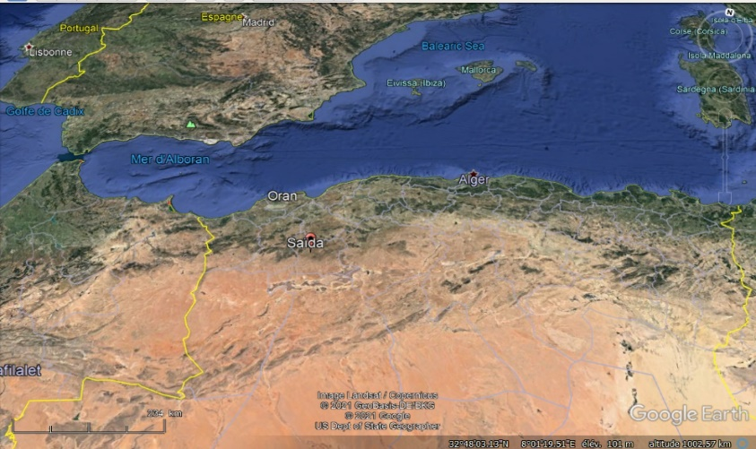

Figure 1: The Study Area (Saida region-Western of Algeria) (Google earth, 2022).

Methods
a. Data used
Two types of data were used: map data and remote sensing data :
a.1. Map data
Soil map 1/200,000 [19] and land occupancy map 1/2 00,000 (B.N.E.D.E.R, 2011).
a.2. Remote Sensing Data
As remote sensing data, we used a Radar image. These data are obtained from the STS99 mission of the NIMA (National Imagery and Mapping Agency of the U.S. Department of defence) and German and Italian space agencies is an 11-day mission, which aims to establish a digital field model (DFM) of the entire earth. The mission uses Radar interferometry.
This mission uses Radars, synthetic aperture, SIR and SAR, in C and X bands.

b. Used materials
b.1. MapInfo Software
MapInfo offers the ability to work very easily on vector documents; it also allows the editing and dressing of raster documents.
MapInfo provides a variety of visualization and editing features including (C.C.T, 1999) :
• Multiple opening tables;
• Managing the display and labelling of layers;
• Creation and modification of thematic analysis;
• Views manipulation;
• Searching for information associated with a layer;
• Management of units and projections.
b.2. Vertical Mapper 2.6
Vertical Mapper 2.6 is important complementary software from MapInfo. It allows (C.C.T, 1999):
• Processing database information in the third dimension using a digital field model (DFM);
• Establish different profiles using treatment on DFM;
• The three-dimensional representation of the field.
Principle of work
The objective is to estimate soil erosion risks based on data collected during analyses of remote sensing and soil data and on the basis of socio-economic elements. To achieve this goal, we have led the work at different levels (Figure 2).
The integration of thematic maps into the GIS helped to identify the impact of each factor in estimating soil erosion and to classify erosion zones by relative importance. The approach is based on a multiplicative function of the four factors that control water erosion: soil nature, slope, land use and anti-erosive practices. The application of this method required the evaluation of the different factors used throughout the study region and their expression in the form of thematic maps.
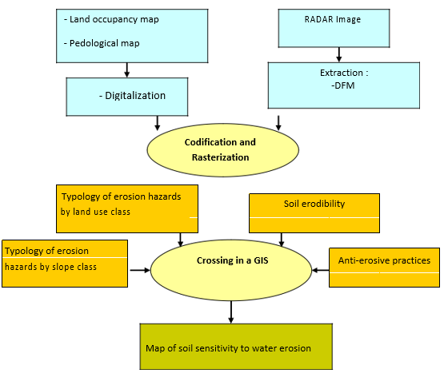
The integration of these maps into a Geographic Information System (GIS) is done by digitization. The different areas obtained for each map are associated with their databases. The crossing of the maps by the "MapInfo" software made it possible to develop a synthetic erosion hazard map.

Figure 3. Methodological work chart.
General approach
There are five main steps:
a.1. Data collection
These are the data used: quantitative and qualitative data (mapping data and data extracted from the Radar image used).

b.2. Preparing data
- Extraction of the DFM from the Radar image.
- Extraction of drift maps from DFM: We exploited the DFM from NASA’s STRM mission of the 11 day period, which began on 11 February 2000 and aims to establish a digital field model (DFM) of the entire earth. The mission uses Radar interferometry. These datas are used to establish the following layers of information (Figure 3):
a- Slope maps: Slopes are the inclination of a surface relative to the horizontal plane. It calculates by the tangent at the surface in the vertical plane. This map is obtained from DFM analysis using Vertical Mapper.
b- Hypsometric map (altitude map): We used the Vertical Mapper to present altitude classes as a map.

Digital field model (DFM)

-Slopes map
-Expositions map

Level-curves
Hypsometric map
Interpolation and Vertical Mapper Treatment
-Hydrographical network
-Watershed limits
River Tools Treatment

Figure 3. Method of extracting derivatives from the DFM (C.C.T, 1999).

- The digitalization of maps (pedological and land use): Generally maps are available in Raster forms. In this form, they cannot be manipulated with mapping software (MapInfo). So, they must be converted into vector files.
4.3. Parameters coding : The codification of the different parameters (as: soil types, types of land use, slope classes) from 1 to 5 depending on their degree of sensitivity to erosion in a growing way.
4.3. 1. Land use : The determination of the soil occupancy factor is based on the density of the vegetation cover, the height of the plant strata, the shape and type of plant formation.
To determine the effect of different class on soil sensitivity to the erosion phenomena, we used the Wischmeier and Smith tables that give pre-established values for forests, matorrals and pastures. These tables are based on the recovery index and the percentage of herbaceous coverage. Land occupation types were grouped into 5 classes, each with an identical behaviour to soil erosion (Table 1).

Type of land occupation | Degree of sensitivity to erosion
Clear Scrubland | 2
Dense scrubland | 1
Clear forest | 1
Dense forest | 1
Low-coverage esparto path | 4
Medium-to-high-coverage esparto path | 3
cerialiculture | 5
Arboriculture | 3
Vineyards | 3
Very low-coverage esparto path | 5
Reforestation | 4
Gardening | 5
Tellian path | 5
Salsolacee path | 5
Sagebrush path | 4
Table 1. Occupation of land and assigned indices.
Order:
01 : Very low sensitivity;
02 : Low sensitivity;
03 : Moderate sensitivity;
04 : High sensitivity;
05 : Very high sensitivity.

4.3. 2. Relief : The topography was calculated from the soil inclination (slope) which it is obtained from Radar image processing. The GIS allows the transformation of this image data into a digital field model (DFM). So, we extracted from the DFM the maps that interest us: the altitude map; the map of hillside exposures and the slopes map.

To enter the slope values into the GIS, we grouped them into 5 classes. Class thresholds were chosen based on field knowledge or proposed values in the literature (Table 2).

Slope class | Degree of sensitivity
0 - 5 | 1
5–10 | 2
10–15 | 3
15-20 | 4
> 25 | 5
Table 2. Slope class and assigned indices.
Order:
01: Very low sensitivity;
02: Low sensitivity;
03 : Moderate sensitivity;
04 : High sensitivity;
05: Very high sensitivity.

4.3.3. The nature of the soil : The paedo-transfer rule established on the type of parenting material is based on the principle that the risks of erosion or land movements are all the important because cohesion is low.

Generally, for consolidated rocks (limestone, granite, sandstone, etc.), the risks are low. However, for low-cohesive or crumbly rocks such as: shale, marl, silt, molasse and alluvial or glacial deposits, the risks of erosion is high (Table 3).

Facies | Material friability | Assigned index
Limestone | High-resistant materials | 1
Pedogenetic limestone of the | Resilient materials | 2
Plain
Dolomias saccharoid | Moderate-resistant materials | 3
Marnes, sandstone, Marno- | Vulnerable materials | 4
limestone,
Spreading scree and
alluvials, clays, silts and | Very vulnerable materials | 5
Elviants
Table 3. Class of materials friability and assigned indices.
Lithological data were integrated into the GIS by digitizing the lithological map of the region at 1/200000. Then the map was divided into five classes depending on the degree of their sensitivity to erosion (Table 4)..

Soil type | Degree of sensitivity to erosion
Limestone brown soil | 02
Halomorphous soil | 02
Alluvial soil bordering the chott | 05
Hydromorphic soil | 02
Green brown soil | 01
Soil redesigned | 03
Red brown soil with humiferous horizon | 01
Meditiraneen brown soil under steppic formation | 03
Light-textured meditiraneen red brown soil | 02
Lithosol | 01
Alluvial soil with sandy texture | 05
Alluvial soil of oued beds | 04
Light-textured meditiraneen brown soil | 01
Mediterranean red brown soil with sandy texture | 04
Plain alluvial soil | 04
Table 4. Soil type and assigned indices
Order:
01 : Very low sensitivity;
02 : Low sensitivity;
03 : Moderate sensitivity;
04 : High sensitivity;
05 : Very high sensitivity;

4.3.4. Anti-erosive practices : Level-curved crops, alternating strips or lounges, reforestation in benches, butting and ridging are the most effective soil conservation practices. This factor represents a single class for the entire region, on which none of the practices cited are used.
Across the region, there are no anti-erosive facilities and farmers do not use anti-erosive cultivation practices. Crops are mostly grainy and ploughing is rarely parallel to level curves. There are some reforestation trials by the local authority. In this context, only one class was assigned to the entire studied area.
4.4. Rasterization : The transformation of data (as: pedology, soil occupancy and slopes) of vector format to the bitmap. This transformation makes it possible to apply on all these data a spatial analysis.
4.5. Crossing : The data was crossed by the following function:

1/n. Σ (Ai+Bi+Ci+Di)

Where:
n: The number of parameters used in the model;
- The pixel information of parameter a (soil occupation);
- The pixel information from parameter b (pedology);
- The pixel information of the parameter c (slope);
- The pixel information of the parameter d (anti-erosive practice).
RESULTS
The methodology developed in this study uses qualitative rules, evaluations and a prioritization of the parameters involved in water erosion: Land occupation, soil types and degree of slope. All of these data are integrated into a GIS for best information management.
The combination of these maps, according to the decision rules mentioned in Table 5 and 6; produced a water erosion risk map. It comprises five classes of erosion risks: very low, low, moderate, high and very high.
Erosion potential was calculated via the interaction between land use and slope classes, using the decision rule presented in Table 5. Also five classes of erosion risk are delineated: very low, low, moderate, strong and very strong.
Erosion | - |  | Slope |  |  | Slope |  |  | Slope |  |  | Slope |  |  | Slope
potential |  | (°) |  |  | (°) |  |  | (°) |  |  | (°) |  |  | (°)
- | - |  | Class 1 |  |  | Class 2 |  |  | Class 3 |  |  | Class 4 |  |  | Class 5
Occupation | Class 1 |  | 1 |  |  | 1 |  |  | 2 |  |  | 3 |  |  | 3
of land
Occupation | Class 2 |  | 1 |  |  | 2 |  |  | 3 |  |  | 3 |  |  | 4
of land
Occupation | Class 3 |  | 2 |  |  | 3 |  |  | 3 |  |  | 4 |  |  | 4
of land
Occupation | Class 4 |  | 3 |  |  | 3 |  |  | 4 |  |  | 4 |  |  | 5
of land
Occupation | Class 5 |  | 3 |  |  | 4 |  |  | 4 |  |  | 5 |  |  | 5
of land

Table 6. Decision Rule of potential Erosion.

The erosion risk map (Figure 3) was developed by the interaction between erosion potential and material friability, using the decision rule presented in Table 7. Five classes of erosion risk are delineated: very low, low, moderate, high and very high risk.
Risk of |  |  | Material |  |  | Material |  |  | Material |  |  | Material |  |  | Material
erosion | - |  | friability |  |  | friability |  |  | friability |  |  | friability |  |  | friability
- | - | 1 |  |  | 2 |  |  | 3 |  |  | 4 |  |  | 5
Erosion | 1 |  | 1 |  |  | 1 |  |  | 2 |  |  | 3 |  |  | 3
potential
Erosion | 2 |  | 1 |  |  | 2 |  |  | 3 |  |  | 3 |  |  | 4
potential
Erosion | 3 |  | 2 |  |  | 3 |  |  | 3 |  |  | 4 |  |  | 4
potential
Erosion | 4 |  | 3 |  |  | 3 |  |  | 4 |  |  | 4 |  |  | 5
potential
Erosion | 5 |  | 3 |  |  | 4 |  |  | 4 |  |  | 5 |  |  | 5
potential
Table 7: Decision Rule of Erosion Risk.

Note: Colour bare sensibility ID for figures 4, 5, 6 and 7. From the top to the bottom: Very high, high, moderate, low and very low sensibility respectively.

Typology of water erosion threats by slope class

Very strong sensitivity
Strong sensitivity
Medium sensitivity
Low sensitivity
Very Low sensitivity

Figure 4. Typology map of water erosion hazards by slope class.

The typology map of water erosion threats by slope (Figure 4) class shows that the risk is very high in mountainous areas where slopes are above 25% (Sidi Boubkeur, Sidi Amar, Youb, Hounet, Ain Soltane, Ouled Brahim...). In plain areas the risk is mild where the slopes are moderates (Doui Thabet, Saida and Hassasna...) (See Photo 1 and 2). However, the steppe zones (south) present a low risk of erosion where the slopes are very less (Sidi Ahmed, Skhouna, Maamora and Moulay Larbi...).

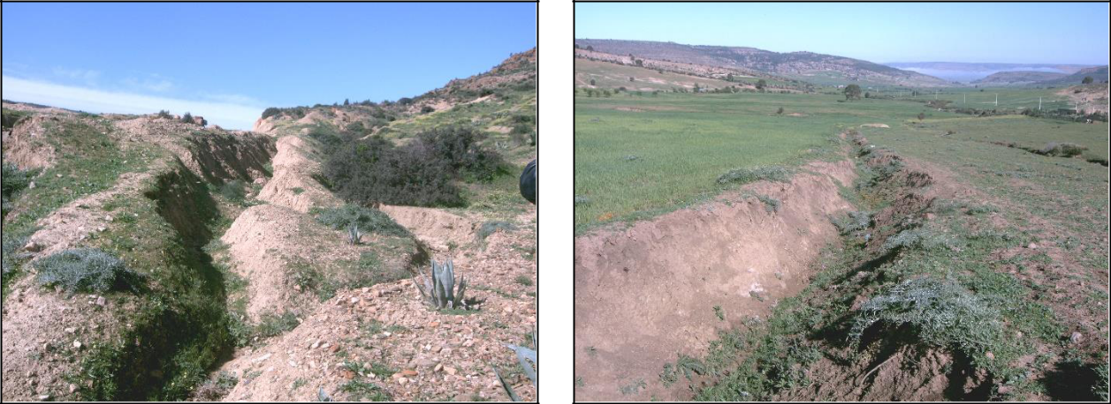

Phot 1. Erosion in ditches in lowland areas. Phot 2.Erosion in ditches in lowland areas
(Aouadj, 2022) (Aouadj, 2022).

Typology of water erosion hazards by soil occupancy class
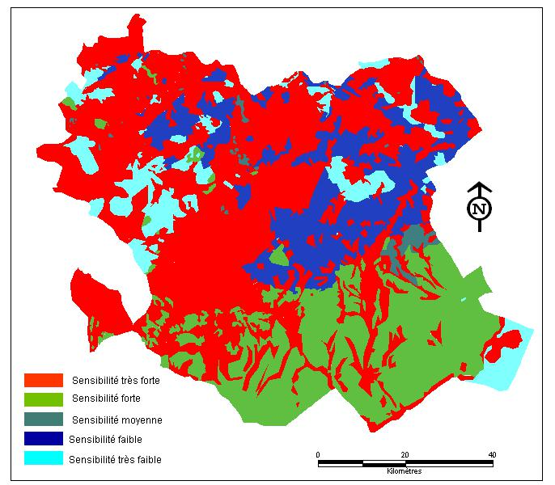

Very strong sensitivity
Strong sensitivity
Medium sensitivity
Low sensitivity
Very Low sensitivity

Figure 5. Typology map of water erosion hazards by land occupancy class.
The typology map of water erosion threats by soil occupancy class (Figure 5) shows that the risk of high and very high erosion threats is spread over a very large area of the Saida territory where there are clear plant covers and/or herbaceous strata. By contrast, the risk is low to very low where there is dense vegetation cover. It presents a small area by comparison to the threatened area by high and very high risks (Hassasna, East of Ouled Brahim, South West of Doui Thabet and South West of Sidi Boubkeur and Sidi Amar ...).

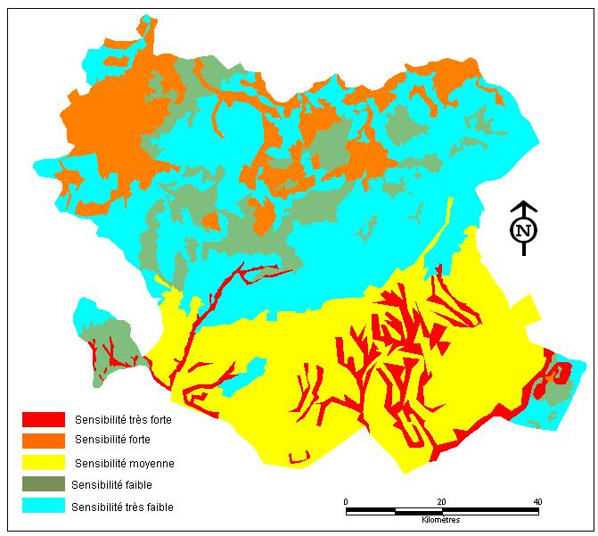
Soil erodibility

Very strong sensitivity
Strong sensitivity
Medium sensitivity
Low sensitivity
Very Low sensitivity

Figure 6: Soil erodibility map.

As showed at Figure 6, the sensitivity is very important in the south (Maâmora, Sidi Ahmed and Moulay Larbi...) where the friability of materials is very low. Usually this type of soil is characterized by a very low cohesion (Spreading scree and alluvials, clays). The high sensitivity is characterized by the regions as: South of Hounet, North East of Youb, Saida Ouled Khaled and North of Ouled Brahim...) (See photo 3 and 4) that are made up of low-cohesion materials (soils) (limons and elvies). Wherase, the low and very low sensitivity characterizes the regions of Moulay Larbi, Skhouna, South of Ain El Hadjer, Doui Thabet, Sidi Boubkeur and South of Ouled Brahim. In these regions soils are characterized by high cohesion (limestone).
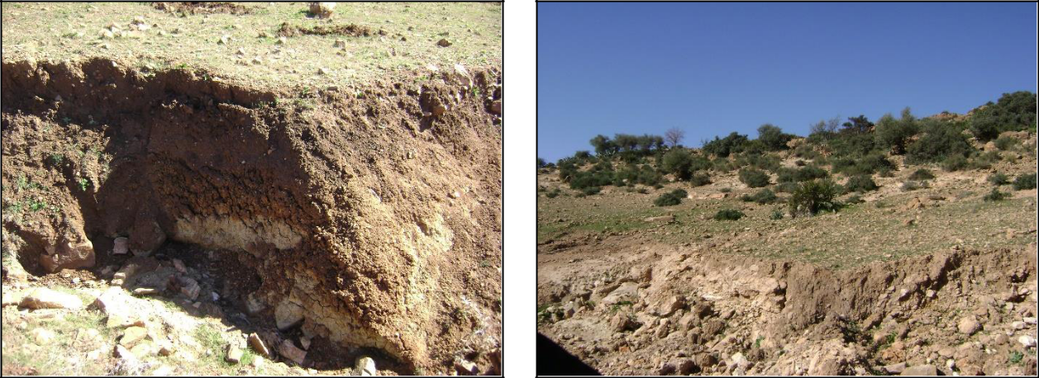

Photo 3. Erosion in ravines in low-level areas. Photo 4. Erosion in ravines in low-level areas. (region of Ain Sultane) (region of Sidi Amar)
(Phot :Aouadj, 2009-2021) (Phot : Aouadj, 2009-2021).

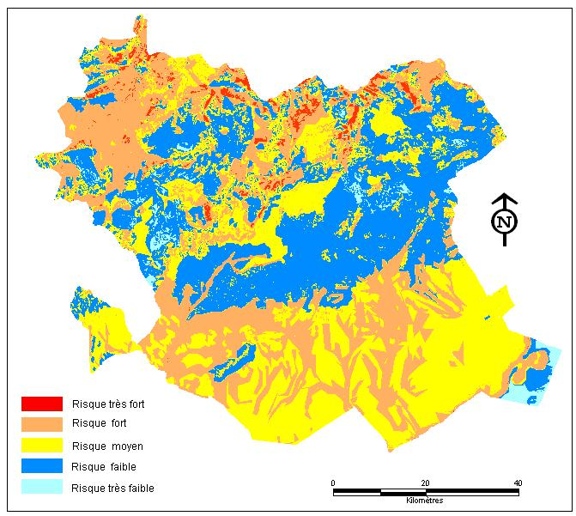
Major risk of erosion

Very high risk
High risk
Medium risk
Low risk
Very Low risk

Figure 7. Saida Water Erosion Risk Map.

Mapping has been established. The result is presented in Figure 7. Erosion and deposition zones are closely linked to soil use and pedomorphology. Degraded soils are located at the top of the interfluves and on the slope.
From a spatial point of view, soil degradation in the province mainly affects downstream of Mina watersheds (Cheliff) and Oued Hammam (Mactaa) with steeper slopes and dominant erosive cultures (photo 5 and 6). Stable and/or repositioning areas are positioned in the low points of the relief. Net erosion mainly affects downstream watersheds, due to steeper slopes and an important presence of erosive crops.
This result highlights the medium and long-term impact of erosion on soil quality and also on the sustainability of crop systems in regions with intensive agrarian practices.

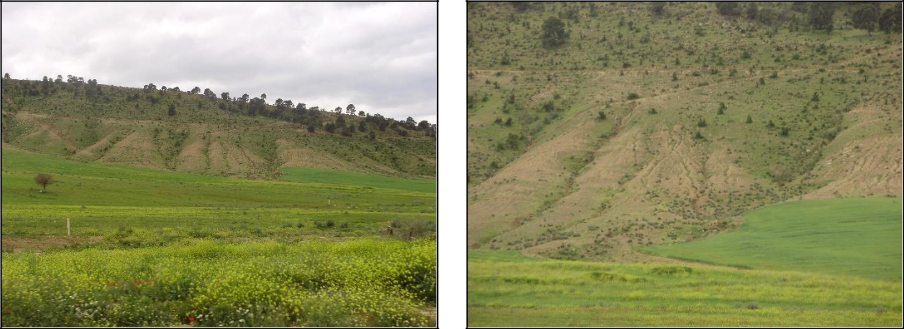

Photo 5. Erosion in tablecloth. Photo 6. Erosion in tablecloth.
(Djebel ”Mount” Sidi Ahmed Zagaie).
(Aouadj, 2009-2021).

INTERPRETATION
Several scientific models, based on geomorphological parameters, have long been developed to determine the sedimentation rate in order to assess soil erosion in the catchment area (Misra, al., 1984 ; Jose et al., 1982. Other methods are widely used to establish watershed prioritisation ( Bali and Karale, 1977 ; Wischmeier and Smith, 1978]. In the field, the Universal Soil Loss Equation (USLE) and the Revised Universal Soil Loss Equation (RUSLE) have been the most frequently used models for predicting soil loss due to erosion. However, the factors used in these models were mainly estimated from field measurements. These traditional methods for quantifying soil loss due to water erosion have many limitations in terms of cost, representativeness and credibility of the obtained data. Indeed, they cannot provide a spatial distribution of soil erosion loss due to the limitation of samples in difficult environments. Hence, the usefulness of using more developed techniques such as: Remote sensing and geographic information systems (GIS). These two methods allow the evaluation of soil erosion and its spatial distribution at a moderate cost and with better accuracy over large areas (Boggs et al., 2001 ; Bartsch et al., 2002 ; Wang et al., 2003 ; Chen et al., 2011 ; Lahlaoi et al., 2015). This present study was carried out by the combination of data (satellite images, existing thematic maps, field observations) and the application of the GIS model, which enabled the production of synthetic maps showing the degree of sensitivity to water erosion.
The visualization of the threats map by region clearly highlights the regional variability of erosion hazard. The obtained results by GIS for each region show that several units stand out:
-The areas detected at risk of high and very high erosion are rich in clays and limestone debris plus the slopes are important and the vegetation is degraded. They are crossed by several river notches. These connect to the main rivers, in this case the wadi (river) of Sidi boubkeur, Sidi amar, Saida, Ouled Khaled, Ouled Brahim, Hounet and Ain El Hadjer. The solid suspension load thus transported is transported from the mountain to the plain, including through the towns of these municipalities.
-The pipeline of rivers through these cities is undersized, causing flooding and spillage of solid loads in urban perimeters during heavy rains or slick runoff. Several points in the cities of the Saida province have become famous for their floods during both the rainy season and the summer storms (for example the floods of 2008), if we take the province of Saida for example.
-In agricultural areas, soils are moderately susceptible to erosion and widely cultivated. Erosion is all the more a threat because soils are left bare for a long time. In lands characterized by a steep slope on the southern versants where vegetation is more degraded and/or dominant erosive crops the risk of erosion is higher.
- Overall, the strongest threat corresponds to very degraded and tidal terrain and on a more or less high slope.
-Moderately affected areas are most often areas characterized by clear vegetation cover and a medium slope.
-Regions that are hardly affected by erosion threat, either due to land use (forests, matorral), or because of the low slopes, (Doui Thabet forest...), and regions where the slope and very low (Hassasna...).
The first affected points of the Saida province are the main intersections and crossings of communication routes. Traffic is often cut off during heavy downpours. In fact, despite the development of sections of streams through the city that the municipality tries to make before each rainy season to overcome this problem (curing solid loads accumulated on the riverbed, strengthening of the banks, cleaning the eyes of the sewerage system). Currently, the province of Saida remains threatened by flooding. A development in mountainous areas, upstream of the province, is necessary.

CONCLUSION
The results of this work show the interest in the use of remote sensing technology and GIS in assessing vulnerability to erosion, especially in mountainous areas. The developed erosion risk map could be a basic document for any proposed development. The method used has identified areas at risk of erosion in the territory of the Saida province. It can be widespread throughout the foothills of the northern Algerian region, which is currently experiencing an increased proliferation of dwellings built in areas at risk of erosion and on riverbeds. It can also be transferred to other mountainous regions of northern Africa (Tunisia and Morocco) due to the geologic, geomorphologic and climatic similarities. Nevertheless, it would be interesting to apply it to other mountainous regions of the World, where mapping the state of erosion by conventional methods is available to compare with the obtained results.
Author Contribution: this manuscript contains complementary results of my doctoral research work. I worked on data collection, interpretation, manuscript final writing, editing and approval. BA my thesis supervisor contributed to the correction the article. ZM performed the processing of my article. AT verified the analytical methods and BB carried out the histological study
Conflicts of Interest: The authors declare that they have no conflict of interests regarding the publication of this article.

REFERENCES
Aouadj S.A (2021). Impact des techniques de restauration écologique sur la dynamique des écosystèmes dégradés des monts de Saida : Cas des forêts de Doui Thabet – (Ouest Algérie). Thesis of Doctorat, University of Tlemcen, Algeria, 167p.
Aouadj S.A, Hasnaoui O. and Nasrallah Y. (2020). Ethnobotanical Approach and Floristic Inventory of Medicinal Plants in the Doui Thabet Region (Saida-Western Algeria). PhytoChem & BioSub Journal, 14 (1) : 92-104.
Aouadj S.A, Nasrallah Y, Hasnaoui O. and Khatir H. (2020). Impacts of anthropogenic pressure on the degradation of the forest of Doui Thabet (Saida, Western Algeria) in the context of the restoration. Acta scientifica naturalis, 7 (2): 68-78.
Aouadj S.A, Nasrallah Y, Hasnaoui O. and Khatir H. (2020). Impact of ecological restoration techniques on the dynamics of degraded ecosystems of the mounts of Saida: Case of the forests of Doui Thabet (West Algeria). Acta scientifica naturalis, 7 (2): 68-77.
Aouadj S.A, Nasrallah Y, Hasnaoui O. and Khatir H. (2020). Rare, endemic and threatned flora of the mounts of saida (western algeria). Agrobiologia, 11 (2): 45–57.
Aouadj S.A, Nasrallah Y. and Hasnaoui O. (2020). Ecological characterization and evaluation of the floristic potential of the forest of Doui Thabet (Saida Western Algeria) in the context of the restoration. Eco. Env. & Cons, 26 (1): 266-278.
Aouadj S.A, Nasrallah Y. and Hasnaoui, O. (2020). Note on the orchids of mounts of Saida (Saida Western Algeria) in the context of the restoration. Eco. Env. & Cons, 26 (2): 37-45.
Aouadj S.A, Nasrallah Y.and Hasnaoui O. (2020). Regional phytogeographic analysis of the flora of the Mounts of Saida (Algeria): evaluation-restoration report. Biodiversity Journal, 11 (1): 25-34.
Aouadj S.A, Zouidi M, Allame A, Brahmi M, Djebbouri M, Nasrallah Y, Hasnaoui O, Nouar B and Khatir H. (2022). Preliminary study of the pre-germinative treatments of Juniperus oxycedrus L. and Pistacia lentiscus L. Res. Conserv. (67): 13-20.
Atika-Nehaï S. and Said-Guettouche M. (2020). Soil loss estimation using the revised universal soil loss equation and a GIS-based model: a case study of Jijel Wilaya, Algeria. Arabian Journal of Geosciences ; 13 (1) : 1-152.
B.N.E.D.E.R. (2011). Etude du développement agricole dans la wilaya de Saida. Rapport final et documents annexes. 1-50.
Bali Y.P and Karale R.L. (1977). A sediment yield index for choosing priority basins, vol 222. IAHS-AISH Publ, p 180.
Bartsch K.P, Van-Miegroet H, Boettinger J. and Dobrwolski J.P. (2002). Using empirical erosion models and GIS to determine erosion risk at Camp Williams. J Soil Water Conserv, (57):29–37.
Benabdeli K. (1998). Protection de l'environnement, quelques bases fondamentales, appliquées et réglementaire présentation d'une expérience réussie. Édit. Graphi Pub, Sidi-Bel-Abbès, (1998) 1-243.
Boggs G, Devonport C, Evans K. and Puig P. (2001). GIS-Based Rapid Assessment of Erosion Risk in a Small Catchment in the Wet/Dry Tropics of Australia. Land Degradation & Development, 12 (1) : 417-434. http://dx.doi.org/10.1002/ldr.457.
Bonneau M. and Souchier B. (1980). Constituants et propriétés du sol. Publié dans Revue géographique des Pyrénées et du Sud-Ouest. Sud-Ouest Européen,51 (3) : 376-377.
Boudy, P. Economie forestière Nord-Africaine. Milieu physique et humain. Ed. Larose, Paris, Tome I, (1948) 1-684.
Boussema M.S. (1996). Système d’Information pour la Conservation et la Gestion des Ressources Naturelles. Colloque international sur le rôle des technologies de télécommunications et de l’information en matière de protection de l’environnement, Tunis, 17-19 avril. (1996).
C.C.T. (1999). Cours de télédétection du Centre canadien de télédétection (C.C.T). CCT, Canda,1-20.
Celik I, Aydin M. and Yazici U. A. (1996). Review of the erosion control studies during the republic period in Turkey. In: Kapur, S., Akça, E., Eswaran, H., Kelling, G., Vita-Finzi, Mermut, A.R. and Ocal, A.D., Eds., 1st International Conference on Land Degradation, Adana, Turkey, 10-14 June, (1996) 175-180.
Chen T, Niu R.Q, Li PX, Zhang L.P. and Du B. (2011). Regional soil erosion risk mapping using RUSLE, GIS, and remote sensing: a case study in Miyun Watershed, North China. Environ Earth Sci, 63 (1) :533–541. http://dx.doi.org/10.1007/s12665-010-0715.z.
Chevalier J.J, Pouliot J, Thomson K. and Boussema M.R. (1995). Systèmes d’Aide à la Planification Pour la Conservation des Eaux et des Sols (Tunisie). Systèmes d’Information Géographique Utilisant les Données de Télédétection. Actes du colloque scientifique international, Hammamet, Tunisie, 1-2 Novembre ; (1995) 4-12.
Haas J, Schack-Kirchner H. and Lang F. (2020). Modeling soil erosion after mechanized logging operations on steep terrain in the Northern Black Forest, Germany. European Journal of Forest Research (139) :549–565 https://doi.org/10.1007/s10342-020-01269-5.
in the Saida region (Western Algeria)
Jose C.S, Das D.C. (1982). Geomorphic prediction models for sediment production rate and intensive priorities of watersheds in Mayurakshi Watershed. In: Proceedings of the international symposium on hydrological aspects of mountainous watershed held at the School of Hydrology. University of Roorkee, 1 (4-6) : 15–23.
Lahlaoi H, Rhinane H, Hilali A, Lahssini S. and Khalile L. (2015). Potential Erosion Risk Calculation Using Remote Sensing and GIS in Oued El Maleh Watershed, Morocco Journal of Geographic Information System. Published Online April 2015 in Sci Res, 12 (7): 128-139. http://dx.doi.org/10.4236/jgis.2015.7201.
Meghraoui M, Habi M, Morsli B, Regagba M. and Seladji A. (2017). Mapping of soil erodibility and assessment of soil losses using the RUSLE model in the Sebaa Chioukh mountains (northwest of algeria): . journal of water and land development; 34 (1) : 205–213. http://dx.doi/10.1515/jwld-2017-0055.
Misra N, Satyanarayana T, Mukherjee R.K. (1984). Effect of top elements on the sediment production rate from Sub-watershed in Upper Damodar Valley. J Agric Eng, 21(3):65–70.
Mostephaoui M, Merdas S, Sakaa B, Hanafi M, Benazzouz M. (2013). Cartographie des risques d’érosion hydrique par l’application de l’équation universelle de pertes en sol à l’aide d’un système d’information géographique dans le bassin versant d’El hamel (Boussaâda) Algérie [Mapping of water erosion by the application of the universal equation of loss of ground using a geographic information system in the catchment area of El Hamel (Boussaada) Algeria]. Journal algérien des régions arides. N° Spécial. 131-147.
Nasrallah Y, Aouadj S.A, Khatir H. (2021). Impact of the exploitation of medicinal plants on biodiversity conservation in the region of Saida and El Bayadh, Algeria. Biodiversity, Research and Conservation: 60(1): 11-22. DOI: https://doi.org/10.2478/biorc-2020-0011
Nasrallah Y, Kefifa,A. (2015). Les actes du Med Suber 1 : 1ère Rencontre Méditerranéenne Chercheurs-Gestionnaires Industriels sur la Gestion des Subéraies et la Qualité du liège. Univ. Tlemcen (2015) 107-117.
Rerboudj A. (2015). Essai de quantification de l'érosion et perspective de la protection du barrage de la Fontaine des Gazelles contre l’envasement (approche numérique). Mémoire de Magister de l’Université Hadj Lakhdar, Batna, Algérie. 1-147.
Thinthoin R. (1948). Les aspects physiques du telle. L. fouquet, Oran, 1-639.
Wang G, Gertner G, Fang S. and Anderson A.B. (2003). Mapping multiple variables for predicting soil loss by geostatistical methods with TM images and a slope map. Photogramm Eng Remote Sens, (69):889–898.
Wischmeier W.H and Smith D.D (1978): Predicting Rainfall Erosion Losses: A Guide to Conservation Planning. Science, US Department of Agriculture Handbook, No. 537, Washington DC.

