- Type of Manuscript: Original paper

- Title: Determination of sex using discriminant function analysis (DFA) of Shoe and Footprints dimensions amongst adults of Cross River State, Nigeria.

- Running Title: Sex prediction using Shoe and Footprint dimensions of Nigerians

- Name of Authors
Michael E. NANDI¹ , Olaleye A. OLABIYI² and Favour G. EHIOBU¹

Affiliation Address
- Department of Anatomy and Forensic Anthropology, Faculty of Basic Medical Sciences, Cross River University of Technology, CRUTECH, Okuku-Campus, Nigeria.
- Department of Anatomy, College of Medicine Idi-Araba, University of Lagos, Lagos State, Nigeria.

Corresponding Author: Mr. Michael E. Nandi, Email: enandi15@gmail.com

Corresponding Address: Department of Anatomy and Forensic Anthropology, Faculty of Basic Medical Sciences, Cross River University of Technology, CRUTECH, Okuku-Campus, Nigeria.

Abstract

Impressions of shoe and footprints are commonly found in crime scenes. Examination of these prints provide useful insights in crime scene investigation. This study attempts to determine gender using discriminant function models of shoe and footprints dimensions in a Cross River State population. A total sample size of 260 subjects, (145 females and 115 males) were taken. Shoe and footprints parameters were taken by first, making an outline on white A4 paper smeared with removable ink. Followed by highlighting the various landmarks of foot lengths (from hill to first, second, third, fourth and fifth toe) and breadths (at ball and hill).
This results showed that shoe and footprints dimensions recorded statistical significant difference (p < 0.05) as seen in the outcome of independent sample t-test for sexual dimorphism for right shoe and footprints. Moreso, the analysis of paired sample test between the left and right shoe and footprints dimensions showed statistical significant difference (P<0.05) in most of the parameters except LT3, LT4 and LT5.
Group centroids which is a function of group membership with cut off functions for the males and females are 0.650 and -5.16 respectively, canonical discriminant function showed skewness with a cluster of the male and female determine sex tilting to the opposite direction respectively.
This present study has demonstrated the utility and precision of sex determination models developed from shoe and footprints dimensions. Therefore, this study has provided a baseline data upon which further studies will thrive. Hence, this data will be useful to a forensic expert saddled with investigations involving human identity.

Key Words: Forensic Science, Shoe and Footprints, Discriminant Function Analysis

INTRODUCTION

Determination of personal identity is the first and the most important step in medico-legal practice and forensic investigations [Music & Bodziak, 1998; Ashley, 1996]. In most forensic cases, human identification is generally carried out through gross examination of remains body or prints [Belser et al. 1996; Luikkonen et al. 1996].
A footprint is an impression of the weight-bearing areas of the plantar surface of the foot [Krishan, 2008].
The human foot is a highly complex structure consisting of 26 major bones and numerous synovial joints. It plays a role in both load support and shock absorption as well as providing balance and stabilization of the body during gait [Tsung et al. 2003; Deepashini et al., 2014]. The shape and structure of human foot varies considerably due to the combined effects of heredity, lifestyle, and environmental factors [Ukoha et al. 2013]. In addition, natural biological variance, age, population group, Body Mass Index [BMI], parity and sex have immense influences on the shape and structure of an individual’s foot [Krauss et al. 2008].

Sex differences in foot morphology have important applications in footwear design [Wunderlich and Cavanagh, 2001; Hemy et al. 2013]. Some authors have reported that in mass disasters such as aircraft crashes, explosions, and warfare, body particles and extremities are often the only remains recovered [Fernando and Vanezis, 1998; Robb, 1999]. Therefore, it can be questioned whether feet and particles torn out of feet have the potential to help in the positive identification of the deceased people.

Even though current forensic scientists perform comprehensive chemical and physical analyses of biological evidence (Hair strands, Blood stain, sweat, saliva etc) found on the crime scene, as their work is often instrumental in apprehending and convicting criminals. However, it is still very pertinent to focus on other physical and miscellaneous evidences with the increasing sophistication of crimes, investigation need to be heightened to employ footprints, handwriting comparisons to determine a valid civil justice system. The application of new technology to criminal and civil investigations has the effect of extending the limits of physical evidence [Antwi et al. 2005; Basu and Bandyopadhyay 2017]. From this evolution of criminal investigation procedures has come a greater need for well-trained forensic scientists as well as initiatives for developing innovative approaches to educating the population [Bates et al. 2013].

A lot of literature exist on the determination of body height via foot measurements and other body segments in forensic sciences [Rutishauser, 1968; Giles and Vallandigham, 1991; Ozden et al. 2005; Krishan, 2007; Atamturk and Duyar 2008; Krishan et al., 2012], which could be somewhat very unreliable in gender differentiation and human identity. Meanwhile, shoe and footprints are said to be found at crime scenes and a few authors believed a lot of offenders often remove their footwear, either to avoid noise or to gain a better grip in climbing walls, etc, while entering or exiting while others are of the view that footwears are better used [Kennedy, 1996; Abdel et al. 2008; Moorthy et al., 2014]. But researchers had provided some results on the determination of sex by individualizing characteristics of footprints [Laskowski and Kyle1988; Hamer and Price 1993; Bidmos and Asala, 2003; Kanchan et al. 2014], meanwhile there is still dearth of literature on shoe prints even though footwears are also regularly seen crime scenes. The shoe and footprints become extremely significant, especially when a body is incomplete or unavailable [Asala et al. 2004].

Shoes and foot prints found in the vicinity of the incidences may also play an important role in the identification of unknown persons.
Therefore, discriminant functions developed from shoe and footprints data for a particular population cannot be applied universally since people from different populations differ in their foot morphology; population-specific standards are necessary for accurate sex determination. Presently there is dearth of data in Cross River State population in particular and paucity of result in Nigeria at large for determination of sex from shoe and footprints dimensions. This preliminary study, therefore, sought to verify the utility and reliability of the shoe and footprint dimensions for gender determination, and establish population-specific discriminant functions equations for sex discrimination in a Cross River State adult population.

MATERIALS AND METHOD

Study Design
Before this research began, an approval was received from the Ethics and Research committee of the Faculty of Basic Medical Sciences Cross River University of Technology, Okuku Campus. The study population comprised of randomly selected Cross River State adults that resides within the 18 local government areas of the state. The study participants were drawn from the three major ethnic groups of the state (Ejagham, Efik and the Bekwarra). A total sample size of 260 (115males and 145females), aged 18-45years, whose both parents are from Cross River State. Subjects with hand or foot malformations like club foot, polydactyl, amputated hands, waiters tip etc, were excluded from this study.
Subject’s full consent was gotten upon conviction of the research protocol and possible benefits and sign informed consent form. Sampling variables including gender, age, and tribe, left and right sides of shoe and footprint dimensions were recorded on the top left corner of the plain sheet.

The shoe and footprint were obtained from the left and right feet of the sample population. First, the black coloured endorsing ink was poured into the constructed foot ink pad, the subjects were then asked to step on the ink pad with the endorsing ink, after which they were directed to place the inked foot firmly on the white plane A4 papers to make an outline. Afterwards, the soles of the feet of each subjects were washed with soap and water and sometimes methylated spirit. Two important landmarks (designated longitudinal axis DLA and base line BL) were highlighted using a black pen and meter rule on the footprints following procedures described by Krishan et al. [2012].

Footprints measurement
The designated longitudinal axis (DLA) was drawn as a straight line from the pterion (i.e the most posterior point of the rear heel margin) to the lateral side of the first toe pad margin. Base line (BL) was drawn perpendicular to the DLA at the rear edge of the footprint, extending from the pterion in both medial and lateral directions while maintaining it perpendicular alignment with the DLA.
The following measurements were taken
The measurements taken on the footprints include as follows:
i. Footprint length measurements of left and right side (T1, T2, T3, T4, T5) were taken from the pternion to the most anterior point of each toe, recorded as dT1 to dT5 respectively.
ii. Footprint BAB was measured from the metatarsal lateral the most lateral point on the metatarsophalangeal joint of toe 5, to the metatarsal medial, the most medial point of the metatarsophalangeal joint of toe1
iii. Footprint Breadth at hill of left and right (LBAH and RBAH) was measured from the calcaneal concavity to calcaneal tubercle laterale.
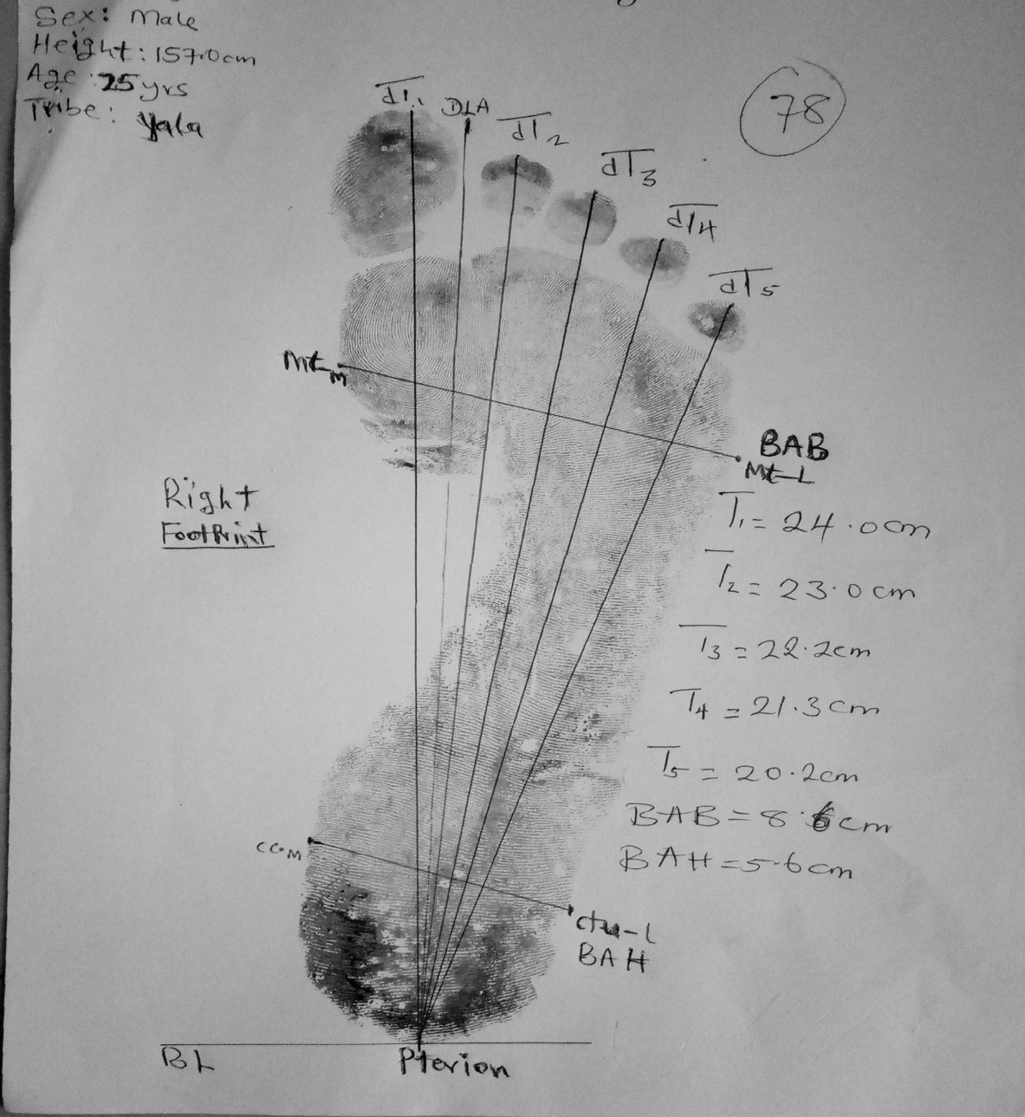
Figure 1: A right footprint and its dimensions

Key to measurement anatomical landmarks: DLA=Designated longitudinal axis, BL=Base line, mt-m= Medial metatarsal point, mt-l= Lateral metatarsal point, ctu-m= Calcaneal concavity medial, ctu-l= Calcaneal tubercle lateral.
Shoe prints measurement
Footwear considered for data collection were flat soled and well fitted shoes, to provide a basis for standardization and to prevent excess length and breadth margins of the shoes. The subjects were asked to put on their shoes and carefully step on the inkpad already smeared with endorsing, before stepping on the plain A3 papers under the supervision of the research team members.
After the footprints outline were taken from the plain paper following the method employed by Okubike et al. (2018), shoe print length was measured using a transparent meter rule calibrated in centimetres, as the direct distance between the top of the tip and the lower margin of the heel of the shoe. Shoe print breadth was measured as the straight distance between the most lateral and medial point of the shoe where the breadth of the print is at its maximum. The values obtained were recorded to the nearest 0.1 cm. Every measurement was taken by one observer in order to avoid inter-observer bias and taken twice to avoid error.

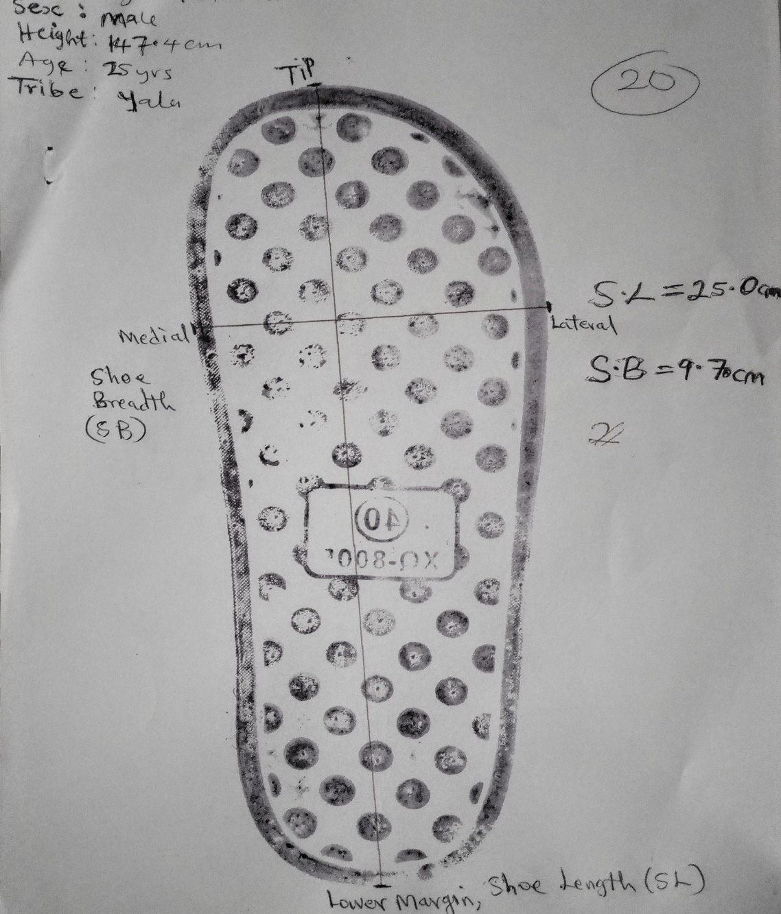
Figure 2: A right shoe print and its length and breadth measurement
Statistical Analysis

The data acquired were subjected to series of analysis using Statistical Package for Social Sciences (SPSS) software version 21, Chicago Inc. The outcome of descriptive statistics is presented as mean, Standard deviation (SD), Standard error of mean (S.E), Minimum (Min) and Maximum (Max) values respectively. Comparisons were made of shoe and footprint dimensions between the males and females using the Student’s (independent) t-test to ascertain if sexual dimorphism exists in the study. The differences were considered
statistically significant at 95% confidence level (i.e., when p < 0.05).
Tests of equality of group means was done to know the reliability of parameters or dimensions that can predict sex with a confidence interval of 99.999 i.e p<0.0001.
Canonical correlation and Wilks Lambda tests were also employed in this study for population group membership and sex predictability between the males and females when Canonical correlation and Wilks Lambda values records p<0.001 respectively.
Functions at group centroids were equally used to present results of sex discrimination cut off (i.e., the demarcation point, which is the average of the mean values for each sex) between the males and their female counterparts. Finally, single and multiple Fisher's linear discriminant functions equations were independently formulated from shoe and footprint dimensions using classification function coefficients to predict sex. The derived equations had separate coefficients and predictions constants unique for individualization of sex.

Results
The present results are documented are in tables 1-11.

Table 1- showing the results of descriptive statistics between the male and female right shoe and footprint dimensions with sexual dimorphism represented similar superscripts
PARAMETERS | MALE  N=115 |  |  |  | FEMALE  N=145
 | Mean±SD | S.E | MIN | MAX | Mean±SD | S.E | MIN | MAX
RT1 (Cm) | 24.10±1.3^{T} | 0.126 | 20.80 | 28.00 | 24.50±1.7^{T} | 1.444 | 20.30 | 32.20
RT2 (Cm) | 23.76±1.3^{R} | 0.125 | 19.40 | 27.20 | 22.73±1.3^{R} | 0.115 | 19.30 | 26.40
RT3 (Cm) | 22.89±1.3^{F} | 0.125 | 18.70 | 26.70 | 21.91±1.3^{F} | 0.112 | 18.10 | 25.30
RT4 (Cm) | 21.86±1.0^{G} | 0.128 | 17.80 | 25.0 | 20.91±20^{G} | 0.104 | 17.60 | 23.80
RT5 (Cm) | 20.42±1.3^{W} | 0.128 | 16.60 | 24.10 | 19.55±1.3^{W} | 0.108 | 16.60 | 22.70
RBAB (Cm) | 9.53±0.8 | 0.076 | 7.90 | 11.70 | 9.76±7.1 | 0.596 | 6.00 | 15.00
RBAH (Cm) | 6.18±4.6 | 0.434 | 3.80 | 5.00 | 5.51±0.7 | 0.061 | 4.10 | 8.00
RSL (Cm) | 24.72±1.6^{V} | 0.156 | 20.50 | 29.20 | 23.71±1.4^{V} | 0.122 | 19.60 | 27.20
RSB (Cm) | 9.49±0.8^{D} | 0.081 | 7.10 | 11.50 | 8.80±0.8^{D} | 0.071 | 7.10 | 11.40
Shoe and footprints dimensions with similar superscripts are statistical significant different at P<0.05.
Key=RT1= Right foot length at big toe, RT2= Right foot length at second toe, RT3= Right foot length at third toe, RT4= Right foot length at fourth toe, RT5= Right foot length at fifth toe, RBAB= Right breadth at ball, RBAH= Right breadth at hill, RSL= Right Shoe length, RSB=Right shoe breadth
The result from table 1, shows the outcome of descriptive statistics alongside independent sample test for sexual dimorphism for the right shoe and footprints. It is observed from this results that almost all the shoe and footprint parameters recorded statistical significant difference (P<0.05) with the males having consistently higher values than their female counterparts except footprint breadth (RBAB and RBAH) that did not show any difference in both sexes.

Table 2-showing the results of descriptive statistics between the male and female left shoe and footprint dimensions with sexual dimorphism represented similar superscripts
PARAMETERS | MALE  N=115 |  |  |  | FEMALE  N=145
 | Mean±SD | S.E | MIN | MAX | Mean±SD | S.E | MIN | MAX
LT1 (Cm) | 24.23±1.41^{A} | 0.13 | 20.90 | 27.70 | 23.12±1.2^{A} | 0.101 | 20.10 | 26.30
LT2 (Cm) | 23.85±1.4 | 0.135 | 19.60 | 27.90 | 24.13±1.5 | 1.327 | 19.20 | 24.50
LT3 (Cm) | 23.05±1.3^{B} | 0.130 | 19.20 | 26.80 | 21.95±1.3^{B} | 0.111 | 18.00 | 24.90
LT4 (Cm) | 21.99±1.3^{X} | 0.129 | 18.60 | 25.50 | 20.961±1.3^{X} | 0.109 | 17.90 | 24.50
LT5 (Cm) | 20.59±1.3^{Z} | 0.124 | 17.50 | 23.70 | 19.602±1.3^{Z} | 0.115 | 17.00 | 24.70
LBAB (Cm) | 9.50±0.8 | 0.075 | 7.80 | 11.70 | 9.47±0.8 | 0.066 | 6.10 | 11.00
LBAH (Cm) | 6.28±4.7^{H} | 0.442 | 4.50 | 56.00 | 5.587±0.7^{H} | 0.060 | 3.80 | 8.00
LSL (Cm) | 24.76±2.0^{T} | 0.194 | 10.40 | 28.6 | 23.770±1.5^{T} | .1249 | 19.00 | 27.90
LSB (Cm) | 9.53±1.6^{J} | 0.158 | 7.30 | 25.10 | 8.74±0.8^{J} | 0.072 | 6.00 | 11.00
Shoe and footprints dimensions with similar superscripts are statistical significant different at P<0.05
Key=LT1= Leftt foot length at big toe, LT2= Left foot length at second toe, LT3= Leftt foot length at third toe, LT4= Leftt foot length at fourth toe, LT5= Leftt foot length at fifth toe, LBAB= Left breadth at ball, LBAH= Leftt breadth at hill, LSL= Leftt Shoe length, LSB Leftt shoe breadth
Table 2 depicts the results of descriptive statistics as well as the independent sample test between the male and female left shoe and footprints variables. Here also the output recorded significantly (P<0.05) higher values in males than the females across majority of the shoe and footprint dimensions except left shoe length at second toe (LT2) and Left Breadth at ball (LBAB)

Table 3- Shows the result tests of equality of group means
 | Wilks' Lambda | F | df2 | Sig. (P-value)
RTI | 1.000 | 0.062 | 258 | <0.001*
RT2 | 0.877 | 36.024 | 258 | <0.001*
RT3 | 0.884 | 33.699 | 258 | <0.001*
RT4 | 0.883 | 34.154 | 258 | <0.001*
RT5 | 0.904 | 27.447 | 258 | <0.001*
RBAB | 1.000 | 0.117 | 258 | <0.001*
RBAH | 0.989 | 2.872 | 258 | <0.001*
RSL | 0.908 | 26.181 | 258 | <0.001*
RSB | 0.864 | 40.776 | 258 | <0.001*
LT1 | 0.851 | 45.322 | 258 | <0.001*
LT2 | 1.000 | 0.036 | 258 | <0.001*
LT3 | 0.861 | 41.725 | 258 | <0.001*
LT4 | 0.873 | 37.503 | 258 | <0.001*
LT5 | 0.883 | 34.128 | 258 | <0.001*
LBAB | 0.954 | 12.465 | 258 | <0.001*
LBAH | 0.988 | 3.075 | 258 | <0.001*
LSL | 0.928 | 19.896 | 258 | <0.001*
LSB | 0.916 | 23.639 | 258 | <0.001*
Shoe and footprint variable with Wik’s Lambda values having P<0.001 are good predictors of sex. Meaning this prediction using the measured variables has a confidence interval of prediction of about 99.999%
From table 3, shows the results of tests of equality of group means carried out from eighteen (18) shoe and footprints dimensions. This test of equality of mean difference for male and female values entered are statistically significant (P< 0.001). This can be inferred that this parameters values can reliably predict sex.

TESTS OF EQUALITY IN POPULATION COVARIANCE MATRICES AND CANONICAL CORRELATION
Table 4- presents the result of Tests of equality in population covariance matrices and canonical correlation
Test Results
Box's M |  | 3051.115
F | Approx. | 16.527
 | df1 | 171
 | df2 | 183895.408
 | Sig. | 0.001*
Eigenvalues
Function | Eigenvalue | % of Variance | Cumulative % | Canonical Correlation
1 | 0.338ª | 100.0 | 100.0 | 0.803
Table 4, shows the Box’s M test of equality in population, covariance matrices as well as the canonical correlation, provides an index of overall model fit. Significant difference (p<0.001) was observed in the Box’s M covariance matrix; hence equal group variance cannot be assumed. This suggests a larger discrepancy in the predictor variables. However, the magnitude or the actual effect size of the predictors (being the canonical coefficients) and the outcome becomes the square of the coefficient of the canonical correlation (0.803)², suggests that the model can only explain 64.48% of the grouping (discriminating) variables (i.e. the sex of the individual).

Table 5- Present Wilks' lambda test for predictability into group membership
Wilks' Lambda
Test of Function(s) | Wilks' Lambda | Chi-square | df | Sig.
1 | 0.747 | 72.504 | 18 | 0.001*
Table 5 shows results of Wilks' lambda test for predictability into group membership as presented showed that the predictor variables will make statistically significant predictions (Wilk’s lambda = 0.747, P< 0.001).
Table 6- shows results of Canonical discriminant function coefficient structured, standardized and unstandardized
 | Box's M Structure Matrix  Coefficients | Standardized canonical  Discriminant function coefficients | Unstandardized canonical  Discriminant function coefficients
Variables (cm) | Functionª | Function | Function^{b}
LT1 | 0.721*** | -0.096 | -0.007
LT3 | 0.692*** | -0.165 | -0.120
RSB | 0.684*** | -0.532 | -0.394
LT4 | 0.656*** | 0.547 | 0.417
RT2 | 0.643*** | 0.062 | 0.046
RT4 | 0.626*** | -0.133 | -0.025
LT5 | 0.626*** | 0.053 | 0.017
RT3 | 0.622*** | 0.019 | 0.012
RT5 | 0.561*** | 0.370 | 0.429
RSL | 0.548*** | 0.314 | 0.240
LSB | 0.521*** | -0.022 | -0.002
LSL | 0.478** | 0.074 | 0.054
LBAB | 0.378** | -0.354 | -0.263
LBAH | 0.188** | 0.527 | 0.386
RBAH | 0.181** | 0.151 | 0.189
RBAB | -0.037* | 0.178 | 0.056
RTI | -0.027* | 0.281 | 0.157
LT2 | -0.020* | 0.345 | 0.265
Constant |  |  | -19.343
Variables with asterisk represents hierarchy of predictability strenght; ***strong predictions; **average prediction; *poor prediction.
From table 6, the unstandardized coefficients used to generate the discriminant function equation. The discriminant function coefficient (unstandardized) indicates the partial contribution of each variable in the discriminant function equation. These values provide information on the relative importance of each variable and are therefore used to assess each individual’s variables unique contribution to the discriminant function equation.

Table 7- shows the results of functions at group centroids
SEX | Function
MALE | 0.650
FEMALE | -0.516
Unstandardized canonical discriminant functions evaluated at group means

Table 7, depicts the results of group centroids (the group mean of the predictor variables), is a function of group membership or classification and also serves as a classification cut off thus a medium of discrimination. As observed, the males have a group mean of 0.650, while the females have a group mean of -0.516. Hence functions at group centroids with a group mean near to a centroid is predicted to belong to that group (i.e. close to 0.650 as male, while -0.516 as female).

TABLE 8- Classification function coefficients of left and right shoe print dimensions of the males and females
Classification Function Coefficients
 | SEX
 | MALE | FEMALE
RSL | 8.72 | 8.44
RSB | 8.27 | 7.49
(Constant) | -147.87 | -133.82
LSL | 8.55 | 8.18
LSB | 7.36 | 6.82
(Constant) | -141.76 | -127.83
Fisher's linear discriminant functions
According to table 8, which shows the outcome of classification function coefficients of left and right shoe prints of the males and females carries the multiple equations. It is observed that once the discriminant functions are determined groups are differentiated, the utility of these functions can be examined via their ability to correctly classify each data point to their priority groups. Again in Table 8, classification function coefficients also known as linear discriminant functions are presented. Classification functions derived from the linear discriminant functions are used to achieve this purpose.

EQUATION 1: MALE FISCHER LINEAR DISCRIMINAT FUNCTION (Right shoe)
From Fischer’s Linear discriminant function equation is presented as C_{k}= C_{k0} + C_{k1}x₁ + C_{k2} x ₂ +...+ C_{km}X_{m}. Where C_{k}is the classification score for group k and C is the Coefficient. These coefficients are presented for each parameter according to sex.

8.72 (RSL) + 8.27 (RSB) -147.87.
The values of the above equation are gotten from table 8.
EQUATION 2: MALE FISCHER LINEAR DISCRIMINAT FUNCTION (Left shoe)
8.55 (LSL) + 7.36 (LSB) -141.76. The vales
The values of the above equation are gotten from table 8.
EQUATION 3: FEMALE FISCHER LINEAR DISCRIMINAT FUNCTION (Right shoe)
8.44 (RSL) + 7.49 (RSB) -133.82
The values of the above equation are gotten from table 8.
EQUATION 4: FEMALE FISCHER LINEAR DISCRIMINAT FUNCTION (Left shoe)
8.18 (LSL) + 6.82 (LSB) -127.83
The values of the above equation are gotten from table 8.

TABLE 9- Classification function coefficients of combined footprint dimensions for multiple discriminant equations.
She and foot dimensions | SEX
 | MALE | FEMALE
RTI | 0.03 | 0.04
RT2 | 2.67 | 2.46
RT3 | -7.94 | -7.28
RT4 | 9.60 | 8.92
RT5 | 3.45 | 3.58
RBAB | 0.00 | 0.02
RBAH | -0.46 | -0.49
LT1 | 9.29 | 8.98
LT2 | 0.10 | 0.10
LT3 | -0.65 | -0.97
LT4 | -5.63 | -5.23
LT5 | 3.70 | 3.38
LBAB | 10.62 | 10.33
LBAH | 0.09 | 0.04
(Constant) | -214.07 | -196.45
Fisher's linear discriminant functions

Table 9, presents outcome of function coefficients for classification combined footprint dimensions documented for males and female showing different coefficient values that depicts variation in gender.

EQUATION 5: MALE FISCHER MULTI-LINEAR DISCRIMINAT FUNCTION
0.03 (RTI) 2.67 (RT2) -7.94 (RT3) + 9.60 (RT4) + 3.45 (RT5) + 0.00 (RBAB) -0.46 (RBAH) + 9.29 (LTI) + 0.10 (LT2) -0.65 + (LT3) -5.63 (LT4) 3.70 (LT5) 10.62 (LBAB) + 0.09 (LBAH)-214.07

EQUATION 6: MALE FISCHER MULTI-LINEAR DISCRIMINAT FUNCTION
0.04 (RTI) + 2.46 (RT2) -7.28 (RT3) + 8.92 (RT4) + 3.58 (RT5) + 0.02 (RBAB) -0.49 (RBAH) + 8.98 (LTI) + 0.10 (LT2) -0.97 (LT3) -5.23 (LT4) + 3.38 (LT5) + 10.33 (LBAB) + 0.04 (LBAH)-196.45

Table 10-Present the results of Classification Summary of variables
Prediction (%) |  | SEX | Predicted Group Membership |  | Total
 |  |  | MALE | FEMALE
Original | Count | MALE | 92 | 33 | 115
 |  | FEMALE | 32 | 113 | 145
 | % | MALE | 73.9 | 26.1 | 100.0
 |  | FEMALE | 25.5 | 74.5 | 100.0
Cross-validated^{b} | Count | MALE | 90 | 35 | 115
 |  | FEMALE | 42 | 103 | 145
 | % | MALE | 65.2 | 34.8 | 100.0
 |  | FEMALE | 29.0 | 71.0 | 100.0
a. 84.2% of original grouped cases correctly classified.
c. 78.6% of cross-validated grouped cases correctly classified.

Table 10, presents classification summary of the shoe and footprint dimensions. As observed, 84.2% of the foot parameters measured were ab initio correctly classified according to sex; however, upon cross validation, 76.8% of the grouped cases therefore accurately classified. This prints parameters based on classification summary are reliable in predicting sex.

RESULT SUMMARY
It was observed that shoe and footprint parameters such as LT1 (0.721), LT3 (0.692), RSB (0.684), LT4 (0.656), RT2 (0.643), RT4 (0.626), LT5 (0.626) are the variables with the highest prediction strength for group membership classification, with the least being R5DPL (-0.020). According to the classification summary 84.2% of the foot parameters measured were ab initio correctly classified according to sex; however, upon cross validation, 76.8% of the grouped cases therefore accurately classified.

DISCUSSION

Shoe and Footprints are often seen as trace evidence at crime scenes and are also an actual representation of the foot size. The similar guidelines regarding foot measurements therefore can be extrapolated to footprints. This study combines both shoe and footprint dimensions to derive discriminant function equations that will be applicable to a forensic expert seeking to predict sex of an adult Cross River State population.

The results of the descriptive statistics for this study was documented in tables 1 and 2, for the male and female samples respectively. This results showed statistical significant differences (P<0.05) in all the shoe dimensions (RSL, RSB, LSL, LSB) with consistent higher values in the male than the female values both the left and right shoe print dimensions recorded statistical significant difference (p<0.05). It was also observed from this results that almost all the footprint parameters recorded statistical significant difference (P<0.05), here also the males recorded higher values than their female counterparts except for footprint breadths (LBAB, RBAB and RBAH) and length at second toe (LT2) that did not show any significant difference in both sexes.
The findings of Hemy et al. (2013) on sex estimation using anthropometry of feet and footprints in a Western Australian population, showed different mean values when compared with the present data. The mean values showed that adults of Cross River population has higher values for foot dimensions compared to that of an Australian population. Moreso, the works of Ozden et al. (2005) on stature and sex estimate using foot and shoe dimensions amongst adults of Turkey differs from the current results among Nigerians. But the two works showed significant difference between the males and females which conforms to the present data.

The present result from tables 3-11 showed different Discriminant function analysis (DFA) for sex determination using all eighteen (18) parameters, variable with Wik’s Lambda values having P<0.001 are good predictors of sex, indicating that prediction using this measured variables has a confidence interval of prediction of 99.999% (Table 3).
This result showed equality in population covariance matrices and canonical correlation of (0.803)², which is converted to percentage and suggests that the model can only explain 64.48% of the grouping (discriminating) variables (i.e. the sex of the individual) as seen in tables 4 and 5 respectively. Although the correlation values is not the same with other studies done by Asala et al. (2004) and Abdel et al. (2007), conveys that there is a strong relationship between shoe and footprints parameters with gender.
The outcome of Wilks' lambda test for predictability into group membership presented in table 4, reveals that the predictor variables will make statistically significant predictions where Wilk’s lambda = 0.747 and p-value is less than 0.001 for 99.999% confidence level. From table 6, the results of Canonical discriminant function coefficient structured, standardized and unstandardized. Here variables with asterisk represents hierarchy of predictability strenght, ranging from strong predictions; average prediction; and poor prediction. Where left and right shoe and footprints dimensions (LT1, LT3, LT4, RSB, RT1, RT2, RT4, LT5, RT3, RT5, RSL and LSB) parameters shows strong predictions of sex. Meanwhile LSL, LBAB, LBAH and RBAH parameters showing average predictions of sex using shoe and footprint dimensions with RBAB, RTI and LT2 parameters showing poor prediction strength.
As presented in table 7, the outcome of the group centroids (the group mean of the predictor variables), which is a function of group membership or classification and also serves as a classification cut off. This results tabulate a group mean of 0.650 and -0.516 for the males and females respectively. Hence functions at group centroids with a group mean near to a centroid is predicted to belong to that group (i.e. close to 0.650 as male, while -0.516 as female). These values for group mean centroids for the prediction of gender did not conform to the findings by Bidmos and Asala, [2003] and Deepashini et al. [2014]. Because no two population can record exact values of shoe and footprint dimensions.

The outcome of classification function coefficient also known as linear discriminant functions were presented in table 8. This study formulated unique linear Fischer discriminant equations from the left and right shoe and footprints dimensions for prediction of sex. According to table 8, the various formulas constants of -161.55 in the males and -146.12 in females respectively for shoe print parameters. The values also showed linear discriminant functions with relative constants of -147.87 and 141.76 for the males’ right and left shoe prints dimensions equations. Meanwhile, the female shoe prints equations constants recorded -133.82 and -127.83 respectively for the right and left sides. Again, this constants and equations derived are very contrary to the formulas published by Ozden et al. [2005] amongst Turks, Hemy et al. [2013] in an Australian Populace, Deepashini et al. [2014] among polish adults. Even the report of Atamturk and Duyar, [2008], amongst the Turks and the research of Fawzy and Kamal [2010].

Nevertheless, the findings by Atamturk and Duyar [2008] on the Turks derived discriminant function cut offs and prediction accuracy percentages ranging between 79.5%-89.5% and 66.7%-82.4% respectively for sex determination using footprints dimensions. Fawzy and Kamal, [2010] also speculated that even though all footprints dimensions were jointly used, a perfect (i.e 100%) accuracy of sex determination would be unattainable but the precision level and reliability test had with a very high group centroid cut off is capable of sex individualization. This their assertion further buttress the usability of the derived formulas from the present study. Therefore, the Fischer Linear discriminant function equations derived from this study for prediction of sex is totally different from those formulated in previous literature. Thus, this formulas are population specific and cannot be applied in any other tribe or ethnic descent.

CONCLUSION

The utility and reliability of sex determination standards developed from shoe and footprints dimensions amongst adults of Cross River State are of great significance in forensic practice. The current study have shown that the accuracy of shoe and footprint dimensions in sex determination is relatively high. The recorded foot index measurement is higher in the males compared to the females. This difference in group function centroids cut offs between the males and females showed gender differences in footwear and footprint dimensions. Even though this results cannot be applied in every world populations, it is recommended that other works be conducted in other world population.

ACKNOWLEDGEMENT

Authors wishes to appreciate the painstaking efforts of the study subjects who sacrificed their time during the data collection exercise.

Conflict of interest: No conflict of interest among the authors and subjects.

REFRENCES

Abdel M, Wafaa M, Abdel H, Randa H, Abdel M, Ragaa M, Fathy H, Hamed A. (2008). Identification of
sex depending on radiological examination of foot and Patella. The American Journal of Forensic Medicine and Pathology. 29 (2):136-140.

Asala, S.,A., Bidmos, MA and Dayal MR. (2004): Discriminant function sexing of fragmentary femur of
South African blacks. Forensic Science International. 145: 25–49.

Ashley W. (1996). What shoe was that? The use of computerized image database to assist in identification.
Forensic Science International. 82(1):7-20.

Adair, TW, Lemay J, McDonald A, Shaw R and Tewes R. (2007). The Mount Bierstadt Study: An Experiment in Unique Damage Formation in Footwear. Journal for Identification. 57 (2): 199-205.

Basu N and Bandyopadhyay SK. (2017): Crime scene reconstruction— Sex prediction from blood stained foot
sole impressions. Forensic Sci. Int’l. 278:156-72.

Bates KT, Savage R, Pataky TC, Morse SA, Webster E, Falkingham PL, et al. (2013). Does footprint
depth correlate with foot motion and pressure. R. Soc Interface.; 10: 1–11.

Belser C, Ineichen M And Pfefferli P. (1996): Evaluation of the ISAS system after two years of practical
experience in forensic police work. Forensic Science International. 82: 53–58.

Bidmos, MA. &Asala, AA. (2003): Discriminant function sexing of the calcaneus of the South African
whites. – Journal of Forensic Science. 48:1213–1218.

Deepashini H, Omar B, Paungmali A, Amaramalar N, Ohnmar H, Leonard J. (2014): An insight into the plantar
pressure distribution of the foot in clinical practice: Narrative review. Polish Ann Med. Polish Pediatric Society. 21: 51–56.

Fernando R and Vanezis P. (1998): Medicolegal aspects of the Thai airbus crash near Katmandu, Nepal:
findings of the investigating pathologists. − Am. Journal of Forensic Medical Pathology. 19, 169–173.

Fawzy IA and Kamal NN (2010). Stature and body weight estimation from various footprint measurements
among Egyptian population. J Forensic Sci. 55: 884-8.

Giles E. and Vallandigham PH. (1991): Height estimation from foot and shoeprint length. Journalof Forensic
Science. 36, 1134–1151

Hatala KG, Dingwall HL, Wunderlich RE, Richmond BG. (2013). The relationship between plantar
pressure and footprint shape.J Hum Evol. Elsevier Ltd. 65: 21–28.

Hamer P and Price C. (1993): Case report: a transfer from skin to clothing by kicking the detection andenhancement of shoeprints. J. Forensic Sci. 33:169–172.
Hemy N, Flavel A, Ishak N, Franklin D. (2013). Sex estimation using anthropometry of feet and footprints in
a Western Australian population. Forensic Sci Int. Elsevier Ireland Ltd. 231: 402-402.

Kennedy R.,B. (1996): Uniqueness of bare feet and its use as a possible means of identification. Forensic Sci
Int. 82: 81–87.

Krauss I, Grau S, Mauch M, Maiwald C, Horstmann T. (2008). Sex-related differences in foot shape.
Ergonomics. 51: 1693–1709.

Kanchan T, Krishan K, Disha P, Meghna M. (2014). Heel-Ball index:An analysis of footprint dimensions for
determination of sex. Egypt J Forensic Sci. Forensic Medicine Authority. 4: 29–33.

Krishan K, Kanchan T, Passi N, DiMaggio JA. (2012). Heel-ball (HB) index: sexual dimorphism of a new
index from foot dimensions. J Forensic Sci. 57: 172–175.

Krishan, K. (2007): Individualizing characteristics of footprints in Gujjars of North India – forensic aspects. –
Forensic Sci. Internat.169, 137–144.

Krishan K. (2008). Estimation of stature from footprint and foot outline dimensions in Gujjars of North India.
Forensic Sci Int. 175: 93–101.

Laskowski E and Kyle VL. (1988): Barefoot impressions: a preliminary study of identification characteristics
and population frequency of their morphological features. J. Forensic Sci. 33: 378–388.

Luikkonen M, Majamaa, H and Virtonen, J. (1996): The role and duties of the shoeprints/ loolmark examiner
in forensic laboratories. − Forensic Sci. Internat.82, 99–108.

Moorthy NT, Bin Mostapa AM, Boominathan R, Raman N. (2014). Stature estimation from footprint
Measurements in Indian Tamils by regression analysis. Egypt J Forensic Sci. Forensic Medicine Authority; 4: 7–16

Music, DK and Bodziak WJ. (1988). Evaluation of the air bubbles present in polyurethane shoe outsoles as
applicable in footwear impression comparisons. J. Forensic Sci. 33, 1185–1197.

Okubike EA, Nandi ME, Iheaza EC and Obun CO. (2018). Stature Prediction using Shoe Print Dimensions of
an Adult Nigerian Population. Arab Journal of Forensic Sciences & Forensic Medicine; 1 Issue (8), 989-1003

Ozden H, Balci Y, Demiru C, Turgut A, Ertugrul M. (2005). Stature and sex estimate using foot and shoe
dimensions. Forensic Sci Int.; 147: 181–184.

Periyasamya R, Mishraa A, Sneh A and Amminib AC. (2011). Preliminary investigation of foot pressure
distribution variation in men and women adults while standing. Foot.; 21: 142–148.

Patil KR and Mody RN. (2005). Determination of sex by discriminant function analysis and stature by
regression analysis: a lateral cephalometric study. Forensic Sci Int; 147: 175–80.

Rutishauser HE. (1968). Prediction of height and weight from size of foot prints. − J. Forensic Sci. 43, 310–
313. Saxena, S.K. (1984): A study of correlation of from hand length, hand breadth and sole length. − Anthrop. Anz. 42, 271–276.

Tsung BYS, Zhang M, Fan YB, Boone DA. (2003). Quantitative comparison of plantar foot shapes under
different weight-bearing conditions. J Rehabil Res Dev.; 40: 517.

Ukoha U, Egwu O, Ezeani M, Anyabolu A, Ejimofor O, Nzeako H. (2013).Estimation of stature using
Footprints in an adult student population inNigeria. Int. J Biomed Adv Res. 4:11-15.

Wunderlich RE, Cavanagh PR. (2001). Gender differences in adult foot shape: implications for shoe design.
Med Sci Sports Exerc. 33: 605–611.

