THE EFFECT OF ATRIPLEX HALIMUS L. AQUEOUS EXTRACT ON DEHYDROEPIANDROSTERONE-INDUCED FEMALE HORMONE DISORDERS IN RATS
Khadidja GHOMID ^{1, 2}, Okkacha HASNAOUI ³, Abdelkader AMMAM ⁴, Farouk BOUDOU¹, Amal BELAKREDAR^{1, 2}

- Department of Environmental Sciences, Faculty of Nature and Life Sciences Djillali Liabes University Sidi-Bel-Abbes-Algeria
- Laboratory for The Eco-Development of Spaces, Department of Environmental Sciences, Faculty of Nature and Life Sciences Djillali Liabes University Sidi-Bel-Abbes-Algeria.
- Laboratory of Ecology and Management of Natural Ecosystems, Department of Biology, Abou Bakr Belkaid University of Tlemcen, BP 119, 13000 - Algeria
- Laboratory of Biotoxicology, Pharmacognosy and Biological Valorization of Plants (LBPVBP), Department of Biology, Faculty of Sciences University Dr. Tahar Moulay Saida- Algeria.
E-mail : ghomid_khadidja@yahoo.com
Abstract
Dehydroepiandrosterone (DHEA) is the most common circulating steroid in the human body and is an essential precursor hormone. Exogenous DHEA, on the other hand, has been shown to cause endocrine disorders in women. Indeed, the use of medicinal plants is of great help in the treatment of female disorders. Thus, the aim of this study is to evaluate the prophylactic and/or therapeutic effect of the aqueous extract of Atriplex halimus L. on sex hormone balance. For this purpose, Female rats were subjected for a period of 21 days to a plant extract dose of 5g/kg body weight (BW)/day (D) either before or after receiving a DHEA dose of 60 mg/kg BW/D for 21 days. The results of the present study show that the administration of DHEA leads to a significant decrease in the level of the luteinizing hormone followed by a significant increase in the level follicle-stimulating hormone, estradiol and progesterone. While treatment with aqueous extract of A. halimus L. either before or after DHEA exposure was able to regulate these hormones and counteract the adverse effects of DHEA supplementation.
Keywords: Atriplex halimus L., Dehydroepiandrosterone, Estradiol, Follicle-stimulating hormone, Luteinizing hormone, progesterone.
INTRODUCTION:
Dehydroepiandrosterone (3β-hydroxy-5-androsten-17-one, DHEA) is a major blood hormone (steroid) in humans and some other primates. Levels change markedly during the life span, rising during early childhood and declining subsequently with age (Gurnell et al. 2007). Pregnenolone is converted to DHEA, which is then metabolized to androstenedione, testosterone, and estrogens (Aoki and Terauchi, 2018). DHEA is produced in the adrenal cortex's zona reticularis, the ovarian theca cells, the testes' Leydig cells, and the brain. DHEA and its 3-sulfated metabolite DHEA-S are plentiful in the bloodstream, but their levels decrease with age (Klinge et al. 2018). Women's DHEA levels fall with age, with women in their 80s having roughly 75% less DHEA than women in their 20s. As a result of this decline, it has been proposed that treating postmenopausal women with DHEA will enhance BMD (Bone in Postmenopausal Women) (Al-Saqi, 2014). DHEA is heavily promoted as an anti-aging supplement that will grow muscle, reduce fat, and boost energy, strength, and immunity. There is evidence that DHEA inhibits bone resorption, and DHEA levels in the blood appear to be linked to bone loss. Clinical trials have conflicting or inconsistent data regarding the skeletal site and gender specific benefit of DHEA. Although DHEA may have some skeletal benefit, the benefit may be limited to elderly individuals with low serum DHEA-S. The safety concerns with the use of DHEA include that it may adversely affect liver function, and lead to acne and masculinizing effects (Nieves, 2013). Supplementing with DHEA has gained popularity in people with adrenal insufficiency and as a means of raising androgens and estrogens, which is thought to help with muscle and bone mass gain. DHEA supplementation, on the other hand, has been shown to have deleterious impacts on the lipid profile (Qin et al. 2020). DHEA supplementation in the treatment of perimenopausal symptoms has been shown to significantly affect the endocrine profile, and may affect the lipid profile, but does not improve perimenopausal symptoms or well-being compared to placebo (Barnhart et al. 1999). Furthermore, there are clear evidences that exogenous DHEA induced polycystic ovary syndrome (PCOS) (Wang et al. 2014; Yuan et al. 2016). Polycystic ovary syndrome is a heterogeneous endocrine disorder characterized by irregular menstrual cycles, hirsuitism and polycystic ovaries (Benjamin et al. 2021). Due to a disruption in the endocrine system's balance in PCOS patients, mechanisms governing follicular growth are disrupted, and morphological alterations in the ovaries are detected. The interaction between granulosa cells and oocytes, as well as the development of follicules and oocytes, is disrupted by high levels of luteinizing hormone (LH) (Koçak, 2021). For thousands of years, medicinal plants have played an important role in the treatment and prevention of human diseases. They have a lot of potential for developing new drugs that will be extremely beneficial to humanity (Dar et al. 2017). Among these plants are some species used in the treatment of female disorders related to infertility. They are known to be a prolific source of secondary metabolites that have an important function both in vivo and in vitro during ovarian folliculogenesis and steroidogenesis in many animal species (Mbemya et al. 2017). Some species such as Asparagus Racemosus, Grifola frondosa, Lepidium meyenii, Tinospora Cordifolia, and others, have been highly regarded sources for reducing PCOS symptoms and on the hormonal imbalance caused by these disruptors (Pachiappan et al. 2017). This is the reason why Atriplex halimus was chosen as a medicinal plant suspected to have the potential to treat this imbalance as it is traditionally used more in the treatment of pathologies related to sex hormones (breast cancer, tumours, ovarian cyst, diabetes) (Hamza et al. 2019). A. halimus L. is a halophyte that belongs to the Chenopodiaceae family and is often known as Guetaf. It has a high nutritional and energy value as a human food and a livestock feed. A. halimus is widely used in traditional medicine for a variety of therapeutic purposes. This plant has traditionally been used to treat heart disease, diabetes, rheumatism, urinary tract inflammation (cystites), and stomach and intestine pain; it also goes well with any diet that requires tissue drainage and toxin removal (ZeghIB et al. 2021). Thus, the aim of this study is to evaluate the prophylactic and/or therapeutic effect of the aqueous extract of Atriplex halimus L. on female sex hormone balance.
MATERIALS AND METHODS
Plant Material
The species Atriplex halimus L. was harvested in the region of Ain Skhouna located at 89 km southeast of the city of Saida- Algeria in August 2019. The plant used was identified by Dr. Hasnaoui Oukacha, a botanist at Dr. Moulay Taher university of Saida in Algeria. The leaves were air-dried and ground into a powder that was stored in boxes in a dry place until further use.
Preparation of plant extract
The aqueous extract of A. halimus L. was prepared by the infusion method by subjecting 10 g of plant powder to 100 ml of boiling distilled water for a period of 2 hours with continuous stirring. After the extraction time has been reached, the extract solution was allowed to cool at room temperature. Then, filtered through a cone of filter paper (Whatman no 1), concentrated to dryness using a rotary evaporator, and stored at 4°C until further use. The obtained extract was filtered through a 0.45 mm membrane filter and injected into a high-performance liquid chromatography (HPLC-UV) system using SHIMADZU prominence LC2030C3D apparatus. The analysis of phenols fingerprints was recorded at 254nm, using Ascentis ® C18 HPLC Column - Sigma-Aldrich 15cm× 4.6mm, and 5µm. The mobile phase components consisted of a 0.1% (v/v) aqueous solution of formic acid and methanol (MeOH). The injection volume was 5 μL and the flow rate was 0.4 mL/min.
Animals and experimental design
The experiments were carried out on 36 female albino rats, each weighing 118.5±7.87 g and aged 8 weeks. The rats were kept in a room with a 12/12 h light/dark cycle and a temperature of 22±2°C, with free access to water and a special rodent pellet diet. Rats were randomly allocated into 6 groups, with 6 rats in each group. Dehydroepiandrosterone (DESTERONE® DHEA) and plant extract were administered orally (gavage) with respective doses of 60 mg/kg body weight (BW)/day (D), and 5g/kg BW/D. The first group (G1) received only distilled water by oral route and served as control; The second group (G2) received DHEA for 21 days; The third group (G3) was treated with DHEA during 21 days prior 21 day treatment with plant extract; The fourth group (G4) received only the plant extract for 21 days; The fifth group (G5) received plant extract during 21 days prior 21 day treatment with DHEA; The sixth group (G6) was treated with both DHEA and the extract at the same time for 21 days.
Biological samples collection
At the end of the experiment, vaginal smears were performed to detect the estrous phases of each rat's cycle. The animals were then sacrificed by means of deep anesthesia with diethyl ether in a large desiccator. After incision of the abdomen, blood was collected from the inferior vena cava for determination of hormone levels (Follicle Stimulating Hormone, Luteinizing Hormone, estradiol and progesterone) using commercial immunoassay kits (VIDAS Assays, BIOMERIEUX).
Statistical Analysis
Results were represented as mean ± SD. Data was analyzed using a one-way analysis of variance (ANOVA) followed by Tukey's test using SigmaPlot version 14.0. The degree of significance is shown as *p < 0.05, **p < 0.01, ***p < 0.001.
RESULTS
The HPLC-UV profile of the A. halimus L. obtained by infusion method yielded a chromatogram (Figure 1) of which three peaks were perfectly identified as: Kaempferol, Rutoside, and Apigenin with proportions of 4,016%, 2.042% and 0.382 % respectively (Table 1).

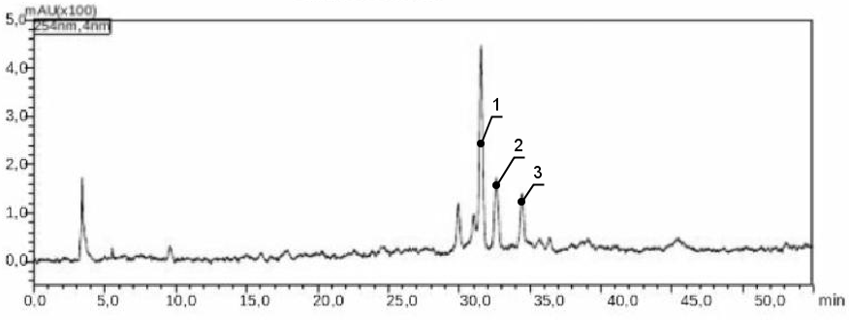
Figure 1. HPLC-UV chromatographic profiles of A. halimus aqueous extract at 254 nm.

TABLE 1. Phenolic Compounds Identified as the result of HPLC-UV of Atriplex halimus L. extract
N° | Identified  compound | Chemical formula | Retention time (min) | Proportion  (%)
1 | Kaempferol | C₁₅H₁₀O₆ | 31,599 | 4,016
2 | Rutoside | C₂₇H₃₀O₁₆ | 32,693 | 2.042
3 | Apigenin | C₁₅H₁₀O₅ | 34,501 | 0.382

The data in Figure 2 show the results of blood serum hormonal parameters determination of the different experimental groups. Indeed, LH hormone levels estimation (Figure 1-A) indicate that the administration of DHEA at a dose of 60 mg/kg BW/D to female rats (G2) induces a significant decrease (P < 0.001) in LH levels compared to control rats (G1), and to rats receiving only the plant extract (G4). Similarly, a significant decrease in LH (P < 0.001) was observed in the groups receiving the plant extract treatment (5g/kg BW/D) either before or after DHEA administration (G3 and G5). On the contrary, the administration of the herbal treatment at the same time as DHEA (G6) countered the adverse effects of this hormone by maintaining a concentration similar to that of the control group. Furthermore, the data collected from the estimation of FSH levels (Figure 1-B) show that the administration of DHEA alone induces a significant increase in FSH levels compared to the control group (G1) and also to the other experimental groups (G3, 4, and 6) with the exception of the group of rats that received the plant extract for 21 days prior to the 21-day treatment with DHEA. While the estimation of estradiol levels (Figure 1-C) shows that the administration of DHEA alone induced in female rats an significant elevation (P < 0.001) of this hormone compared to the control group (G1) and the other experimental groups (G3, 4, 5, and 6). Finally, the estimation of progesterone levels in experimental female rats (Figure 1-D) reveal that DHEA alone causes a significant increase (P < 0.001) in progesterone levels as compared to the control group (G1) and the other experimental groups (G3, 4, and 6), with the exception of the rats that received the plant extract for 21 days previous to the DHEA therapy.

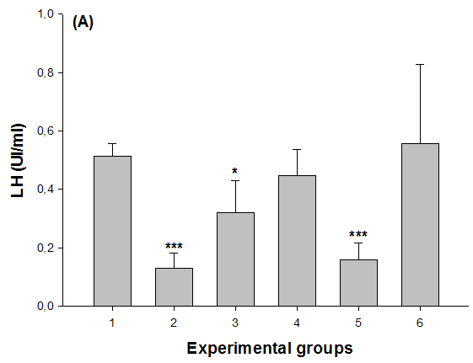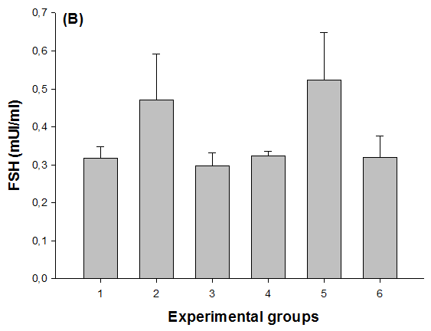
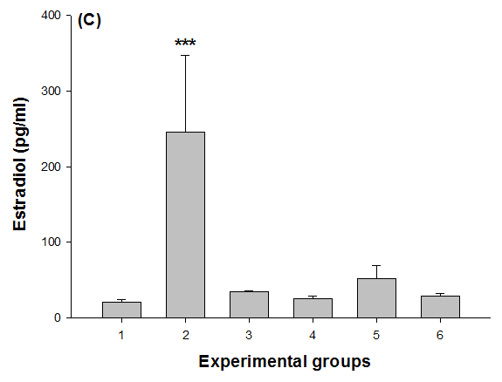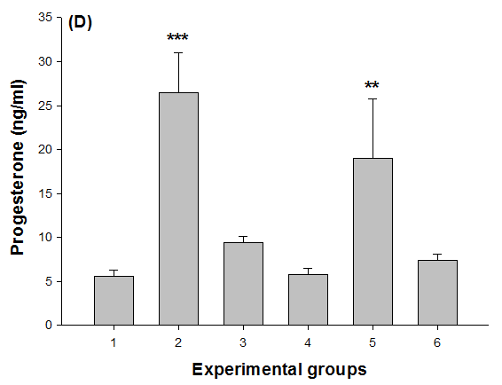
Figure 2. Assessment of hormone levels in the different experimental groups. A: LH levels (U/mL); B: FSH levels (mU/mL); C: estradiol levels (pg/mL); D: progesterone levels (ng/mL).
DISCUSSION
The results of the present study show that the administration of DHEA (60 mg/kg BW/D) to female rats for a period of 21 days leads to a significant decrease in the level of the LH hormone followed by a significant increase in the level of the following hormones: FSH, estradiol and progesterone. Sunkara et al. (2012) confirm that the addition of DHEA may increase FSH receptors in the early stages of folliculogenesis. DHEA could therefore have a beneficial effect on follicle recruitment. Furthermore, the side effect of DHEA on estrogen receptors should not be overlooked. Similarly, a study of DHEA supplementation in cases of decreased ovarian reserve also showed that after DHEA administration, the group of women experienced significant decreases in estradiol levels on the third day of the cycle (Gleicher and Barad, 2011). Furthermore, a case study of two men treated with 50 or 25 mg of DHEA per day over a period of one year revealed a decrease in testosterone and an increase in progesterone, probably depending on the dose of DHEA applied. The hypothesis is that the increase in progesterone parallels an increase in its metabolite, allopregnanolone. The authors conclude that the increase in progesterone under DHEA supplementation in men should be given special attention (Nadjafi-Triebsch et al. 2003). The significant decrease in plasma LH concentration after DHEA administration may also be explained by the negative feedback of progesterone and estradiol on hypothalamic LH neurons (Coutinho and Kauffman, 2019). As previously stated, ovarian estradiol and progesterone secretions govern the sequence of neuroendocrine events that direct ovulatory cyclist through both negative and positive feedback actions in the brain and anterior pituitary gland (Gleicher and Barad, 2011). In addition, this study found that treatment with aqueous Atriplex halimus L. extract counteracts the harmful effects caused by exposure to DHEA. Indeed, the treatment of rats pre-exposed to DHEA (G3) with the plant extract showed a good improvement in LH levels compared to the group of rats (G5) treated with the plant extract before being exposed to DHEA. Whereas, the analysis of the other hormones tested (FSH, estradiol, and progesterone) showed that in both cases of treatment with the plant extract, i.e. before or after the administration of DHEA, A. halimus L. was able to regulate the expression of these three hormones and to counteract the effects of DHEA. This shows that this plant has both prophylactic and curative properties against the harmful effects of DHEA. Since current treatments for diseases such as polycystic ovarian syndrome are not fully effective and have undesirable side effects, attempts must be made to find more beneficial treatment options with minimal side effects. As a result, herbal medicines, which contain several active components without major side effects, have become popular (Eardley et al. 2010). Indeed, it is well known that medicinal plants not only improve reproductive dysfunctions, but also play a remarkable role in balancing hormonal status and menstrual cycles (Moini Jazani et al. 2019). Herbal medicine, which is part of complementary medicine, was first introduced in traditional Persian and Chinese medicine. Chinese herbs have a long history in the management of gynaecological problems and infertility (Hosseinkhani et al. 2018). The main mechanisms of herbal effectiveness in PCOS are not yet fully understood. However, these mechanisms appear to improve the hormonal balance of LH, FSH and testosterone, as well as oxidative stress and metabolic disorders. There is evidence to suggest that certain plants can regulate menstrual cycles and improve fertility by inducing an increase in mid-body progesterone levels, a slight inhibition of FSH release and the stimulation of LH release (Tamanini et al. 2003; Kandasamy et al. 2016). However, a high concentration of polyphenols and flavonoids has been proven in the aqueous extract of Atriplex halimus (Ounaissia et al. 2020; Bouaziz et al. 2021). The presence of flavonoid compounds in these natural extracts was found to converts testosterone to estradiol and decreases serum testosterone levels by increasing aromatase activity (Modaresi et al. 2012). These secondary metabolites have strong antioxidant potential, as antioxidant compounds in plants protect ovarian tissue from oxidative stress in PCOS by decreasing lipid peroxidation, superoxide dismutase, glutathione peroxidase, and reactive oxygen species in ovarian tissue (Ahangarpour et al. 2016).
CONCLUSION
The present study demonstrated that the aqueous extract of Atriplex halimus L. had a remarkable protective effect against hormonal disorders in female rats caused by DHEA administration and its mechanism is related, at least in part, to its richness in secondary metabolites, such as flavonoids that appear to improve the hormonal balance of LH, FSH, estradiol, and progesterone. However, further research is needed to isolate the bioactive compounds and elucidate the mechanism involved in the protective activity of this plant.
REFERENCES
Ahangarpour A., Najimi S. A., & Farbood Y. (2016). Effects of Vitex agnus-castus fruit on sex hormones and antioxidant indices in a d-galactose-induced aging female mouse model. Journal of the Chinese Medical Association 79(11): 589-596.
Al-Saqi S. H. (2014). New approaches to treat women’s urogenital problems, Karolinska Institutet (Sweden).
Aoki K. and Terauchi Y. (2018). Effect of dehydroepiandrosterone (DHEA) on diabetes mellitus and obesity. Vitamins and hormones 108: 355-365.
Barnhart K. T., Freeman E., Grisso J. A., Rader D. J., Sammel M., Kapoor S., & Nestler J. E. (1999). The effect of deydroepiandrosterone supplementation to symptomatic perimenopausal women on serum endocrine profiles, lipid parameters, and health-related quality of life." The Journal of Clinical Endocrinology & Metabolism 84(11): 3896-3902.
Benjamin J. J., Koshy T., & KN M. (2021). DHEA and polycystic ovarian syndrome: Meta-analysis of case-control studies. PloS one 16(12): e0261552.
Bouaziz, S., Amri, M., Taibi, N., Zeghir-Bouteldja, R., Benkhaled, A., Mezioug, D., & Touil-Boukoffa, C. (2021). Protoscolicidal activity of Atriplex halimus leaves extract against Echinococcus granulosus protoscoleces. Experimental Parasitology 229: 108155.
Coutinho, E. A., & Kauffman, A. S. (2019). The role of the brain in the pathogenesis and physiology of polycystic ovary syndrome (PCOS). Medical Sciences 7(8): 84.
Dar R. A., Shahnawaz M., & Qazi P. H. (2017). General overview of medicinal plants: A review. The Journal of Phytopharmacoloy 6(6): 349-351.
Eardley I., Donatucci C., Corbin J., El-Meliegy A., Hatzimouratidis K., McVary K., & Lee S. W. (2010). Pharmacotherapy for erectile dysfunction. The Journal of Sexual Medicine 7(1): 524-540.
Gleicher N., & Barad D. H. (2011). Dehydroepiandrosterone (DHEA) supplementation in diminished ovarian reserve (DOR). Reproductive Biology and Endocrinology, 9(1), 1-12.
Gurnell E. M., Hunt P. J., Curran S. E., Conway C. L., Pullenayegum E. M., Huppert F. A., & Chatterjee V. K. K (2007). A randomised, controlled trial of long-term DHEA replacement in primary adrenal insufficiency. Journal of Clinical Endocrinology and Metabolism 93: 400-409.
Hamza N., Berke B., Umar A., Cheze C., Gin H., & Moore N (2019). A review of Algerian medicinal plants used in the treatment of diabetes. Journal of ethnopharmacology 238: 111841.
Hosseinkhani A., Asadi N., Pasalar M., & Zarshenas M. M. (2018). Traditional Persian Medicine and management of metabolic dysfunction in polycystic ovary syndrome. Journal of traditional and complementary medicine 8(1): 17-23.
Kandasamy S., Inmozhi Sivagamasundari R., Bupathy A., & Sethupathy S. (2016). The plasma nitric oxide and homocysteine levels and their association with insulin resistance in south Indian women with polycystic ovary syndrome.Int J Res Med Sci 4(11): 4829.
Klinge C. M., Clark B. J., & Prough R. A. (2018). Dehydroepiandrosterone research: past, current, and future. Vitamins and hormones 108: 1-28.
Koçak S. (2021). PCOS Animal Models: An Approach Induced By Dehydroepiandrosterone." Experimental and Applied Medical Science 2(1): 136-145.
Mbemya G. T., Vieira L. A., Canafistula F. G., Pessoa O. D. L., & Rodrigues A. P. R. (2017). "Reports on in vivo and in vitro contribution of medicinal plants to improve the female reproductive function. Reprodução & Climatério 32(2): 109-119.
Modaresi M., Mahdian B., & Jalalizand A. (2012). The effect of hydro-alcoholic extract of fenugreek seeds on female reproductive hormones in mice. International Conference on Applied Life Sciences, IntechOpen.
Moini Jazani, A., Nasimi Doost Azgomi, H., Nasimi Doost Azgomi, A., & Nasimi Doost Azgomi, R (2019). A comprehensive review of clinical studies with herbal medicine on polycystic ovary syndrome (PCOS). DARU Journal of Pharmaceutical Sciences 27(2): 863-877.
Nadjafi-Triebsch C., Huell M., Burki D., & Rohr U. D. (2003). Progesterone increase under DHEA-substitution in males. Maturitas 45(3): 231-235.
Nieves J. W. (2013). Alternative therapy through nutrients and nutraceuticals. Osteoporosis, Elsevier: 1739-1749.
Ounaissia K., S. Bennadja, et al. (2020). Phytochemical screening and anti-bacterial activity of methanolic extracts of the aerial parts of Atriplex halimus L., from Biskra (Algeria). International Journal of Agricultural and Natural Sciences 13(1): 26-33.
Pachiappan, S., S. Matheswaran, et al. (2017). Medicinal plants for polycystic ovary syndrome: A review of phytomedicine research. Int J Herb Med 5(2): 78-80.
Qin, Y., H. O. Santos, et al. (2020). Effects of dehydroepiandrosterone (DHEA) supplementation on the lipid profile: A systematic review and dose-response meta-analysis of randomized controlled trials. Nutrition, Metabolism and Cardiovascular Diseases 30(9): 1465-1475.
Sunkara S. K., Coomarasamy A., Arlt W., & Bhattacharya S (2012). Should androgen supplementation be used for poor ovarian response in IVF Human Reproduction 27(3): 637-640.
Tamanini, C., Basini, G., Grasselli, F., & Tirelli, M. (2003). Nitric oxide and the ovary." Journal of Animal Science 81(14_suppl_2): E1-E7.
Wang Y. X., Zhu W. J., & Xie B. G. (2014). Expression of PPAR-γ in adipose tissue of rats with polycystic ovary syndrome induced by DHEA. Molecular medicine reports 9(3): 889-893.
Yuan, X., Hu, T., Zhao, H., Huang, Y., Ye, R., Lin, J., & Chen, Z. J.. Brown adipose tissue transplantation ameliorates polycystic ovary syndrome. Proceedings of the National Academy of Sciences 113(10): 2708-2713.
ZeghIB, K., BoUtlelIS, D. A., MeNAI, S., & DeBoUBA, M. (2021). Protective effect of Atriplex hAlimus extract against benzene-induced haematotoxicity in rats. Vol. 93, N 4

