Study on Biosorption of Lead (II) and Manganese (II) from Aqueous Solutions Using Sodium Alginate and Pleurotus ostreatus (Oyster Mushroom) Beads
Tin Myat Myat Soe^{1*}, Nyein Min Zaw² and Ngu Wah Thinn³
¹Mandalay Technological University, Mandalay, Myanmar
²Mandalay Technological University, Mandalay, Myanmar
³Mandalay Technological University, Mandalay, Myanmar
Corresponding author email: tinmyatmyatsoe1977@gmail.com*

A B S T R A C T
This study investigates the biosorption of lead (II) and manganese (II) in aqueous solutions using sodium alginate and mushroom (Pleurotus ostreatus) beads as adsorbents. In Mandalay City, heavy metal contamination was found above WHO standards. Heavy metals are toxic to not only every organ but also every system in the human body. To address this problem, a mixture of mushroom and alginate beads was used to remove lead (Pb) and manganese (Mn) concentrations from synthetic solutions. These experiments were carried out by varying initial metal concentrations, biosorbent dosages, and pH. The reduction percentages of Pb (II) and Mn (II) were determined by an atomic absorption spectrophotometer (AAS). The combination of alginate and mushrooms resulted in above 75% reduction in Pb and 55% reduction in Mn. Mushrooms showed the most significant effect on the reduction of the metals in both experiments. The analysis of the FTIR spectrum showed that the uptake of metal ions by mushrooms involves interactions of ions with hydroxyl, carboxyl, and amide groups. This research contributes basic knowledge to the development of environmentally sustainable approaches to mitigate metal pollution through the application of natural adsorbents. The aim of this study is to develop efficient and sustainable methods for mitigating the environmental impact of lead and manganese contamination through biosorption.

KEYWORDS: AAS, biosorption, FTIR, heavy metal, mushroom and alginate bead.

INTRODUCTION
Heavy metals are naturally occurring elements in the Earth's crust since its formation, posing serious risks to human health and the environment. Groundwater and surface water contamination by heavy metals is a global concern, particularly in low-income or developing countries. Most heavy metals are non-biodegradable and tend to accumulate in living organisms (Kamarudzamana et al., 2015; Taliba, A. S et al., 2005).
In Myanmar, heavy metal pollution has been reported in various regions, including Mandalay, where population growth has exacerbated environmental challenges. Studies have identified the presence of calcium (Ca), copper (Cu), magnesium (Mg), mercury (Hg), arsenic (As), manganese (Mn), lead (Pb), iron (Fe), and zinc (Zn) in water samples, with concentrations sometimes exceeding WHO standards (Kamarudzamana et al., 2015; Taliba, A. S et al., 2005; WHO 2008; WHO 2011; Bacquart et al., 2015).
The removal or reduction of these heavy metals is crucial for human health and environmental protection. Researchers have investigated various techniques, including physical, chemical, and biological methods, to address this issue. While these methods have shown promise, challenges such as high costs, sludge production, and technical constraints remain (Chen G.et al., 2023).
Water, essential for all life forms, supports plants, animals, and human life. However, heavy metal contamination in groundwater is a serious issue globally. In Myanmar, Mandalay has seen a rise in population, leading to increased studies on heavy metals since 2014. Samples from regions like Aung-Myay-Tharzan, Chan-Aye-Tharzan, Chan Mya-Tharzi, Mahar-Aung-Myay, Pyi-Gyi-Tagon, and Amarapura have shown levels of calcium (Ca), copper (Cu), magnesium (Mg), mercury (Hg), arsenic (As), manganese (Mn), lead (Pb), iron (Fe), and zinc (Zn). Lead is particularly toxic to every organ and system in the human body, with the maximum acceptable lead limits in water set at 0.01 mg/L (10 µg/L) by the World Health Organization (WHO 2011; Maw. A. M.et al.,2020). Similarly, excessive manganese (Mn) in the environment can cause health issues. The WHO suggests a concentration of manganese in drinking water should be less than 0.05 mg/L (USEPA 2013; WHO 2011; Chen, G et al., 2023). In 2015, it was reported that the concentrations of manganese and other metals were found unsafe in many wells in Myanmar (Bacquart et al., 2015)
Recent studies have explored biosorption and adsorption methods for heavy metal removal, utilizing materials like chitosan, bentonite, zeolite, and alginate as biosorbents. Alginate, extracted from brown marine algae and bacterial sources, has shown promise for heavy metal removal. Its high surface area, biocompatibility, and abundance make it an attractive option. Alginate works by forming complexes with metal ions, effectively sequestering them from aqueous solutions. Studies have demonstrated its effectiveness in removing various heavy metals, including lead, copper, cadmium, and nickel. Alginate-based adsorbents are relatively easy to prepare and can be tailored to specific metal removal requirements, making them a promising candidate for future research in heavy metal remediation ( Kamarudzamana et al., 2015 ; Xiangliang, P et al ., 2005).
Mushroom was excellent in both binding properties and tolerance to metals and adverse environments, such as various pH and temperature conditions (Abbas, S. H et al., 2014; Vimala, et al., 2009). Mushrooms are environmentally friendly and can quickly grow many organic wastes or lignocellulosic wastes within 3–4 weeks. Oyster mushrooms, such as Pleurotus ostreatus, are not only cheaper but also easier to collect in Myanmar. Pleurotus ostreatus mushroom, in particular, has shown promise in absorbing heavy metals from its surroundings. In combination with other materials, such as mushrooms, alginate has demonstrated synergistic effects, enhancing heavy metal removal efficiency. (Khan, M.W et al.,2013: Nongthombam, J et al.,2021) This study aims to reduce heavy metal concentrations using a biosorption method with Pleurotus ostreatus mushroom as an inexpensive biosorbent, mixed with sodium alginate to form beads for its low cost, ease of use, and excellent removal efficiency. The objective of this work is to evaluate the effect of Pleurotus ostreatus powder and alginate mixture beads on removing lead and manganese from aqueous solutions.

MATERIALS AND METHODS

Instrumentation

Atomic absorption spectrophotometer (AA-7000, Shimadzu, Japan) using air-acetylene flame system was used for metal determination. Shaker (SK 2000, Thermo Fisher, USA) was used for shaking the mixture solutions. Air oven (SH-DO-100FG, Serial No. 200530DO-100FG, Korea) was used to clean and dry glassware. The biomass spectrums were generated using Fourier transform infrared spectrophotometer (FTIR) (IRTracer-100, Shimadzu, USA). FTIR spectrometer, where spectral scanning was conducted from 500 to 3500 cm-1. Digital hotplate and stirrer were used (Hotplate Stirrer, HSD-330, Korea).

Chemicals and reagents

Sodium alginate (C6H7O6Na), Anhydrous calcium chloride (CaCl2), Lead (II) acetate, Manganese (II) solution, Hydrogen peroxide (H2O2), Nitric acid (HNO3) and Hydrochloric Acid (HCl) were purchased from the local market in Myanmar.
2.3. Collection and preparation of mushroom powders
The fresh mushroom (Pleurotus ostreatus) samples were purchased from the local market in Kyaukse, Myanmar. The mushroom samples were thoroughly cleaned with tissue paper to remove the dust, cut into pieces with a knife and dried at room temperature for 3 days. After drying, it was ground with a blender and stored in plastic bags for later use at room temperature.
2.4. Preparation of bead formation
All the glassware (tubes, conical flasks, beakers, etc.) was sunk with HNO3 for several hours in acidic water (10% nitric acid) before proceeding with a regular washing procedure and washed with deionized (DI) water before being used in the experiments. Then, they were dried in an oven at 60◦C for 24 hrs. Firstly, sodium alginate (C6H7O6Na) (4% and 6%) was added to the 100 ml of DI water and stirred with magnetic stirrer at 60°C for 35 min. The mushroom powders (4% and 6%) were added to the sodium alginate solutions and stirred with a magnetic stirrer for 35 min. After cooling, this solution is dropped by a 60 ml CC syringe without a needle into the 1M calcium chloride solution and left for 5 hours to obtain strength. The diameter of fresh beads was 2 to 4.5 mm. They were washed with DI water and dried at room temperature overnight. The formation of these beads is shown in Fig. 1.

Fig 1. Bead formation of (a) 4% Alginate and 4% Mushroom Powders,
(b) 4% Alginate and 6% Mushroom Powders,
(c) 6% Alginate and 4% Mushroom Powders, and
(d) 6% Alginate and 6% Mushroom Powders.

Preparation of Lead (II) Solution and Manganese (II) Solution
Lead II acetate and manganese II solution were purchased from the local market in Myanmar. Pb (II) solution and Mn (II) solution were prepared separately by dissolving 100 ppm of each of Pb (II) and Mn (II) in deionized water. The solutions were stirred with a magnetic stirrer for 30 min.

pH Adjustment

The original pH of Pb (II) and Mn (II) solutions was adjusted by using 1 M NaOH solution and 1 M HCl solution to get pH 3 and pH 5. After the pH was adjusted, the mixture of alginate and mushroom powder beads was added to the Pb (II) solution and the Mn (II) solution.

Biosorption Experiments
The bead dosage (2 g) was added to flasks containing 20 ml of lead (II) and Mn (II)-bearing solution with pH adjusted at pH 3 and pH 5. Flasks were shaken at 100 rpm at room temperature for 45 min, during which time the removal of Pb (II) concentration was reached at the equilibrium stage [11]. Samples were filtered with cellulose membrane papers. Then, each sample filtrate of lead (II) was digested using closed digestion (microwave) and those of Mn (II) using the open digestion method. The metal concentrations in the filtrate were determined by AAS (7000 AA).

FTIR Characterization

Dried metal-loaded and metal-free (control) beads were separately prepared for FTIR analysis. Firstly, the dried bead sample was ground with a mortar and pestle to fine powder. Equal amounts of 2.0 mg from each sample were taken and then mixed with approximately 200.0 mg of potassium bromide. Each potassium bromide treated control and sample were again ground to fine powder with a mortar and pestle and pressed under vacuum into pellets, which were then analyzed using FTIR.

Statistical Analysis

The regression analysis on the effect of the three variables on the sorption capacity of the biosorbent was carried out with the statistical software R (version 3.0) by using the packages tidyverse, dplyr, forcats, ggplot2, and lubridate. The data were trimmed to only the treatment variables and calculated as the percent reduction relative to the initial concentration of Pb and Mn.

RESULTS AND DISCUSSION
The Reduction of Lead
The beads, which contain 4% alginate and 6% mushroom powder at pH 5, showed the highest reduction percent of Pb (II) (Fig. 2). All the combinations of pH, alginate, and mushroom showed above the 75% reduction of Pb (II) from the mixture in Fig. 2. The effect of pH was higher at pH 5 than at pH 3 in Pb (II) reduction. Similar to our result, Vimala and Das found that pH values increased, biosorbent surfaces were more negatively charged, and the biosorption of metal ions (positive charge) increased and reached equilibrium at pH 5.0 for Pb (Vimala R.,2009). The mushroom showed the most distinct effect on the reduction of Pb (II).

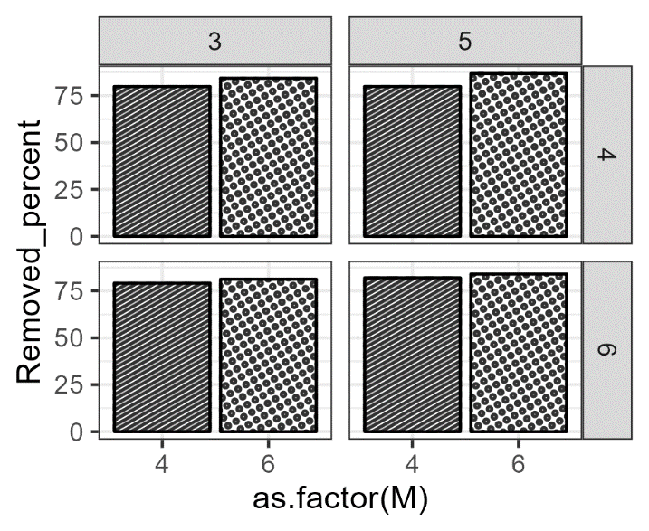
Alginate percent
Mushroom percent percent
pH

Fig 2. The effect of mushroom, alginate and pH on Pb (II) reduction
The detailed effects were further analyzed in the regression analysis with 2k factorial design, R version 3.0, and the effect terms were compared for interpretation (Table 1). The regression analysis of Pb (II) reduction is shown in Table 1 along with the respective probability values. The residual error for the model was 1.889, the multiple R-squared was 0.7514, and the adjusted R-squared was 0.5857. The F-statistic of the model for Pb (II) reduction was 4.535 on 6 and 9 degrees of freedom and the probability value of the model was 0.02164. Although the model was significantly better than the default model, the adjusted R-squared value showed that the model explained only over half of the variations in the experiment. The analysis showed that the mushroom had a significant positive effect on the reduction of Pb (II) with a p-value of 0.00276. This might mean that the higher the percentage of mushroom in the beads, the better the removal would be. Our findings are consistent with Kariuki et al., who found that increased mushroom biomass enhanced Pb (II) biosorption because increasing the biomass dosage progressively increases the adsorption sites for the metal ions (Kariuki, Z et al., 2017)
However, the mentioned fact is entangled with the interaction effect of mushrooms and alginate. The interaction graph was shown in Fig. 3 and 4% alginate inclusion in the beads increased the chance of removing the metal at the higher percentage of mushroom powder in the beads. The change in pH effect in the range of 3 and 5 also showed a positive term for reducing the Pb (II) ions with a p-value of 0.06216. It has been known that pH has a strong influence on metal ion removal. The appearance of the weak effect in this experiment might be due to the fact that the range chosen was narrow and its effect showed a low value.

Table 1. Linear regression analysis of the effect of mushroom, alginate and pH on Pb reduction
 | Estimates | t-value | Pr(>|t|)
Intercept | 82.1177 | 173.861 | < 2e-16 ***
pH | 1.0054 | 2.129 | 0.06216.
Alginate | -0.5710 | -1.209 | 0.25750
Mushroom | 1.9265 | 4.079 | 0.00276 **
pH:Alginate | 0.3775 | 0.799 | 0.44473
pH:Mushroom | 0.2902 | 0.614 | 0.55416
Alginate:Mushroom | -0.8914 | -1.887 | 0.09173.
Signif. codes: 0 ’***’ 0.001 ’**’ 0.01 ’*’ 0.05 ’.’ 0.1 ’ ’ 1. Residual standard error: 1.889 on 9 degrees of freedom. Multiple R-squared: 0.7514, Adjusted R-squared: 0.5857. F-statistic: 4.535 on 6 and 9 DF, p-value: 0.0216
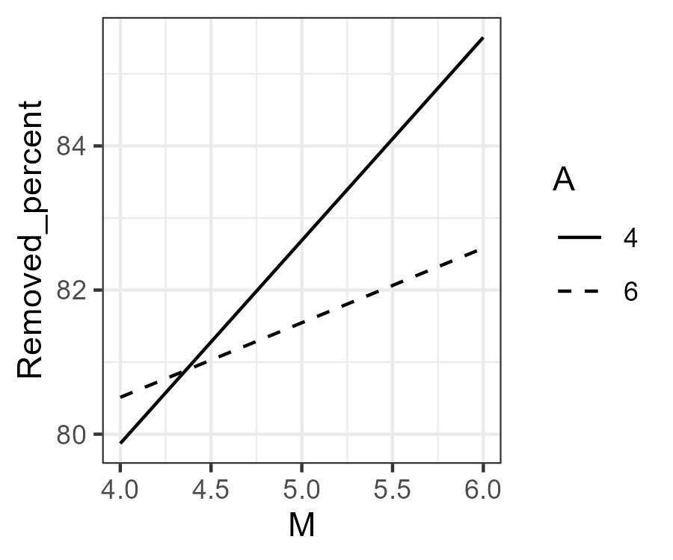
Fig 3. Interaction effect between mushroom and alginate on Pb (II) reduction

The reduction of manganese

All the combinations of pH, alginate, and mushroom showed above 55% reduction of the Mn (II) from the mixture (Fig. 4). The effect of pH was higher at pH 5 than at pH 3 in the removal of Mn (II). Fadel et al. also revealed that biosorption by Saccharomyces cerevisiae was optimal above pH 5 (Fadel, M et al., 2017). The mushroom showed the most distinct effect on the reduction of Mn (II). In general, the overall graph for both Pb (II) and Mn (II) reduction experiment showed that the inclusion of mushroom increased the percentage of the metals removed from the tested mixture (Fig. 5).
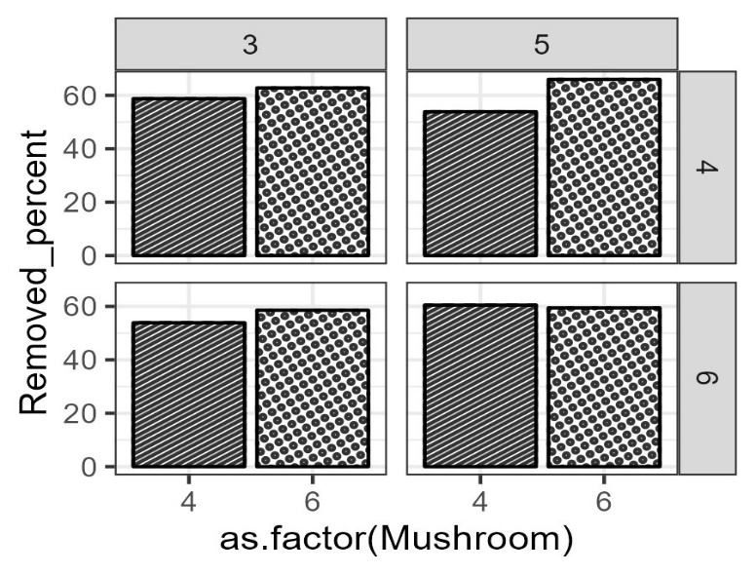
Mushroom percent percent
Alginate percent

pH
Figure 4. The effect of mushroom, alginate and pH on Mn reduction
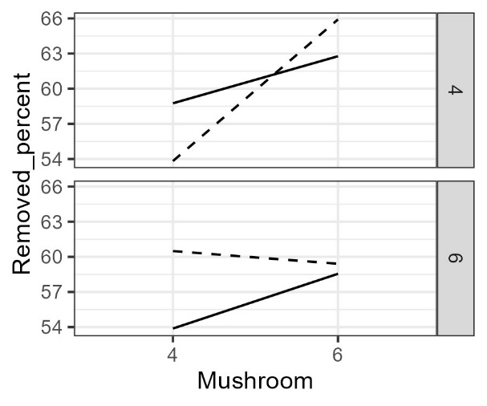
Alginate percent
Figure 5. Interaction effect between mushroom and alginate on Pb (II) and Mn (II) reduction
Table 2 shows the regression analysis for the Mn (II) reduction from the mixture. The linear model had a residual error of 1.224. The multiple R-squared for the model was 0.9515, and the adjusted R-squared was 0.909. F-statistic for the model was 22.4 on 7 and 8 degrees of freedom, and the model was significantly better than the default model with a p-value less than 0.001. The adjusted R-squared value indicated that the model explained more than 90% of the variation of the data in the experiment. The regression estimates for most of the variables and their interaction effects showed significant terms. The estimate for the mushroom effect on the Mn (II) reduction was distinct, with a magnitude of 2.4624 and a P-value of 4.18e-05, and it had a positive effect, meaning the more mushroom inclusion in the bead might increase the reduction percentage in removing Mn (II) from the mixture. Mahmoud et al. also revealed a marked increase in the removal of Mn (II) by increasing of biosorpent mass of Aspergillus spp. (Mahmoud,A,et al., 2017)

Table 2. Linear regression analysis of the effect of mushroom, alginate and pH on Mn reduction
 | Estimates | t-value | Pr(>|t|)
Intercept | 59.1987 | 193.511 | 5.69e-16 ***
pH | 0.7100 | 2.321 | 0.048852 *
Alginate | -1.1167 | -3.650 | 0.006492 **
Mushroom | 2.4624 | 8.049 | 4.18e-05 ***
pH:Alginate | 1.1577 | 3.784 | 0.005355 **
pH:Mushroom | 0.2896 | 0.947 | 0.371461
Alginate:Mushroom | -1.5648 | -5.115 | 0.000913 ***
pH:Alginate: Mushroom | -1.7290 | -5.652 | 0.000480 ***

Signif. codes: 0 ’***’ 0.001 ’**’ 0.01 ’*’ 0.05 ’.’ 0.1 ’ ’ . Residual standard error: 1.224 on 8 degrees of freedom. Multiple R-squared: 0.9515, Adjusted R-squared: 0.909. F-statistic: 22.4 on 7 and 8 DF, p-value: 0.0001179

However, this interpretation might not be complete because there was an interaction term among all three variables with a magnitude of -1.7290 and a P-value of 0.0005. The analysis of interaction was visualized in Fig. 5. While the effect of mushroom on Mn (II) reduction increased at both pH values of 3 and 5 in 4% alginate, its effect showed a higher degree of slope at pH 5. The mushroom effect in 6% alginate seemed lower than in 4% at both pH values, although the effect at pH 5 showed a higher reduction percentage.
The Mn (II) reduction model appears to be more robust, with a higher Adjusted R-squared and more significant predictors, especially the three-way interaction term. Mushroom is consistently a significant positive predictor for both Mn (II) and Pb (II) reduction, suggesting its importance in promoting metal reduction. These results prompt further investigation into the specific mechanisms by which mushroom, pH, alginate, and their interactions influence Mn (II) and Pb (II) reduction. The significance of the three-way interaction in the Mn (II) reduction model underscores the complexity of these relationships, necessitating a nuanced understanding of the variables involved. Replication studies and validation with additional datasets would strengthen the reliability and generalizability of these findings.

FTIR Characterization

The characteristic spectrum of the alginate and mushroom bead is composed of a broad band approximately at 3313 cm-1 that arises from the stretching of hydroxyl groups, low intensity bands at about 2926 cm-1 attributed to –CH2 groups, and 2364 cm-1 is stretching of (C≡N) group; at 1612 cm-1 is asymmetric and symmetric stretching modes, C=O stretching vibration, 1533 cm-1 and 1450 cm-1 are stretching vibrations that come from the respective carboxylate salt groups (-COONa), and a number of vibrations in the range 1138–1093 cm-1 assigned to the glycoside bonds in the polysaccharide (C-O-C stretching). FTIR spectra before and after adsorption are shown in Fig. 6 and Table 3.
For the spectrum of Pb (II) ion after adsorption on a mixture of alginate and mushroom bead shows a nearly 20 cm-1 shift towards lower wavenumbers that was observed for the peak assigned to C-H stretching vibration. And over 3300 cm-1 peak of O-H stretching mode has disappeared. In contrast to our result, the comparison of the FTIR spectrum of raw biomass and after metal ion biosorption shows that the stretching vibration of O-H group shifted from 3396 to 3425 cm-1 for biomass loaded with lead [15]. However, two peaks of C=O stretching vibration and C=C stretching mode shift higher wave numbers by nearly 20 cm-1. C=N vibration mode is lower 10 cm-1 shift occur, and C-H bending peak is observed at 1344 cm-1. The 1081 cm-1 peak is for C-O stretching vibrations in carbohydrates and polysaccharides. 1045 cm-1 may be associated with C-O stretching vibrations as well, and it could be related to the presence of ether linkages or other oxygen-containing functional groups. 1022 cm-1 could be associated with C-O stretching vibrations or potentially C- C stretching vibrations in the context of carbohydrates or polysaccharides. Shifts or changes in these peaks were expected to be seen due to interactions between the metal ions and the alginate molecules. For instance, shifts in the C-O stretching frequencies may indicate coordination of Pb (II) with oxygen atoms in the alginate structure.
The spectrum of Mn (II) ion after adsorption on alginate shows that a mixture of alginate and mushroom bead shows a nearly 10 cm-1 higher shift wavelength for O-H stretching vibration. However, C-H stretching mode peak occurs at the same wavelength as the pure bead, and (C≡N) group stretching mode disappears. C-H bending mode is 60cm-1 shift to a lower wavelength compared to pure bead IR spectrum. In the same way, C-O stretching, C-N stretching, and C-H bending vibration modes peak also shift higher wavelengths. The shifts or changes in these peaks after the adsorption of Mn (II) could indicate the interaction of Mn (II) with functional groups present in alginate and mushrooms.
The provided information describes the infrared (IR) spectra of alginate and mushroom beads, as well as the changes observed after the adsorption of Pb (II) and Mn (II) ions on the mixture of alginate and mushroom

Table 3. Position of the main peaks in FTIR spectra of sodium alginate and mushroom bead before adsorption, after adsorption of Pb (II), and Mn (II).
Wave length of sodium alginate and mushroom bead before adsorption(cm⁻¹) | Wave length of sodium alginate and mushroom bead after adsorption(cm⁻¹) |  | Assignment
 | Pb (II) | Mn (II)
3313 |  | 3435 | O-H stretching
2926 | 2902 | 2924 | C-H stretching
2364 | 2394 |  | (C≡N) stretching
1612 | 1637 | 1639 | C=O stretching
1533 | 1550 |  | C=N stretching
1450 | 1423 | 1385 | C-H bending
1138 | 1344 | 1269 | C-O stretching
1093 | 1081 | 1153 | C-N stretching
756 | 1045 | 1045 | C-H bending
657 | 1022 | 893 | C-metal stretching
 | 935 | 819

Fig 6. FTIR spectrum of (A) pure beads, (B) biomass after Pb (II) adsorption and (C) biomass after Mn (II) adsorption
beads. The observed shifts and changes in peak intensities after metal ion adsorption (Pb (II) and Mn (II)) on the alginate and mushroom bead mixture suggest alterations in the molecular structure of the beads due to the interactions with the metal ions. These changes may indicate the coordination of metal ions with specific functional groups in alginate and mushrooms, providing valuable information about the adsorption process and the nature of metal-ion interactions with the bead components (Kamarudzamana et al., 2015; Taliba, A. S et al., 2005; Khan, M.W.et al., 2013).

CONCLUSIONS AND RECOMMENDATIONS

The analyses of Mn (II) and Pb (II) reduction dynamics reveal relationships among key variables in biological metal reduction processes. In Mn (II) reduction, the model demonstrates a good fit (Adjusted R-squared: 0.909), emphasizing the role of mushroom in promoting Mn (II) reduction. The negative impact of alginate hints at potential inhibitory effects, while the three-way interaction (pH, alginate, and mushroom) underscores the complexity of their contributions. Further research should explore the biochemical pathways underlying these effects, enhancing our understanding of Mn (II) reduction. In Pb (II) reduction, the model, though statistically significant (F-statistic: 4.535, p-value: 0.02164), exhibits a slightly lower goodness of fit (Adjusted R-squared: 0.5857). Mushroom remains a significant positive predictor, aligning with its role in Mn (II) reduction. The marginal significance of pH and the non-significant effect of alginate suggest a nuanced relationship with Pb (II) reduction. The findings highlight the need for additional research to uncover factors influencing microbial Pb reduction processes. Overall, these analyses contribute to advancing the academic understanding of metal reduction, emphasizing the interactions shaping these complex biological phenomena.
FTIR results suggested carboxyl, hydroxyl, and amide were the potential functional groups that may be involved in the Mn (II) biosorption. As a conclusion, the mixture of mushrooms (Pleurotus ostreatus) and alginate beads has been more absorbed for the removal of Mn (II) than Pb (II) from the aqueous solution.

REFERENCES
Abbas, S. H. Ismail, I. M. Mostafa, T. M. & Sulaymon, A. H. (2014). Biosorption of heavy metals a review. J. Chemical Sci. Technol. 3(4):74-102. https://www.researchgate.net/publication/266795209
Bacquart, T. Frisbie, S. Mitchell, E. Grigg, L. Cole, C. Small, C. Sarkar, B. (2015). Multiple inorganic toxic substances contaminating the groundwater of Myingyan Township, Myanmar: Arsenic, manganese, fluoride, iron, and uranium. Elsevier B.V. Volume 517. http://dx.doi.org/10.1016/j.scitotenv.2015.02.038, 0048-9697
Chen, G. Viengvilay, K. Yu, W. Mao, T. Zhihui Qu, Liang, B. Chen, Z. & Li, Z. (2023). Effect of Different Modification Methods on the Adsorption of Manganese by Biochar from Rice Straw, Coconut Shell, and Bamboo. ACS, https://doi.org/10.1021/acsomega.3c02685
Fadel, M., N. M. Hassanein, M. M. Elshafei, A. H. Mostafa, M. A. Ahmed and H. M. Khater (2017). "Biosorption of manganese from groundwater by biomass of Saccharomyces cerevisiae." HBRC Journal 13(1): 106-113.
Geen, A. V. Win, K. H. Zaw, T. Naing, W. Mey, J. L. Mailloux, B. (2014). Confirmation of elevated arsenic levels in groundwater of Myanmar. Science of the Total Environment. 478: 21–24. doi: 10.1016/j.scitotenv.2014.01.073
Kariuki, Z., Kiptoo, J., Onyancha, D. (2017). Biosorption studies of lead and copper using rogers mushroom biomass ‘Lepiota Hystrix’. South African Journal of Chemical Engineering. 23. doi:10.1016/j.sajce.2017.02.001.
Kamarudzamana, N. A, Chayb, C. T, Amira, A, & Taliba, A. S. (2015). Biosorption of Mn (II) ions from Aqueous Solution by Pleurotus Spent Mushroom Compost in a Fixed-Bed Column. Social and Behavioral Sciences (195), 2709 – 2716, doi: 10.1016/j.sbspro.2015.06.379
Khan, M.W. Ali, M. A. khan, N. A. Muhammad Aslam Khan, M. A. Abdul Rehman, A. & Jav, N., (2013) Effect of Different Levels of Lime and pH on Mycelial Growth and Production Efficiency of Oyster Mushroom (pleurotus spp). Pak. J. Bot., 45(1): 297-302, https://www.researchgate.net/publication/287905250
Mahmoud, A, Massoud, M., Abdel-Motaal, F., El-Zayat, S. (2017). Tolerance and Biosorption of Manganese, Iron and Aluminium by Five Aspergillus Species Isolated from Freshwater. Catrina: The International Journal of Environmental Sciences. 16. 61-69. 10.21608/cat.2017.14284.
Maw, A. M. Phyu, P.K. Aung, N. M. Mar, K. K. Khin, S. O. Khaing, K. K. Thura, A. Thu, A. Zin, P. W. Thin, K. M. Thant, K. Z. (2020). Approach to assessment of heavy metals contamination in drinking water, Mandalay region, Myanmar. IOP Conference Series: Earth and Environmental Science, doi:10.1088/1755-1315/496/1/012008
Nongthombam, J. kumar, A. & Patidar, S., (2021). Review on Study of Growth and Cultivation of Oyster Mushroom. Plant Cell Biotechnology and Molecular Biology. https://www.researchgate.net/publication/349238624
Qazilbash, A. A. (2004). Isolation and characterization of heavy metal tolerant biota from industrially polluted soils and their role in bioremediation. Biological Science, 41, 210-256. Doctoral dissertation, Quaid-i-Azam University Islamabad, Pakistan. 210-256 pp.
Talbi, A., Kemper, K., Minnatullah, K., Foster, S., Tuinhof, A. (2005). An Overview of Current Operational Responses to the Arsenic Issue in South and East Asia. World Bank, Washington, DC.
USEPA (2013) United States Environmental Protection Agency. Secondary Drinking Water Regulations: Guidance for Nuisance Chemicals; USEPA: Washington, DC, USA, 2013.
Vimala, V, Nilanjana Das, (2009) Biosorption of cadmium (II) and lead (II) from aqueous solutions using mushrooms: A comparative study, Journal of Hazardous Materials, 168 (1): 376-382
WHO (2008) Guidelines for drinking-water quality, 3rd edn. World Health Organization, Geneva. https://www.who.int/water_sanitation_health/dwq/fulltext.pdf Cited June 2017. Accessed December 2018.
WHO (2011) Lead in drinking-water. Background document for preparation of WHO Guidelines for drinking-water quality. Geneva, World Health Organization (WHO/SDE/WSH/03.04/9/Rev/1)
Xiangliang, P. Jianlong, W. Daoyong, Z. (2005). Biosorption of Pb (II) by Pleurotus ostreatus immobilized in calcium alginate gel. Process Biochemistry 40. 2799–2803. doi: 10.1016/j.procbio.2004.12.007

